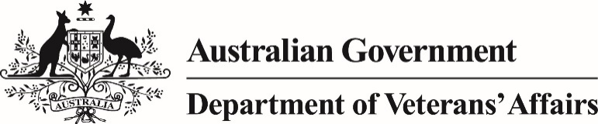

The Vietnam Veterans Family Study (VVFS) is the most significant research program ever undertaken by the Australian Government into the health of the families of Australia’s Vietnam veterans.

The Department of Veterans’ Affairs (DVA) undertook this study to better understand the long-term impacts of service on the health and welfare of the families of Vietnam veterans.

The study examined the physical, mental and social health of Vietnam veterans and their families, covering a broad range of health outcomes for these people.

More than 27,000 people participated in the studies, comprising veterans, partners and their children. These included:

* 10,000 randomly selected Army Vietnam veterans and their families, including their partners, ex‑partners, children, stepchildren, brothers, sisters, nieces and nephews; and
* 10,000 randomly selected Defence Force personnel who served in the Army during the Vietnam War era (1962–75) but did not deploy to Vietnam and their families, including their partners, ex‑partners, children and stepchildren. This provided a control group representing comparable families.

A Scientific Advisory Committee of independent research experts provided oversight of the study and a Consultative Forum represented the veteran community perspective.

The key findings found that the majority of sons and daughters born to Vietnam veterans are leading healthy and productive lives. However, analysis found that the families of Australia’s Vietnam veterans are more likely to have significant emotional, physical, and social problems when compared to families of those who served in that era who did not go to Vietnam.

The key factors that appeared to explain the intergenerational impact of deployment were:

* servicemen’s post-traumatic stress disorder (PTSD)
* harsh parenting in childhood among the offspring of Vietnam veterans
* problems at school among the sons and daughters of Vietnam veterans

When examining mortality amongst the children of Vietnam veterans, the research found that the children of Vietnam veterans and Vietnam-era personnel had lower mortality rates when compared to the general population, and that there were no significant differences in deaths from cancer.

The research shows that operational service affects more than just the person who serves; it can also impact on family members.

The research did not find a causal link between a father being exposed to Agent Orange and the health of children.

**Support**

Open Arms — Veterans and Families Counselling (formerly VVCS), is a national mental health service that provides 24-hour free and confidential counselling, group programs and suicide prevention training for current and ex-serving Australian Defence Force personnel, and their families.

To get support or to find out more, call 1800 011 046 or visit the [Open Arms website](http://www.OpenArms.gov.au).

Further self-help support tools and information is available through the [At-Ease portal](http://at-ease.dva.gov.au).

In addition, all Vietnam veterans are eligible for a Gold Card at age 70.

The suite of VVFS reports is available on the [DVA website](http://www.dva.gov.au/vvfs).

**Vietnam Veterans Family Study**

Aim: To determine the effect, if any, that active Vietnam service had on the physical, mental and social wellbeing of the sons and daughters of Australian Vietnam veterans.

Cost: $11.5 million

Participation: more than 27,000 including veterans, partners and their children.

**Research contributors**

* Australian Institute of Family Studies (AIFS)
* Australian Institute of Health and Welfare (AIHW)
* Open Mind Research Group Pty Ltd
* Taylor Nelson Sofres Research Australia Pty Ltd
* Enhance Management Pty Ltd
* Colmar Brunton Social Research Pty Ltd

**Key findings (compared to Vietnam-era personnel)**

The majority of children of Vietnam veterans were leading healthy and productive lives. However, they were more likely to:

* be diagnosed with or treated for depression (21% vs 14%), anxiety (22% vs 13%) or PTSD (4% vs 1%);
* have suicidal thoughts (41% vs 31%), suicidal plans/actions (12% vs 7%);
* have skin conditions (21% vs 14%), migraines (13% vs 7%) and experience sleep disturbances (15% vs 9%).

**Vietnam Veterans Family Study**