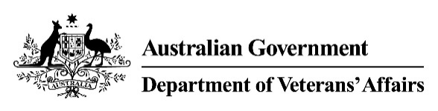 | Mastication & Deglutition  Medical Impairment Assessment
Veteran |  |  |  |  | UIN
Please assess the following conditions:
For this assessment, each condition needs to be assessed in isolation from all others. This means that when assessing a condition, you will need to assess the impairment as though only that single condition is present, and that the veteran is otherwise healthy and normal. If it is not possible to separate the impairment in this way, please select a description of the total impairment rating under “combined conditions.”

- Please select the most accurate description of the need for modification of the consistency of diet, due to each condition in isolation.
Description | Insert condition: | Insert condition: | Insert condition: | Insert condition: | Insert condition: | OR | Combined Conditions  (if unable to isolate)
None. | ☐ | ☐ | ☐ | ☐ | ☐ |  | ☐
Limited to semi-solid foods. | ☐ | ☐ | ☐ | ☐ | ☐ |  | ☐
Limited to soft or mashed foods. | ☐ | ☐ | ☐ | ☐ | ☐ |  | ☐
Limited to pureed foods. | ☐ | ☐ | ☐ | ☐ | ☐ |  | ☐
Limited to liquid foods. | ☐ | ☐ | ☐ | ☐ | ☐ |  | ☐
Requires tube feeding or gastrostomy. | ☐ | ☐ | ☐ | ☐ | ☐ |  | ☐
- Are there any other comments you would like to make regarding the impact of the veteran’s ability to chew and swallow?

Doctor's signature | Doctor's name | Date | Time to complete form

