COMMUNITY NURSING NEWSLETTER No. 51
January 2025
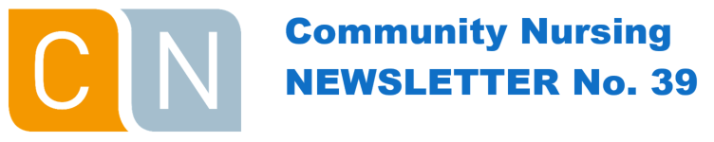

This Newsletter is issued to provide updates to DVA contracted Community Nursing providers.

Clinical Documentation Requirements
Providers are reminded that all clinical documentation should adhere to the guidelines outlined in the Notes for Community Nursing Providers.

Referral for the Community Nursing Program
A community nursing provider must receive a valid written referral for an eligible client before the commencement of services, from one of the following authorised referral sources:
- GP
- treating medical practitioner in a hospital
- hospital discharge planner
- nursing practitioner specialising in a community nursing field.

Referral requirements:
- referrals should outline necessary services to meet an assessed nursing care need for a medical condition. The clinically required nursing and personal care interventions should be included in the referral
- the authorised referral source must provide a written referral for a client to request community nursing services
- the referral should be on either the referral source’s official letterhead, the community nursing provider’s official referral form, or the DVA Community Nursing referral form, and be sent directly to the community nursing provider
- referrals from GPs and nurse practitioners are valid for 12 months (then a new referral required). Hospital referrals are valid for 6 weeks.

A referral must include the following information:
- authorised referral source details, including provider number (hospital provider number for discharge planner or treating medical practitioner referral)
- medical condition/s the client requires community nursing services for, and clinical details of the condition/s including recent illnesses and injuries
- if medication administration or assistance is required, a medication authority or signed current medication chart / list that includes medication information
- a measure of the client’s level of independence
- other health / support services the client is receiving.

Comprehensive Nursing Assessment
A Registered Nurse (RN) must assess the nursing care need/s of a client through a comprehensive clinical assessment, conducted face-to-face in the client’s home.

A comprehensive clinical assessment must include the use of validated assessment tools based on current community nursing industry best practice standards. Assessment tools required will be based on the identified care needs of the client, for example:
- skin assessment
- continence assessment
- falls risk assessment tool (FRAT)
- pain assessment
- sleep assessment
- nutritional assessment.

If the client’s level of independence has not been included in the referral, the RN should assess this as part of the initial comprehensive assessment, using an industry recognised measure of assessing independence. The tool should include Activities of Daily Living (ADLs) such as showering, grooming, dressing, bowel and bladder care, transfers and mobility. If assistance to eat is required, a nutritional assessment must also be conducted to determine the nutritional risk.

Nursing care plan
A client’s nursing care plan must be developed and signed by an RN and the client or their representative, following the comprehensive assessment. The care plan is to be developed with, and tailored to the client, factoring in the client’s needs, goals and preferences, regularly reviewed and updated including when:
- the client’s needs, goals or preferences change
- the client’s ability, mental health, cognitive or physical function, capacity or condition deteriorates or changes
- the care that can be provided by a client’s carer changes
- risks emerge or change or there is an incident that impacts the client
- all or part of the client’s care is transferred between others involved in the client’s care.

A nursing care plan must include:
- clinical and personal care interventions to meet identified care needs
- client’s level of / capacity for independence
- client’s goal/s of care and agreed actions (short and long term), including their cultural needs
- desired outcome/s of care
- delegation of care within scope of practice
- review dates
- agreed days and approximate timeframes that services will be delivered
- supports for the client’s wellbeing and quality of life, maximising the client’s independence and supporting their reablement
- information about the risks associated with care and service delivery and how staff can support clients to manage these risks.

Advertising as a Community Nursing provider for DVA
There are set advertising requirements that you must adhere to which are outlined in section 13 in the Terms and Conditions for the provision of Community Nursing Services.

The DVA logo cannot be utilised in any media, websites, or advertising materials. You are also not permitted to promote yourself as a preferred DVA provider.

If you are unsure about whether any proposed advertising aligns with the Terms and Conditions, please email community.nursing.contracts@dva.gov.au and the request will be reviewed on a case-by-case basis.

Further information can be found in the Terms and Conditions for the Provision of Community Nursing Services on the DVA website.
Open Arms – Veterans & Families Counselling


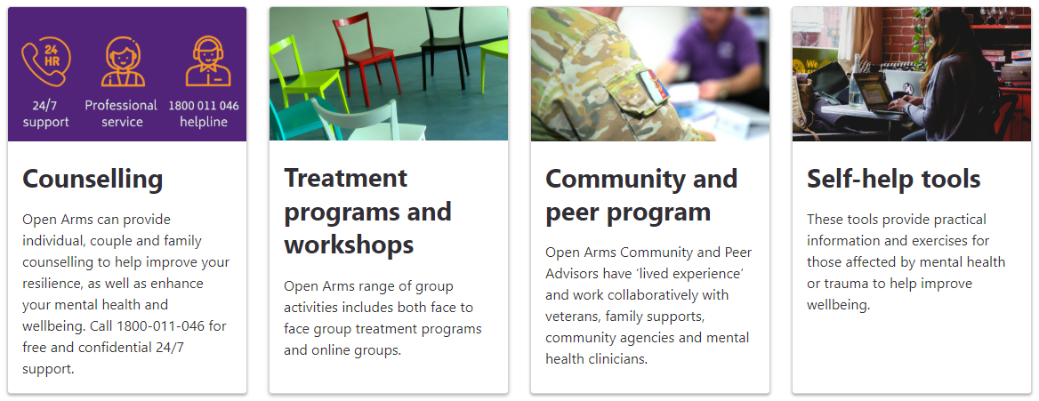

Open Arms - Professional Development
Open Arms assists health providers to understand the military experience and maintain clinical best practice by offering free online training courses and webinars to help clinicians, practice nurses and other clinical practice staff to better support the mental health needs of veterans. Courses include:
- Open Arms Practitioner’s Guide (1 hr) - A program for counsellors and providers to understand common mental health impacts from military service, clinical treatment expectations, psychological and resilience training used by the Australian Defence Force (ADF).
- Understanding our veterans: the ADF and the people who serve (2 hrs) - A program to provide an overview of military history, the impact of a veteran's military service, special issues impacting a veteran and DVA support for veterans.
- Understanding the military experience (2 hrs) - A program for mental health clinicians to better understand veteran patients, the long-term effects of military service on mental health, and how military training and culture shape behaviours after service.

Where a certificate is awarded through DVA Train, health professionals may use it for Continuing Professional Development Points.

These courses and others can be found at www.openarms.gov.au/professionals/professional-development

Open Arms - DVA General Advice Line
A free consultation service (operated by Phoenix Australia) providing mental health-related resources and information about available treatment options to individuals and organisations that deliver services to veterans.
- Staffed by mental health clinicians with extensive experience
- No query is too simple or too complex
- Mental health does not need to be the primary focus of work with a client
- Phone 1800 838 777 between 9.00am and 4.00pm AEST Monday to Friday.

