2023 Gender Pay Gap Employer Statement

Gender Pay Gap
The gender pay gap refers to the overall difference in average earnings between men and women, while equal pay means that men and women receive the same pay for the same work.
The Department of Veterans Affairs (DVA) is committed to further embedding gender equality and equity into all that we do, and maintaining a focus on a gender balance at all levels.
We have set targets to address gender equality in the workplace, and analysed payroll data to identify any remuneration gaps between women and men (such as classification or tenure). As a result, we are tracking well towards renumeration equality.
As of 31 December 2023, DVA’s gender pay gap stands at 2.1 per cent, which is less than the APS average of 3.6 per cent.
While our female staff are well-represented across all classifications, they have accessed more parental leave and flexible work arrangements than their male colleagues in 2023-24. DVA will continue to promote targeted initiatives such as ensuring male staff are aware of leave entitlements and access flexible work arrangements.

Gender Profile
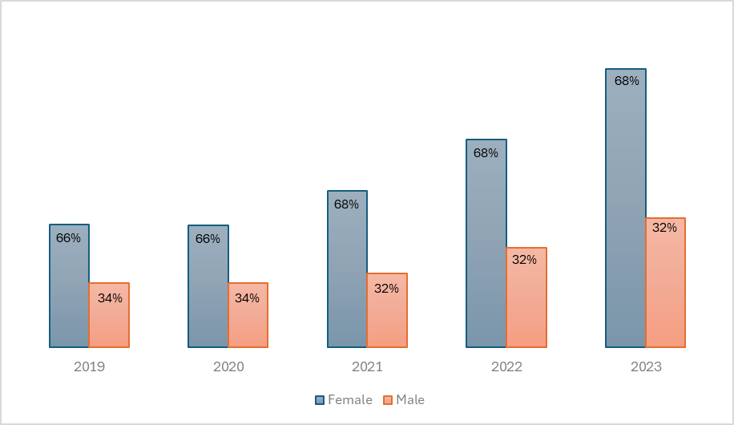
Chart 1: DVA gender profile
Chart 1 shows the department's workforce gender profile has remained steady despite an increase in overall staffing numbers, evidencing our ongoing commitment to recruitment equity.

Future focus
While DVA has a relatively small gender pay gap, it is still not equal. To this end we will focus our efforts on making sure all staff are aware of parental leave flexibility, flexible work arrangements and have the opportunity to develop and build their careers. DVA is focusing on strategic workforce planning to improve the gender balance across the workforce and across all classifications.
We will work closely with our Gender Equity Staff Committee and focus our efforts on continuing to implement our Gender Equality Action Plan to monitor and address gender-based behaviour differences, to ensure all our employees have the opportunity to achieve work-life balance.

DVA’s gender pay gap excludes the Secretary, casual employees, contractors, labour-hire staff, statutory appointees, employees on long-term leave and those identifying as non-binary.

