**Cooking for One or Two**

Masterclasses

Appendix

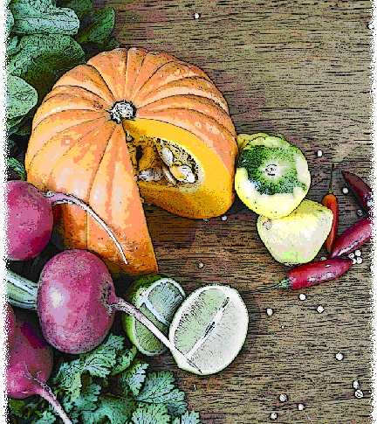

# Appendix A: Masterclass evaluation survey

|  |
| --- |
| Cooking for One or Two masterclass evaluation survey |

(To be completed at the end of the two week program)

**How to complete this survey**

|  |
| --- |
| If the facilitator would like to evaluate the program, please use the following survey. The purpose of this survey is to evaluate changes over time. |

*Please answer every question you can. If you are unsure about how to answer a question, please ask the facilitator or assistant.*

1 Since completing the program, describe the ways in which the variety in your diet has increased or decreased?

____________________________________________________________________________________________________________________________________________________________________________________________________________________________________________________________________________________________________

2 Since completing the program, please describe how your cooking ability has changed:

____________________________________________________________________________________________________________________________________________________________________________________________________________________________________________________________________________________________________

3 Since completing the program, please describe any changes in your social interactions:

____________________________________________________________________________________________________________________________________________________________________________________________________________________________________________________________________________________________________

**Thank you for taking the time to complete this survey.**