Commonwealth War Graves Commission

Information

Sheet



**EL ALAMEIN AND THE WAR IN THE WESTERN DESERT**

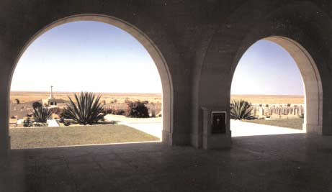

***A view of El Alamein War Cemetery from the Alamein Memorial***

**THE DESERT CAMPAIGN**

The campaign in the Western Desert was fought between the Commonwealth Forces (with, later on, the addition of two brigades of Free French and one each of Polish and Greek troops) all based in Egypt, and the Axis Forces (German and Italian) based in Libya. The battlefield, across which the struggle surged back and forth between 1940 and 1942, was the 1.000 kilometres of desert between Alexandria in Egypt and Benghazi in Cyrenaica. It was a war of manoeuvre and lengthy movement in which, until the final phase. each advance by either side generated the same problems of over- extended lines of supply and reinforcement. For both sides the objectives were not the acquisition of' desert sand but the control of the Mediterranean, the link with the East through the Suez Canal, the Middle East oil supplies and the supply route to Russia throuah Persia.

The battle of El Alamein, 23 October-4 November 1942, is the most famous event in this confrontation and was one of the decisive battles of history. In intensity it rivalled anything hitherto known and it was the culmination of a campaign in which the Eighth Army and the Desert Air Force had fought as one, their own flanks and supply routes guarded, and those of the enemy harassed, by the Navy, and their supplies brought to them by the Merchant Navy. The victory led to the final expulsion of the Axis Forces from North Africa in April 1943.

The battlefield Graves of those who died in the desert campaign were moved into the Commonwealth war cemeteries at El Alamein, Sollurn, Tobruk, Acroma, Benghazi and Tripoli. The names of soldiers and airmen whose graves are unknown are commemorated, with those of their comrades from the other operations in the Middle East, on the Alamein Memorial, and the names of the missing sailors on the memorials at their home ports.

**EL ALAMEIN WAR CEMETERY AND THE ALAMEIN MEMORIAL**

There are 7,367 burials in the cemetery, of which 821 are unidentified by name. The names of a further 603 men, whose remains were cremated. are commemorated on the Cremation Memorial within the cemetery.

The Alamein Memorial bears the names of 11,874 soldiers and airmen who have no known grave. The 8,687 missing

soldiers died in the campaigns in the Western Desert (8,392), Iraq (184), Syria and Lebanon (116) and Persia (33). The

3,187 missing airmen died not only in these four campaigns but also in the operations in Greece, Ethiopia, the French, British and Italian Somalilands, Eritrea and Madagascar.

The cemetery and memorial were designed by Sir Hubert Worthington, the Commission's Principal Architect for the ceme- teries in North Africa, and the memorial was unveiled by Field Marshal Montgomery on 24 October 1951. The memorial cloister, some 80 metres long, is entered through three arches leading from the forecourt, and at each side of the forecourt broad flights of steps lead to the flat roof of the memorial, from which there is a view of the cemetery, the surrounding desert and, to the north beyond the road, the sea. Above the arched entrance to the cloister the dedicatory inscription reads:

WITHIN THIS CLOISTER ARE INSCRIBED THE NAMES OF THE SOLDIERS AND AIRMEN OF THE BRITISH COMMONWEALTH AND EMPIRE WHO DIED FIGHTING ON LAND OR IN THE AIR WHERE TWO CONTINENTS MEET AND TO WHOM THE FORTUNE OF WAR DENIED A KNOWN AND HONOURED GRAVE. WITH THEIR FELLOWS WHO REST IN THIS CEMETERY, WITH THEIR COMRADES IN ARMS OF THE ROYALNAVY AND WITH THE SEAMEN OF THE MERCHANT NAVY THEY PRESERVED FOR THE WEST THE LINK WITH THE EAST AND TURNED THE TIDE OF THE WAR.

1939-1945

In the marble floor just inside the central archway are set in bronze letters, surrounded by a bronze ring, the following words:

TO THE GLORY OF GOD

AND TO THE UNDYING MEMORY OF THE EIGHTH ARMY

23rd OCTOBER-4th NOVEMBER 1942

On the walls within the cloister are fixed the panels bearing the names.

The main part of the building is of limestone from quarries in the immediate vicinity, but pavings and copings are of mar- ble (Travertine) from Italy, and the name-panels are of Portland stone from England.

The Cross of Sacrifice at the far side of the cemetery is raised high on a podium approached by flights of steps on either side. There is some planting among the plots of graves to soften the effect of the sea of headstones, but the spreading grass lawns and headstone borders full of flowers typical of most Commission cemeteries are necessarily absent in this desert site which occupies 20 hectares.

Near the cemetery are national memorials to casualties of the First South African Division in the Battle of Cyrenaica, which took place in November and December 1941, and to the casualties of the 9th Australian Division who were killed in the Battle of El Alamein. German and Italian memorials stand a few kilometres further west along the coast road.

El Alamein village lies approximately 130 kms west of Alexandria. The cemetery itself is situated in a small built-up area, also referred to as Alamein, 1 km along the old road past the turning to El Alamein village. A new dual carriageway bypass loops around Alamein. It is therefore necessary for visitors to turn off at the dual carriageway taking the old road that runs parallel to the carriageway coastal road. El Alamein War Cemetery is located to the left or south of this road approximately

500 m from the junction of the coastal road. The main cemetery entrance will be found a further 100 metres to the south along the gravel walkway leading to the memorial, which forms the northern boundary of the cemetery.

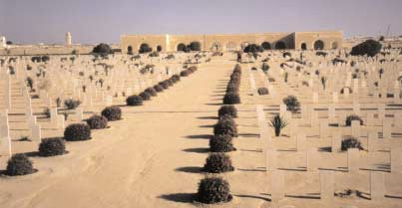

***El Alamein War Cemetery, looking towards the Alamein Memorial***

Published by the Commonwealth War Graves Commission, 2 Marlow Road, Maidenhead, Berkshire, SL6 7DX, England. Tel: 01628 634221. http://www.open.gov.uk./cwgc/cwgchome.htm