**Commonwealth**

**War Graves**

**Commission**

**Information**

**Sheet**



**THE PLYMOUTH NAVAL MEMORIAL, DEVON, ENGLAND**

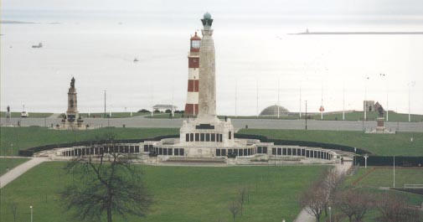

After the 1914-18 War, the Imperial War Graves Commission (as it was then) had to find an appropriate way of commemorating those members of the forces who had died but had no known grave. It was decided that soldiers would be named on memorials to be built on or near where they fell, but a different approach was needed for men of the Royal Navy, the majority of deaths having occurred at sea where no permanent memorial could be provided.

An Admiralty committee considered the subject and recommended that the three manning ports in Great Britain - Chatham, Plymouth and Portsmouth - should each have an identical memorial of unmistakable naval form; an obelisk which would serve as a leading mark for shipping.

Sir Robert Lorimer (1864-1929) was the architect chosen to realize this idea. By the time he started work on his design in

1921 he had already done a considerable amount of work for the Commission, designing cemeteries and memorials in Italy, Greece and Egypt. He was the Commission’s principal architect for the United Kingdom until 1927 and he also designed the war cemeteries in Germany and the Scottish National Memorial in Edinburgh.

For each naval memorial he planned a stone tower supported by four corner buttresses, each with a lion couchant. Towards the top, the tower branches out in the form of four ships’ prows. Above them are representations of the four winds, which in turn support a large copper sphere symbolising the globe. The sculptor for these features was Henry Poole. The names of just over 7,000 sailors commemorated on the Plymouth Naval Memorial were cast on bronze panels placed on the buttresses, and the sides of the tower bear the names of the principal naval engagements fought in the war and an inscription, also in bronze, that reads:

IN HONOUR OF THE NAVY AND TO THE ABIDING MEMORY OF THOSE RANKS AND RATINGS OF THIS PORT WHO LAID DOWN THEIR LIVES IN THE DEFENCE OF THE EMPIRE AND HAVE NO OTHER GRAVE THAN THE SEA

The site chosen for the Plymouth Naval Memorial was in the park on the north side of the Hoe, between the Drake Statue and the Armada Memorial. It was unveiled by Prince George in July 1924.

After the Second World War it was decided that the naval memorials would be extended to provide space for commemorating the naval dead without graves of that war. The same materials should be used, namely portland stone with bronze name panels, but since the three sites were dissimilar, a different architectural treatment was required for each place.

For Plymouth, a sheltered sunken garden was created on the landward side of the memorial with bronze name panels fixed to the curved retaining wall. There are nearly 16,000 names on the 1939-45 extension to the memorial. The central section of the wall is inscribed with the following words from Chapter 44 of the Book of Ecclesiasticus:

ALL THESE WERE HONOURED IN THEIR GENERATIONS AND WERE THE GLORY OF THEIR TIMES

On either side of the panel are two sculpted figures of sailors of the Royal Navy on the alert, by Charles Wheeler. At the end of the wall are two further figures, depicting a Royal Marine and a member of the Maritime Regiment of the Royal Artillery. These are by William McMillan, who was also responsible for the statues of Neptune and Amphitrite with sea horses at the entrance to the memorial.

In addition to commemorating seamen of the Royal Navy who sailed from Plymouth, the First World War panels of the memorial also commemorate sailors from Australia and South Africa. Other Dominions wished for commemoration elsewhere and their sailors are commemorated for the most part on memorials in their own home ports. After the Second World War, Canada and New Zealand again elected for commemoration at home, but the Plymouth Memorial commemorates sailors from all other parts of the Empire. The dedicatory inscription on the seaward side of the obelisk reads:

IN HONOUR OF THE NAVY AND TO THE ABIDING MEMORY OF THESE RANKS AND RATINGS OF THIS PORT WHO LAID DOWN THEIR LIVES IN THE DEFENCE OF THE EMPIRE AND HAVE NO OTHER GRAVE THAN THE SEA AND THEIR COMRADES OF AUSTRALIA SOUTH AFRICA NEWFOUNDLAND INDIA PAKISTAN CEYLON FIJI GOLD COAST HONG KONG KENYA MALAYA NIGERIA SIERRA LEONE AND BURMA WHOSE NAMES ARE HERE RECORDED.

The architect for the Second World War extension to the memorial was Sir Edward Maufe (1882-1974) who was the Commission’s principal architect for the United Kingdom after the Second World War. He also designed the Air Forces Memorial at Runnymede for the Commission and Guildford Cathedral. The extension was unveiled by Princess Margaret in May 1954, with additional panels, honouring those who died ashore but have no known grave, being unveiled by Admiral Sir Mark Pizey on 11 November 1956. The memorial has been the site of many thousands of individual pilgrimages and each year on Remembrance Sunday a major ceremony is held.

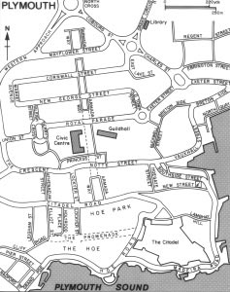

*The memorial is accessible at all times and there is car parking nearby.*

**Naval**

**Memorial**

*The Memorial Register is kept at the Tourist Information Office, Island House, 9 The Barbican, Plymouth, PL1 2LS Tel: 01752 304849, Fax: 01752 257955 and also in the Naval Historical Section at Plymouth library.*

*The Commonwealth War Graves Commission is responsible for marking and maintaining the graves of members of the forces of Commonwealth countries who died in the two world wars, for building and maintaining memorials to the dead whose graves are unknown and for providing records and registers of these burials and commemorations, totalling 1.7 million and found in most countries throughout the world.*

Published by the Commonwealth War Graves Commission, 2 Marlow Road, Maidenhead, Berkshire, SL6 7DX, England. Tel: 01628 634221

Fax: 01628 771208

Web Site: www.cwgc.org

E-Mail: General Enquiries: general.enq@cwgc.org

E-Mail: Casualty & Enquiries: casualty.enq@cwgc.org

ISA4 01/00