*Commonwealth War Graves Commission*



**The Air Forces Memorial, Runnymede**

The Royal Air Force saw some of the earliest action of the Second World War when on 4 September 1939, the day after war was declared, Blenheim and Wellington bombers attacked German shipping near Brunsbüttel and Wilhelmshaven. In those raids seven aircraft were lost and twenty-five airmen killed, the first casualties in what would become a world-wide struggle to gain mastery in the air upon which victory depended. It was a struggle that would last the war through and would cost the lives of more than 116,000 men and women of the Air Forces of the Commonwealth.

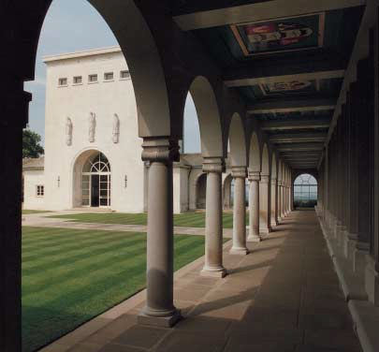

Many of those who died were lost without trace and their graves are unknown. The missing thousands are today remembered on memorials around the world: at El Alamein and Singapore, at Ottawa and on the island of Malta. Those lost in operations from bases in the United Kingdom and North and Western Europe - more than 20,000 - are commemorated at the Air Forces Memorial, Runnymede. Most of these casualties served in the ranks of the Royal Air Force but as the war progressed, Britain welcomed airmen and women from all the Commonwealth's Air Forces and from other countries too: Americans volunteered for service with the RAF before the USA entered the war and fought alongside those whose homelands in Europe had been overrun.

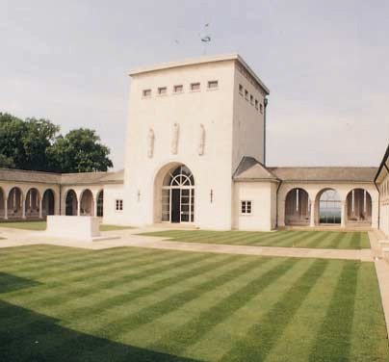

Some of those who died were killed in service with vital transport, training and maintenance units, others as agents in special operations in occupied Europe, but most were lost while serving with the operational commands of the Royal Air Force in the long and bitter air war over north-western Europe.

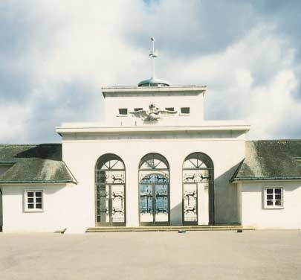

It was a war that saw periods of desperate crisis and drama, attrition and numbing routine. Throughout, the Air Forces fulfilled crucial supporting roles to the land campaigns and at sea, and during the long years when Britain stood isolated and vulnerable on the edge of a Europe largely under German occupation, they stood both as the first line of defence and the potent means of striking back.

**The Fall of Norway and France**

**The War at Sea**

Germany's invasion of Denmark and Norway in April 1940 brought to an abrupt end the early months of uneasy quiet that followed the declaration of war in 1939. The RAF offered crucial air support to the small expeditionary force sent from Britain in a desperate but unsuccessful attempt to halt the German occupation. In May, when Germany made a swift and devastating move on France and the Low Countries, it fell to the RAF to meet the air needs of practically the whole Allied front.

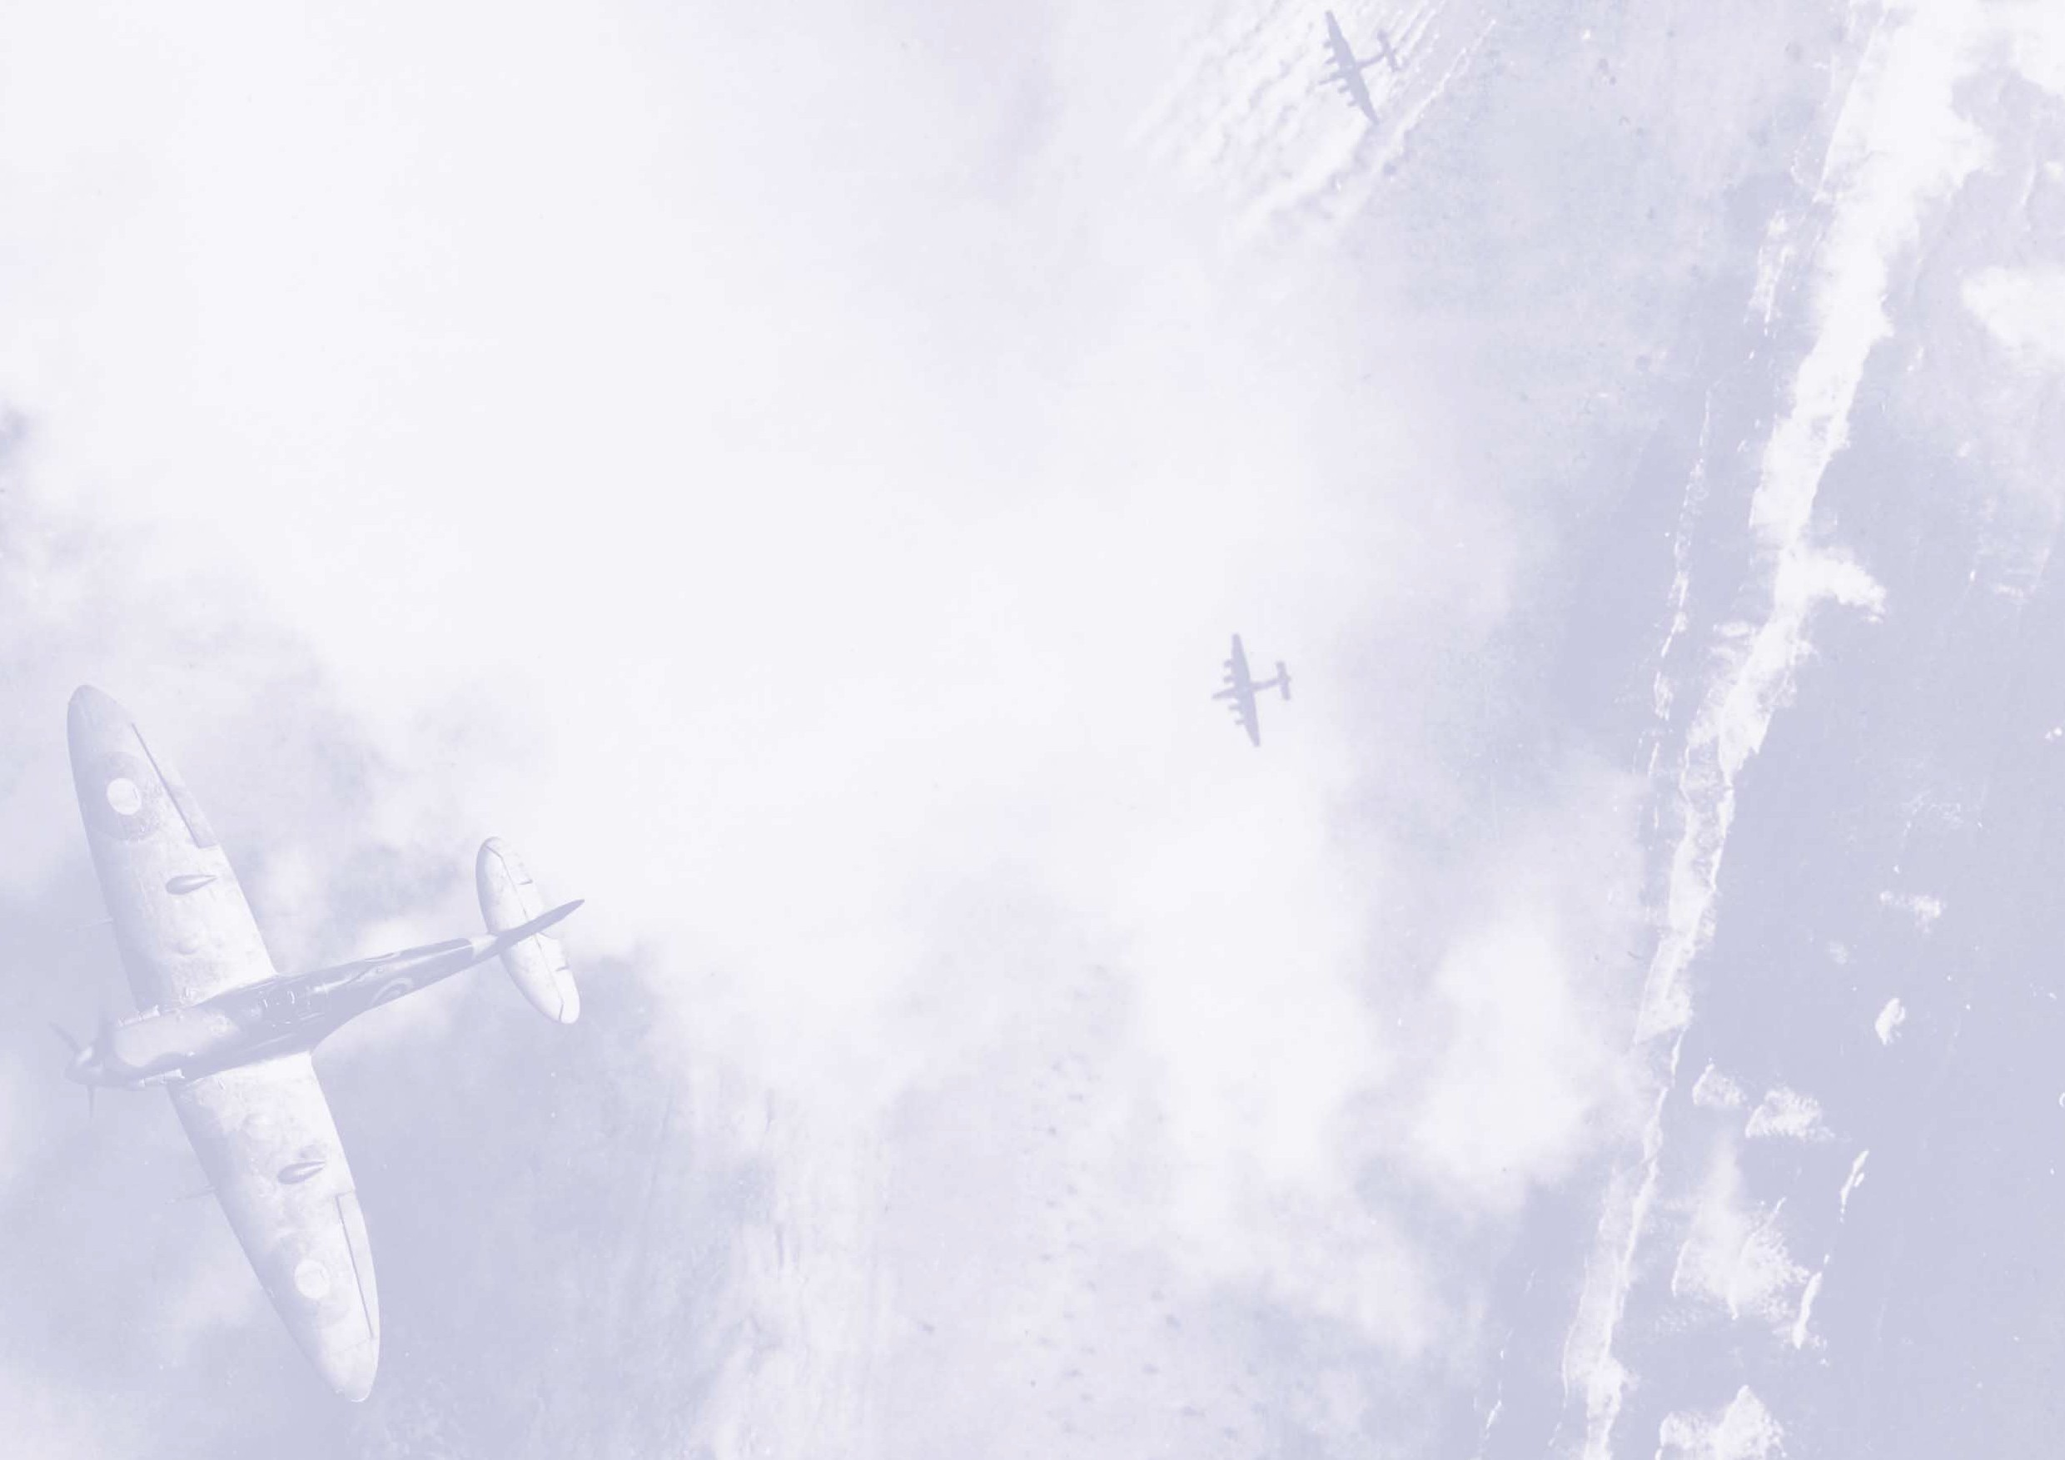

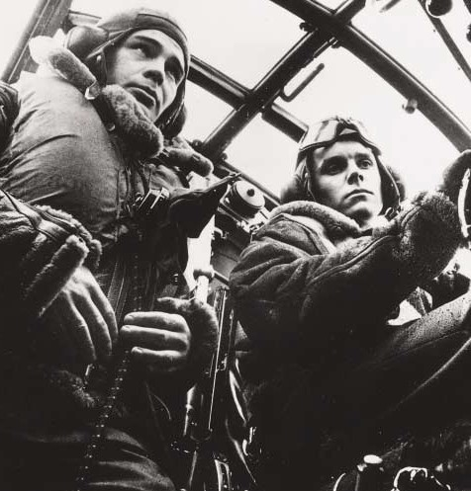

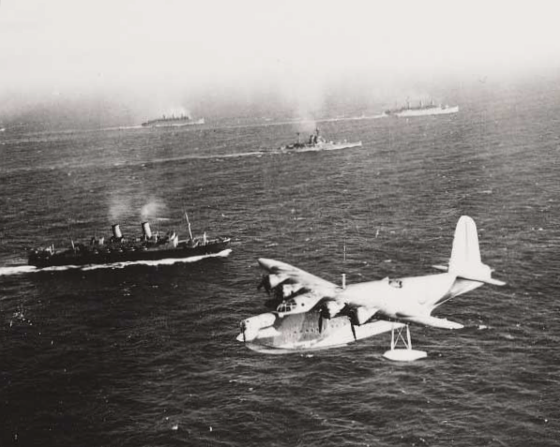

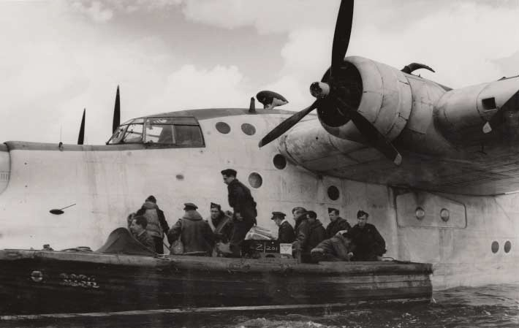

With the German offensive gaining momentum, heavy losses were suffered as fighters and bombers based in France and Britain struck at occupied airfields and ports, destroyed vital bridges, harassed transport columns and supply lines, anything to hinder the German advance. Nevertheless, the Allied land forces were soon forced to fall back to the Channel ports for evacuation and while the air battle for Dunkirk brought the Royal Air Force and the Luftwaffe together for their first real trial of strength, almost 340,000 British and Allied troops were evacuated from the beaches below. By the end of June, France had fallen and the whole coast of western Europe, from the Bay of Biscay to the Northern Cape, was under German control.

**The Battle of Britain**

Britain now faced a real crisis. Germany was poised for an invasion, but first she set about securing superiority in the air by destroying the network of airfields and fighter stations upon which Britain's defences rested. Soon these critical targets were being subjected to heavy and persistent attack by German bombers with huge fighter escorts.

For a few short weeks the fighting in the summer skies above Britain was intense. The number of fighter pilots involved in the battle was comparatively small but losses were heavy - more than 500 were killed - and the burden of responsibility they carried enormous. Despite the relentless pressure, the Luftwaffe could not gain the upper hand and on 7 September, when Fighter Command was reduced to its very last reserves of machines and trained pilots, the Germans turned their attention elsewhere, beginning a series of night bombing raids on British cities intended to disrupt, destroy and shatter civilian morale; by mid-September the threat of invasion was receding; the Battle of Britain was nearing its end and the Blitz had begun.

The devastating raids continued throughout the winter but Fighter Command had recovered quickly and with improved equipment and skill bred of experience, the defending night fighters began to turn the tide. By early May 1941 the worst of the raids were over.

By the summer of 1940, Germany's domination of Europe's western seaboard introduced a new and deadly threat to Britain's vital supply lines - the U-boat.

For the next three years, support from the air played a crucial part in the Battle of the Atlantic as German submarines and ships were hunted down and sunk. Between April 1940 and March

1943 almost 16,000 mines were laid by Bomber Command in so called 'gardening' operations. Fighter Command made a significant contribution with air escort and offensive fighter patrols, particularly in the Arctic, but the leading role in the protection of Allied shipping fell to Coastal Command.

Coastal Command's work was not glamorous. With a constant need for vigilance its squadrons flew thousands of hours, hundreds of thousands of kilometres, in reconnaissance patrols covering an operational area that stretched from the southern tip of Greenland to Norway, from the coast of occupied France to the Atlantic's Western Approaches. Scanning the oceans for the elusive submarines, at the mercy of the often appalling weather and with the ever present threat of mechanical failure, this was attritional warfare at its bleakest.

Squadrons of the Fleet Air Arm and the Royal Australian Air Force flew with Coastal Command from 1940 to the end of the war, but even so its resources were barely sufficient. Even flying from bases in Iceland, its old shore-based aircraft did not have the range necessary to hunt the submarines operating deep in the Atlantic. It was not until 1943 and the introduction of new long- range aircraft and improved detection equipment that Coastal Command could adopt the more aggressive role that would be instrumental in turning the tide against the U-boat menace. By the end of the war, 727 U-boats had been sunk,

192 of them credited to Coastal Command, but the Battle of the Atlantic cost 11,000 Coastal Command lives.

*above: A Sunderland flying boat of Coastal*

*Command watches over a convoy*

*left: Disembarking a Sunderland*

**The Normandy Campaign**

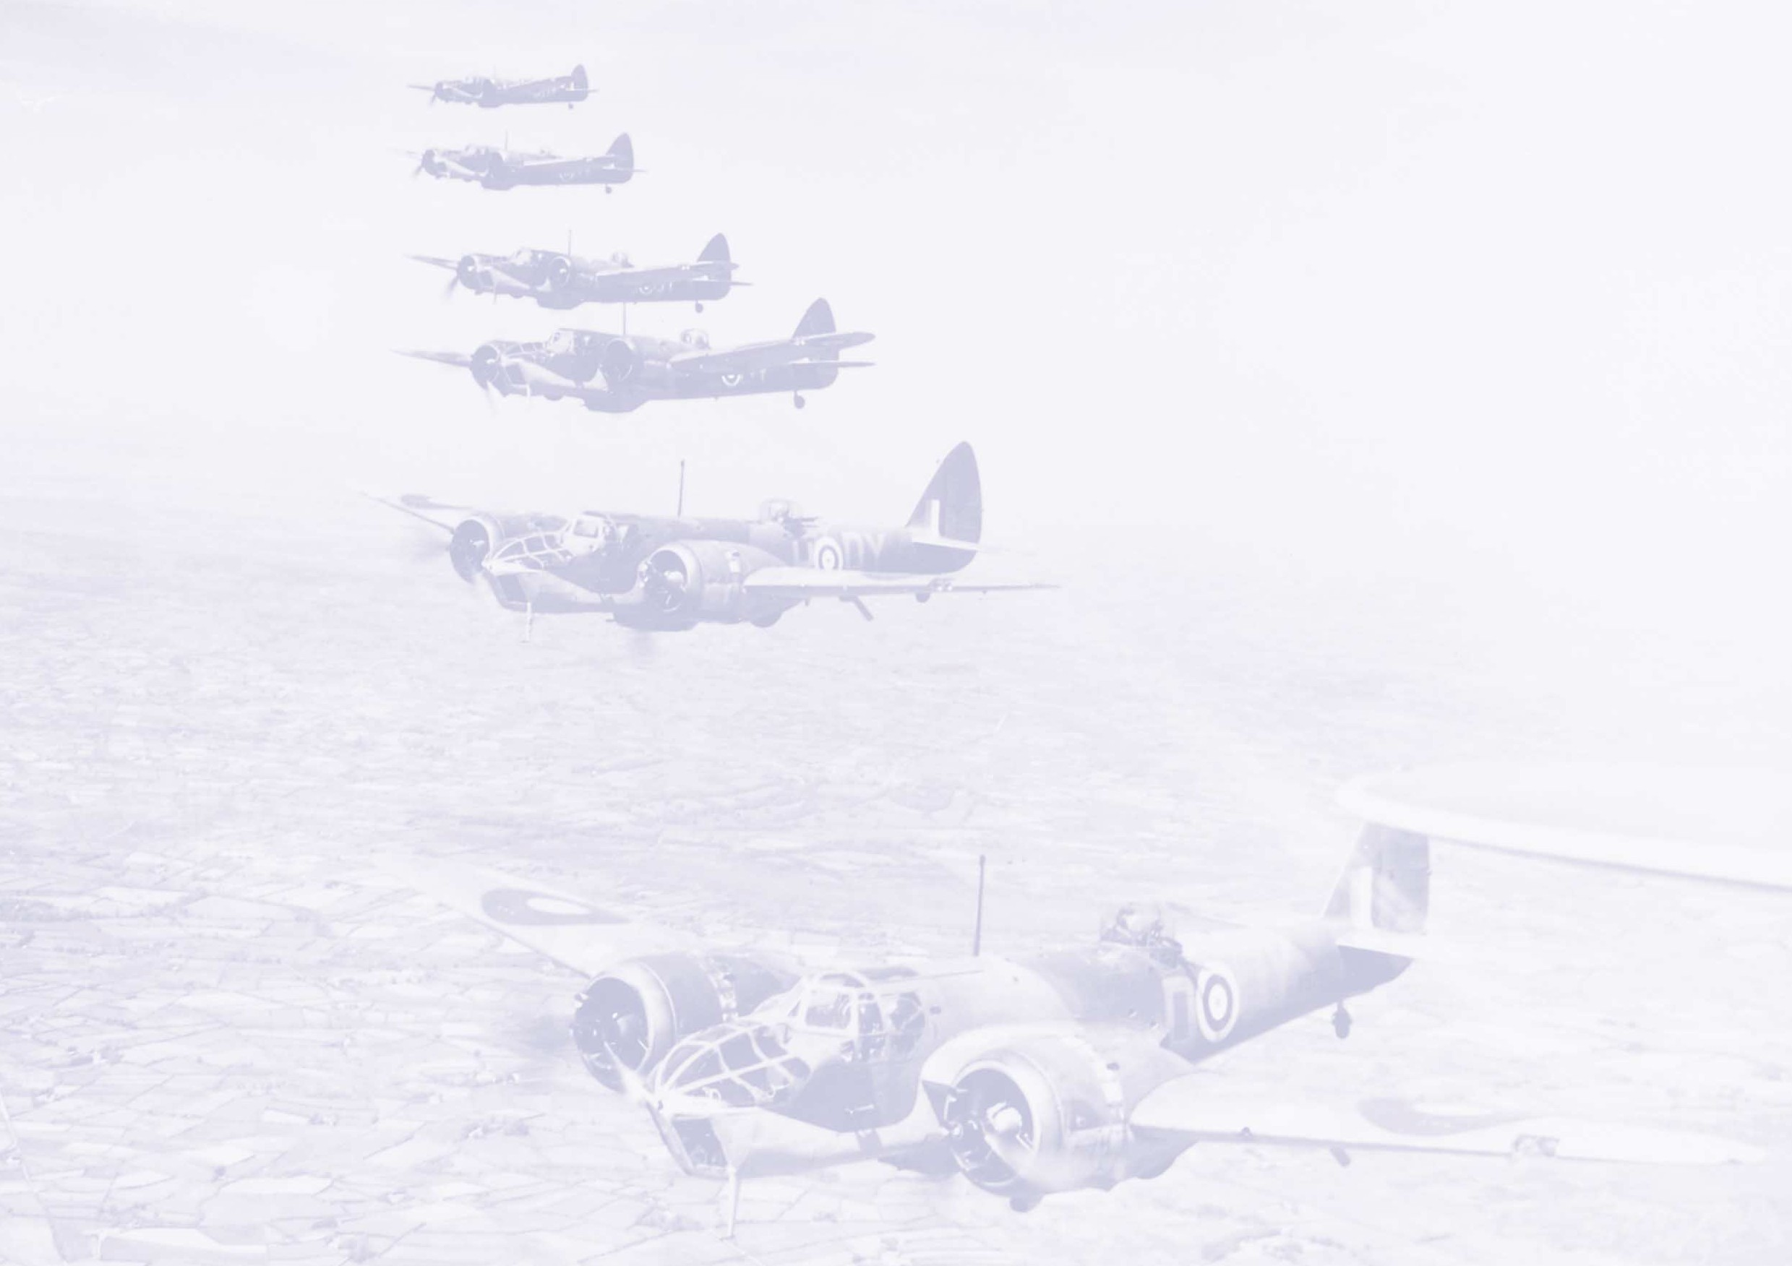

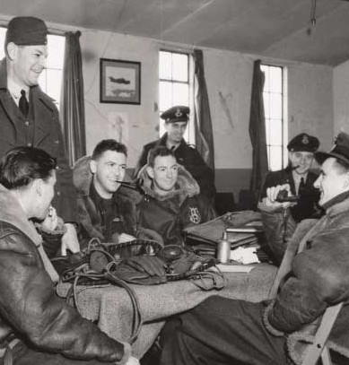

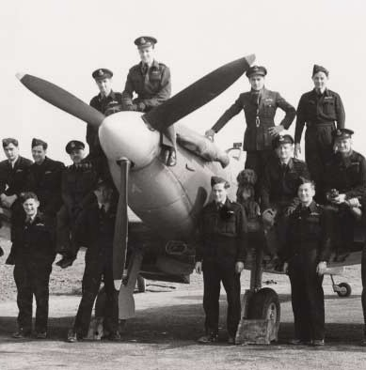

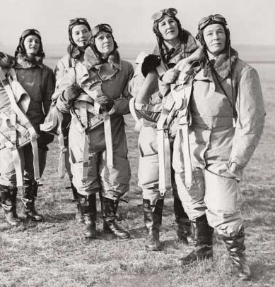

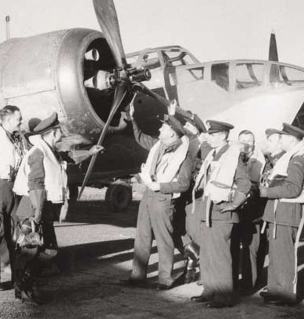

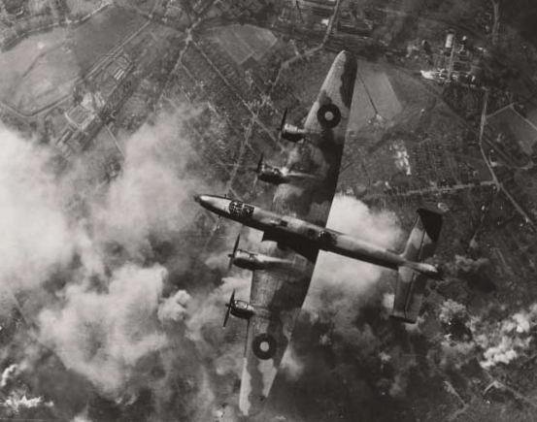

**The Bomber Offensive**

For much of the war Bomber Command was the only branch of the armed forces in a position to take the war to Germany. It flew missions practically every day and night of the war, its targets airfields, submarine bases, shipping, troop concentrations and communications; but it was not until the German offensive of 1940 that it was free to begin the long range strategic bombing of targets that would hit the German war economy hardest - her cities and industry.

The limited range and capacity of bombers and lack of effective navigational equipment meant that results from the earliest raids were poor but a turning point was reached in 1942 with the introduction of new four engine bombers and airborne radar. The first 'thousand bomber' night saturation raid on Cologne in May captured the public's imagination and the introduction in August of a special Pathfinder Force to guide bombers to their targets increased effectiveness further. In 1943, Bomber Command, now joined by the United States Eighth Air Force, began their 'round the clock' strategic bombing campaign and a series of audacious precision raids struck at the Ruhr Dams, the V-rocket research site at Peenemunde and sank the battleship Tirpitz in 1944.

There was a high price to be paid for these successes though: during the course of the war Bomber Command lost 55,000 airmen killed. The average age of its crews was just twenty-two.

By 1944, with Germany under pressure on the Eastern Front and in Italy, the time was ripe for a renewed land campaign in France, a campaign that would see all branches of the Allied armed forces working together in close co-operation and mutual support.

In the months leading up to the Normandy landings, meticulous preparations were made in which the Commonwealth air forces played a vital role. Bombers targeted coastal batteries, rail and road networks were destroyed, and special service squadrons worked to supply the French resistance. Air reconnaissance units thoroughly surveyed the proposed battle areas building up a store of information that would later prove invaluable to the land forces. But most crucial of all were the weeks of concentrated and remorseless attacks by fighters and light bombers that systematically destroyed the Luftwaffe in France, establishing not just superiority in the air, but supremacy. On D-Day, the Germans flew less than 100 sorties in defence of Normandy while the Allied Tactical Air Forces had 171 squadrons at their disposal to support the landings. In the following weeks, as the Allied armies advanced, close fighter support continued from hastily constructed airfields on French soil, with Bomber Command responding on demand to calls for strategic strikes.

**The Final Blows**

By August, the Allies had broken out of Normandy and were in pursuit of a German army in full flight, their heavily congested escape routes presenting easy targets for Allied raids from the air. As the advance pressed towards the Belgian frontier, Bomber Command struck at the German

garrisons cut off in the Channel ports and in September the Allied air forces prepared the way and offered support to the unsuccessful airborne attempt to seize the Rhine crossing at Arnhem in Holland. As the Germans were gradually forced back towards their own frontiers, strategic bombing of targets in Germany was resumed.

The Germans' brief December offensive in the Ardennes proved to be the last large scale effort of the Luftwaffe in the west and in the early months of 1945 they were driven back, forced to operate from airfields ever deeper into Germany. When the Allies made their airborne crossing of the Rhine on 24 March 1945 they met no resistance from the air, and in the first seventeen days of April, Allied air attacks on the overcrowded airfields remaining in German hands destroyed more than 2,000 aircraft stranded on the ground through lack of fuel. As the war in Europe drew towards its conclusion in May 1945, heavy bombers could at last be spared for humanitarian tasks, carrying supplies to the starving people of Holland and bringing released prisoners of war back to Britain.

**The Memorial**

*"As only free men can, they knew the value of that for which they fought,*

*and that the price was worth paying."*

Her Majesty Queen Elizabeth II, 17 October 1953

The site of the Runnymede Memorial overlooks the Thames and the riverside meadow where Magna Carta, enshrining man's basic freedoms under law, was sealed by King John in 1215. The land upon which it stands was donated by Sir Eugen and Lady Effie Millington-Drake in 1949.

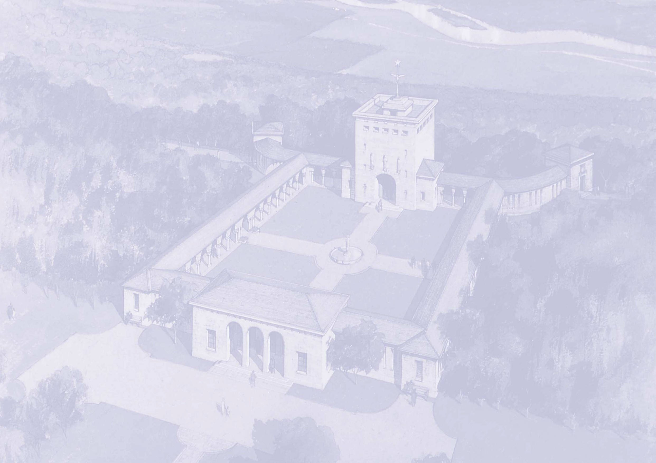

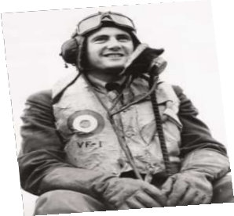

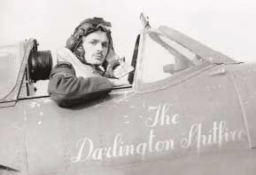

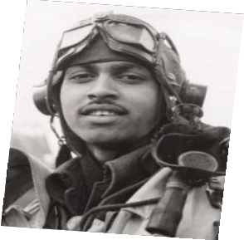

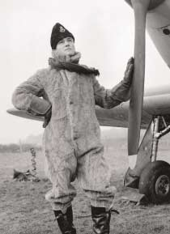

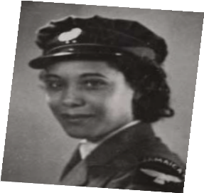

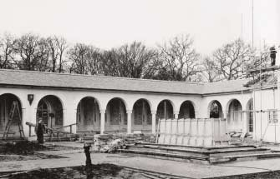

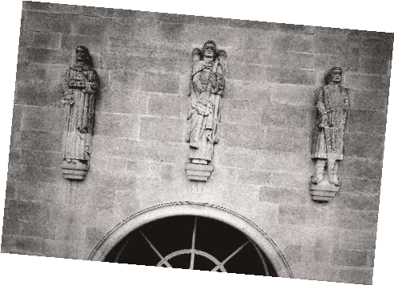

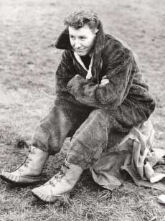

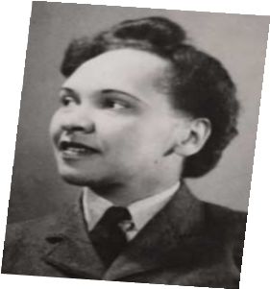

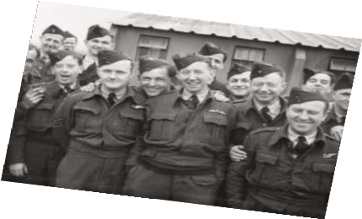

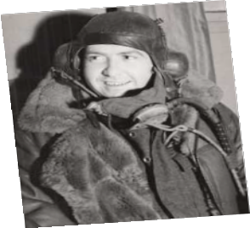

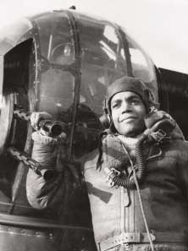

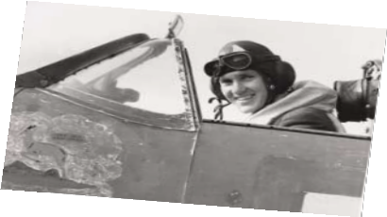

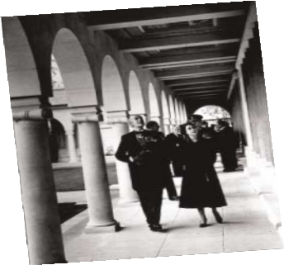

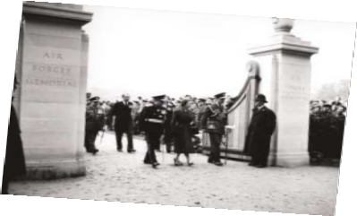

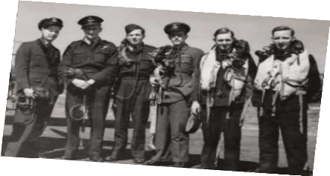

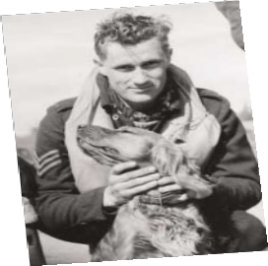

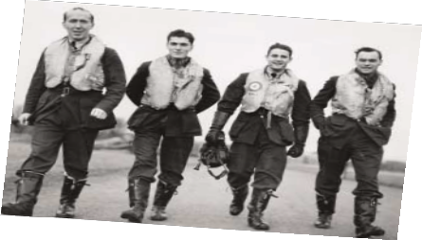

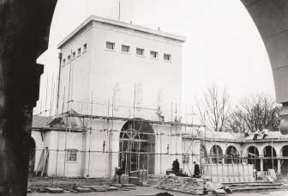

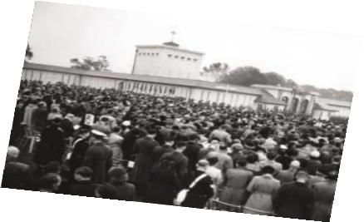

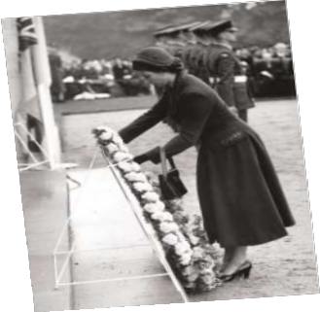

The memorial was designed by Sir Edward Maufe, the Commission's principal architect for the United Kingdom after the Second World War, and consists of a shrine embraced by a cloister in which the names of the dead are recorded. These, grouped according to the year of death, are inscribed on the stone reveals and mullions of the narrow windows giving the impression of partly opened stone books. The coats of arms of the Commonwealth countries are represented on the cloister ceilings.

The cloisters have curved wings terminating in two lookouts. The entrance, through a triple arched portico, gives access to the cloisters; on the north side is the shrine, entered through a single arch with three stone figures by Vernon Hill representing Justice, Victory and Courage.

Engraved on the great north window of the shrine are words from the 139th Psalm, sometimes called the Airman's Psalm.

*If I climb up into Heaven, Thou art there; If I go to Hell, Thou art there also.*

*If I take the wings of the morning*

*And remain in the uttermost parts of the sea, Even there also shall Thy hand lead me;*

*And Thy right hand shall hold me.*

Above the angels flanking the text are engraved vapour trails taken from actual photographs of the sky during the Battle of Britain. The design is by John Hutton, who was also responsible for the painted ceilings of the shrine and lookouts which depict the four winds, the planets and the phases of the moon scattered with stars.

From the shrine two staircases lead to a gallery, on a window of which is engraved a poem written soon after the memorial was completed by a student, Paul H Scott. From the gallery, a further staircase leads to the roof of the tower which is surmounted by an Astral Crown of blue and gold.

The Runnymede Memorial was opened by Her Majesty Queen Elizabeth II on 17 October 1953 and the text of her dedicatory address, some of which is reproduced here, is displayed inside the entrance loggia. Her Majesty returned to celebrate the memorial's fifty years as a place of commemoration and remembrance on

17 October 2003.

*"...wherever and for as long as freedom flourishes on the earth, the men and women who possess it will thank them and will say they did not die in vain."*

**AIR FORCES MEMORIAL**

The Memorial is open every day except Christmas Day and New Years Day, as follows:



Winter

(1 November - 31 January)

Weekdays: 08.00 - 16.00

Weekends & Public Holidays:

10.00 - 16.00

Summer

(1 February - 31 October)

Weekdays: 08.00 - 18.00

Weekends & Public Holidays:

10.00 - 18.00

A Memorial Register and introduction are kept at the Memorial. Publications relating to the Commission's work can be supplied upon request.

Commonwealth War Graves

Commission

Enquiries Section

2 Marlow Road Maidenhead Berkshire

SL6 7DX

United Kingdom

Tel: +44 (0) 1628 507200

Fax: +44 (0) 1628 771208

E-mail: casualty.enq@cwgc.org

Web Site: www.cwgc.org

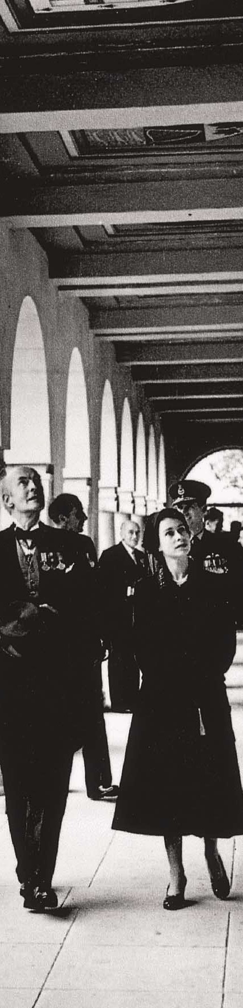

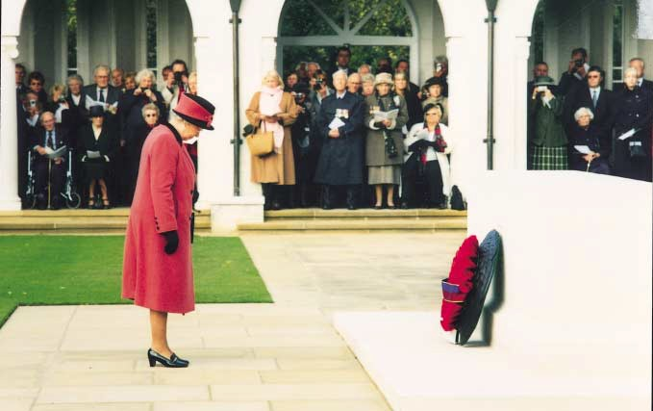

Photographs by courtesy of Marcus Taylor, Imperial War Museum and Air Historical Branch (RAF)