Commonwealth War Graves Commission

Information

Sheet



**THE TOWER HILL MEMORIAL, LONDON, ENGLAND**

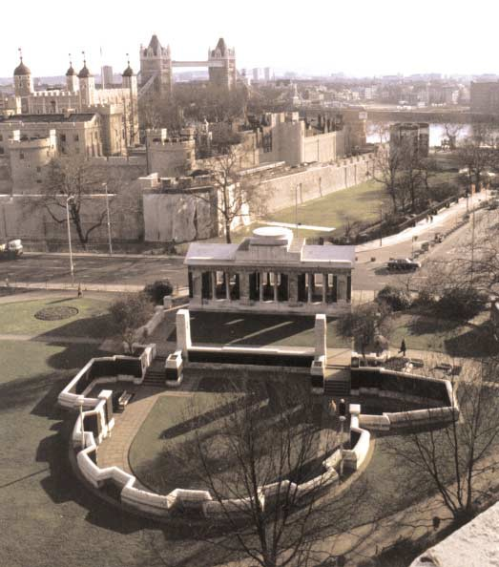

**THE MERCHANT NAVY AND FISHING FLEETS AT WAR**

In the First World War, the civilian navy’s duty was to be the supply service of the Royal Navy, to transport troops and supplies to the Armies, to transport raw materials to overseas munitions factories and munitions from those factories, to maintain, on a reduced scale, the ordinary import and export trade, to supply food to the home country and - in spite of greatly enlarged risks and responsibilities - to provide both personnel and ships to supplement the existing resources of the Royal Navy.

From the outset of the war, British waters were strewn with enemy mines and losses of men and vessels were high. They were increased by the enemy’s use of submarines and torpedoes, and grew year by year, reach- ing a peak in 1917 when in January the German government announced the adoption of “unrestricted sub- marine warfare”.

Later in that year, however, losses began to decrease, the reasons being threefold. First, the new Ministry of Shipping introduced successful preventative measures; secondly, the United States of America entered the war; and finally, the convoy system was set up, with the use of warships to escort merchant vessels. In 1918, therefore, new British tonnage exceeded losses and the German Submarine was mastered.

By the end of the war, 3,305 merchant ships had been lost, with a total of over 17,000 lives.

In the Second World War, losses were again considerable during the earlier stages. However, by 1943 improved methods of defence and an increased rate of shipbuilding greatly reduced the proportion of losses, which, from September of that year, were exceeded by new tonnage.

The Atlantic was the chief battleground of this long conflict at sea. In the most disastrous year, 1942, four- fifths of the total merchant ship losses occured in the North and South Atlantic. In addition, the convoys mak- ing their way to Russia round the North Cape with supplies of all kinds were particularly vulnerable to attack, since for a considerable distance they passed within range of enemy-occupied Norway. In the Mediterranean too, convoys to Malta, dependent for its existence upon supplies from outside, ran the gauntlet of sea and air attacks on an increasingly heavy scale. Finally, in home waters losses throughout the war accounted for more than one quarter of the total, due to enemy mines, submarine and light surface craft activity and air attacks.

In all, a total of 4,786 merchant ships were lost during the war. The number of merchant seamen who gave their lives totalled nearly 32,000.

**THE MEMORIAL**

The Tower Hill Memorial, which commemorates men of the Merchant Navy and Fishing Fleets who gave their lives to preserve the life of the nation and who have no grave but the sea, stands on the south side of the garden of Trinity Square, London. The Memorial is built of Portland stone and the 1914-18 monument con- sists of a vaulted corridor 21.5 metres long, 7 metres wide and 7 to 10 metres high, open at either end. It has three wide openings at front and back in which are placed pairs of columns and is surmounted by a solid ped- iment bearing the dedicatory inscription. The names of the dead are arranged alphabetically under their ships, with the name of the Master or Skipper (if it appears) first in each case. They are inscribed on bronze pan- els covering the eight main masonry piers which support the roof. No rank or rating other than Master or Skipper is indicated.

The monument, designed by Sir Edwin Lutyens, was begun in 1927 and unveiled by Her Majesty Queen

Mary on 12 December 1928. It commemorates 11,919 names and bears the following inscription:

1914-1918

TO THE GLORY OF GOD AND TO THE HONOUR OF

TWELVE THOUSAND OF THE MERCHANT NAVY AND FISHING FLEETS WHO HAVE NO GRAVE BUT THE SEA

When the question arose of commemorating the men of the Merchant Navy who lost their lives during the

1939-45 War and have no known grave, it was agreed that the new Memorial should be combined with the existing 1914-18 Tower Hill Memorial to form a complete whole. The architect, Sir Edward Maufe, achieved this by designing a semi-circular sunken garden adjoining the 1914-18 memorial. In this way a sufficient wall area was obtained to record the total of near 24,000 names, without building high walls on Tower Hill. The garden is nearly two metres below the general level of Tower Hill Gardens, so that the surrounding walls rise less than one metre above that level.

From the 1914-18 Memorial, stone steps flanked by high stone pylons, on which are the Merchant Navy badges and wreaths, lead down to the sunken garden. Between the flight of steps is the main dedicatory inscription, which reads:

1939-45

THE TWENTY-FOUR THOUSAND OF THE MERCHANT NAVY AND FISHING FLEETS WHOSE NAMES ARE HONOURED ON THE WALLS OF THIS GARDEN

GAVE THEIR LIVES FOR THEIR COUNTRY AND HAVE NO GRAVE BUT THE SEA

This inscription is guarded by sculptured figures in stone representing an office and a seaman of the Merchant Service. The internal face of the semi-circular wall surrounding the garden is cased in bronze, which bears in relief the names of the men commemorated. At regular intervals round this bronze casing are seven stone sculptured allegorical figures representing the Seven Seas. All the sculpture is the work of Charles Wheeler.

The garden itself is primarily a lawn, surrounded by a stone path on which there are teak seats. In the cen- tre is a “pool” of bronze, engraved as a mariners’ compass, and set to magnetic north.

This Second World War Memorial was unveiled to Her Majesty Queen Elizabeth II on 5 November 1955. Those commemorated on the Memorial are as follows:

|  |  |  |
| --- | --- | --- |
| United Kingdom Merchant Navy and Fishing Fleets | | 23,414 |
| United Kingdom Merchant Navy (of Australia) | | 62 |
| United Kingdom Merchant Navy (of New Zealand) | | 72 |
| United Kingdom Merchant Navy (of South Africa) | | 182 |
| Australian Merchant Navy |  | 47 |
| United Kingdom Lighthouse and Pilotage Services: - | | |
| Pilots |  | 16 |
| Lighthouse and Steam Vessel Service | | 64 |
|  | Total | 23857 |

The Memorial registers, giving details of those commemorated and a fuller account of the role of the Merchant Navy and Fishing Fleets, may be consulted at Trinity House Corporation, Trinity Square (Cooper’s Row Entrance). Tel: 0171 480 6601. Copies may also be purchased from the Commonwealth War Graves Commission.

**PLAN OF THE MEMORIAL SHOWING THE ARRANGEMENT OF THE PANELS**

1914-18

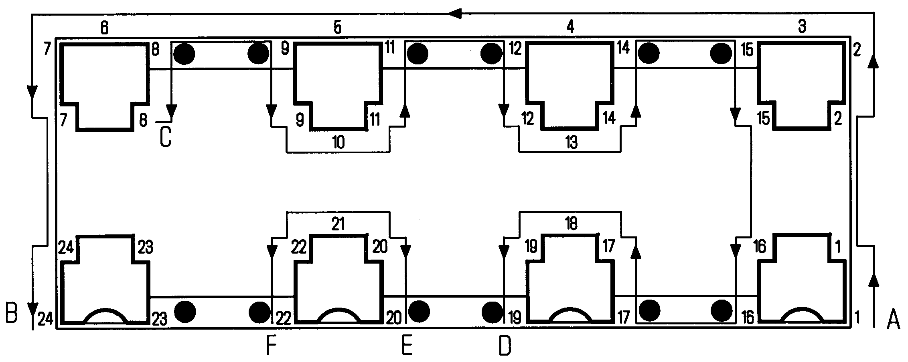

The names of the dead are to be found under the names of the ships in which they were serving. The ships of the Merchant navy are placed in alphabetical order of their names, followed by those of the Fishing Fleets similarly arranged. The panels containing the names of the ships of the Merchant Navy commence at the point indicated on the plan by the “A” and continue as shown by the arrows, to “B”, and from “C” to “D”. The ships of the Fishing Fleets are set out in the same manner from “E” to “F”. The panels indicated on the plan as number 23 contains no names of ships or men.

**1939-45**

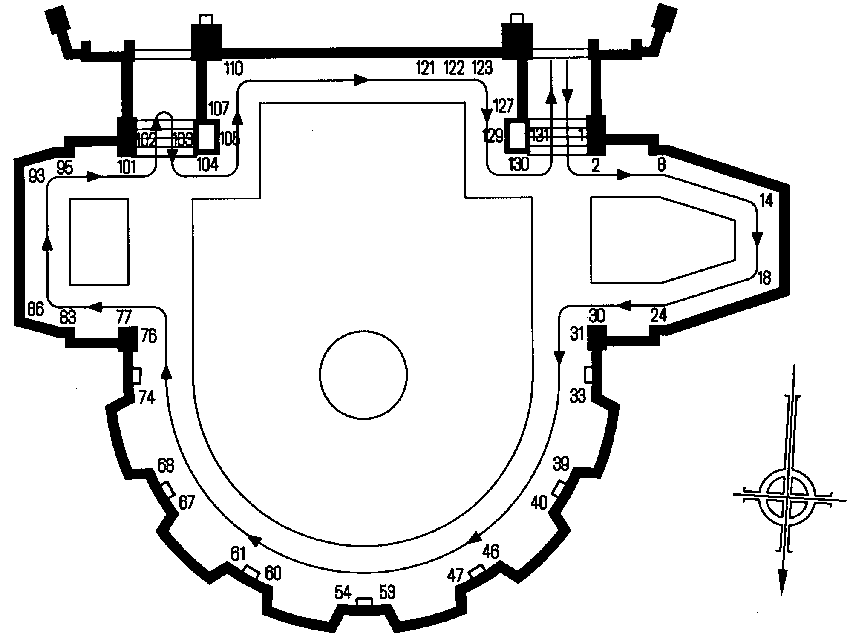

The names of the dead are to be found under the names of the ships in which they were serving. The ships of the Merchant Navy are arranged in alphabetical order on panels 1 to 121. Panel 122 bears the names of the men of the Lighthouse and Pilotage Services. Vessels of the Fishing Fleets appear on panels 123 to 129. Panels 130-132 bear the names of the men of the Merchant Navy who were identified as war casualties too late for inclusion in their proper order on the memorial.