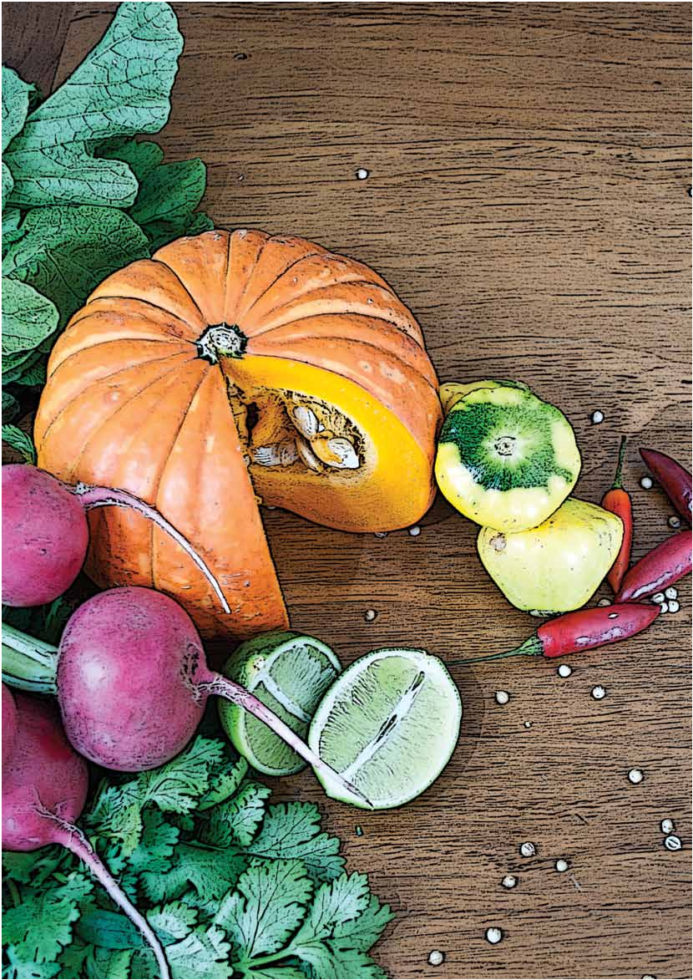RECIPES FOR
LIFE

Cooking forOne or Two

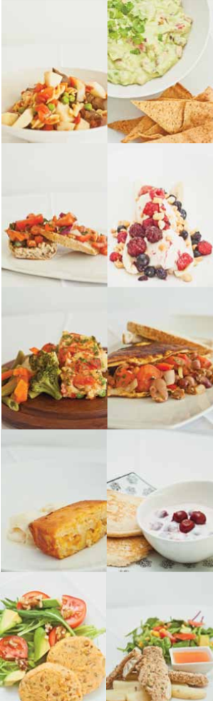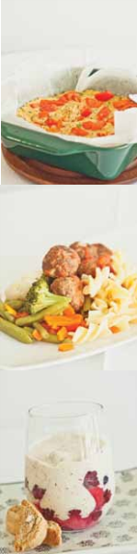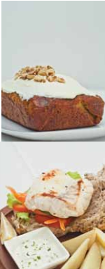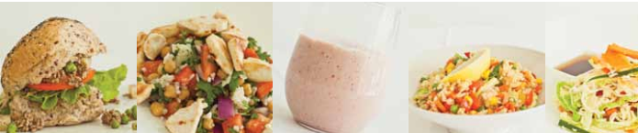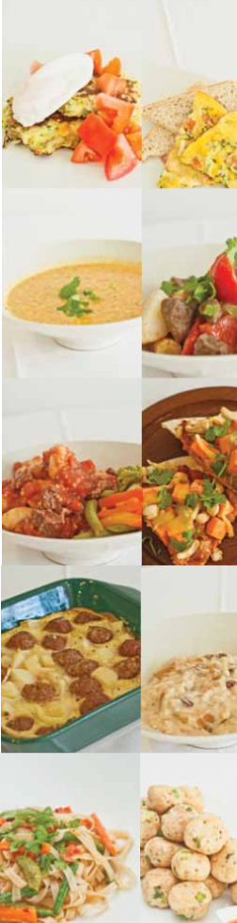Cover photograph and design by Samantha Murphy
August 2012 Inside photographs and layout by Madeleine Burke

Introduction

. . . . . . . . . . . . . . . . . . . . . . . . . . . . . . . . . . . . . . . . . . . . . . . . . . . . . . . . . . . . . . . . . . . . . . . . . . . . . . . . . . . . . . . . . . . . . . . .

Recipes for Life brings together healthy eating and healthy living, building on the
existing Cooking for One or Two program. This cookbook contains 45 new nutritious recipes as well as other health tips for people aged 65 years or over.

Recipes for Life was developed in response to feedback from participants in the Cooking for
One or Two program who highlighted the need
The recipes and health messages are based on current health recommendations. They were developed by a team from the Faculty of Health at the University of Newcastle
in conjunction with veterans and the Department of Veterans’ Affairs. The recipes and health messages have also been reviewed by health experts.

Recipes for Life promotes having fun while

for more recipes. The new recipes are easy to taking care of your health. We hope you

prepare, use common ingredients, are very nutritious, and taste delicious.

Professor Julie Byles

Director of the Research Centre for Gender, Health & Ageing University of Newcastle
New South Wales
enjoy the recipes and find the health messages informative.

Di McArtney

Department of Veterans’ Affairs Newcastle
New South Wales

 This project has been kindly funded by the Department of Veterans’ Affairs

Contents

. . . . . . . . . . . . . . . . . . . . . . . . . . . . . . . . . . . . . . . . . . . . . . . . . . . . . . . . . . . . . . . . . . . . . . . . . . . . . . . . . . . . . . . . . . . . . . . .

Acknowledgments 3 Mains (continued)
. . . . . . . . . . . . . . . . . . . . . . . . . . . . . . . . . . . . . . . . . . . . . . .

Light Meals
. . . . . . . . . . . . . . . . . . . . . . . . . . . . . . . . . . . . . . . . . . . . . . .

Meatballs 28

Beef Stir Fry 29

Baked Egg Parcel 4 Poached Egg & Zucchini Fritters 5 Corn & Ham Omelette 6 Asparagus, Tomato & Ricotta Frittata 7 Ham & Vegetable Slice 8 Curried Mince Bread Rolls 9
Chicken & Instant Noodle Salad 10

Homemade Fish & Chips 30 Chicken Tandoori Pizza 31 Fried Rice 32 One Pot Lamb Curry 33 Toad in the Hole 34
Pork & Hokkien Noodle Stir Fry 35

Chicken & Chickpea Salad

Beef, Potato & Corn Salad
11 Desserts
12 . . . . . . . . . . . . . . . . . . . . . . . . . . . . . . . . . . . . . . . . . . . . . . .

Sweet Potato & Bean Soup 13 Curried Bean Soup 14 Chicken Noodle Soup 15 Minestrone Soup 16 Vegetarian Mexican Omelette 17 Satay Noodles 18
Bubble & Squeak Rissoles with Salad 19

Pancakes with Cherry Yoghurt 36 Banana Berry Split 37 Orange Pudding 38 Apple Crumble 39 Baked Pear Custard 40 Pear & Sultana Rice Pudding 41
Modern Trifle 42

Mains
. . . . . . . . . . . . . . . . . . . . . . . . . . . . . . . . . . . . . . . . . . . . . . .

Entertaining & Drinks
. . . . . . . . . . . . . . . . . . . . . . . . . . . . . . . . . . . . . . . . . . . . . . .

Baked Salmon with Lemon Sauce 20 Beef & Gnocchi Casserole 21 Veal Roll 22 Marinated Lamb Wrap 23 Beef & Vegetable Bolognese 24 Salmon Patties 25 Tuna Bake 26
Grilled Fish Burger 27

Avocado Dip with Tortilla Chips 43 Bruschetta 44 Chicken Satay Meatballs 45 Carrot Cake 46 Iced Red Berry Mocktail 47 Tropical Mocktail 48

Health Messages 49

Freezer Friendly Vegetarian

2 RECIPESFORLIFE

Acknowledgments

. . . . . . . . . . . . . . . . . . . . . . . . . . . . . . . . . . . . . . . . . . . . . . . . . . . . . . . . . . . . . . . . . . . . . . . . . . . . . . . . . . . . . . . . . . . . . . . .

We would like to sincerely thank the following people and organisations for their contribution to Recipes for Life:

Department of Veterans’ Affairs

Prof Julie Byles, Director of the Research Centre for Gender, Health & Ageing, University of Newcastle

Di McArtney, Department of Veterans’ Affairs, Newcastle

Lou Micallef, Ex-Service Organisation Volunteer Coordinator

Catherine Chojenta, Research Academic, Research Centre for Gender, Health & Ageing, University of Newcastle

Ellie Gresham, Dietitian and Research Assistant, Research Centre for Gender, Health & Ageing, University of Newcastle

Samantha Diamond, Dietitian and Project Assistant, Research Centre for Gender, Health & Ageing, University of Newcastle

Katherine Brain, Nutrition and Dietetics student, and Project Assistant, Research Centre for Gender, Health & Ageing, University of Newcastle

Jennifer Byrne, Ageing Research Manager, Research Centre for Gender, Health & Ageing, University of Newcastle

Kimberley Griffith and Sasha Lorien, Nutrition and Dietetics students ,University of Newcastle

Anne Hills, Dietitian, and Lecturer, School of Health Sciences, University of Newcastle

Dr Lesley Wicks, Dietitian, and Senior Lecturer, School of Health Sciences, University of Newcastle

Dr Sylvie Lambert, NHMRC Fellow, South Western Sydney Clinical School, University of New South Wales

Duncan Munnings, Sociology student, University of Newcastle

Prof Sandra Capra, School of Human Movement Studies, University of Queensland

Jeff Fairweather, Associate Director Social Health, Aged Care and Coordination, Department of Veterans’ Affairs
A/Prof Lindy Clemson, Ageing, Work and Health Research Unit, University of Newcastle

Prof Ron Plotnikoff, Priority Research Centre in Physical Activity and Nutrition, University of Newcastle

Patsy Bourke, Hunter New England LHD Falls Injury Prevention Coordinator

Prof Nancy Pachana, School of Psychology, University of Queensland

Sue Gherdovich, Program Manager Population Health, beyondblue: the National Depression and Anxiety Initiative

Suha Ali, National Dementia Risk Reduction Manager, Alzheimer’s Australia

Marie Ormiston, Roads and Maritime Services

Judy Lindsay, Regional Telecross Coordinator

A/Prof Jane Taylor, Oral Health, University of Newcastle

Prof David Durrheim, Director of Health Protection, Hunter New England Health

Non Lavaro, Administrative Assistant, Research Centre for Gender, Health & Ageing, University of Newcastle

Cassie Curryer, Research Assistant, Research Centre for Gender, Health & Ageing, University of Newcastle

Madeleine Burke and Samantha Murphy, Graphic Design students, University of Newcastle

Natalie Edwards, Dietitian, Research Centre for Gender, Health & Ageing, University of Newcastle

Jon Handley, Newcastle Welfare & Pension Officers Network, Toronto RSL Sub-Branch

Malcolm Scott, Newcastle Welfare & Pension Officers Network, Waratah-Mayfield RSL
Sub-Branch

Hollie Tuckerman, Events Coordinator at the Belair Baptist Church, Adamstown

The focus group and survey participants

RECIPESFORLIFE 3

Serves 2

Preparation Time 15 min Cooking Time 30 min

Baked Egg Parcel

. . . . . . . . . . . . . . . . . . . . . . . . . . . . . . . . . . . . . . . . . . . . . . . . . . . . . . . . . . . . . . . . . . . . . . . . . . . . . . . . . . . . . . . . . . . . . . . .

Method Ingredients

1.Preheat oven to 220°C (200°C fan-forced).

2.Grease 4 ramekins or small oven dishes with cooking oil spray.

3.Place 1 slice of bread in each ramekin.

4.Whisk together eggs, tomato, cheese, ham or bacon and chives.

5.Pour a quarter of the mixture into each dish.

6.Bake for 30 minutes. Allow to cool slightly before eating.

• 4 slices wholemeal bread (at room temperature)

• 4 eggs

• 2 tomatoes, diced

• 4 tablespoons reduced-fat cheese, grated

• 2 slices lean ham or shortcut bacon, diced

• 1 tablespoon chives (fresh or dried), finely chopped

• Cooking oil spray

A Healthy Tip!

. . . . . . . . . . . . . . . . . . . . . . . . . . . . . .

Eating a balanced diet containing foods from all of the five food groups is beneficial to good health. This recipe contains ingredients from four of the five food groups (see page 50 for more information on the five food groups).

4 RECIPESFORLIFE

Serves 2

Preparation Time 20 min Cooking Time 30 min

Poached Egg & Zucchini Fritters

. . . . . . . . . . . . . . . . . . . . . . . . . . . . . . . . . . . . . . . . . . . . . . . . . . . . . . . . . . . . . . . . . . . . . . . . . . . . . . . . . . . . . . . . . . . . . . . .

Method Ingredients

1.Place potato in a microwave-safe bowl with some water. Microwave for 5-10 minutes or until soft and then drain and mash.

2.Combine the mashed potato, zucchini, flour, onion, cheese, 1 egg and pepper (optional). Mix well.

3.Heat oil in a fry pan on medium heat. Add a spoonful of the mixture and cook for 2-3 minutes on both sides. Repeat until all the mixture has been used.

4.Meanwhile, fill a saucepan with water and bring to the boil.

• 1 large potato, peeled and coarsely chopped

• 1 large zucchini, grated • ½ cup self-raising flour • ½ onion, diced
• ¼ cup reduced-fat cheese, grated • 3 eggs
• Pepper (optional)

• 1 tablespoon canola oil

• 1 tomato, diced

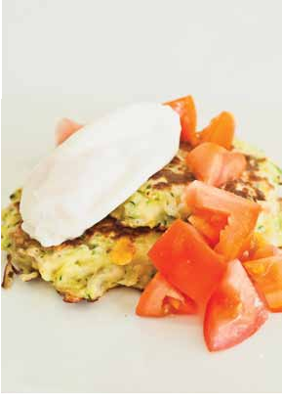5.Crack 1 egg into a bowl and carefully pour into the boiling water. Cook for 1-2 minutes. Repeat with last egg.

6.Serve the fritters with a poached egg and diced tomato on top.

A Healthy Tip!

. . . . . . . . . . . . . . . . . . . . . . . . . . . . . .

It is important to keep your brain active to reduce your risk of developing dementia. Cooking a new recipe is a great way to keep your brain active.

RECIPESFORLIFE 5

Serves 2

Preparation Time 20 min Cooking Time 25 min

Corn & Ham Omelette

. . . . . . . . . . . . . . . . . . . . . . . . . . . . . . . . . . . . . . . . . . . . . . . . . . . . . . . . . . . . . . . . . . . . . . . . . . . . . . . . . . . . . . . . . . . . . . . .

Method Ingredients

1.Preheat oven to 200°C (180°C fan-forced). Line an oven tray with baking paper.

2.Combine corn, ham, zucchini, tomato, eggs and parsley.

3.Heat cooking oil spray in a fry pan on medium to high heat.

4.Pour mixture into pan and cook for 15 minutes.

5.Remove from pan and place on prepared oven tray. Sprinkle with cheese and place in

• ½ cup corn kernels • 50g lean ham, diced
• 1 small zucchini, grated • 1 small tomato, diced
• 3 eggs

• 1 teaspoon parsley (fresh or dried), finely chopped

• Cooking oil spray

• ½ cup reduced-fat cheese, grated

the oven for 5-10 minutes. Serve with:

6.Cut in half and serve on wholegrain toast. • 2 slices wholegrain toast (margarine optional)

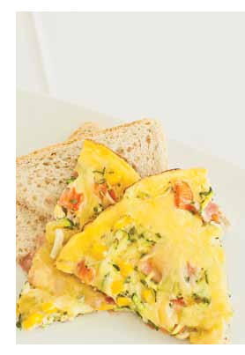A Healthy Tip!

. . . . . . . . . . . . . . . . . . . . . . . . . . . . . .

Never refreeze foods that have been defrosted or partially thawed as this may cause food poisoning.

6 RECIPESFORLIFE

Serves 2

Preparation Time 15 min

Asparagus, Tomato & Cooking Time 50 min Ricotta Frittata

. . . . . . . . . . . . . . . . . . . . . . . . . . . . . . . . . . . . . . . . . . . . . . . . . . . . . . . . . . . . . . . . . . . . . . . . . . . . . . . . . . . . . . . . . . . . . . . .

Method Ingredients

1.Preheat oven to 200°C (180°C fan-forced). Grease a 1.5 litre capacity (6 cups) oven dish with cooking oil spray.

2.Follow rice cooking instructions below.

3.Whisk together the asparagus, peas, eggs, rice, ricotta, tuna and basil.

4.Pour into the prepared dish and top with diced tomato. Bake for 20-25 minutes.

5.Remove from oven and allow to cool slightly before serving with salad or vegetables.

• Cooking oil spray • 34 cup rice
�
• 6 asparagus stems (canned), chopped

• ½ cup peas • 2 eggs
• ¹�³ cup reduced-fat ricotta

• 200g chilli flavoured canned tuna

• 2 teaspoons basil (fresh or dried), finely chopped

• ½ tomato, diced

Serve with:

• 1-2 cups salad or vegetables

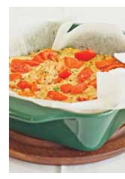How to Cook Rice (Makes 2 cups cooked rice)

On The Stove Top

1. Place 1 cup (200g) of rice in a saucepan. Add 1½ cups (375ml) of cold water. Bring to boil. Stir occasionally.

2. Reduce heat and simmer covered for 12-14 minutes.

3. Remove from heat and set aside, covered for 5-10 minutes. Use a fork to separate the grains and

serve
In The Microwave

1. Place 1 cup (200g) of rice in a microwave-safe bowl. Add 1½ cups (375ml) of cold water. Place lid on top.

2. Cook on High (800watts or 100%) for 5 minutes, then cook on Medium (500watts or 50%) for a further 7 minutes.

3. Set aside, covered, for 3 minutes. Use a fork to separate the grains and serve.

A Healthy Tip!

. . . . . . . . . . . . . . . . . . . . . . . . . . . . . .

Joining a volunteer organisation, having outings with friends and inviting people over for dinner are great ways to stay socially active.

RECIPESFORLIFE 7

Serves 2

Preparation Time 25 min Cooking Time 50 min

Ham & Vegetable Slice

. . . . . . . . . . . . . . . . . . . . . . . . . . . . . . . . . . . . . . . . . . . . . . . . . . . . . . . . . . . . . . . . . . . . . . . . . . . . . . . . . . . . . . . . . . . . . . . .

Method Ingredients

1.Preheat oven to 200°C (180°C fan-forced) and grease a 1.5 litre (6 cups) capacity oven dish with cooking oil spray.

2.Combine all ingredients together except tomato and parsley. Mix well.

3.Pour mixture into oven dish and top with tomato pieces and parsley.

4.Bake for 40-50 minutes. Cool for 5 minutes then cut into two pieces.

5.Serve with salad or vegetables.

• Cooking oil spray • ½ cup peas
• 1 carrot, grated • ½ onion, diced
• ½ medium red capsicum, diced

• 100g lean ham, diced (or salmon) • ½ cup reduced-fat cheese, grated • ½ cup self-raising flour
• 4 eggs, lightly beaten • 1 tomato, diced
• 2 teaspoons parsley (fresh or dried), finely chopped

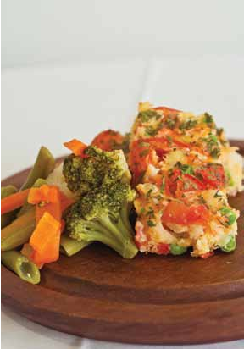Serve with:

• 1-2 cups salad or vegetables

A Healthy Tip!

. . . . . . . . . . . . . . . . . . . . . . . . . . . . . .

Physical activity can improve your mood, increase your energy levels and help you sleep better. Walking to the shops or parking your car in a space that requires you to walk some distance to the shops is an easy way to increase activity levels. You could buy ingredients to try a new recipe like this one.

8 RECIPESFORLIFE

Serves 2

Preparation Time 15 min Cooking Time 30 min

Curried Mince Bread Rolls

. . . . . . . . . . . . . . . . . . . . . . . . . . . . . . . . . . . . . . . . . . . . . . . . . . . . . . . . . . . . . . . . . . . . . . . . . . . . . . . . . . . . . . . . . . . . . . . .

Method Ingredients

1.Heat cooking oil spray in a fry pan on medium to high heat. Add onion and potato and cook for 2-3 minutes. Add mince and cook for a further 5 minutes.

2.Add peas, curry powder and chicken stock and stir. Bring to the boil then reduce heat to low and simmer for 15 minutes.

3.Mix the cornflour and water together and add to the mince mixture. Allow to thicken before adding the mint. Remove from heat and cool.

4.Cut the bread rolls open and place the lettuce and tomato slices on one side. Top with the curried mince and serve.

• Cooking oil spray

• ¼ onion, finely diced

• ½ potato, peeled and diced • 150g lean mince (any type) • ½ cup peas
• 1 tablespoon curry powder

• ½ cup reduced-salt chicken stock • ½ teaspoon cornflour
• 1 tablespoon water

• 2 teaspoons dried mint • 2 wholegrain bread rolls
• Lettuce (as much as desired)

• 1 tomato, sliced

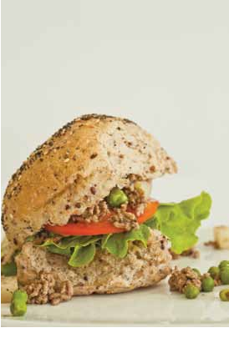A Healthy Tip!

. . . . . . . . . . . . . . . . . . . . . . . . . . . . . .

To prevent food poisoning ensure you wash your hands after handling raw meat.

RECIPESFORLIFE 9

Serves 2

Preparation Time 25 min Cooking Time 25 min

Chicken & Instant Noodle Salad

. . . . . . . . . . . . . . . . . . . . . . . . . . . . . . . . . . . . . . . . . . . . . . . . . . . . . . . . . . . . . . . . . . . . . . . . . . . . . . . . . . . . . . . . . . . . . . . .

Method Ingredients

1.Fill a saucepan with water and bring to the boil. Add noodles and cook for 2-3 minutes. Drain.

2.If the chicken needs to be cooked, heat oil in a small fry pan, add chicken and cook on medium heat for 10-15 minutes.

3.Combine the cabbage, cucumber, carrot and capsicum in a bowl.

4.Mix soy sauce and vinegar together and pour over salad.

5.Mix in the noodles, chicken and almonds (optional).

• 2 cups instant noodles (2 packets)

• 150g lean shredded chicken (either from a BBQ chicken or diced chicken breast)

• 1 tablespoon canola oil (if cooking chicken)

• ¼ cabbage, shredded

• 1 cucumber, sliced into strips • 1 carrot, sliced into strips
• ½ capsicum, sliced into strips

• 1 tablespoon salt-reduced soy sauce

• ½ -1 tablespoon white vinegar

• 2 tablespoons almonds (optional)

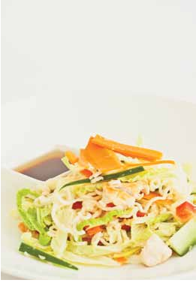A Healthy Tip!

. . . . . . . . . . . . . . . . . . . . . . . . . . . . . .

Socialising is important for optimal health and well-being. This is a great recipe to take on a picnic with family or friends.

10 RECIPESFORLIFE

Serves 2

Preparation Time 30 min Cooking Time 40 min

Chicken & Chickpea Salad

. . . . . . . . . . . . . . . . . . . . . . . . . . . . . . . . . . . . . . . . . . . . . . . . . . . . . . . . . . . . . . . . . . . . . . . . . . . . . . . . . . . . . . . . . . . . . . . .

Method Ingredients

1.Follow rice cooking instructions on page 7.

2.Heat cooking oil spray in a fry pan on medium heat. Add chicken and cook for 10-15 minutes.

3.Combine the chickpeas, rice, mint, parsley, tomato, cucumber and red onion in a bowl. Add the chicken after it is cooked.

4.Pour lemon juice over the salad and serve.

• 2/ cup rice
3

• Cooking oil spray

• 1 lean chicken breast, diced

• ½ cup canned chickpeas, drained

• ½ cup fresh mint, coarsely chopped

• ½ cup fresh parsley, coarsely chopped

• 2 tomatoes, diced

• ½ Lebanese cucumber, diced • ¼ red onion, diced
• ¼ cup lemon juice

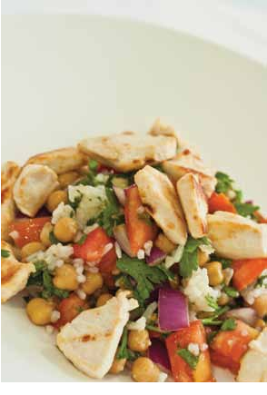A Healthy Tip!

. . . . . . . . . . . . . . . . . . . . . . . . . . . . . .

Quitting smoking is a challenge. It is important that you delay acting on the urge to smoke. After five minutes the urge to smoke weakens and your desire to quit will come back.

RECIPESFORLIFE 11

Serves 2

Preparation Time 25 min Cooking Time 25 min

Beef, Potato & Corn Salad

. . . . . . . . . . . . . . . . . . . . . . . . . . . . . . . . . . . . . . . . . . . . . . . . . . . . . . . . . . . . . . . . . . . . . . . . . . . . . . . . . . . . . . . . . . . . . . . .

Method Ingredients

1.Place potatoes in a microwave-safe bowl with some water. Microwave for 5-10 minutes or until soft.

2.Heat cooking oil spray in a fry pan on medium heat. Add beef and cook for 10 minutes. (If using leftovers or roast beef from the deli do not cook).

3.Make the dressing by mixing the sweet chilli, yoghurt and lemon juice together.

4.Combine the potatoes, corn, beef and tomatoes.

5.Top with dressing and sprinkle with coriander.

6.Serve with bread.

• 4 potatoes, diced

• ½ cup canned corn kernels • Cooking oil spray
• 200g lean beef, diced (can use leftovers from another meal or roast beef from the deli)

• 2 tomatoes, diced

• ½ tablespoon sweet chilli sauce

• 1 tablespoon low-fat natural yoghurt

• Juice of one lemon

• Handful of fresh coriander, coarsely chopped

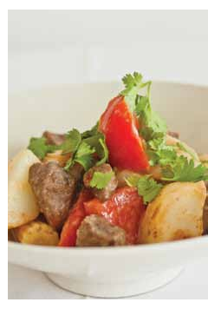Serve with:

• 2 slices wholegrain bread or 1 wholegrain bread roll

A Healthy Tip!

. . . . . . . . . . . . . . . . . . . . . . . . . . . . . .

While you are waiting for the kettle to boil do some strength and balance exercises such as side leg raises, half squats and heel rises. See page 66 for information on how to perform these exercises.

12 RECIPESFORLIFE

Serves 2

Preparation Time 30 min Cooking Time 30 min

Sweet Potato & Bean Soup

. . . . . . . . . . . . . . . . . . . . . . . . . . . . . . . . . . . . . . . . . . . . . . . . . . . . . . . . . . . . . . . . . . . . . . . . . . . . . . . . . . . . . . . . . . . . . . . .

Method Ingredients

1.Heat oil in a large saucepan on medium heat. Add onion, bacon, garlic and mustard. Cook until onion is soft.

2.Add the chicken stock, sweet potato and potatoes. Bring to the boil then reduce to simmer for 20 minutes.

3.Blend the mixture in a blender (optional) and return to the saucepan.

4.Add the kidney beans and parsley and mix through. Add some milk if the soup is too thick and heat through.

5.Serve with wholegrain bread.

• 1 tablespoon canola oil • ½ onion, diced
• 100g shortcut bacon, trimmed and diced

• ½ teaspoon garlic (fresh or dried) • 1 teaspoon wholegrain mustard
• 2 cups salt-reduced chicken stock

• ¼ medium sweet potato, peeled and diced

• 1½ medium potatoes, peeled and diced

• 100g canned kidney beans, drained

• 1 teaspoon parsley (fresh or dried), finely chopped

• Milk (optional)

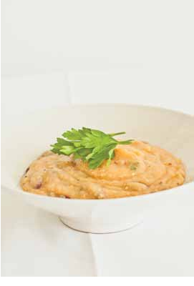Serve with:

• 2 slices wholegrain bread or 1 wholegrain bread roll

A Healthy Tip!

. . . . . . . . . . . . . . . . . . . . . . . . . . . . . .

It is important to drink 6-8 glasses of fluid per day and consume foods with a high fluid content (eg soup) to remain hydrated.

RECIPESFORLIFE 13

Serves 2

Preparation Time 25 min Cooking Time 35 min

Curried Bean Soup

. . . . . . . . . . . . . . . . . . . . . . . . . . . . . . . . . . . . . . . . . . . . . . . . . . . . . . . . . . . . . . . . . . . . . . . . . . . . . . . . . . . . . . . . . . . . . . . .

Method Ingredients

1.Heat oil in a saucepan on medium heat.

Add onion and cook for 5 minutes. Add curry paste and cook, stirring for 1 minute.

2.Add stock, lentils or beans and carrots. Bring to the boil then reduce to simmer for 20 minutes.

3.Blend the mixture in a blender (optional) and return to saucepan on low heat.

4.Add coconut milk and heat for 5 minutes. Stir in coriander.

5.Serve with wholegrain bread.

• 1 teaspoon canola oil • ½ brown onion, diced
• 1 tablespoon curry paste

• 1 cup salt-reduced vegetable stock

• 400g can of lentils or five bean mix, drained

• 2 carrots, diced

• ½ cup light coconut milk

• 1 tablespoon coriander (fresh or dried), finely chopped

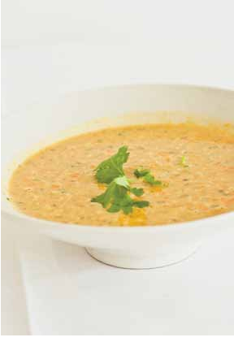Serve with:

• 2 slices wholegrain bread or 1 wholegrain bread roll

A Healthy Tip!

. . . . . . . . . . . . . . . . . . . . . . . . . . . . . .

As we get older our immunity is often reduced and we become more vulnerable to infections. It is very important that
we keep our vaccinations up-to-date to prevent infection.

14 RECIPESFORLIFE

Serves 2

Preparation Time 25 min Cooking Time 55 min

Chicken Noodle Soup

. . . . . . . . . . . . . . . . . . . . . . . . . . . . . . . . . . . . . . . . . . . . . . . . . . . . . . . . . . . . . . . . . . . . . . . . . . . . . . . . . . . . . . . . . . . . . . . .

Method Ingredients

1.Heat oil in a saucepan on medium heat. Add the onion, garlic and chicken and cook for 10 minutes until soft.

2.Add the stock and water and bring to the boil. Add spaghetti and reduce heat to medium. Simmer for 10 minutes.

3.Add potato, carrot, peas, corn and cauliflower and cook for 20-30 minutes.

4.Stir in parsley and serve.

• 1 teaspoon canola oil • ½ brown onion, diced
• ½ teaspoon garlic (fresh or dried) • 200g lean chicken breast, diced
• 3 cups salt-reduced chicken stock • ½ cup water
• ½ cup (60g) dried spaghetti • ½ potato, peeled and diced • ½ carrot, diced
• ½ cup peas

• ½ cup corn kernels

• ½ cup cauliflower, diced

• 2 tablespoons fresh parsley, chopped

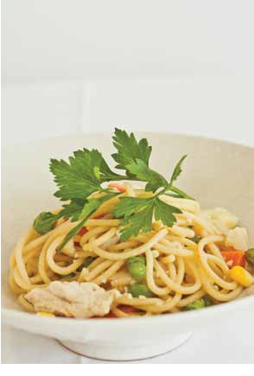A Healthy Tip!

. . . . . . . . . . . . . . . . . . . . . . . . . . . . . .

There are a number of licence options for car drivers and motorcycle riders from the age of 85. Older drivers and riders can have an assessment every two years from the age of 85 to hold an unrestricted licence,
or can opt to have a modified licence at any stage.

RECIPESFORLIFE 15

Serves 2

Preparation Time 25 min Cooking Time 35 min

Minestrone Soup

. . . . . . . . . . . . . . . . . . . . . . . . . . . . . . . . . . . . . . . . . . . . . . . . . . . . . . . . . . . . . . . . . . . . . . . . . . . . . . . . . . . . . . . . . . . . . . . .

Method Ingredients

1.Heat oil in a large saucepan on medium heat. Add onion, garlic, carrot and potato and cook for 5 minutes.

2.Add all other ingredients and simmer for 20-25 minutes.

3.Serve with a sprinkle of parmesan cheese on top (optional).

• 1 tablespoon canola oil • 1 onion, chopped
• 2 teaspoons garlic (fresh or dried) • 1 carrot, diced
• 1 potato, peeled and diced

• 200g canned diced tomatoes

• 2 teaspoons basil (fresh or dried)

• 2 teaspoons parsley (fresh or dried)

• 2 cups salt-reduced vegetable stock

• ½ cup (60g) dried pasta

• 200g canned five bean mix, drained

• ¼ cup frozen peas • 1 zucchini, diced
• 1 tablespoon parmesan cheese (optional)

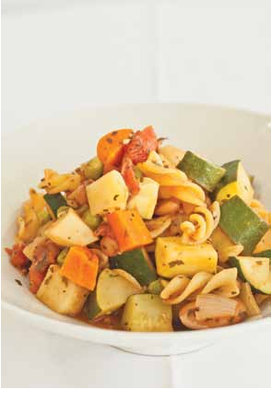A Healthy Tip!

. . . . . . . . . . . . . . . . . . . . . . . . . . . . . .

Eating a healthy diet containing plenty of different coloured vegetables will help you to maintain a healthy weight.

16 RECIPESFORLIFE

Serves 2

Preparation Time 20 min Cooking Time 15 min

Vegetarian Mexican Omelette

. . . . . . . . . . . . . . . . . . . . . . . . . . . . . . . . . . . . . . . . . . . . . . . . . . . . . . . . . . . . . . . . . . . . . . . . . . . . . . . . . . . . . . . . . . . . . . . .

Method Ingredients

1.Whisk eggs and milk together.

2.In a separate bowl combine beans, tomato, capsicum, onion, parsley and taco mix. Mix well.

3.Heat cooking oil spray in a fry pan to medium heat and pour in egg mixture. Cook for 5 minutes or until the egg starts to set.

4.Sprinkle the bean mixture and cheese on top. Continue to cook for another 3-4 minutes.

5.Fold omelette in half and cut in two. Serve each half on a slice of wholegrain bread.

• 4 eggs

• ¼ cup reduced-fat milk

• ½ cup canned five bean mix, drained

• 1 tomato, diced

• ½ red or yellow capsicum, diced

• ½ onion, diced

• 2 teaspoons parsley (fresh or dried)

• 2 teaspoons dried taco mix • Cooking oil spray
• ¼ cup reduced-fat cheese, grated

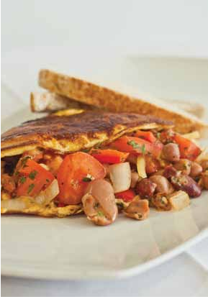Serve with:

• 2 slices wholegrain bread (margarine optional)
A Healthy Tip!

. . . . . . . . . . . . . . . . . . . . . . . . . . . . . .

If you are having difficulties keeping weight on add high energy extras to foods such as margarine, oil, milk powder, cream, coconut milk and nuts. Replacing the milk with cream and adding extra cream and cheese in this recipe will increase the energy content and assist with weight gain. See your doctor or a dietitian for specific advice.

RECIPESFORLIFE 17

Serves 2

Preparation Time 20 min Cooking Time 20 min

Satay Noodles

. . . . . . . . . . . . . . . . . . . . . . . . . . . . . . . . . . . . . . . . . . . . . . . . . . . . . . . . . . . . . . . . . . . . . . . . . . . . . . . . . . . . . . . . . . . . . . . .

Method Ingredients

1.Place noodles in a large bowl and cover with boiling water. Cover and allow to stand for
5 minutes. Drain.

2.Mix together the peanut butter, sweet chilli sauce and soy sauce.

3.Heat oil in a fry pan on high heat. Add onion, carrot, snow peas, green beans and capsicum and cook for 5-10 minutes.

4.Add the rice noodles and sauce to the fry pan. Cook for 2-3 minutes.

5.Divide into bowls, sprinkle with coriander leaves and serve.

• 2 cups dried rice noodles

• 2½ tablespoons low-fat crunchy peanut butter

• 1 tablespoon sweet chilli sauce

• 1 tablespoon reduced-salt soy sauce

• 1 tablespoon canola oil • ½ onion, diced
• 1 small carrot, sliced

• 1 cup snow peas, ends removed

• 1 cup green beans, chopped largely

• ½ capsicum, diced

• Fresh coriander leaves to serve

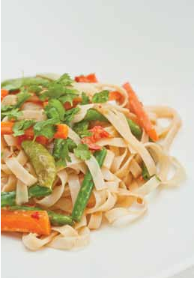A Healthy Tip!

. . . . . . . . . . . . . . . . . . . . . . . . . . . . . .

Eating some vegetarian meals every week can have health benefits as well as save you money. This vegetarian recipe is cheap, healthy and very easy to prepare so why not give it a go!

18 RECIPESFORLIFE

Serves 2

Preparation Time 25 min Cooking Time 45 min

Bubble & Squeak Rissoles with Salad

. . . . . . . . . . . . . . . . . . . . . . . . . . . . . . . . . . . . . . . . . . . . . . . . . . . . . . . . . . . . . . . . . . . . . . . . . . . . . . . . . . . . . . . . . . . . . . . .

Method Ingredients

1.Preheat oven to 200°C (180°C fan-forced).

2.Place the potatoes and sweet potato in a microwave-safe bowl with some water. Microwave for 5-10 minutes or until soft and then drain and mash.

3.Mix in the garlic, thyme, chickpeas, egg and rolled oats.

4.Shape into rissoles and bake on a lined oven tray for 15 minutes on both sides.

5.Mix lettuce, avocado, tomato and walnuts together and serve with rissoles.

• 2 small potatoes, peeled and coarsely chopped

• ¼ small sweet potato, peeled and diced

• 1 teaspoon garlic (fresh or dried)

• 2 teaspoons thyme (fresh or dried)

• ½ cup canned chickpeas, drained • 1 egg
• 1/ cup rolled oats • 1 cup lettuce
3
• ½ avocado

• 1 tomato, diced

• 1 tablespoon walnuts, coarsely chopped

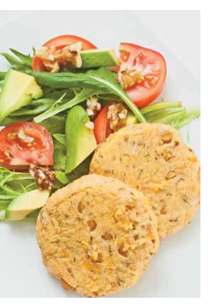Note: you could use leftover vegetables instead of potato and sweet potato

A Healthy Tip!

. . . . . . . . . . . . . . . . . . . . . . . . . . . . . .

Having a glass of water or other fluid with meals and between meals helps to increase your fluid intake and keep you hydrated.

RECIPESFORLIFE 19

Serves 2

Preparation Time 15 min Cooking Time 45 min

Baked Salmon with Lemon Sauce

. . . . . . . . . . . . . . . . . . . . . . . . . . . . . . . . . . . . . . . . . . . . . . . . . . . . . . . . . . . . . . . . . . . . . . . . . . . . . . . . . . . . . . . . . . . . . . . .

Method Ingredients

1.Follow rice cooking instructions on page 7.

2.Preheat oven to 200°C (180°C fan-forced).

3.Wrap the salmon in foil and bake for 15-20 minutes.

4.Prepare the dressing by whisking together parsley, lemon zest and juice, garlic
and mustard.

5.Remove salmon from oven and transfer to

• ½ cup rice

• 2 salmon fillets

• 3 teaspoons parsley (fresh or dried), finely chopped

• Zest and juice of 1 lemon*

• 1 teaspoon garlic (fresh or dried)

• 2 teaspoons wholegrain mustard

two separate plates. Drizzle dressing over salmon.

6.Serve the salmon with rice and vegetables.

Serve with:

• 2 cups steamed vegetables

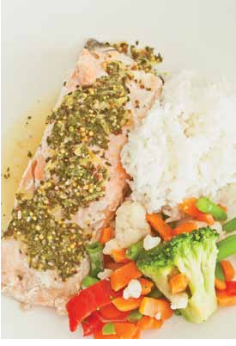* Lemon zest: tiny pieces of lemon peel. Grating the outer yellow layer of a lemon will give you lemon zest.

A Healthy Tip!

. . . . . . . . . . . . . . . . . . . . . . . . . . . . . .

To maintain a healthy mind consume two serves of oily fish (eg salmon, tuna or sardines) per week.

20 RECIPESFORLIFE

Serves 2

Preparation Time 20 min Cooking Time 1h 25 min

Beef & Gnocchi Casserole

. . . . . . . . . . . . . . . . . . . . . . . . . . . . . . . . . . . . . . . . . . . . . . . . . . . . . . . . . . . . . . . . . . . . . . . . . . . . . . . . . . . . . . . . . . . . . . . .

Method Ingredients

1.Preheat the oven to 200°C (180°C fan-forced).

2.Combine beef, garlic, bacon, onion, gnocchi and tomatoes in a casserole dish. Bake for approximately 1 hour.

3.Remove from oven, add the parsley and basil and return to oven for approximately
20 minutes.

4.Serve with steamed vegetables.

* Gnocchi: small dumplings made from potato and flour. You can find gnocchi in the pasta aisle or fridge section of your supermarket.

• 250g lean beef, diced

• 2 teaspoons garlic (fresh or dried)

• 2 pieces shortcut bacon, trimmed and diced

• ½ onion, diced

• 1½ cups gnocchi*

• 400g can of diced tomatoes

• 2 teaspoons parsley (fresh or dried), coarsely chopped

• 1 teaspoon fresh basil, coarsely chopped

Serve with:

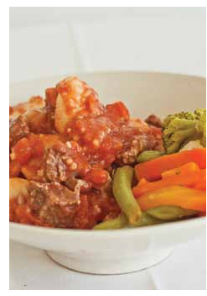• 2 cups steamed vegetables

A Healthy Tip!

. . . . . . . . . . . . . . . . . . . . . . . . . . . . . .

A healthy diet includes a variety of different foods from the five food groups. This recipe is great when you feel like something different. See page 50 for more information on the five food groups.

RECIPESFORLIFE 21

Serves 2

Preparation Time 15 min Cooking Time 30 min

Veal Roll

. . . . . . . . . . . . . . . . . . . . . . . . . . . . . . . . . . . . . . . . . . . . . . . . . . . . . . . . . . . . . . . . . . . . . . . . . . . . . . . . . . . . . . . . . . . . . . . .

Method Ingredients

1.Preheat oven to 200°C (180°C fan-forced).

2.Lay veal on a board and top with spinach, walnuts and cheeses. Roll the veal up and secure with a toothpick.

3.Place veal on an oven tray lined with baking paper and bake for 20-30 minutes.

4.Serve with bread and steamed vegetables.

• 2 slices veal schnitzel (100g each)

• ¼ cup frozen spinach, drained • 2 tablespoons walnuts
• 2 tablespoons parmesan cheese, grated

• 2 tablespoons reduced-fat feta cheese, diced

Serve with:

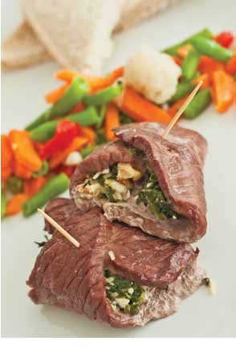• 2 slices wholegrain bread (margarine optional)

• 2 cups steamed vegetables

A Healthy Tip!

. . . . . . . . . . . . . . . . . . . . . . . . . . . . . .

Staying socially active is important for optimal health and well-being. This recipe is great if you have family or friends
over for dinner. You will look like a true masterchef!

22 RECIPESFORLIFE

Serves 2

Preparation Time 40 min Cooking Time 30 min

Marinated Lamb Wrap

. . . . . . . . . . . . . . . . . . . . . . . . . . . . . . . . . . . . . . . . . . . . . . . . . . . . . . . . . . . . . . . . . . . . . . . . . . . . . . . . . . . . . . . . . . . . . . . .

Method Ingredients

1.Combine the lemon juice, chicken stock cube and garlic. Mix well.

2.Place the lamb and beans in an oven dish and pour the lemon juice mixture over the top. Leave to marinade for 30 minutes.

3.Preheat oven to 200°C (180°C fan-forced) then place the lamb mixture in the oven and cook for 30 minutes.

4.Spread the hummus onto the tortillas or pita bread and top with salads and cheese.

5.Remove lamb from the oven and place on the tortillas or pita bread. Wrap and serve.

• Juice of 1 lemon

• ½ reduced-salt chicken stock cube

• 2 teaspoons garlic (fresh or dried) • 200g lean lamb, diced
• 1 cup canned five bean mix, drained

• 2 wholemeal tortillas or pita bread

• 2 tablespoons hummus*

• Lettuce (as much as desired)

• 1 tomato, sliced

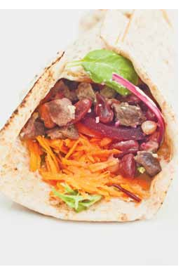• 1/ cup reduced-fat cheese, grated • 1 carrot, grated
3
• ½ cup canned sliced beetroot

* Hummus: Middle-Eastern dip made from chickpeas. You can find hummus in the refrigerator section of your supermarket.

A Healthy Tip!

. . . . . . . . . . . . . . . . . . . . . . . . . . . . . .

Fibre is important for bowel health and is found in fruits, vegetables and wholegrain products. This recipe is high in fibre and tastes great!

RECIPESFORLIFE 23

Serves 2

Preparation Time 25 min Cooking Time 20 min

Beef & Vegetable Bolognese

. . . . . . . . . . . . . . . . . . . . . . . . . . . . . . . . . . . . . . . . . . . . . . . . . . . . . . . . . . . . . . . . . . . . . . . . . . . . . . . . . . . . . . . . . . . . . . . .

Method Ingredients

1.Fill a saucepan with water and bring to the boil. Cook pasta for 10-15 minutes. Drain well.

2.Heat oil in a saucepan on medium heat. Add mince, onion and garlic and cook for 5 minutes.

3.Add carrot, zucchini, broccoli and tomato to the mince. Cook for 10 minutes with the
lid on.

4.Add lentils and simmer for 5 minutes.

5.Serve with pasta and sprinkle with parmesan cheese (optional).

• 120g dried spaghetti • 1 teaspoon canola oil • 150g lean beef mince
• ½ large brown onion, finely chopped

• 1 teaspoon garlic (fresh or dried) • ½ large carrot, diced
• ½ large zucchini, diced

• 100g broccoli, finely chopped • 400g can of diced tomatoes
• 400g can of brown lentils, drained

• 1 tablespoon parmesan cheese (optional)

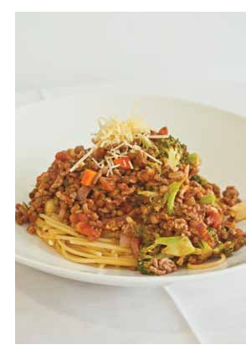A Healthy Tip!

. . . . . . . . . . . . . . . . . . . . . . . . . . . . . .

To maintain a healthy lifestyle you should perform 30 minutes of moderate intensity physical activity on most days, preferably all days, such as a brisk walk. This recipe goes down really well after physical activity.

24 RECIPESFORLIFE

Serves 2

Preparation Time 15 min Cooking Time 25 min

Salmon Patties

. . . . . . . . . . . . . . . . . . . . . . . . . . . . . . . . . . . . . . . . . . . . . . . . . . . . . . . . . . . . . . . . . . . . . . . . . . . . . . . . . . . . . . . . . . . . . . . .

Method Ingredients

1.Place the potatoes in a microwave-safe bowl with some water. Microwave for 5-10 minutes or until soft and then drain and mash. Leave to cool slightly.

2.Add salmon, lemon zest, egg, bread crumbs or wholemeal flour and vegetables to potatoes. Using damp hands shape into four patties.

3.Heat oil in a fry pan over medium heat. Cook patties for 4 minutes on each side or until golden.

• 2 potatoes, peeled and coarsely chopped

• 240g canned salmon, drained • 1 teaspoon lemon zest*
• 1 egg

• ½ cup bread crumbs or wholemeal flour

• ½ cup frozen pea, corn and carrot mix

• 1 tablespoon canola oil

4.Serve with vegetables or salad.

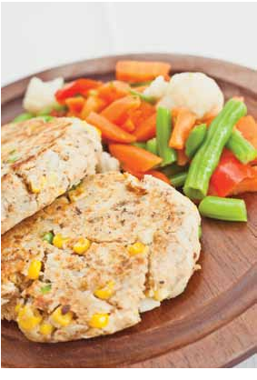Serve with:

• 2 cups steamed vegetables or salad

* Lemon zest: tiny pieces of lemon peel. Grating the outer yellow layer of a lemon will give you lemon zest.

A Healthy Tip!

. . . . . . . . . . . . . . . . . . . . . . . . . . . . . .

Oily fish contains Omega-3 fats (eg salmon, trout and anchovies) which can improve your mood, making you feel happy and healthy. Aim to consume two serves of oily fish per week.

RECIPESFORLIFE 25

Serves 2

Preparation Time 25 min Cooking Time 55 min

Tuna Bake

. . . . . . . . . . . . . . . . . . . . . . . . . . . . . . . . . . . . . . . . . . . . . . . . . . . . . . . . . . . . . . . . . . . . . . . . . . . . . . . . . . . . . . . . . . . . . . . .

Method Ingredients

1.Preheat the oven to 210°C (190°C fan-forced). Grease a 1.5 litre (6 cups) capacity oven dish with cooking oil spray.

2.Fill a saucepan with water and bring to the boil. Cook pasta for 10-15 minutes. Drain well.

3.While waiting for pasta to cook, place broccoli and peas in a microwave-safe bowl with some water. Microwave for 5 minutes.

4.Combine broccoli, peas, tuna, pasta and cherry tomatoes in prepared baking dish.

5.Beat together the eggs, milk and parsley, and season with pepper. Pour into the dish and sprinkle with cheese.

6.Cover dish with foil and bake for 20 minutes. Remove foil and bake for an additional 15 minutes or until golden.

• Cooking oil spray • 1 cup dried pasta
• 1 cup broccoli, chopped

• ½ cup peas (fresh or frozen)

• 200g can tuna in water, drained and flaked

• ½ punnet cherry tomatoes, chopped

• 3 eggs

• 2/ cup reduced-fat milk
3

• ½ teaspoon parsley (fresh or dried)

• Black pepper to taste

• ¼ cup reduced-fat cheese, grated

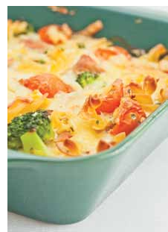A Healthy Tip!

. . . . . . . . . . . . . . . . . . . . . . . . . . . . . .

Do not eat food that has been out of the fridge for more than two hours as harmful bacteria may grow on the food and cause food poisoning.

26 RECIPESFORLIFE

Serves 2

Preparation Time 25 min Cooking Time 40 min

Grilled Fish Burger

. . . . . . . . . . . . . . . . . . . . . . . . . . . . . . . . . . . . . . . . . . . . . . . . . . . . . . . . . . . . . . . . . . . . . . . . . . . . . . . . . . . . . . . . . . . . . . . .

Method Ingredients

1.Preheat oven to 220°C (200°C fan-forced). Line an oven tray with baking paper. Place potato wedges on tray, spray potatoes with cooking oil spray and bake for 30 minutes.

2.Line grill with foil and heat to a medium to high heat.

3.Cook the snapper for 3-4 minutes on both sides. Flip carefully.

4.Cut the bread rolls in half and grill for 1 minute.

5.Combine the yoghurt, mayonnaise, lemon juice, parsley and chives.

6.Spread the yoghurt mixture onto the bread roll and top with snapper and salad. Serve with potato wedges.

• 2 small potatoes, cut into wedges • Cooking oil spray
• 2 x 120g snapper fillets • 2 wholegrain bread rolls
• 2½ tablespoons low-fat natural yoghurt

• 1½ tablespoons low-fat mayonnaise

• 1 tablespoon lemon juice

• 1 teaspoon parsley (fresh or dried)

• 1 teaspoon chives (fresh or dried) • 4 large lettuce leaves
• 1 tomato, sliced

• ½ cucumber, sliced

• ½ carrot, grated

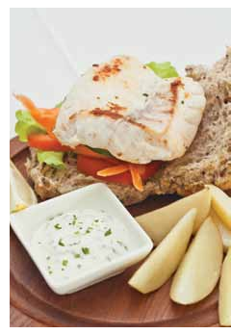A Healthy Tip!

. . . . . . . . . . . . . . . . . . . . . . . . . . . . . .

A good indicator of weight loss is how well your clothes fit. If your clothes are loose you have lost weight. If this is the case and weight loss is not intentional it is important to eat regularly and choose foods high in energy such as nuts, full-fat dairy products, fats and oils, avocado and sweets (eg chocolate, biscuits and cakes).

RECIPESFORLIFE 27

Serves 2

Preparation Time 25 min Cooking Time 45 min

Meatballs

. . . . . . . . . . . . . . . . . . . . . . . . . . . . . . . . . . . . . . . . . . . . . . . . . . . . . . . . . . . . . . . . . . . . . . . . . . . . . . . . . . . . . . . . . . . . . . . .

Method Ingredients

1.Preheat oven to 200°C (180°C fan-forced).

2.Combine mince, onion, lemon zest, basil, ricotta and oats in a bowl.

3.Shape into small balls and place on an oven tray.

4.Bake for 20 minutes, turn meatballs and bake for another 20 minutes.

5.Meanwhile, combine tomatoes and chicken stock and heat in a saucepan on a medium heat for 5 minutes.

• 250g lean mince (any type) • ¼ onion, finely diced
• Zest of 1 lemon*

• 1 tablespoon basil (fresh or dried) • 65g low-fat ricotta
• ½ cup rolled oats

• 400g can of diced tomatoes

• ¼ cup reduced-salt chicken stock

6.Top meatballs with sauce and serve with pasta and vegetables.
Serve with:

• 1 cup cooked pasta

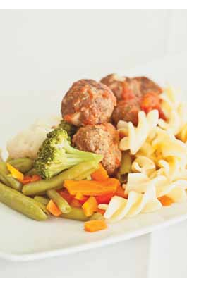• 2 cups steamed vegetables

* Lemon zest: tiny pieces of lemon peel. Grating the outer yellow layer of a lemon will give you lemon zest.

A Healthy Tip!

. . . . . . . . . . . . . . . . . . . . . . . . . . . . . .

Getting out and about helps your mind stay active and can improve your mood. Go see a movie, walk the dog, join a group or shop for ingredients for a new recipe like this one!

28 RECIPESFORLIFE

Serves 2

Preparation Time 20 min Cooking Time 20 min

Beef Stir Fry

. . . . . . . . . . . . . . . . . . . . . . . . . . . . . . . . . . . . . . . . . . . . . . . . . . . . . . . . . . . . . . . . . . . . . . . . . . . . . . . . . . . . . . . . . . . . . . . .

Method Ingredients

1.Follow rice cooking instructions on page 7.

2.Heat oil in a wok or fry pan over high heat, add beef and cook until browned. Remove and set aside.

3.Add the garlic, chilli, onion, capsicum, broccoli, corn and carrot to the wok and cook for 3 minutes.

4.Return the beef to the wok. Add cabbage, soy sauce and fish sauce. Cook for 2 minutes.

5.Serve stir fry with rice.

• / cup rice
3
4

• 1 tablespoon canola oil • 250g lean beef, sliced
• ½ teaspoon garlic (fresh or dried) • ½ red chilli, thinly sliced*
• ½ onion, sliced

• ½ capsicum, sliced

• ½ cup broccoli, chopped • 200g canned corn
• ½ carrot, sliced

• ¼ cabbage, shredded

• 1 tablespoon reduced-salt soy sauce

• 2 teaspoons fish sauce

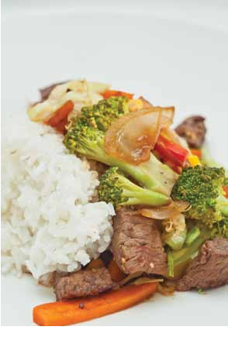* Wash your hands after touching a chilli and before you touch anything else.

A Healthy Tip!

. . . . . . . . . . . . . . . . . . . . . . . . . . . . . .

If you are out drinking avoid shouts and choose drinks with low alcohol content. This will help you to limit the amount of alcohol you consume.

RECIPESFORLIFE 29

Serves 2

Preparation Time 40 min Cooking Time 30 min

Homemade Fish & Chips

. . . . . . . . . . . . . . . . . . . . . . . . . . . . . . . . . . . . . . . . . . . . . . . . . . . . . . . . . . . . . . . . . . . . . . . . . . . . . . . . . . . . . . . . . . . . . . . .

Method Ingredients

1.Preheat oven to 220°C (200°C fan-forced). Line an oven tray with baking paper.

2.Cut the potatoes into chips. Microwave or boil them until tender. Arrange them in a single layer on the oven tray.

3.Mix the flour, breadcrumbs and egg in one bowl. Place the parsley in another bowl.

4.Coat the fish in the breadcrumb mix before coating in parsley.

5.Bake the chips in the oven for 15 minutes. Add the fish and cook for a further 10-15 minutes.

6.Meanwhile, combine avocado, lettuce, cucumber, corn kernels, tomato, lemon juice and sweet chilli sauce. Serve with fish and chips.

• 2 small potatoes, peeled • ¼ cup plain flour
• ½ cup breadcrumbs • 1 egg
• 1 teaspoon dried parsley

• 250g boneless white fish fillets • ½ avocado, diced
• 1 cup lettuce, shredded • ½ cup cucumber, diced • ½ cup corn kernels
• 1 large tomato, diced

• 1 tablespoon lemon juice

• 1 teaspoon sweet chilli sauce

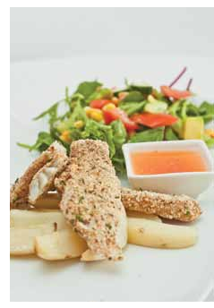A Healthy Tip!

. . . . . . . . . . . . . . . . . . . . . . . . . . . . . .

This recipe for homemade baked fish and chips is a healthier alternative to take-away fried fish and chips as it is lower in energy, fat and salt.

30 RECIPESFORLIFE

Serves 2

Preparation Time 20 min Cooking Time 25 min

Chicken Tandoori Pizza

. . . . . . . . . . . . . . . . . . . . . . . . . . . . . . . . . . . . . . . . . . . . . . . . . . . . . . . . . . . . . . . . . . . . . . . . . . . . . . . . . . . . . . . . . . . . . . . .

Method Ingredients

1.Place sweet potato in a microwave-safe bowl with a little water. Microwave for 5-10 minutes or until soft.

2.Preheat oven to 200°C (180°C fan-forced).

3.Combine yoghurt and tandoori paste. Mix in the chicken.

4.Spread tomato paste onto the pita bread. Top the pita bread with chicken mix, sweet potato, cashews and cheese.

5.Bake for 10-15 minutes or until cheese is golden brown. Remove from oven and allow to cool slightly.

6.Cut pizza into 6 slices and sprinkle with coriander (optional).

• ½ sweet potato, peeled and diced

• 2 tablespoons low-fat natural yoghurt

• 1½ teaspoons tandoori paste

• 1 cup pre-cooked or BBQ chicken, diced

• 2 wholemeal pita bread

• 2 tablespoons reduced-salt tomato paste

• / cup cashews
1
3

• / cup reduced-fat cheese, grated
1
3

• Fresh coriander, coarsely chopped (optional)

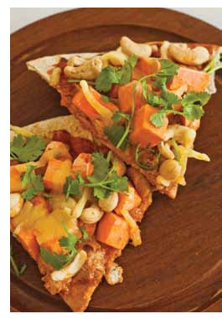A Healthy Tip!

. . . . . . . . . . . . . . . . . . . . . . . . . . . . . .

Physical activity helps keep your heart and lungs healthy, maintains bone and muscle strength, assists you to move more easily and improves concentration. This pizza is great after exercise.

RECIPESFORLIFE 31

Serves 2

Preparation Time 25 min Cooking Time 40 min

Fried Rice

. . . . . . . . . . . . . . . . . . . . . . . . . . . . . . . . . . . . . . . . . . . . . . . . . . . . . . . . . . . . . . . . . . . . . . . . . . . . . . . . . . . . . . . . . . . . . . . .

Method Ingredients

1.Follow rice cooking instructions on page 7.

2.Heat oil in a large fry pan, add meat, onion and garlic and cook until the meat has cooked through. Add the rice and stir through.

3.Add all the vegetables and stir for 2 minutes. Move the mixture to the side of the fry pan.

4.Pour eggs into the empty side of the fry pan and stir into mixture. Keep stirring until eggs have been mixed in.

5.Add soy sauce and peanuts (optional). Stir through the mixture.

6.Serve with lemon wedge (optional).

• 1 cup rice

• 1 tablespoon canola oil

• 150g lean bacon, ham or chicken, chopped (exclude or use tofu for vegetarian option)

• ½ onion, diced

• 1 teaspoon garlic (fresh or dried) • 100g cabbage, shredded
• 1 cup frozen peas and corn • ½ capsicum, diced
• 1 carrot, diced • 2 eggs
• 2 teaspoons reduced-salt soy sauce

• 2 tablespoons unsalted peanuts (optional)

• 1 lemon, cut into wedges (optional)

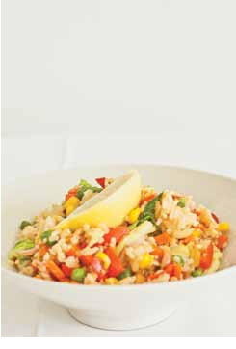A Healthy Tip!

. . . . . . . . . . . . . . . . . . . . . . . . . . . . . .

Rice has a very high risk of food spoilage. It is therefore best to eat rice immediately after cooking and avoid storing for later consumption.

32 RECIPESFORLIFE

Serves 2

Preparation Time 25 min Cooking Time 1 h 15 min

One Pot Lamb Curry

. . . . . . . . . . . . . . . . . . . . . . . . . . . . . . . . . . . . . . . . . . . . . . . . . . . . . . . . . . . . . . . . . . . . . . . . . . . . . . . . . . . . . . . . . . . . . . . .

Method Ingredients

1.Preheat oven to 200°C (180°C fan-forced) and grease a 1.5 litre (6 cup) capacity oven dish with cooking oil spray.

2.Place lamb in the oven dish. Mix in the curry powder, cinnamon, garlic and onion. Bake for 20 minutes.

3.Fill a saucepan with water and bring to the boil. Cook pasta for 10-15 minutes. Drain well.

4.Place potato and carrot in a microwave-safe bowl with a little water and microwave for 5-10 minutes or until soft.

5.Remove lamb from the oven and add chicken stock, tomatoes, potato, carrot, peas and pasta. Bake for 30 minutes.

6.Remove from the oven and serve.

• Cooking oil spray

• 250g lean lamb, diced

• 1 tablespoon curry powder • 1 teaspoon dried cinnamon • ½ onion, diced
• 1 teaspoon garlic (dried or fresh) • ¾ cup dried spiral pasta
• 1 potato, diced • 1 carrot, diced
• 1½ cups reduced-salt chicken stock

• 400g can of diced tomatoes

• ¾ cup peas

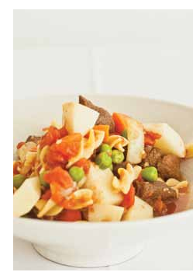A Healthy Tip!

. . . . . . . . . . . . . . . . . . . . . . . . . . . . . .

Quitting smoking can significantly improve your health. Strategies to help with quitting include: taking up a new hobby, exercising or cooking new recipes like this curry.

RECIPESFORLIFE 33

Serves 2

Preparation Time 20 min Cooking Time 1 hour

Toad in the Hole

. . . . . . . . . . . . . . . . . . . . . . . . . . . . . . . . . . . . . . . . . . . . . . . . . . . . . . . . . . . . . . . . . . . . . . . . . . . . . . . . . . . . . . . . . . . . . . . .

Method Ingredients

1.Preheat oven to 220°C (200°C fan-forced). Grease a 1.5 litre (6 cup) capacity oven dish with cooking oil spray.

2.Place the sausages, potatoes, mixed vegetables and onion into the oven dish.

3.Bake for 20 minutes or until sausages start to brown.

4.Mix flour, canola oil, eggs, milk and mustard in a bowl.

5.Remove the oven dish from the oven and pour the batter over the sausage mixture.

6.Bake for another 40 minutes. Serve.

• Cooking oil spray

• 3 low-fat thin sausages, sliced • 2 potatoes, peeled and diced
• 1 cup frozen mixed vegetables • ¼ onion, diced
• ½ cup plain flour

• 2 teaspoons canola oil • 2 eggs
• ¾ cup reduced-fat milk

• 2 teaspoons wholegrain mustard

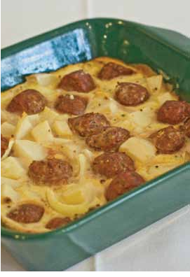A Healthy Tip!

. . . . . . . . . . . . . . . . . . . . . . . . . . . . . .

It is very important to ensure your vaccinations are up-to-date to reduce your risk of infection. Are you up-to-date with your vaccinations? Check with your doctor next time you visit.

34 RECIPESFORLIFE

Serves 2

Preparation Time 25 min Cooking Time 20 min

Pork & Hokkien Noodle Stir Fry

. . . . . . . . . . . . . . . . . . . . . . . . . . . . . . . . . . . . . . . . . . . . . . . . . . . . . . . . . . . . . . . . . . . . . . . . . . . . . . . . . . . . . . . . . . . . . . . .

Method Ingredients

1.Place noodles in a large bowl and cover with boiling water. Allow to stand for 5 minutes before draining.

2.Heat oil in a wok or fry pan on high heat. Add the pork and cook for 5 minutes or until brown. Remove and set aside.

3.Add vegetables, onion and garlic to pan and stir fry for 2-3 minutes.

4.Return the pork to the pan. Add oyster sauce, stock and noodles.

• 250g fresh hokkien noodles • 1 tablespoon canola oil
• 250g lean pork, sliced

• 2 cups frozen mixed vegetables • ½ onion, chopped
• 1 teaspoon garlic (fresh or dried) • ¼ cup oyster sauce
• ¼ cup reduced-salt chicken stock

5.Stir fry for 2 minutes. Serve.

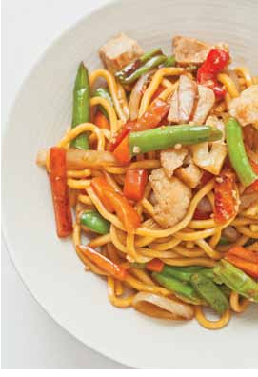A Healthy Tip!

. . . . . . . . . . . . . . . . . . . . . . . . . . . . . .

This recipe is quick, easy and very healthy. The perfect meal to prepare after a day out!

RECIPESFORLIFE 35

Serves 2

Preparation Time 15 min Cooking Time 15 min

Pancakes with Cherry Yoghurt

* Pancakes can be Frozen

. . . . . . . . . . . . . . . . . . . . . . . . . . . . . . . . . . . . . . . . . . . . . . . . . . . . . . . . . . . . . . . . . . . . . . . . . . . . . . . . . . . . . . . . . . . . . . . .

Method Ingredients

1.Heat cooking oil spray in a fry pan on medium heat.

2.Whisk together flour, bicarbonate of soda, egg and milk in a bowl.

3.Place ½ cup of mixture into the fry pan. Flip when bubbles begin to appear. Repeat until all the mixture has been used.

4.Combine yoghurt, cherries and icing sugar in a bowl.

5.Serve pancakes with yoghurt topping.

• Cooking oil spray

• ½ cup wholemeal self-raising flour

• ¼ teaspoon bicarbonate of soda • 1 egg
• ¾ cup reduced-fat milk

• 250g low-fat natural yoghurt

• 1 cup frozen or morello cherries (can substitute with any frozen berries)

• 1 tablespoon icing sugar

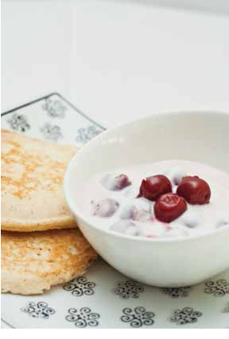A Healthy Tip!

. . . . . . . . . . . . . . . . . . . . . . . . . . . . . .

Maintaining a healthy weight but still enjoying life’s food pleasures can be a challenge. This dessert is low in fat and high in fibre making it an excellent choice if you are trying to keep your weight down. It is important to remember that
it is okay for older people to carry a little extra weight, but you don’t want to carry too much. See page 52 to see how you measure up.

36 RECIPESFORLIFE

Serves 2

Preparation Time 10 min Cooking Time Nil

Banana Berry Split

. . . . . . . . . . . . . . . . . . . . . . . . . . . . . . . . . . . . . . . . . . . . . . . . . . . . . . . . . . . . . . . . . . . . . . . . . . . . . . . . . . . . . . . . . . . . . . . .

Method Ingredients

1.Slice the bananas in half longways and place in two separate serving bowls.

2.Place 2 scoops of frozen yoghurt on top of each banana.

3.Scatter mixed berries and chopped nuts on top of yoghurt to serve.

• 2 bananas, peeled

• 4 scoops reduced-fat frozen yoghurt

• ½ cup frozen mixed berries

• 2-4 tablespoons unsalted chopped peanuts (or any other nut)

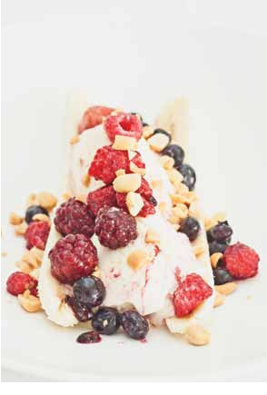A Healthy Tip!

. . . . . . . . . . . . . . . . . . . . . . . . . . . . . .

If you are unsure about your driving ability an Accredited Older Driver Assessor can teach, assess and advise you on your driving ability. The Roads and Maritime website lists all Accredited Older Driver Assessors, or phone 132 213 for more information.

RECIPESFORLIFE 37

Serves 2

Preparation Time 15 min Cooking Time 30 min

Orange Pudding

. . . . . . . . . . . . . . . . . . . . . . . . . . . . . . . . . . . . . . . . . . . . . . . . . . . . . . . . . . . . . . . . . . . . . . . . . . . . . . . . . . . . . . . . . . . . . . . .

Method Ingredients

1.Preheat oven to 200°C (180°C fan-forced). Grease a loaf tin or muffin tray with cooking oil spray.

2.Combine flour, sugar and orange zest in a bowl.

3.In a separate bowl combine oil, orange juice, orange pieces and egg.

4.Pour the orange juice mixture into the dry ingredients. Mix well and pour into an oven dish.

• Cooking oil spray

• ½ cup self-raising flour • 2 tablespoons sugar
• Zest of half an orange*

• 1½ tablespoons canola oil

• ¼ cup full pulp orange juice • 1 orange, diced
• 1 egg

5.Bake for 30 minutes or until cake springs back when touched in the centre. Remove from the oven and allow to cool for 5 minutes before removing from the tin.

6.Serve with yoghurt or ice-cream.

Serve with:

• 400g low-fat yoghurt or 4 scoops of reduced-fat ice-cream

* Orange zest: tiny pieces of orange peel. Grating the outer layer of an orange will give you orange zest.

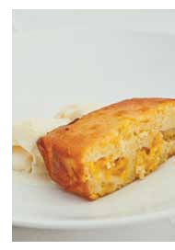A Healthy Tip!

. . . . . . . . . . . . . . . . . . . . . . . . . . . . . .

If you are feeling a little down watch a funny or feel-good movie. Laughter is the best medicine!

38 RECIPESFORLIFE

Serves 2

Preparation Time 15 min Cooking Time 15 min

Apple Crumble

. . . . . . . . . . . . . . . . . . . . . . . . . . . . . . . . . . . . . . . . . . . . . . . . . . . . . . . . . . . . . . . . . . . . . . . . . . . . . . . . . . . . . . . . . . . . . . . .

Method Ingredients

1.Preheat oven to 200°C (180°C fan-forced). Grease a small oven dish with cooking oil spray.

2.Combine the flour, sugar, cinnamon margarine and oats in a bowl. Use your fingertips to rub the margarine into the flour mixture until the mixture resembles fine breadcrumbs.

3.Stir in the walnuts (optional).

4.Spoon apple into the oven dish and scatter the crumble mixture evenly over the apples. Bake in the oven for 15 minutes or until golden.

• Cooking oil spray

• 1/ cup wholemeal plain flour
3

• 2 tablespoons brown sugar, firmly packed

• 1 teaspoon dried cinnamon or mixed spice

• 3 teaspoons margarine

• 3 tablespoons rolled oats

• 1 tablespoon walnuts, coarsely chopped (optional)

• 400g can of apples

5.Spoon the apple crumble into serving bowls Serve with:

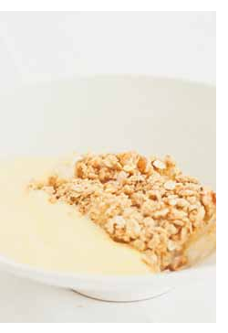and serve with yoghurt, custard or ice-cream. • 400g low-fat yoghurt or 1½ cups low-fat custard or 4 scoops of reduced-fat ice-cream

A Healthy Tip!

. . . . . . . . . . . . . . . . . . . . . . . . . . . . . .

Fibre is very important for bowel health and can reduce constipation. This recipe contains fruit, wholemeal flour and oats which are great sources of fibre.

RECIPESFORLIFE 39

Serves 2

Preparation Time 15 min Cooking Time 1 hour

Baked Pear Custard

. . . . . . . . . . . . . . . . . . . . . . . . . . . . . . . . . . . . . . . . . . . . . . . . . . . . . . . . . . . . . . . . . . . . . . . . . . . . . . . . . . . . . . . . . . . . . . . .

Method Ingredients

1.Preheat oven to 150°C (130°C fan-forced).

2.Grease 2 ramekin dishes with cooking oil spray. Arrange pears over base of ramekin dishes.

3.Heat the milk on low heat in a saucepan on the stove.

4.In a bowl combine sugar and custard powder, then whisk in maple syrup or honey, eggs and vanilla essence. Gradually add hot milk while continuing to whisk.

• Cooking oil spray

• 1 pear, peeled and thinly sliced • 1 cup reduced-fat milk
• 1 tablespoon castor sugar • 1 teaspoon custard powder
• 1½ tablespoons maple syrup or honey

• 2 eggs

• ½ teaspoon vanilla essence

5.Pour mixture over pears and bake for 1 hour

or until set. Serve with:

6.Serve with ice-cream. • 4 scoops of reduced-fat ice-cream

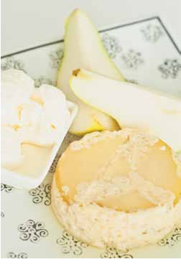A Healthy Tip!

. . . . . . . . . . . . . . . . . . . . . . . . . . . . . .

This recipe is the perfect dessert to serve family and friends when they come over for lunch or dinner.

40 RECIPESFORLIFE

Serves 2

Preparation Time 10 min Cooking Time 40 min

Pear & Sultana Rice Pudding

. . . . . . . . . . . . . . . . . . . . . . . . . . . . . . . . . . . . . . . . . . . . . . . . . . . . . . . . . . . . . . . . . . . . . . . . . . . . . . . . . . . . . . . . . . . . . . . .

Method Ingredients

1.Place milk, vanilla, cinnamon and honey in a large saucepan; bring to the boil over medium to high heat, stirring constantly.

2.Add the rice and sultanas, reduce to medium to low heat and cook, stirring occasionally for 20-30 minutes or until rice has cooked and thickened. Remove from heat.

3.Meanwhile, place the brown sugar and pear in a saucepan. Bring to the boil, then simmer for 5 minutes or until pear has softened.

• 2½ cups reduced-fat milk • 1 teaspoon vanilla essence
• 1 teaspoon dried cinnamon • 1 tablespoon honey
• ½ cup arborio rice*

• 1 tablespoon sultanas

• 1 teaspoon brown sugar

• 1 pear, peeled and diced

4.Fold pear mixture through rice and serve.

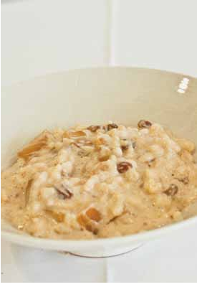* Arborio rice: a short-grain, high-starch rice. It can be found in the rice section at your supermarket.

A Healthy Tip!

. . . . . . . . . . . . . . . . . . . . . . . . . . . . . .

Calcium is important for strong and healthy bones. This recipe contains almost one serve of your daily calcium needs per serve.

RECIPESFORLIFE 41

Serves 2

Preparation Time 10 min Cooking Time Nil

Modern Trifle

. . . . . . . . . . . . . . . . . . . . . . . . . . . . . . . . . . . . . . . . . . . . . . . . . . . . . . . . . . . . . . . . . . . . . . . . . . . . . . . . . . . . . . . . . . . . . . . .

Method Ingredients

1.Combine the yoghurt, vanilla essence, hazelnut meal and brown sugar.

2.Place berries in a glass and top with yoghurt mixture.

3.Serve with biscotti (optional).

• 400g low-fat natural yoghurt • 1 teaspoon vanilla essence
• 4 tablespoons hazelnut meal • 1 tablespoon brown sugar
• 1 cup mixed berries, or any other fruit

• 4-6 slices biscotti* (optional)

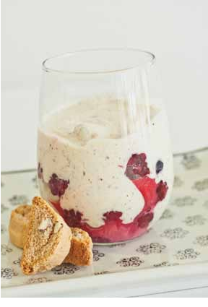* Biscotti: Twice-baked Italian almond biscuits. It can be found in the biscuit aisle at your supermarket.

A Healthy Tip!

. . . . . . . . . . . . . . . . . . . . . . . . . . . . . .

It is very important that we keep our brains active to prevent or delay memory loss. Some good ways to keep our brains active include: taking up a new hobby, reading and writing, playing cards or doing crosswords.

42 RECIPESFORLIFE

Serves 4

Preparation Time 25 min Cooking Time 5 min

Avocado Dip with Tortilla Chips

. . . . . . . . . . . . . . . . . . . . . . . . . . . . . . . . . . . . . . . . . . . . . . . . . . . . . . . . . . . . . . . . . . . . . . . . . . . . . . . . . . . . . . . . . . . . . . . .

Method Ingredients

1.Mash avocado and mix with natural yoghurt.

2.Add onion, tomato, five bean mix, corn kernels, lemon juice and coriander leaves and mix well.

3.Cut the tortillas into triangles. Place on oven tray and spray tortillas with cooking oil spray.

4.Bake tortillas for approximately 2-3 minutes or until golden brown.

5.Serve dip with tortilla chips.

• 1 avocado

• ½ cup low-fat natural yoghurt • ¼ red onion, diced
• 1 tomato, diced

• 200g canned five bean mix, drained

• ½ cup corn kernels • Juice of 1 lemon
• Handful of fresh coriander leaves, coarsely chopped

• 4 tortillas

• Cooking oil spray

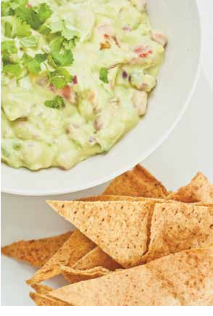A Healthy Tip!

. . . . . . . . . . . . . . . . . . . . . . . . . . . . . .

Smoking increases the risk of developing many health conditions and it is never too late to quit. Try fiddly snacks like this recipe, which keep your hands active and your mind off smoking.

RECIPESFORLIFE 43

Serves 2

Preparation Time 15 min Cooking Time 5 min

Bruschetta

. . . . . . . . . . . . . . . . . . . . . . . . . . . . . . . . . . . . . . . . . . . . . . . . . . . . . . . . . . . . . . . . . . . . . . . . . . . . . . . . . . . . . . . . . . . . . . . .

Method Ingredients

1.Preheat oven to 220°C (200°C fan-forced). Line an oven tray with baking paper.

2.Brush bread with oil, and bake for approximately 3-5 minutes.

3.Meanwhile, combine tomato, onion, basil, garlic and vinegar in a bowl.

4.Top crunchy bread with tomato mixture and serve.

• ½ long multigrain French bread stick, sliced

• 1 tablespoon olive oil • 2 tomatoes, diced
• ¼ red onion, diced

• ¼ cup fresh basil leaves, coarsely chopped

• ½ teaspoon garlic (fresh or dried)

• 1 tablespoon balsamic vinegar

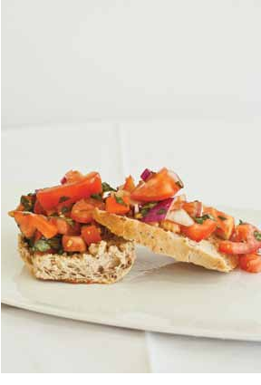A Healthy Tip!

. . . . . . . . . . . . . . . . . . . . . . . . . . . . . .

This is a great recipe to use when entertaining guests or when you need to ‘take a plate’ to a social event.

44 RECIPESFORLIFE

Serves 6

Preparation Time 20 min Cooking Time 30 min

Chicken Satay Meatballs

. . . . . . . . . . . . . . . . . . . . . . . . . . . . . . . . . . . . . . . . . . . . . . . . . . . . . . . . . . . . . . . . . . . . . . . . . . . . . . . . . . . . . . . . . . . . . . . .

Method Ingredients

1.Preheat oven to 220°C (200°C fan-forced). Line an oven tray with baking paper.

2.Combine the chicken mince, green onion, garlic, ginger, breadcrumbs and peanut butter in a bowl.

3.Roll into small balls and place on the lined oven tray.

4.Bake for 15 minutes. Turn the meatballs over and cook for a further 15 minutes.

• 850g lean chicken mince

• 5 green onions (shallots), sliced • 1 teaspoon garlic (fresh or dried)
• 1 teaspoon ginger (fresh or dried) • 1 cup breadcrumbs
• 200g low-fat peanut butter

• ½ cup sweet chilli sauce

5.Serve with sweet chilli sauce as a dipping sauce.

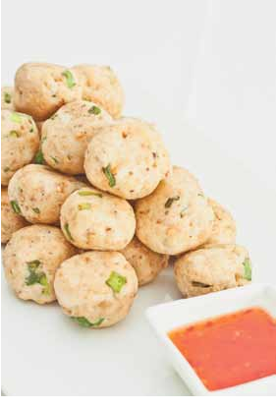A Healthy Tip!

. . . . . . . . . . . . . . . . . . . . . . . . . . . . . .

Ensure you wash your hands and all utensils after handling raw chicken to prevent cross contamination with other ingredients.

RECIPESFORLIFE 45

Serves 12

Preparation Time 25 min Cooking Time 40 min

Carrot Cake

. . . . . . . . . . . . . . . . . . . . . . . . . . . . . . . . . . . . . . . . . . . . . . . . . . . . . . . . . . . . . . . . . . . . . . . . . . . . . . . . . . . . . . . . . . . . . . . .

Method Ingredients

1.Preheat oven to 200OC (180OC fan-forced). Grease a loaf tin with cooking oil spray and line with baking paper.

2.Combine oil, brown sugar and eggs in a bowl and whisk well. Add the flours and spice into the mixture and mix.

3.Add in the carrot and walnuts and pour the batter into the cake tin. Bake for 40 minutes or until cake springs back when touched in the centre.

4.Leave cake to cool in tin for 10 minutes then transfer cake to a wire rack and allow to cool completely.

5.Meanwhile, combine the cream cheese, icing sugar and lemon juice. Mix well.

• Cooking oil spray • 1 cup canola oil
• 1 cup brown sugar • 4 eggs, beaten
• ¾ cup white self-raising flour

• ¾ cup wholemeal self-raising flour

• 2 teaspoon mixed spice

• 4 medium carrots, grated • ¾ cup walnuts, chopped
• 200g reduced-fat cream cheese • / cup icing sugar
1
3
• ¼ cup lemon juice

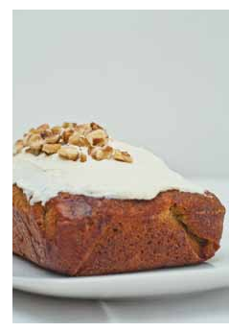6.Spread the cream cheese mixture over the cake and serve.

A Healthy Tip!

. . . . . . . . . . . . . . . . . . . . . . . . . . . . . .

If your appetite is poor you may find it difficult to eat enough food to keep weight on. Eating regular meals and snacks at set times can help to increase your appetite allowing you to eat more. This cake is perfect for a morning, afternoon or evening snack.

46 RECIPESFORLIFE

Serves 2

Preparation Time 10 min Cooking Time Nil

Iced Red Berry Mocktail

. . . . . . . . . . . . . . . . . . . . . . . . . . . . . . . . . . . . . . . . . . . . . . . . . . . . . . . . . . . . . . . . . . . . . . . . . . . . . . . . . . . . . . . . . . . . . . . .

Method Ingredients

1.Combine berries, watermelon and cranberry juice in a blender.

2.Blend until smooth.

3.Pour into wine glasses and top with soda water.

4.Serve with strawberries (optional).

• 150g frozen berries

• 100g watermelon

(if not in season use additional mixed berries)

• ½ cup cranberry juice • 1 cup soda water
• Fresh strawberries, sliced (optional)

A Healthy Tip!

. . . . . . . . . . . . . . . . . . . . . . . . . . . . . .

For optimal health you should consume no more than 2 standard drinks a day. Use a mocktail like this one as an alternative to an alcoholic drink.

RECIPESFORLIFE 47

Serves 2

Preparation Time 10 min Cooking Time Nil

Tropical Mocktail

. . . . . . . . . . . . . . . . . . . . . . . . . . . . . . . . . . . . . . . . . . . . . . . . . . . . . . . . . . . . . . . . . . . . . . . . . . . . . . . . . . . . . . . . . . . . . . . .

Method Ingredients

1.Combine mango or peaches with banana, raspberries, yoghurt and milk in a blender.

2.Blend until smooth.

3.Pour into wine glasses.

• ½ mango, cut into cubes, or

½ cup canned peaches, drained

• 1 banana

• ¼ cup frozen raspberries

• ½ cup reduced-fat yoghurt (any flavour)

• ½ cup reduced-fat milk

A Healthy Tip!

. . . . . . . . . . . . . . . . . . . . . . . . . . . . . .

Aim to have one or two alcohol-free days per week. When craving a drink, make a mocktail and serve it in a wine glass or have some water or juice served in a wine glass.

48 RECIPESFORLIFE

Modifying Recipes

. . . . . . . . . . . . . . . . . . . . . . . . . . . . . . . . . . . . . . . . . . . . . . . . . . . . . . . . . . . . . . . . . . . . . . . . . . . . . . . . . . . . . . . . . . . . . . . .

All of the recipes provided can be modified by substituting, adding or eliminating ingredients listed in the recipes.
You may modify a recipe to suit your personal preferences, to include fresh foods that are in season, to use foods that are on special or more affordable, and to add variety to your diet.

. . . . . . . . . . . . . . . . . . . . . . . . . . . . . . . . . . . . . . . . . . . . . . . . . . . . . . . . . . . . . . . . . . . . . . . . . . . . . . . . . . . . . . . . . . . . . . . . Healthy Snack Ideas

If you are feeling hungry through the day try some of the snack ideas below:

• A fruit smoothie

• Fruit salad and reduced-fat yoghurt or custard

• Small handful of dried fruit

• Small handful of unsalted nuts

• Pikelet with jam

• Vegetable sticks and hummus

• Wholegrain rice crackers and salsa

• Baked beans on half an English muffin

• Reduced-fat cheese slices with wholemeal crackers

• Raisin toast with a thin spread of margarine

• A tub of reduced-fat plain or fruit-flavoured yoghurt

• Crispbreads with cottage cheese and sweet chilli sauce

• Fruit muffin

• Piece of fruit

• Air-popped or microwave popcorn

• Glass of reduced-fat milk

• Slice of banana bread

• Celery sticks with peanut butter

• Rice cakes with reduced-fat cheese and tomato

• Wholemeal crumpet with a drizzle of honey

• Date or pumpkin scone

• A couple of digestive biscuits

• Pita bread with avocado, reduced-fat cheese and tomato

RECIPESFORLIFE 49

Food Group

Healthy Eating

. . . . . . . . . . . . . . . . . . . . . . . . . . . . . . . . . . . . . . . . . . . . . . . . . . . . . . . . . . . . . . . . . . . . . . . . . . . . . . . . . . . . . . . . . . . . . . . .

Eating a variety of foods from each of the five food groups provides the nutrients and energy needed for good health.

The table below identifies the five food groups and the number of recommended serves healthy men and women aged 50 years and over should consume each day to meet their requirements.
Recommended Recommended daily serves for daily serves for men aged 50 women aged  and over 50 and over | One serve equivalents

Vegetables and 5 legumes* / beans

Fruit 2

Grain foods 4 - 6 (mostly
wholegrain)
5 • ½ cup cooked vegetables

• ½ cup cooked, dried or canned beans, chickpeas or lentils

• 1 cup raw green leafy vegetables (eg lettuce, rocket or spinach)

• 1 small potato, or equivalent of sweet potato or corn

• ½ cup of other vegetables eg 1 small to medium tomato

2 • 1 medium sized fruit eg apple, pear, orange, banana

• 2 small fruit eg apricot, plum, kiwi fruit • 1 cup diced, cooked or canned fruit
• ½ cup 100% fruit juice

• 30g dried fruit eg 4 dried apricot halves, 1½ tablespoons sultanas

3 - 4 • 1 slice bread or ½ bread roll

• ½ cup cooked rice, pasta, noodles, barley or quinoa

• ½ cup cooked porridge or 2/3 cup breakfast cereal flakes or ¼ cup muesli

• 3 crispbreads

• 1 crumpet or small English muffin or scone

• ¼ cup flour

50 RECIPESFORLIFE

Food Group  Recommended Recommended daily serves for daily serves for men aged 50 women aged  and over 50 and over | One serve equivalents

Lean meat and 2 - 3 poultry, fish,
eggs, nuts and seeds, and legumes* / beans

Dairy foods and 2 - 4 alternatives
(mostly reduced-fat)

Additional foods 0 - 3 / sometimes
foods
2 • 65g cooked lean red meat or ½ cup lean mince or 2 small chops or 2 slices roast meat

• 80g cooked poultry

• 100g cooked or 1 small can of fish (no added salt, not in brine)

• 2 large eggs

• 1 cup cooked dried beans, lentils, chickpeas, split peas, or canned beans

• 170g tofu

• 30g nuts or seeds, or nut / seed paste

4 • 1 cup cow’s, calcium-fortified soy, rice or oat milk

• ½ cup evaporated unsweetened milk • 200g ( / cup) yoghurt
3
4
• 40g (2 slices) hard cheese • 120g ricotta

0 - 3 • 4 plain sweet biscuits

• ½ small chocolate bar (25g) • 1/ meat pie
3
• 12 (60g) hot chips

• 1½ scoops ice-cream

• 1 can (375ml) soft drink

• 400ml regular beer or 600ml light beer or 200ml wine or 60ml spirits

These recommended dietary patterns have been developed for healthy older men and women of average height who undertake small to moderate amounts of physical activity.

These dietary patterns will need to be modified for taller, more active or unwell individuals. These recommendations are not designed for frail older people who need high energy, nutrient-dense foods to maintain their weight and nutrition.

Note: The recommended number of serves and one serve equivalents of the food groups indicated in the table above may change. Please refer to www.eatforhealth.gov.au or phone 1300 064 672 for the current dietary guidelines.

* What are legumes?

Legumes are a group of plant foods including:
• Beans such as navy (used in baked beans), kidney, lima, white, pinto, chickpeas and soy beans

• Peas

• Lentils • Peanuts

Legumes are high in fibre and protein, low in fat and contain many vitamins and mineral.

RECIPESFORLIFE 51

Healthy Weight & Weight Gain

. . . . . . . . . . . . . . . . . . . . . . . . . . . . . . . . . . . . . . . . . . . . . . . . . . . . . . . . . . . . . . . . . . . . . . . . . . . . . . . . . . . . . . . . . . . . . . . .

Maintain a healthy weight

• A healthy weight for older people is a body mass index (BMI) of 22 to 27 kg/m2. The BMI range for older people is a little bit higher than the BMI recommendations for adults. Older people can afford to carry a
little extra weight as this helps with weight maintenance and recovery from illness if illness occurs. BMI is calculated by dividing your weight in kilograms by your height in metres squared ie BMI= kg/m2.

• Weight maintenance occurs when the amount of energy you consume as food is in balance with the amount of energy you expend through physical activity.

• If you eat more food than you expend through physical activity you will gain weight. If you eat less food than you expend through physical activity you will lose weight.

• It is important to maintain a healthy weight as it can reduce the risk of developing health conditions such as heart disease, diabetes and high blood pressure.

• Being too thin (BMI less than or equal to 22kg/m2) can increase the risk of infection and slow recovery from illness. If your BMI is below 22kg/m2, a little weight gain will be beneficial.

• If you are obese (BMI greater than or equal to 30 kg/m2) your doctor or dietitian may advise you on ways to lose weight.

• Maintaining muscle mass is also very important. Physical activity and healthy eating are the best ways to maintain muscle mass.

• Losing weight without trying may be a sign of trouble and you should discuss this with your doctor or dietician.

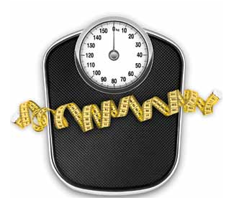52 RECIPESFORLIFE

Food Safety
- 40

. . . . . . . . . . . . . . . . . . . . . . . . . . . . . . . . . . . . . . . . . . . . . . . . . . . . . . . . . . . . . . . . . . . . . . . . . . . . . . . . . . . . . . . . . . . . . . . .

Food safety is of great importance and incorrect food management can result in food poisoning. Bacteria can multiply rapidly in situations where foods are
exposed to warmth and moisture causing food poisoning and spoilage. Foods that are exposed to these conditions are classified as falling into the Danger Zone.

The following table provides handy hints to reduce your risk of food poisoning within your home:

Avoid
Water Boiling Point - 100

- 90

Cooking Temperatures - 80 destroy most bacteria
- 70

- 60

Danger Zone - 50 Food in this range
experiences rapid
growth of bacteria - 30 Avoid 5°C to 60°C - 20

- 10

Water freezing point - 0

Freezing temperatures stop bacterial growth

Tips

Poor hygiene practices

Poor food-preparation habits

Cross-contamination

Foods not cooked/ heated long enough

Foods remaining in the danger zone (5°C to 60°C) for extended periods of time

Food stored incorrectly
• Wash hands and clean work area thoroughly before cooking • Keep fingernails short and clean
• Wash your hands again if you go to the toilet, sneeze, touch your nose, face, hair or skin

• Cover any cuts or sores with a waterproof bandage

• Avoid preparing food for others if you have a cold or infection

• Avoid using a tea-towel to dry washed utensils. Allow utensils to drip dry.

• Store raw ingredients correctly before cooking

• Always use clean and dry cooking utensils and equipment.

• Use clean equipment for raw and cooked ingredients

• Keep benches, kitchen equipment and tableware clean and dry

• Clean all utensils, equipment and surfaces with hot, soapy water after preparing raw meat and poultry and before contact with other foods

• Use a breadboard for bread only.

• Always heat food to steaming hot (greater than 75°C).

• Serve food above 60°C or below 5°C only • Keep the fridge at 5°C or below
• Keep frozen food frozen solid

• Don’t eat food that has been out of the fridge for more than 2 hours

• Purchase chilled, frozen and hot food towards the end of your shopping trip. Keep hot and cold foods separate

• If transporting hot foods store in an insulated container or wrap in foil

• If transporting cold food store in a cooler bag and keep it cold with ice and frozen drinks.

• Seal food in an airtight container and label clearly with the name and date.

RECIPESFORLIFE 53

. . . . . . . . . . . . . . . . . . . . . . . . . . . . . . . . . . . . . . . . . . . . . . . . . . . . . . . . . . . . . . . . . . . . . . . . . . . . . . . . . . . . . . . . . . . . . . . .

Food Storage Tips

To ensure your food stays safe to consume ensure that you follow these simple tips:

• Use sealed, clear, labelled, stackable containers as they can be easily identified and keep the fridge and pantry tidy

• Store eggs with the pointy end down as this helps them keep fresh for longer. Avoid storing eggs near strongly scented foods such as onion or garlic as eggs may absorb the flavour

• Keep pantry items stored away from direct sunlight

• Always store meat, poultry and fish separately

• Sliced meats such as deli meats should be used within a few days after purchase

• Always cover cooked and ready-to-eat foods to prevent cross-contamination

• Freeze meat, poultry and fish on the day of purchase

• When thawing meat, poultry or seafood, allow up to 24 hours to thaw completely and always thaw in the fridge, not on the bench

• Never refreeze foods that have been defrosted or partially thawed

• When stocking the freezer, store recently purchased foods at the back and bring the older foods to the front to ensure the food is consumed before its use-by date

• Liquid expands when frozen, therefore when using containers to store foods do not fill the container to the very top

• If using freezer bags to store food, ensure the air has been removed prior to storage to prevent bacteria growth

• Do not place hot food in the fridge, wait until there is no steam coming out from the food before putting it into the fridge

• When in doubt, throw it out!

Cooking Small, Eating Well, 2010, ‘Cooking Small, Eating Well - A Manual for Demonstration-Based Cooking - Motivating Adults to Eat Well’, Hawthorn Community
Education Project Inc.

54 RECIPESFORLIFE

. . . . . . . . . . . . . . . . . . . . . . . . . . . . . . . . . . . . . . . . . . . . . . . . . . . . . . . . . . . . . . . . . . . . . . . . . . . . . . . . . . . . . . . . . . . . . . . .

Listeria Monocytogenes

Listeria Monocytogenes is a microorganism that may cause an infection called listeriosis if you eat contaminated food. Listeria bacteria are common in the environment and may contaminate different types of foods from the farm right through food processing to the retail market.

Listeria infection can be very serious for the elderly and people whose immune systems are weakened by disease or illness, regardless of age. Listeria can be found in certain types of foods, especially ready-to-eat foods that have not been stored or handled correctly after being produced or cooked. Unlike most micro-organisms, listeria can multiply in foods such as soft cheeses, smoked salmon and sandwich meats even when stored under refrigeration for a long time. You can reduce your risk of contracting listeriosis by following these tips:

• Wash hands before and after preparing food

• Wash knives and cutting boards after handling uncooked foods

• Wash your hands after handling animals

• Avoid most chilled and ready to eat foods eg soft cheese (safe if cooked hot), takeaway cooked and chilled chicken, cold meats, pate, pre-prepared and packaged salads, raw seafood,
unpasteurised dairy products, sushi and sandwiches that contain the above foods.

See the table on page 56 for Recommended Food Storage Guidelines.

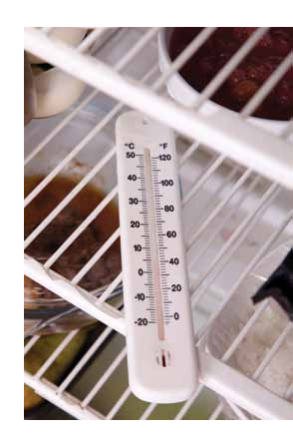• Thoroughly cook raw meat and poultry

• Wash raw vegetables and fruit thoroughly before eating

• Keep raw meat separate from vegetables, cooked foods and ready-to-eat foods
(eg do not allow the blood from meat to come into contact with other food)

• Use separate chopping boards for raw meat and foods that are ready to eat (ie cooked food)

RECIPESFORLIFE 55

56 RECIPESFORLIFE
Pantry Storage
Refrigerator Storage
Freezer Storage
Product
Time
Method
Product
Time
Method
Product
Time
Method
Canned food
12 months
Store in a cool, dry
cupboard
Poultry
3 - 5 days
Wrap and store
at the base of the
fridge as this is the
coldest part of the
refrigerator
Meat
6 months
Wrap in plastic
cling wrap or
store in a sealed
container
Dry pasta
2 years
Seal and store in a
cool, dry cupboard
Seafood (fresh)
2 - 3 days
Wrap and store
at the base of the
fridge as this is the
coldest part of the
refrigerator
Poultry
6 months
Wrap in plastic
cling wrap or
store in a sealed
container
Uncooked rice
2 years
Seal and store in a
cool, dry cupboard
Milk and cream
6 days
Keep sealed
Seafood
3 months
Wrap in plastic
cling wrap or
store in a sealed
container
Bread
5 days
Seal and store in a
cool, dry cupboard
to prevent bread
from drying out
Fruits and
vegetables
1 - 2 weeks
Store in the chiller
at the base of the
refrigerator
Fruits and
vegetables
6 months
Store fruits and
vegetables in
individual freezer
bags or sealed
containers
Cereal
6 - 12
months
Refold lining after
use and store in a
cool, dry cupboard
Bacon
1 week
Wrap loosely
Breads and
Cakes
6 months
Wrap in plastic
cling wrap or
store in a sealed
container
Flour
1 year
Seal and store in a
cool, dry cupboard
Cheese
2 months
Wrap or cover
tightly to prevent
drying
Ice-cream /
Ice-blocks
1 month
Store in provided
container
Sugar
2 years
Seal and store in a
cool, dry cupboard
Butter
2 months
Wrap or cover
tightly to prevent
drying
Fresh pasta
2 months
Store in provided
container
Herbs & Spices
6 months
Store in a cool, dry
cupboard
Eggs
2 weeks
Store in egg holder
in the refrigerator
Pastry
2 months
Wrap in plastic
cling wrap and
store in supplied
packaging
Note:
Keep pantry items stored away from direct
sunlight
Note:
Sliced meats should be used within a few days
after purchase
Always cover cooked and ready to eat foods to
prevent cross-contamination
Note:
Freeze meat, poultry and fish on the day of
purchase
Allow up to 24 hours to thaw meat, poultry or
seafood completely and always thaw in the fridge,
not on the bench
Never refreeze foods that have been defrosted or
partially thawed
Cooking Small, Eating Well, 2010, ‘Cooking Small, Eating Well - A Manual for Demonstration-Based Cooking - Motivating Adults to Eat Well’, Hawthorn Community Education Project Inc

Oral Health

. . . . . . . . . . . . . . . . . . . . . . . . . . . . . . . . . . . . . . . . . . . . . . . . . . . . . . . . . . . . . . . . . . . . . . . . . . . . . . . . . . . . . . . . . . . . . . . .

Oral health plays an important role in the health and well-being of older people and therefore quality of life. Dental decay and gum disease are common oral health problems and can result in difficulties chewing and swallowing. It is very important that you follow good oral hygiene practices to help prevent oral health problems. A healthy mouth will improve overall health and wellbeing.

Good oral hygiene practices require a team care approach of; oral health assessment, oral health care planning, daily oral hygiene practices and dental treatment. Good practices include:

• Visiting your dentist or oral health professional regularly to achieve and maintain good oral health

• Brushing morning and night

• Using high fluoride toothpaste

• Keeping your mouth moist

• Using antibacterial products (eg a mouthwash) after lunch

• Eating a healthy, balanced diet

• Avoid sweet food and drinks between meals.
Things to look out for and report to your dentist:

• Painful teeth, mouth or jaw

• Mouth sores lasting more than two weeks

• Red or white patches on the gums, tongue, or floor of the mouth lasting more than two weeks

• Bleeding gums

• Loose teeth

• Swelling

• Soreness or cracks in the corner of the mouth

• Difficulties chewing and swallowing.

Dentures are relatively common in older people and like natural teeth they must be looked after.

Denture care:

• Clean all denture surfaces using a denture brush

• Dentures should be removed at night, cleaned and stored in a container of cold water in a safe place. This allows the mouth to rest and prevents fungal infection

• Hardened pieces of plaque can be removed by soaking dentures overnight in one part white vinegar and two parts water

RECIPESFORLIFE 57

• Clean dentures over a hand-basin half filled with water to prevent breakage if dropped

• Your gums, tongue and palate also need to be cleaned with a toothbrush.

Department of Veterans Affairs (DVA) Dental Schedule

Veterans’ are able to claim dental hygienist services under the Department of Veterans Affairs (DVA) Dental Schedule. Phone
133 254 or 1800 555 254 or see the website below for more information

www.peacekeepers.asn.au/veterans/ Fact%20Sheets/HSV17%20Dental%20 Services.pdf

More information

www.ada.org.au

www.health.vic.gov.au/agedcare/ maintaining/oralhealth.htm

www.womenshealth.gov/publications/

our-publications/the-healthy-woman/oral_ health.pdf

58 RECIPESFORLIFE

Hydration & Bowel Health

. . . . . . . . . . . . . . . . . . . . . . . . . . . . . . . . . . . . . . . . . . . . . . . . . . . . . . . . . . . . . . . . . . . . . . . . . . . . . . . . . . . . . . . . . . . . . . . .

Thirst sensation decreases with ageing, increasing dehydration risk. If you only drink when you are thirsty it is likely you are not consuming enough fluid to remain hydrated. You should drink 6 to 8 glasses of fluid per day and even more in hot weather or when exercising.

Beverages that can be included in your fluid intake include:

• Water

• Milk

• Juice

• Cordial

• Soda or mineral water

• Soft drinks (excluding cola)

• Decaffeinated tea or coffee.

Fluids containing caffeine such as tea, coffee and cola as well as alcoholic beverages do not contribute towards your fluid intake as they have a diuretic effect which reduces hydration.

Hydration status can be determined by the colour of your urine. If your urine is clear you are hydrated. If your urine is a dark yellow colour you are dehydrated and you need to drink more fluids. Other common signs and symptoms of dehydration include: dry-mouth, thirst, dizziness, headache and fatigue.

Strategies to increase your fluid intake include:

• Drink fluids with meals and between meals
• Ensure fluids are readily available at all times – have a bottle or jug in the fridge or on the bench

• Eat foods with high water content (eg fruit, vegetables, yoghurt or soup)

• Keep a record of how many glasses of fluid you have consumed each day. You could use fridge magnets or a calendar to tally the number of glasses you have drunk

• Limit your intake of alcoholic and caffeinated beverages

• Drink a glass of fluid after every glass of alcohol or caffeinated tea, coffee or cola drink.

Dehydration is a common cause of constipation. Constipation can lead to bowel and bladder problems such as faecal and urinary incontinence and diverticular disease.

Strategies to help reduce constipation include:

• Drinking plenty of fluids

• Limiting your intake of alcoholic and caffeinated beverages

• Eating a high fibre diet which includes fruits, vegetables and wholegrains

• Being physically active.

If constipation persists seek advice from your doctor.

For further information regarding bowel health see your doctor or visit www.BladderBowel.gov.au

• Consume a soup with your meal
RECIPESFORLIFE 59

Alcohol: The Right Mix

. . . . . . . . . . . . . . . . . . . . . . . . . . . . . . . . . . . . . . . . . . . . . . . . . . . . . . . . . . . . . . . . . . . . . . . . . . . . . . . . . . . . . . . . . . . . . . . .

Alcohol Guidelines

Healthy men and women should:

• Drink no more than 2 standard drinks on any day

• Drink no more than 4 standard drinks on a single occasion

Drinking no more than 2 standard drinks on any day:

• Reduces the risk of heart disease, liver damage, high blood pressure and other health conditions

• Assists with weight loss

• Assists with avoiding falls and accidents.
Tips for low risk drinking:

• Drink low alcohol drinks

• Make every second drink non alcoholic

• Have 1 to 2 alcohol free days per week

• Refill your own glass

• Do other activities whilst drinking eg play pool, darts, bowls or cards

• Avoid shouts so you can drink at your own pace

• Drink out of a wine glass, but fill it with your favourite non-alcoholic beverage

• If you drink wine dilute it with spritzer or soda water

• Sample different mocktail recipes (see recipes in cookbook).

What is a standard drink?

BEER BEER BEER BEER BEER BEER

1.1 1.6 285ml 425ml
Full Strength Beer 4.8% Alc./Vol

0.8 1.2 285ml 425ml
Mid Strength Beer 3.5% Alc./Vol

0.6 0.9 285ml 425ml
Low Strength Beer 2.7% Alc./Vol
1.5 375ml
Full Strength Beer 4.8% Alc./Vol
1 375ml
Mid Strength Beer 3.5% Alc./Vol
0.8 375ml
Low Strength Beer 2.7% Alc./Vol

SPIRITS SPIRITS
SPIRITS
WINE

2.1 375ml
High Strength

Pre-mix Spirits 7% Alc./Vol

1.2 330ml
Full Strength

Ready to Drink 5% Alc./Vol
1 30ml
High Strength

Spirit Nip 40% Alc./Vol

22 700ml
High Strength

Bottle of Spirits 40% Alc./Vol

0.9 60ml

Standard Serve of Port 18% Alc./Vol

1.4 150ml Average
Restaurant Serve

of Champagne 12% Alc./Vol

1.4 170ml Average
Restaurant Serve

of White Wine 11.5% Alc./Vol

7.5 750ml Bottle
of White Wine 12.5% Alc./Vol

More information

Phone 133 254 or see the websites below for more information

The right mix: www.therightmix.gov.au (low risk drinking guide) www.dva.gov.au/service_providers/documents/manual_AS+BI.pdf (drink refusal skills)

60 RECIPESFORLIFE

Quit Smoking

. . . . . . . . . . . . . . . . . . . . . . . . . . . . . . . . . . . . . . . . . . . . . . . . . . . . . . . . . . . . . . . . . . . . . . . . . . . . . . . . . . . . . . . . . . . . . . . .

Quit smoking

Stopping smoking is the most important thing you can do for your health now and in the future;

• No matter how old you are

• Even if you are well

• Even if you have an illness.

Tips to help with quitting smoking:

• Delay acting on the urge to smoke. After five minutes the urge to smoke weakens and your desire to quit will come back

• Deep breaths. Take a long slow breath in and slowly release it out again, repeat three times

• Do something else to take your mind off smoking, such as exercise or gardening

• Include ‘fiddly’ snacks, see Healthy Snack Ideas page 49.

Avoiding Weight Gain

When you quit smoking weight gain can be a consequence. Firstly your appetite can increase, your likes and dislikes can change, your metabolism slows down and food can be used as a substitution to smoking.

To manage your weight when you quit smoking it is a good idea to:

• Avoid high fat and high sugar snacks

• If you normally smoke after a meal, get up and find something else to do, don’t sit and continue to eat

• Exercise, as it helps to burns energy, decreases appetite and the urge to smoke.

More information

www.quitnow.gov.au/internet/quitnow/ publishing.nsf

Quitline 131 848

Call for a free quit smoking pack and over the phone assistance.

RECIPESFORLIFE 61

Physical Activity

. . . . . . . . . . . . . . . . . . . . . . . . . . . . . . . . . . . . . . . . . . . . . . . . . . . . . . . . . . . . . . . . . . . . . . . . . . . . . . . . . . . . . . . . . . . . . . . .

Check with your doctor before participating in any physical activity.

It is recommended that you engage in 30 minutes of moderate intensity
physical activity on most, if not all days. Physical activity includes cardiovascular, strength and balance components which is important in maintaining a healthy lifestyle.

A moderate level of activity noticeably increases your heart and breathing rate. You may sweat, but you are still able to hold a conversation.

There are a number of ways that you could reach your 30 minute total, such as:

• Taking a half-hour brisk walk, bicycle ride, engaging in tai chi or water aerobics

• Taking three, 10-minute periods of activities; such as a brisk walk for 10 minutes, swimming for 10 minutes and climbing stairs for exercise for 10 minutes, all in the same day.

Health Benefits of physical activity:

• Builds stamina (keeping heart and lungs healthy)

• Maintains bone and muscle strength

• Assists with moving more easily (agility and flexibility)
Tips when commencing or starting physical activities:

• A form of physical activity should be part of life regardless of age, weight, health problems or abilities

• Include a range of physical activities that incorporate fitness, strength, balance and flexibility

• For those who have not been active for a while, or who are starting a new type of activity, begin at a level that is easily manageable and build gradually

• Those who have participated in vigorous physical activity should continue to do so in a manner that is suited to their capability

• Consider doing activities with a partner, friends, family members or neighbours

• If activities are outdoors, get up early to beat the heat in summer or late in winter when it is warmer

• Have a backup plan for indoor activity for when the weather conditions are less suitable outdoors

• Wear sun protection, comfortable clothing and supportive footwear

• Try varying activities like changing start time, place or the activity you do

• Reduces falls and falls injury risk (improve strength and balance)

• Improves concentration (keeps mind active).

62 RECIPESFORLIFE

. . . . . . . . . . . . . . . . . . . . . . . . . . . . . . . . . . . . . . . . . . . . . . . . . . . . . . . . . . . . . . . . . . . . . . . . . . . . . . . . . . . . . . . . . . . . . . . .

• If you experience discomfort or pain, seek advice from a health professional regarding management of the condition and possible exercise modification

• If you have any chronic conditions please consult your doctor or health professional about an appropriate activity program.

Suggested types of activities you could do:

Moderate - 30 minutes most days However, activities can be done in three lots of 10 minute intervals.

Choose low Glycaemic Index (GI) foods and recipes: Glycaemic Index
Glycaemic index or GI is a measure of how quickly carbohydrate foods are absorbed into the body and raise blood sugar levels. High GI foods are absorbed rapidly and make our blood sugar levels rise and fall quickly, providing energy for only a short period of time. Low GI foods are absorbed slowly making our blood sugar levels
rise and fall gradually providing energy for long time periods. Low GI foods are recommended for diabetics as these foods help to stabilise blood sugar levels.

Cycling, swimming, washing the car, walking the dog, gardening, water aerobics, dancing, mopping and vacuuming.

Strength - two or three times per week Weight or resistance training, climbing stairs instead of taking the lift or escalator.

Flexibility – try to do every day

Tai chi, lawn bowls, yoga, stretching exercises while watching TV (see Stretching and Balance Exercises page 64).

Balancing – try to do everyday Kettle exercises (see Kettle Exercises
page 66), Tai Chi, relevant group exercises.

RECIPESFORLIFE 63

Stretching & Balance Exercises

. . . . . . . . . . . . . . . . . . . . . . . . . . . . . . . . . . . . . . . . . . . . . . . . . . . . . . . . . . . . . . . . . . . . . . . . . . . . . . . . . . . . . . . . . . . . . . . .

You may need to see a health professional to supervise when first starting to provide advice about how to get the best results from these exercises.

Front leg and ankle stretch

Remove your shoes and sit on the edge of a chair. Lean back and stretch your legs out in front of you. Keep your heels on the floor and stretch your ankles so that your toes point towards the floor. If you don’t feel the stretch in your ankles, lift your heels off the floor. Hold this position for 10-20 seconds. Repeat 3-5 times.

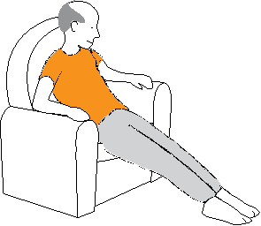Hamstring stretch

Sit on the lounge with your right leg up, toes pointing up as shown. Try to keep this leg straight. With a straight back, lean forward until you feel a gentle stretch in the back of your right leg. Hold this position for 10-20 seconds. Repeat
3-5 times, then turn around and do this stretch with your left leg.
Stand on one foot

Stand next to the kitchen bench or the back of a steady chair – hold on if you need to. Lift your right leg and stand for 10 seconds on your left leg. Repeat 5 times.
If you feel steady enough, do it without holding on. If you are very steady on your feet, try this with your eyes shut.

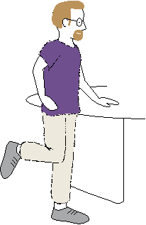Walk heel to toe

Stand next to a support (the kitchen bench will do) and step forward by putting the heel of one foot directly in front of the toes of the other foot, so that they touch (or almost touch). If you can do this easily without holding on, try it with your eyes shut. Have someone stand next to you to support you if you need help.

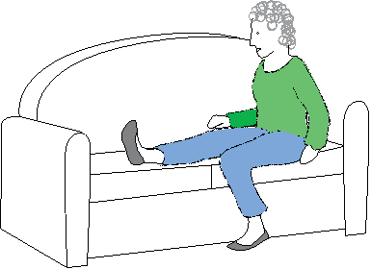64 RECIPESFORLIFE

. . . . . . . . . . . . . . . . . . . . . . . . . . . . . . . . . . . . . . . . . . . . . . . . . . . . . . . . . . . . . . . . . . . . . . . . . . . . . . . . . . . . . . . . . . . . . . . .

Stand up and sit down (or chair raise) (for strength and balance)

Sit on a chair with your feet flat on the floor and slightly apart. Try to keep your back and shoulders straight throughout this exercise. Slowly stand up, trying not to use your hands (or as little as possible).
Slowly sit back down and pause. Do this 8 – 15 times.

Shoulder roll (for flexibility)

Using a gentle circular motion, hunch your shoulders upwards, backwards, downwards and forwards. Do this slowly 5 times, then reverse the direction.
Knee lifts (for strength)

Sit back in your chair with your back straight. Bend your knee and lift your left leg towards your chest. Hold for a few seconds then lower slowly. Do this 8 – 10 times with each leg.

Heels up toes up (for flexibility)

Start with feet flat on the floor and lift heels as high as you can, keeping the balls of your feet on the floor. Slowly lower heels until feet are flat, then lift toes until they point upwards. Repeat these up and down movements for 30 seconds.

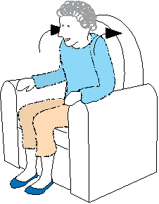RECIPESFORLIFE 65

Kettle Exercises

. . . . . . . . . . . . . . . . . . . . . . . . . . . . . . . . . . . . . . . . . . . . . . . . . . . . . . . . . . . . . . . . . . . . . . . . . . . . . . . . . . . . . . . . . . . . . . . .

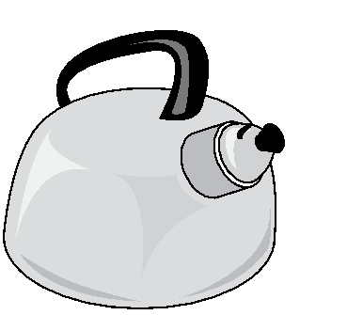We have called the exercises on this page “kettle exercises” because they can be done while you are waiting for the kettle to boil or even while talking on the telephone. All you need is a stable piece of furniture about the height of a kitchen bench to hold on to. Don’t hold your breath when you do these exercises.

Side leg raises (improves both strength and balance)

Stand sideways to the bench and hold on with your right hand to support yourself. Slowly take your left leg out to your
left side. Keep your back and both legs straight. Hold the position for one second then slowly lower. Repeat 8 times at first, increasing to 15. Turn around and hold on with your left hand while you raise your right leg.

Half squats (improves leg strength)

Stand facing the bench with your feet apart (about shoulder width), feet facing forward and holding onto the bench with both hands. Leaning very slightly forward, but keeping your back straight, slowly bend both legs, keeping your knees over your feet (the action is like you are going to sit on a chair). Do not have your buttocks lower than your knees. As you return to the up position, squeeze your buttocks together as if there is a $5 note between them that you don’t want to drop. Repeat 8 times at first, increasing to 15.

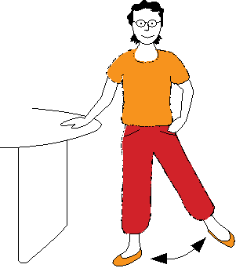66 RECIPESFORLIFE

. . . . . . . . . . . . . . . . . . . . . . . . . . . . . . . . . . . . . . . . . . . . . . . . . . . . . . . . . . . . . . . . . . . . . . . . . . . . . . . . . . . . . . . . . . . . . . . .

Heel raises (for strength and balance)

Stand sideways to the bench, feet apart (shoulder width) holding on with one hand to support yourself. Slowly rise up on to your toes, hold for one second and lower again. Do this 8 times at first, increasing
to 15. Make sure your movements are not rushed.

As you progress, try these exercises holding on with one fingertip, then not holding at all.

If this is easy for you, try it with no hands and with your eyes closed.

RECIPESFORLIFE 67

Social Activity

. . . . . . . . . . . . . . . . . . . . . . . . . . . . . . . . . . . . . . . . . . . . . . . . . . . . . . . . . . . . . . . . . . . . . . . . . . . . . . . . . . . . . . . . . . . . . . . .

Stay involved in social activities

Socialising is important for keeping healthy, happy and well. Look for opportunities to get involved in social activities or work with others to plan them.

What you can do:

• Invite family or friends to your home for a meal or to the park for a picnic (eg ask each person to bring a plate of food to share)

• Ask a friend to join you on an outing or to run daily errands

• Learn a new skill or hobby

• Join a special interest or hobby group eg craft, gardening, sporting, walking or bird watching

• Ask someone you know to exercise with you

• Take the dog for a walk (see below for POOPs information for caring for animals)

• Contact your local council or a volunteer’s organisation and offer to help others
Pets of Older Persons (POOPs)

Pets are therapeutic for people of all ages. The Pets of Older Persons program was established by the RSPCA to care for the pets of people aged over 65 years and palliative care patients in the community. The services they provide including:

• Regular monitoring of pets

• Support in caring for pets

• Veterinary treatment when needed

• Monthly home visits for grooming and flea control

• Temporary foster or boarding accommodation if needed

• Dog walking.

Contact details

02 9782 4408

poops@rspcansw.org.au

www.rspcansw.org.au/programs/pets_of_ older_persons_poops

• Contact your local Ex-Service organisation to see if they have a day club

• Contact an Ex-Service organisation’s Welfare Officer.

68 RECIPESFORLIFE

. . . . . . . . . . . . . . . . . . . . . . . . . . . . . . . . . . . . . . . . . . . . . . . . . . . . . . . . . . . . . . . . . . . . . . . . . . . . . . . . . . . . . . . . . . . . . . . .

More information

Veterans’ Access Network (VAN) directory General Enquiries Telephone 133 254 Regional callers 1800 555 254

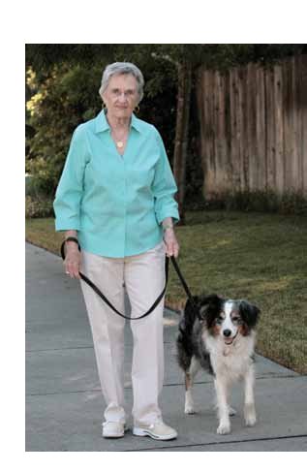Department of Veterans’ Affairs www.dva.gov.au/health_and_wellbeing/ activities/Pages/index.aspx

For eligible veterans, Coordinated Veterans Care can organise involvement in group activities, assistance in the home and help with transport

www.dva.gov.au/health_and_wellbeing/ health_programs/cvc/Pages/default.aspx

Men’s Sheds

Men’s sheds provide places for men to get together

www.mensshed.org

Phone 1300 550 009

Touchbase

The Touchbase website is an information portal where you and your family can access information and links to resources on a wide range of topics, from jobs, sports clubs and hobbies through to fitness, wellbeing and counselling.

http://touchbase.gov.au

RECIPESFORLIFE 69

Mental Health

. . . . . . . . . . . . . . . . . . . . . . . . . . . . . . . . . . . . . . . . . . . . . . . . . . . . . . . . . . . . . . . . . . . . . . . . . . . . . . . . . . . . . . . . . . . . . . . .

Stay healthy and happy

• Eat well - Food is one of life’s great pleasures and can play a vital role in maintaining good physical and mental health. Good nutrition can provide an overall sense of wellbeing and help you stay strong and active.

• Limit alcohol - Alcohol can have a brief mood-lifting effect, but any short-term relief doesn’t last. Risky levels of drinking can impact on both physical and mental health, so it is important to work out what is a safe level of drinking for you and stick to it.

• Get some exercise – physical activity can help lift your mood, increase energy levels and even help you get a better night’s sleep.

Treat yourself well

• Cook yourself a nice meal

• Call a friend to share it with you.

Think nice thoughts

• Remember happy times

• Daydream and imagine yourself somewhere wonderful.

Manage negative thoughts

• Share thoughts and feelings
Get out and about

• Join a group, exercise class, course (eg University of the Third Age) or participate in Men’s Shed

• Go to a movie or visit your local library, art gallery or museum

• Take a train ride with a friend

• Shop for ingredients for a recipe you haven’t cooked before

• Take a dog for a walk.

Make plans and set goals –

small things you can achieve and enjoy, like...

• Learning a new recipe

• Reading a book

• Creating your own herb or vegetable garden

• Going for a walk every day.

Seek help if you are down or worried

• From your doctor, church or beyondblue

• Your doctor can arrange for you to see a counsellor under Medicare.

• Don’t let negative thoughts take over. Recognise unhelpful thoughts eg ‘things will never get better’ and challenge them with more helpful ways of thinking
eg ‘things will be better tomorrow’.

70 RECIPESFORLIFE

. . . . . . . . . . . . . . . . . . . . . . . . . . . . . . . . . . . . . . . . . . . . . . . . . . . . . . . . . . . . . . . . . . . . . . . . . . . . . . . . . . . . . . . . . . . . . . . .

More information

Department of Veterans’ Affairs http://at-ease.dva.gov.au/www/html/60-understanding-mental-health.asp

Black Dog Institute www.blackdoginstitute.org.au

Beyondblue

For information on depression, anxiety and related disorders, available treatments and where to get help.
See the website www.beyondblue.org.au or phone 1300 22 4636.

beyondblue has a range of publications available to download or order free of charge, including:
• OBE (Over Bl**dy Eighty)… Our Stories booklet - A marvellous collection of personal stories that celebrates the lives and experiences of older Australians and their wellbeing

• Older People and Depression booklet – Information about depression in older people, including tips for staying active.

Omega-3 and Mood

Omega-3 fats are polyunsaturated fats (good fats). Our bodies do not make omega-3 fats so we have to get these fats through food. Eating adequate amounts of omega-3 can make you feel happier and reduce your risk of mood disorders such as depression. Examples of foods containing omega-3 fats include:

• Oily fish such as salmon, trout, tuna, swordfish, anchovies, sardines, mackerel and herring

• Nuts and seeds including walnuts and flaxseeds

• Oils including flaxseed, canola, soybean, hemp and walnut oils

• Omega-3 enriched foods including milk, eggs, bread and margarine.

• beyondblue and Council on the Ageing (COTA) provide free talks tailored
to Veterans’ groups on the topic of depression and anxiety, including what you can do to enjoy better health.
For further information, or to book a session, contact COTA in your State or Territory, at www.cota.org.au or phone 08 8232 0422.

RECIPESFORLIFE 71

Active Brain

. . . . . . . . . . . . . . . . . . . . . . . . . . . . . . . . . . . . . . . . . . . . . . . . . . . . . . . . . . . . . . . . . . . . . . . . . . . . . . . . . . . . . . . . . . . . . . . .

Keeping our brains healthy is important for living a fulfilling, healthy and long life.

Keeping mentally, socially and physically active is important at any age. For optimum brain health, you should eat healthy foods, maintain healthy blood pressure, cholesterol, blood sugar, weight, not smoke and drink alcohol in moderation.

Some tips for keeping your brain active:

• Learn a new recipe

• Read

• Write letters, stories, poetry, or keep a diary

• Take up a hobby

• Go to theatre, visit a gallery or museum

• Play board games or cards

• Do jigsaw, crossword, word or number puzzles

• Enrol in a course or learn something new

• Build a model

• Get involved in a club or local community group

• Learn about a new topic.
Food tips for a healthy brain:

• Eat a variety of foods from different food groups.

• Choose vegetables, fruits, legumes, nuts, wholegrain breads and cereals, including pasta and rice

• Choose fish, lean meats, eggs, reduced-fat dairy and soy foods

• Choose monounsaturated and polyunsaturated oils such as canola, olive, sunflower, soybean, safflower and flaxseed and margarine spreads made from these types of oils

• Limit foods high in saturated fat such as butter, deep fried foods, processed deli meats, pastries, cakes and biscuits

• Add colour to your meals by aiming for five serves of different coloured vegetables each day

• Eat fruit every day

• Include legumes in a couple of meals each week

• Plain frozen or canned vegetables and fruits are nutritious and save on preparation time

• Choose wholemeal or wholegrain breads and cereals as they contain more fibre and taste great too

72 RECIPESFORLIFE

. . . . . . . . . . . . . . . . . . . . . . . . . . . . . . . . . . . . . . . . . . . . . . . . . . . . . . . . . . . . . . . . . . . . . . . . . . . . . . . . . . . . . . . . . . . . . . . .

• Use reduced-fat milk or reduced-fat yoghurt

• Replace butter with margarine spreads or oils, such as canola, olive, sunflower or safflower

• Choose canned, frozen or fresh fish including tuna, salmon, sardines, mackerel, herring or trout. Limit your intake of deep-fried fish

• Choose lean cuts of meat or remove the fat yourself before cooking

• Drink plenty of water – it’s convenient, cheap and a great thirst-quencher.

More information

Mind your mind – Alzheimer’s Australia’s dementia risk reduction program

Phone 1800 100 500

http://mindyourmind.org.au/

RECIPESFORLIFE 73

Driving For Older People

. . . . . . . . . . . . . . . . . . . . . . . . . . . . . . . . . . . . . . . . . . . . . . . . . . . . . . . . . . . . . . . . . . . . . . . . . . . . . . . . . . . . . . . . . . . . . . . .

One of the most important roles of the Roads and Maritime Services (RMS) (previously Roads and Traffic Authority (RTA)) is to ensure that the NSW roads are as safe as possible. Part of that role is to ensure drivers and riders undergo annual medical and driving tests upon reaching a certain age. For all licence holders, annual medical reviews are required from 75 years of age. This is to ensure that older drivers are medically fit and are able to drive competently and safely.

Health conditions likely to affect driving include:

• Blackouts

• Cardiovascular conditions

• Diabetes

• Hearing problems

• Musculoskeletal conditions

• Neurological conditions, including dementia, seizures and epilepsy, vestibular disorders and other neurological conditions

• Psychiatric conditions

• Sleep disorders

• Substance misuse

• Vision and eye disorders.
A number of licence options exist for car drivers and motorcycle riders from the age of 85. Older drivers and riders can undertake an assessment every two years from the age of 85 (ie 85, 87, 89, 91 etc) to hold an unrestricted licence, or can opt to have a modified licence at any stage.

Heavy vehicle drivers in licence classes LR, MR, HR and HC will need to undertake annual medical and driving assessments from 80 years of age.

If you believe that your driving skills have deteriorated, or someone you know has deteriorating skills, there are options for you to consider. Ideally most drivers will recognise when it is appropriate to retire from driving or seek a modified licence.

Licence options

If an individual has competent driving skills but is no longer up to driving in more challenging situations (eg over long distances, in heavy traffic or at night) RMS can issue a modified licence which still allows them to continue driving under some circumstances.

Some individuals may have a licence
that they no longer need, such as a heavy vehicle or motorbike licence. Older drivers can change to a regular Class C (car) licence at no cost by simply advising the nearest motor registry.

74 RECIPESFORLIFE

. . . . . . . . . . . . . . . . . . . . . . . . . . . . . . . . . . . . . . . . . . . . . . . . . . . . . . . . . . . . . . . . . . . . . . . . . . . . . . . . . . . . . . . . . . . . . . . .

If an individual no longer wants to drive, they can return their licence to a motor registry in person or by mail. If they send their licence by mail they will need to prepare a short note advising RMS of their decision. If an individual no longer wants to drive but wants to retain a card for identification, they can exchange their licence for a NSW Photo Card at no fee.

Alternative transport

If an individual’s driving skills have deteriorated, public transport is a safe option.

Details on government bus, train and ferry services are available by calling
131 500. Check with your local council, senior citizens clubs and community groups for local transport options and services.

If an individual is unsure about their driving ability, they can seek advice from a driving instructor that is an Accredited Older Driver Assessor. Accredited Older Driver Assessors can teach, assess and advise students on their driving ability. The Roads and Maritime website lists all Accredited Older Driver Assessors.

For more information visit:

www.rta.nsw.gov.au/index.html

www.austroads.com.au

or phone:

132 213 (general enquiries)

132 701 (24hr traffic enquiry line)

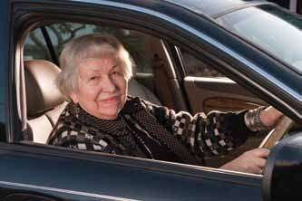Relatives or friends may also be in a position to provide transport.

Informing Roads and Maritime Services

Some individuals decide when to stop driving, others will be guided by the advice of family and friends. However, in some cases, the best alternative may be to inform RMS if you are concerned that someone is no longer driving safely. You
should speak to the person before deciding to contact a motor registry.

RECIPESFORLIFE 75

Vaccinations

. . . . . . . . . . . . . . . . . . . . . . . . . . . . . . . . . . . . . . . . . . . . . . . . . . . . . . . . . . . . . . . . . . . . . . . . . . . . . . . . . . . . . . . . . . . . . . . .

Keep your vaccinations up to date

Government funded vaccinations:

• Influenza vaccine is funded for everyone 65 years and over, Aboriginal and Torres Strait Islander people over 15 years of age and any adult with a chronic medical condition. It is recommended that you have this vaccine annually.

• Pneumococcal vaccine (23vPPV) a single dose is funded for everyone over 65 years of age and Aboriginal and Torres Strait Islander people over 50 years of age.

Recommended but not government-funded vaccinations:

• Diphtheria-tetanus-pertussis adult vaccine a single dose should be given after 50 years of age. This is particularly important for new grandparents caring
Why should older people keep their vaccinations up to date?

• Some vaccinations don’t last for a lifetime and need to be kept up to date

• As we get older our immunity can decline and we become more vulnerable to infections

• Conditions such as heart disease, lung disease and diabetes can increase the risk of infections

• Vaccination is the most effective way of providing protection against infectious disease and stopping the spread of infections.

Note: If you have any allergy, especially to eggs please let your doctor know before receiving any vaccination.

For more information see your doctor or visit:

for young babies. www.ncirs.edu.au or phone 02 9845 1433

• International travellers should seek travel health advice for relevant vaccines.

www.immunise.health.org.au/ or phone 1800 671 811

76 RECIPESFORLIFE
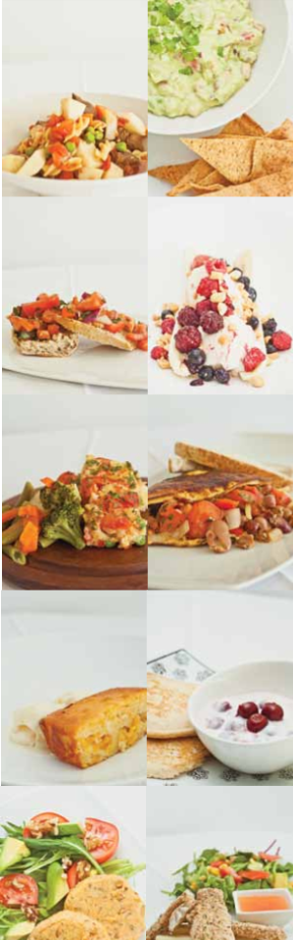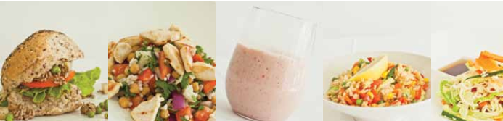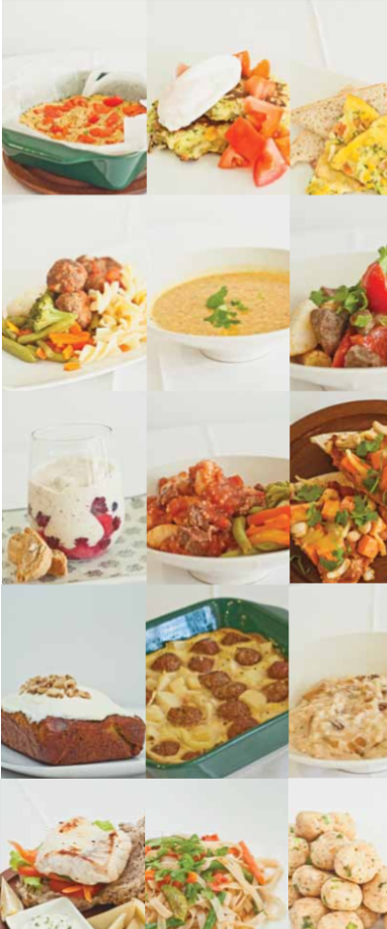

Cooking for 1 or 2 is a basic cooking skills program for ageing well. The Cooking for 1 or 2 program is designed to increase participant’s confidence in preparing a variety of healthy meals using simple cooking methods.

This program also provides participants with information on healthy ageing through presentations focusing on: basic cooking skills, safe food handling, healthy eating, physical activity, and healthy and economical ways of spending food dollars.

For more information visit the Cooking for 1 or 2 website: www.cookingfor1or2.org
Happy & Healthy Living!

