*Commonwealth War Graves Commission*



**Kranji War Cemetery and the Singapore Memorials**

**Prelude to War in the Far East**

t had long been recognised that the defence of British and Allied territories in South East Asia depended heavily on preserving peace with Japan, but when war broke out in Europe in September 1939,

I

Japan had herself been at war with China for two years, and, further preoccupied with the possibility of a Russian invasion, she was thought to pose little immediate threat. Commonwealth forces were soon heavily committed elsewhere, and lulled into a sense of complacent security by

the Japanese situation, the Malay peninsula was left poorly defended.

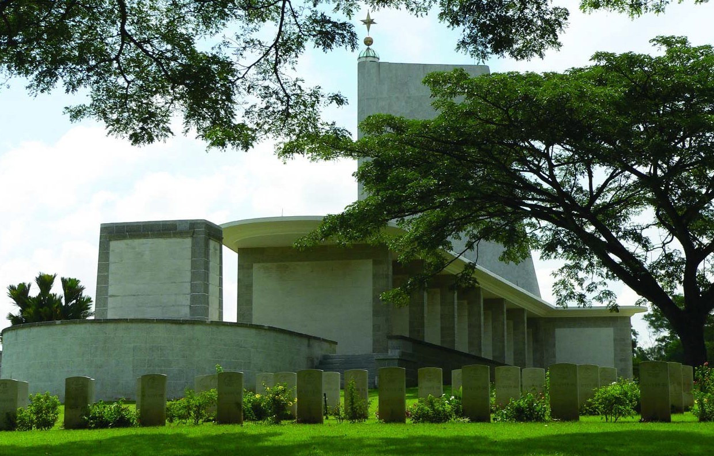

The Japanese, however, were anxious to gain control of the area's rich natural resources for their war effort in China, a need made more urgent by crippling trade sanctions applied to them in the Far East by Britain, the Netherlands and the United States. When the Germans invaded Russia in June 1941, the threat to Japan from that quarter was removed allowing

them greater freedom of action. Even so, they felt unable to support a prolonged campaign against the United States and her Commonwealth allies, and recognised the need for speed, intensity and surprise in their strike.

*The inscription wall*

The Japanese prepared carefully, and on the night of

7/8 December 1941, they attacked Pearl Harbour,

destroying the US Pacific Fleet upon which the defence of the area so heavily relied. Simultaneously, they launched attacks on Hong Kong, the Philippines, Thailand and north- east Malaya. With overwhelming superiority in the air and disciplined veterans from the war in China specially trained in jungle warfare on the ground, the Japanese went on to overrun much of the Far East in a matter of months.

**The Fall of Singapore**

On 8 December 1941, the Japanese landed troops at Khota Bharu, in the extreme north-east of Malaya near the Thai border. The defending Commonwealth forces were heavily disadvantaged from the outset and although they resisted fiercely, the Japanese pressed steadily down the peninsula. By the end of January 1942, the exhausted remnants of the Allied force had withdrawn across the Straits of Johore to Singapore island, where they joined a civilian population heavily swollen by refugees and harassed by heavy and frequent air raids.

Singapore was reputed to be an 'island fortress', the 'Gibraltar of the east', but the reality was somewhat different. The island's defences were concentrated on the naval base at Changi and were designed to protect that base and harbour from attacks from the sea. There were no landward defences and the whole of the northern shore was vulnerable. This

was where the Japanese landed on 8 February.

By now, the Japanese were themselves in severe difficulties with supplies and were significantly outnumbered by the defending force; for days, Commonwealth reinforcements - most of them raw and untried - had been pouring into Singapore, where local defence units had also been mobilised. Nevertheless, by a combination of bluff and supreme confidence bred of the speed of their early success, the Japanese succeeded in forcing a withdrawal to the city itself, where the surrender was taken on 15 February.

Thousands of men and women of the Commonwealth forces were killed during the fierce fighting, much of it hand to hand, in Malaya and Singapore, but many more died as prisoners under the Japanese occupation, which for the most part continued until September 1945.

**Kranji War Cemetery**

(4,500 Commonwealth burials)

Before 1939, Kranji was a military camp and at the time of the Japanese invasion it was the site of a large ammunition magazine. After the fall of the island the

Japanese established a prisoner of war camp at

Kranji and eventually a hospital was organised nearby at Woodlands.

After the war, the small cemetery started by the prisoners at Kranji was developed into a permanent war cemetery by the Army Graves Service when it became evident that a larger cemetery at Changi could not remain undisturbed. Changi had been the site of the main prisoner of war camp in Singapore and a large hospital had been set up there by the Australian Infantry Force. In 1946 the graves were moved from Changi to Kranji, as were those from the Buona Vista prisoner of war camp and many others from all parts of the island. Later,

Second World War burials from Saigon Military Cemetery in French Indo- China (now Vietnam) and graves of both world wars from Bidadari Christian Cemetery, Singapore,

were also brought to Kranji.

The **Chinese Memorial** in Plot 44 marks a collective grave for 69 Chinese servicemen, all members of the Commonwealth forces who were killed during the occupation in February 1942.

**Singapore Memorial**

The memorial, which stands within Kranji War Cemetery, bears the names of over 24,000 casualties of the Commonwealth land and air forces who died during the Second World War and have no known grave. Those of the land forces died during the campaigns in Malaya and Indonesia or in subsequent captivity, many of them during the construction of

the Burma-Thailand railway, or at sea while being transported into captivity elsewhere. The airmen died during operations over the whole of

southern and eastern Asia and in the surrounding seas and oceans.

The **Singapore Cremation Memorial** (immediately behind the main memorial) commemorates almost

800 dead, mostly of the Indian forces, whose remains were cremated in accordance with their religious beliefs. The **Singapore (Unmaintainable Graves) Memorial**, at the western end of the main memorial,

bears the names of a further 250 casualties of the campaigns in Singapore and

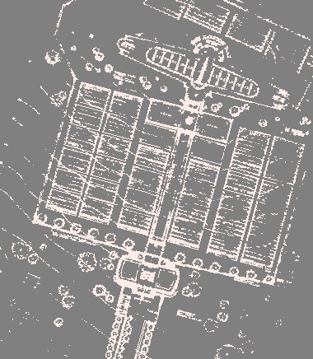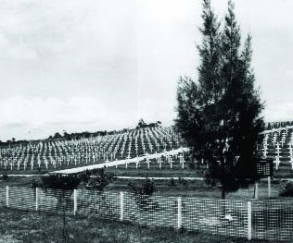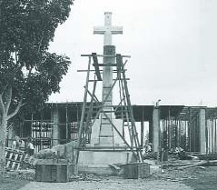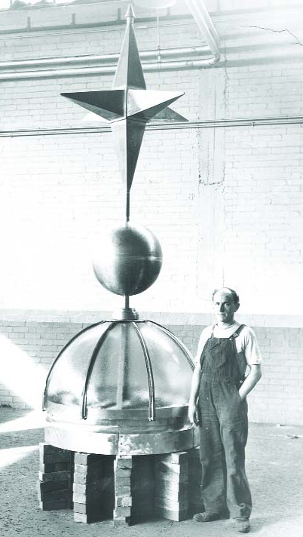

*top: Kranji War Cemetery in 1949*

*centre: Construction of the Cross of Sacrifice in 1956*

*below: Glass dome and bronze finial that caps the Memorial*

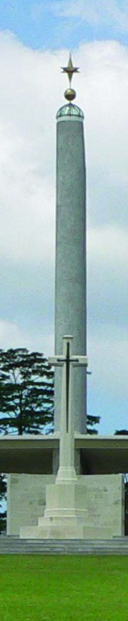

Malaya whose known graves in civil cemeteries could not be maintained and, on religious grounds, could not be moved to a war cemetery.

During the last hours of the Battle of Singapore, wounded civilians and servicemen taken prisoner by the Japanese were brought to the civil hospital in their hundreds, and more than 400 who died there were buried in an emergency water tank dug in the hospital grounds before the war. After the war it was decided that as individual identification of the dead would be

impossible, the grave should be left undisturbed and following consecration by the Bishop of Singapore a cross in memory of all those buried there was raised over it by the military authorities. The 107 Commonwealth servicemen

buried in the grave are commemorated on the **Singapore Civil Hospital**

**Grave Memorial** which stands at the eastern end of the main memorial.

Kranji War Cemetery and the Singapore Memorials were designed by Colin St Clair Oakes. Adjoining Kranji War Cemetery is Kranji Military Cemetery, a substantial non-world war cemetery of almost 1,500 burials created in 1975.

*Kranji War Cemetery, known locally as the Kranji Memorial, is 22 kilometres north of the city of Singapore, on the north side of Singapore Island overlooking the*

*Straits of Johore. It is just off the Singapore-Johore (Woodlands) road at the milestone 13½. There is a short approach road from the main road. There are bus stops on the main road facing the cemetery and a MRT terminal will be found a short distance away. Visitors arriving by taxi should be sure that their driver is confident of the cemetery's location.The cemetery is constructed on a hill accessed by three flights of steps, rising over four metres from the road level.*

**The Commonwealth War Graves Commission**

The Commonwealth War Graves Commission is responsible for marking and maintaining the graves of those members of the Commonwealth forces who died during the two world wars, for building and maintaining memorials to the dead whose graves are unknown and for providing records and registers of these burials and commemorations, totalling 1.7 million and found in most countries throughout the world.

Enquiries on location of individual burials or commemorations may be directed to the offices below or through the Commission's Internet site, the Debt of Honour Register at **www.cwgc.org** - a search by surname database detailing the place of burial or commemoration for any of the individuals commemorated by the Commission.

**For further information contact:**

Commonwealth War Graves Commission

2 Marlow Road Maidenhead Berkshire, SL6 7DX United Kingdom

Tel: +44 (0) 1628 507200

Fax: +44 (0) 1628 771208

Email: casualty.enq@cwgc.org