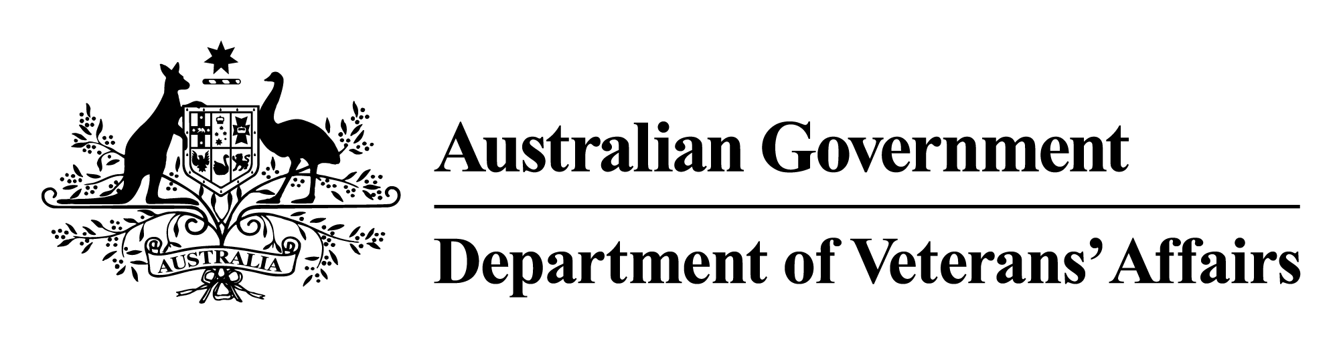

Vietnam Veterans Family Study

VOLUME 1

Introduction and Summary of the Studies of Vietnam Veteran Families

October 2014

© Commonwealth of Australia 2014

This work is copyright. Apart from any use as permitted under the *Copyright Act 1968*, no part may be reproduced by any process without prior written permission from the Commonwealth. Requests and inquiries concerning reproduction and rights should be addressed to the publications section, Department of Veterans’ Affairs or emailed to [publications@dva.gov.au](mailto:publications@dva.gov.au).

Published by the Department of Veterans’ Affairs, Canberra, 2014. Publication no. P02092

ISBN 978-0-9941961-0-1 (Volume 1)  
 978-0-9941961-1-8 (Volume 2)  
 978-0-9941961-2-5 (Volume 3)  
 978-0-9941961-3-2 (Volume 4)  
 978-0-9941961-4-9 (full set)  
 978-0-9941961-5-6 (electronic version)

**Suggested citation**

Commonwealth of Australia 2014, *Vietnam Veterans Health Study*. Volume 1, *Introduction and Summary of the Studies of Vietnam Veterans Families*, Department of Veterans’ Affairs, Canberra.

Copies of this report can be found on the DVA website: [www.dva.gov.au](http://www.dva.gov.au/)

Special note

It is important to remember that this study represents a snapshot of a specific period in the lives of participants, whose health and welfare might well have changed since the time of their involvement. Regrettably, it is not possible to take account of any changed circumstances in the report.

Foreword

The Vietnam Veterans Family Study, a ground-breaking intergenerational health study, was established in order to gain a better understanding of the effects of Vietnam War service on the physical, mental and social health of the family members of Australian Vietnam veterans. The research will help to guide future policy and initiatives aimed at supporting current and former military personnel and their families.

In 2006 the Australian Government released a report entitled *The Feasibility of a Study into the Health of Children of Vietnam Veterans*. The feasibility study had involved ‘determining the research questions and methodology, assessing available study designs, and identifying external factors that may impact on the validity and reliability of a study into the health of children of Vietnam veterans’. The report concluded that such a study was viable, and it provided the foundation for this Vietnam Veterans Family Study.

In response to the results of the feasibility study the then Centre for Military and Veterans’ Health (now the Centre for Australian Military and Veterans’ Health) was appointed to develop a Research Protocol for the Vietnam Veterans Family Study. The protocol took into account a broad range of health outcomes and allowed for a ‘tiered’ research approach, with independent reports for each tier. It anticipated that differing independent research institutions would carry out different elements of the research, according to their specific expertise and capability.

In September 2007 the Department of Veterans’ Affairs advertised for expressions of interest to form a panel of research organisations. It subsequently evaluated each of the research organisations that had applied on the grounds of relevant skills, experience and understanding of the research methodology. The successful research organisations became members of the Research Panel, and panel members then tendered to take up individual components of the study, resulting in multi-volume reporting.

Acknowledgments

The Department of Veterans’ Affairs expresses its heartfelt thanks to all who took the time to participate in this landmark study. This study is dedicated to them.

The department also thanks the following groups and individuals:

* members of the independent Scientific Advisory Committee, for their guidance and expert scientific and research advice:
  + Professor Bryan Rodgers, Chair—Australian National University
  + Dr Paul Jelfs—Australian Bureau of Statistics
  + Professor Ilan Katz—University of New South Wales
  + Professor Michael Sawyer—University of Adelaide
  + Dr Lyndall Strazdins—Australian National University
  + Professor Elizabeth Waters—University of Melbourne
* members of the Vietnam Veterans Family Study Consultative Forum, for their valuable contribution:
  + Major General Mark A Kelly AO, DSC, Chair—Commissioner, Repatriation Commission and Military Rehabilitation and Compensation Commission
  + Brigadier Bill Rolfe AO (Ret’d), former Chair—former Commissioner, Repatriation Commission and Military Rehabilitation and Compensation Commission
  + Dr Roderick Bain—Returned and Services League of Australia and Australian Veterans and Defence Services Council
  + Mrs Pat Cleggett—Partners of Veterans Association of Australia
  + Dr David Cockram—Vietnam Veterans Association of Australia
  + Mr Paul Copeland OAM, JP—Australian Peacekeepers and Peacemakers Association and son of a Vietnam veteran
  + Reverend Graeme Davis CSM—Vietnam Veterans Federation of Australia
  + Commodore Mike Dowsett, AM (Ret’d)—Defence Force Welfare Association
  + Mrs Tiffany Naughton—daughter of a Vietnam veteran
  + Dr Ken O’Brien—Vietnam Veterans Association of Australia and son of a Vietnam veteran
  + Mr Geoff Parker—Children of Vietnam Veterans Health Study Inc.
  + Mrs Sue Parker—Partners of Veterans Association of Australia
  + Mr David Penson CSM—Australian Peacekeepers and Peacemakers Association
  + Mrs Janice Properjohn—Vietnam Veterans Association of Australia
  + Mr John Vincent OAM—The Australian Federation of Totally and Permanently Incapacitated Ex Servicemen and Women Ltd
  + Mr William Wallace—Children of Vietnam Veterans Health Study Inc.
* the Minister for Veterans’ Affairs, Senator the Hon. Michael Ronaldson, and preceding Ministers the Hon. Warren Snowdon MP, the Hon. Alan Griffin MP and the Hon. Bruce Billson MP
* the Repatriation Commission and Military Rehabilitation and Compensation Commission
* the following departmental advisers, for their assistance with this project
  + Dr Graeme Killer, AO—Principal Medical Adviser
  + Dr Eileen Wilson, BA, MSc, PhD—former departmental epidemiologist and research adviser
* the researchers.

In particular, the department records its sincere thanks to Professor Bryan Rodgers, Independent Scientific Adviser and Chair of the Scientific Advisory Committee, for his enormous contribution to the study overall. His input during the study was invaluable. This research will be a valuable resource for future efforts to understand more about the intergenerational impact of operational military service.

Contents

Foreword iii

Acknowledgments iv

Australia’s involvement in the Vietnam War xi

Part One Report summary 1

1 Outline 3

1.1 The research objective 3

1.2 The Vietnam War 3

1.3 Why does all this matter now? 4

2 The conduct of the study 5

3 The sons and daughters of Vietnam veterans and Vietnam-era personnel: differences in their health 9

3.1 The differing kinds of health problems 9

3.2 The size of the differences 10

4 The Mortality Study 13

4.1 Suicide 15

5 Factors connecting fathers’ experience of the Vietnam War to their sons’ and daughters’ health many years later 19

6 Experiences of Vietnam veterans’ families 25

6.1 Going to war 25

6.2 Separation from family 26

6.3 Welcome back 26

6.4 Family life after the war 27

6.5 Parenting 28

6.6 Family cohesion 28

6.7 Help for Vietnam veterans and their families 29

6.8 Acceptance 31

7 Answering the research question 33

Part Two Background to the Study 35

8 Purpose of the study 37

9 Structure of the report 39

10 Previous research into Vietnam veterans 41

10.1 Department of Veterans’ Affairs studies of the health of Australian Vietnam veterans 41

10.2 Other Australian studies of Vietnam veterans 45

11 The Vietnam Veterans Family Study: history and approach 47

11.1 The feasibility of a study of the health of the children of Vietnam veterans 48

11.2 The Research Protocol 49

11.3 Study design 49

11.4 Study participants 51

11.5 Governance and contributors 56

12 Research components of the study 59

13 Study time frame 63

14 Conclusion 65

Appendix A Members of the Research Panel 67

Appendix B Invitations to register for the study 69

Appendix C Study participants: a summary 73

Appendix D Consultative Forum and Scientific Advisory Committee membership 75

Shortened forms 77

Glossary 79

References 83

Tables

Table 11.1 Number of randomly selected study participants, by response 54

Table 11.2 Randomly selected study participants: registration and response rates 54

Table 11.3 Self-select study participants: registration and response rates 55

Table 12.1 Research components of the Vietnam Veterans Family Study, by volume 60

Table C.1 Study participants, by participant type, 2 February 2012 73

Figures

Figure 11.1 Registered participants and respondents: randomly selected and self-select groups 55

Australia’s involvement in the Vietnam War

In May 1962 the Australian Government announced its intention to send military advisors to Vietnam. The arrival of the first members of the Australian Army Training Team Vietnam in August 1962 marked the beginning of the Australian Army’s commitment to the Vietnam War. The Royal Australian Navy’s first wartime visit to South Vietnam occurred in 1963, when HMA Ships *Quiberon* and *Queenborough* were dispatched to Saigon on a diplomatic visit. The Royal Australian Air Force’s first operational mission of the war took place in May 1963, when a Dakota transport aircraft of C Flight, No. 2 Squadron, based at Butterworth in Malaysia, carried out a series of relief flights to aid Montagnard refugees. The creation and deployment of the RAAF Transport Flight Vietnam followed in 1964.

In 1965 the Australian Government expanded the nation’s involvement in Vietnam. The Australian Army dispatched the 1st Battalion, Royal Australian Regiment (1RAR), and supporting units to serve with US forces in Bien Hoa in South Vietnam. HMAS *Sydney* transported the bulk of the ground forces, and the voyage that carried 1RAR to Vietnam in May 1965 was the first of *Sydney*’s 25 voyages into the area of operations.

In May 1965 the Australian Government also introduced amendments to the National Service Act to make National Servicemen liable for overseas service, this being the fourth time National Service provisions had been used since Federation. Before 1965 only regular military personnel had been involved in the war in Vietnam, but the Menzies Government wanted to increase Army numbers to almost 40,000 in order to meet overseas commitments. Men selected for National Service were required to serve for two years full time in the Regular Army and three years part time in the Regular Army Reserve.

The years 1966 and 1967 have been described as a period of consolidation. Australian involvement in Vietnam was increased with the establishment of the 1st Australian Task Force, which comprised two battalions, a Special Air Service squadron, and combat and logistical support units based at Nui Dat, as well as the 1st Australian Logistical Support Group at Vung Tau. The task force included the RAAF’s No. 9 Squadron operating Iroquois helicopters as well as support units. No. 2 Squadron RAAF deployed in 1967, working with the US Air Force at Phan Rang. InMarch 1967 HMAS *Hobart* began the first of a series of six-monthly RAN destroyer rotations that continued until 1971.

The next phase of Australia’s involvement in Vietnam occurred between late 1967 and mid-1969, when the Australian Task Force expanded with the addition of a third infantry battalion. This represented the peak of Australia’s involvement in the war. In April 1970 the Prime Minister, the Hon. John Gorton, announced that the government would begin scaling back its commitment to Vietnam later that year. In November the Australian Task Force reverted to a two-battalion structure; this marked the beginning of a gradual withdrawal. The remaining two battalions returned to Australia in 1971 and the last of the support units and Australian Army Training Team Vietnam personnel left in 1972. The RAAF squadrons returned to Australia in 1971 and 1972. The RAN’s commitments also wound down. The last of the destroyer deployments occurred in 1971 and *Sydney* made its final voyage to Vietnamese waters in 1972.

In the four weeks before the South Vietnamese surrender in April 1975, RAAF personnel were involved in delivering humanitarian aid, moving refugees and transporting war orphans. During the same month the RAAF conducted the final evacuation of staff from the Australian embassy in Saigon.

The Vietnam War was Australia’s largest military commitment since the Second World War. A total of 60,416 Australians have been identified as Vietnam veterans:

* 41,899 Army personnel
* 13,573 RAN personnel
* 4,944 RAAF personnel.

About 500 of these veterans are female, the majority of whom were nurses. Another 19,450 personnel were National Servicemen. Five hundred and twenty-one Australians lost their lives in Vietnam; six of them were listed as missing presumed dead, but their remains have since been located. More than 2,300 Australians were wounded in action.

Part One   
  
Report summary

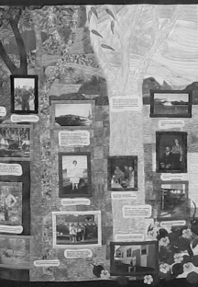

# Outline

## The research objective

The primary question for the research projects described in the four volumes of this report on the Vietnam Veterans Family Study is whether the service of Australian men in the Vietnam War led to adverse effects on the physical, mental and social health of their children. Behind this apparently straightforward question lie many complex factors relating to the way people develop in a social world, regardless of war or other catastrophes, and the difficulties associated with researching the consequences of events that occurred some 40 years ago. This summary acknowledges these complexities but seeks to provide a simple account of what we know and what we do not know, how we can learn from the past, and how that knowledge might be applied if subsequent generations are to avoid or better cope with similar situations.

This account is based on the contributions of the many people who took part in the Vietnam Veterans Family Study. It is not the result of a single, discrete study: rather, it relies on information gleaned from a complementary set of research projects designed to cast light on the problems encountered by families and their offspring and to understand the dynamics that have played out over decades. It goes beyond numbers to reflect the experiences of the fathers, mothers and partners, and sons and daughters who were both participants in and instigators of the research. It was they who called for the work to be done and they who offered the narrative of their experiences since the war.

## The Vietnam War

From Australia’s perspective, the Vietnam War had several distinctive features. Lasting from 1962 to 1975, it was Australia’s longest war of the 20th century. It involved regular military personnel and National Servicemen who were selected by ballot according to their date of birth. About one third of those who served in Vietnam were conscripts.

Many in the Australian community opposed the nation’s involvement in Vietnam, particularly during the latter years of the war. The figures suggest that more Australians took part in the Moratorium marches of 1970 and 1971 than served in the entire period of the war. Songs of protest and regret, often written and sung by sons and daughters of the veterans, became part of Australian folklore.

Some Vietnam veterans felt they were mistreated on their return to Australia, and many faced a long period of re-adjustment. Those who arrived home on HMAS *Sydney* were given parades through the streets of the city or town in which the ship docked almost as soon as they returned, but those who returned by plane at the end of their tour were denied this recognition. In 1987 a Welcome Home parade was held in Sydney, and in 1992 the Australian Vietnam Forces National Memorial was dedicated on Canberra’s Anzac Parade. With these gestures, many veterans began to feel their service was valued and that the community honoured them as it did veterans of earlier wars.

## Why does all this matter now?

We all bear the imprint of our past, our experiences in early childhood being central to how we feel, think and behave as adults. Memories and earlier learning bring images and sensations of the past into the present, contributing to the shaping of our emotions, preferences and choices. The same applies to our external world: where we live, the jobs we do, our social networks and our close personal ties all reflect past events, some of which might even be forgotten by now. No amount of research can delineate the paths individuals will follow through their lifetime, but what we can do is clarify the common forces and themes that lead many people in similar directions and help shape their lives. This leads to greater understanding—of ourselves and of others.

# The conduct of the study

In response to the urging of members of the Vietnam veteran communities—that is, Vietnam veterans, their partners and ex-partners, and their sons and daughters—the Vietnam Veterans Family Study was established as part of the Department of Veterans’ Affairs Family Studies Program in 2007.

The Vietnam Veterans Family Study program rests on two basic ideas. First, more than 10,000 Australians who had served in the Vietnam War were randomly selected and contacted, and they and their families, where willing, became part of a study some 40 years after the war. This provided an opportunity to evaluate common factors applying within the group. (Of course, not every serviceman or every family member will report or recall the same things, so the investigation assessed probabilities: there will never be an instance where 100 per cent of a study population experienced or reports a particular problem.) Second, the large group of study participants who served in the Vietnam War would be compared with randomly selected members of a group of individuals who served in the Australian Defence Force during the same period but were not deployed to the Vietnam combat zone (referred to here as Vietnam-era personnel).

Importantly, on hearing of the study, many Vietnam veterans and Vietnam-era personnel volunteered to participate; they are referred to as self-select Vietnam veterans and Vietnam-era personnel. Other groups of participants were also included—the siblings of Vietnam veterans and their sons and daughters and the families of Navy and Air Force personnel who served at the time of war—but the most important comparison for the study is that between the randomly selected Vietnam veterans and the Vietnam-era personnel and their respective family members.

The backbone of the study program was the Main Survey: it provided the basis for quantifying the differences between Vietnam veterans’ families and the families of Vietnam-era personnel. The Main Survey respondents also answered many questions about the time when the veterans’ children were growing up; this offered an avenue for trying to understand the experiences and pathways that might have led to differences in the health and wellbeing of the sons and daughters at the time of the survey.

As a complement to studying the health and wellbeing of the surviving sons and daughters, a special study was carried out of sons and daughters who were reported to have died before the conduct of the Main Survey. This study, called the Children of Vietnam Veterans Mortality Study, used records of deaths to examine the ages at which the deaths occurred and the causes of death.

Four other smaller in-depth studies were also carried out. Three of these were qualitative studies, two of them involving the collection of new information from families that had registered for the Vietnam Veterans Family Study.

* One of the qualitative studies focused on the children of veterans and asked open-ended questions covering a number of themes as a way of learning more about the experience of growing up in a veteran family. This involved children of Vietnam veterans who were Army regulars, children of Vietnam veterans who were conscripted into the Army (National Servicemen) and children of Vietnam-era personnel.
* The second qualitative study gathered even more in-depth information from six families by interviewing fathers, mothers, and sons and daughters wherever possible. Three of these families were Vietnam veteran families and three were the families of Vietnam-era personnel. The focus was on the intergenerational effects of service on health and wellbeing.
* The third qualitative study involved a re-analysis of the findings from a previous study that had collected information from sons and daughters of Vietnam veterans who had received help from what was then called the Vietnam Veterans Counselling Service (now the Veterans and Veterans Families Counselling Service). These sons and daughters would not necessarily have been participants in the studies conducted for the Vietnam Veterans Family Study.
* The fourth study used a mix of quantitative and qualitative approaches to the analysis of telephone interview data from 173 sons and daughters of Vietnam veterans, Vietnam-era personnel and siblings of Vietnam veterans (that is, nephews and nieces of the Vietnam veterans and Vietnam-era personnel).

These in-depth studies proved extremely valuable in bringing to light topics and themes that needed to be incorporated in the more structured questionnaire required for the Main Survey. They also offered many insights into the stories of the individuals who provided information—in a way that cannot be readily achieved through quantitative survey methodology. Some of the in-depth studies also resulted in verbatim accounts that illustrate and lend force to specific findings of the research program as a whole. The mix of qualitative and quantitative approaches is fundamental to the results presented in this report.

# The sons and daughters of Vietnam veterans and Vietnam-era personnel: differences in their health

## The differing kinds of health problems

A primary objective of the Main Survey component of the Vietnam Veterans Family Study was to quantify the differences in health status between the sons and daughters of Vietnam veterans and those of Vietnam-era personnel. The survey looked at a wide range of health situations, using parents’ reports about their children’s health and illnesses in early life (including the mothers’ pregnancies) and sons’ and daughters’ reports about their recent and past health.

The concept of health was interpreted in a broad sense to include physical health, mental health and social health, this last category covering personal relationships, educational achievement and economic wellbeing. The analyses the Australian Institute of Family Studies performed involved 34 measures from the survey; it found significant differences between the comparison groups for 12 of the 34 measures. Detailed methods were used to ensure that these differences among the sons and daughters were not a result of differences existing between the fathers in the two groups before their period of military service—for example, the father’s own family of origin and educational background.

The first important thing to note from the findings for the sons and daughters is the pattern of the differences found. Significant differences were found for most of the measures of mental health (ever diagnosed with or treated for depression, anxiety or posttraumatic stress disorder, suicidal thoughts, and suicidal plans or actions). No significant differences were found for recent substance abuse, but there was a difference for past marijuana use. In all these instances the sons and daughters of Vietnam veterans showed higher rates than those of the Vietnam-era personnel.

In the case of physical health among the sons and daughters, only three measures out of 16 showed significant differences between the two groups. Notably, those three measures were all conditions for which psychological factors are strongly implicated—skin conditions, migraines and sleep disturbance. No differences were found for arthritis and other joint disorders, circulatory problems, cancers, diabetes, respiratory disease, hearing problems, liver disease or kidney disease.

Additionally, no significant differences were found for the five measures relating to the mother’s history of pregnancy—problems in conceiving a baby, miscarriage, stillbirth, babies born with spina bifida, and babies born with a cleft lip and/or palate. These outcomes have previously been considered as having a possible link with fathers’ exposure to herbicides and pesticides (including dioxin used in Agent Orange). The Main Survey did not, however, have the very large sample sizes that would be needed to assess the possible impact of deployment to Vietnam on comparatively rare outcomes such as spina bifida and cleft lip and/or palate in children.

In the case of social health, the sons and daughters of Vietnam veterans were more likely to have had more than one marriage or de facto relationship than the sons and daughters of Vietnam-era personnel and were also more likely to be in a de facto relationship rather than a marriage at the time of the survey. For education, the offspring of Vietnam veterans were less likely to have a university degree and more likely to have post-school certificates and diplomas. No significant differences were found for stability of employment over time (that is, the number of jobs held) or for homelessness, criminal convictions or being the victim of criminal violence. The offspring of Vietnam veterans were, however, more likely to report past financial stress compared with the offspring of Vietnam-era personnel, a difference that did not apply to the 12 months before the survey but arose from previous times.

In all 34 comparisons between the offspring of Vietnam veterans and those of Vietnam-era personnel, members of the latter group were found to be healthier.

## The size of the differences

In large surveys it is possible to find differences between groups that are statistically significant but for which the size of the difference is not necessarily important in practical terms. It is therefore necessary to carefully consider the size of the differences that were noted for the mental, physical and social health measures in the Main Survey of the Vietnam Veterans Family Study.

In the case of depression, anxiety, and suicidal plans and actions, the sons and daughters of Vietnam veterans were almost twice as likely as the sons and daughters of Vietnam-era personnel to report being diagnosed with or treated for depression, being diagnosed with or treated for anxiety, or making plans for or attempting suicide. Reports of being diagnosed with or treated for posttraumatic stress disorder were three times more common for the sons and daughters of Vietnam veterans. For example, 21.1 per cent of the offspring of Vietnam veterans had been diagnosed with or treated for depression compared with 13.6 per cent of the offspring of Vietnam-era personnel; for PTSD, the figures were 4.3 and 1.3 per cent respectively. All such figures were derived after adjustment for differences in fathers’ pre-deployment circumstances.

Differences for education, employment, financial stress and homelessness were less marked. For example, 40.8 per cent of the Vietnam veterans’ sons and daughters had a university degree compared with 48.7 per cent of the sons and daughters of Vietnam-era personnel. It is possible that some of these aspects of social health were more problematic in years preceding the survey.

# The Mortality Study

The Children of Vietnam Veterans Mortality Study—which, among other things, looked at the very important consideration of suicide, which has obvious links with mental health (especially depression)—was carried out using information provided by parents participating in the Vietnam Veterans Family Study. It covered over 25,000 children born in the years preceding the time of registration for the overall Vietnam Veterans Family Study, in 2008 to 2010.

Analyses of the data for the Mortality Study were carried out in two stages by the Australian Institute of Health and Welfare and the Australian Institute of Family Studies. Their reports make up Volume 3, which is divided into two parts. Part One, prepared by the Australian Institute of Health and Welfare, examines mortality rates for sons and daughters of veterans compared with those for the general Australian population and looks at causes of death among the sons and daughters of Vietnam veterans and those of Vietnam-era personnel, taking account of sex and age of risk (childhood or age 15 years and onwards). Part Two, prepared by the Australian Institute of Family Studies, focuses on differences between the offspring of Vietnam veterans and those of Vietnam-era personnel, taking account of a number of differences between the fathers even before their period of military service. This involved using information many of the fathers had provided in their responses to the Main Survey.

The Mortality Study had two primary aims. The first was to compare mortality rates for the sons and daughters of veterans with those for children in the general Australian population. From the estimation of standardised mortality ratios, the analysis found that sons and daughters from the randomly selected Vietnam veteran group and from the Vietnam-era personnel group had lower overall mortality rates than children from the general population who were born during the same period: the rates were about 30 to 40 per cent less across the two groups. This cannot be accounted for by ‘unconfirmed deaths’ reported by parents but not verifiable in death registers. Even if all the unconfirmed deaths turned out to have been actual deaths, they would add only 15 per cent to the estimated mortality rates. Some of these deaths were probably the result of miscarriages and stillbirths, or even errors in completion of the survey forms. It is thus very likely that fathers who served in the Australian Army between 1962 and 1975 were healthier overall than other men of their generation and this could be reflected in the health (and mortality) of their children. It is also possible that families who accepted the invitation to participate in the Vietnam Veterans Family Study were healthier than families who could not be contacted or who were invited but chose not to participate. Deaths arising from cancers and external causes showed rates similar to those for the general population, whereas deaths from ‘other causes’ had especially low standardised mortality ratios.

The second main aim of the Mortality Study was to determine whether the sons and daughters in the Vietnam veteran group had an increased risk of mortality relative to the sons and daughters of Vietnam-era personnel. The results of these analyses extend the findings from the Main Survey of surviving offspring (as outlined) and reinforce some of those conclusions. A higher proportion of the sons and daughters of Vietnam veterans were found to have died in comparison with the sons and daughters of Vietnam-era personnel. The crude death rates (that is, unadjusted for sex or year of birth) were 28 per 1,000 for the former group and 19 per 1,000 for the latter (using the randomly selected samples). It should be kept in mind that these results are based on relatively small numbers of deaths—390 in all from both groups combined—and the offspring of veterans are still, on average, quite young.

About a half of the deceased offspring were aged less than 20 years at the time of their death. In the general population we would expect the causes of death among young children to include perinatal deaths, SIDS (sudden infant death syndrome), congenital problems and cancers (AIHW 2014); through childhood and into early adulthood common causes of death are accidents (transport and drowning), poisoning and suicide.

The great majority of the sons and daughters involved in the Vietnam Veterans Family Study are not yet at an age where we would expect to see substantial numbers of deaths from coronary heart disease, adult cancers, cerebrovascular disease or chronic respiratory disease, which are the most common causes of death in older adults. Given the relatively small number of deaths in the study, broad categories of causes needed to be used for the statistical analyses.

The question that arises, then, is which causes of death were implicated in the differences found between the sons and daughters of Vietnam veterans and those of Vietnam-era personnel? There was no significant difference in the proportions of sons and daughters who died from cancer. We cannot know whether a difference might emerge in the future if we were to follow up the current surviving sons and daughters into their old age. On the basis of the 51 children in the randomly selected groups that were confirmed to have died from cancer by 2009, however, this was no more likely to have occurred for the offspring of Vietnam veterans than for those in the comparison group. For causes of death other than cancer, the findings depended on gender and the period of risk under consideration (either the childhood years or 15 years or more). From age 15 onwards deaths resulting from external causes (which include suicide and accidental deaths) and deaths from ‘other causes’ (not cancer and not external causes) were more frequent in the sons of Vietnam veterans compared with the sons of Vietnam-era personnel. These differences were not found in younger sons and were not evident in daughters at any age.

The additional analyses the Australian Institute of Family Studies performed helped put these initial results into a broader context. They showed that the greater overall mortality rate in the sons and daughters of the Vietnam veterans (compared with those of Vietnam-era personnel) was not a result of differences between the respective groups of fathers before their period of military service. The analyses also identified deaths from suicide, especially in the sons, as being more common in the Vietnam veteran group.

## Suicide

In terms of years of potential life lost (based on a notional full life, often set at 75 years), suicide is one of the leading causes of life lost in developed countries (for example, 5.7 per cent of all years of potential life lost in the United States in 2011) even though the number of suicides in the general population might seem small (about 1.7 per cent of all deaths in Australia in 2012, representing 11 deaths per 100,000 population). Previous research has found that suicide rates might be higher among the offspring of Vietnam veterans, so this was an important part of the Mortality Study analyses (AIHW 2000). Again, however, caution is required when interpreting the findings: they are based on relatively small numbers of deaths. Just 74 confirmed deaths were the result of suicide for all the sons and daughters registered for the Vietnam Veterans Family Study and, of these, 41 occurred in the two main comparison groups—that is, the randomly selected Vietnam veterans and the randomly selected Vietnam-era personnel. Nevertheless, these deaths accounted for over 10 per cent of all the confirmed deaths in the study families before the time of the study, in 2008 to 2010.

The results of the Australian Institute of Health and Welfare’s estimation of standardised mortality ratios (in Part One of Volume 3) showed that the rate of death from suicide among the offspring of Vietnam veterans was about the same as that in the general Australian population who were born during the same period as the participants in the Family Study.

In addition to the estimation of standardised mortality ratios, direct comparisons were made between the sons and daughters of Vietnam veterans and those of Vietnam-era personnel—the same comparison that underpinned the findings from the Main Survey of health outcomes among the surviving offspring. The Australian Institute of Health and Welfare’s initial analyses showed that the Vietnam veterans’ sons had significantly higher total mortality rates and higher rates for deaths due to external causes (which includes suicide) than the sons of Vietnam-era personnel, but the differences in rates for suicide alone were *not* statistically significant. The further analyses the Australian Institute of Family Studies performed were able to take account of the differences in the backgrounds of the fathers in the two comparison groups, albeit by restricting these analyses to the families who also took part in the Main Survey. The adjusted analyses found a statistically significant difference in suicide rates between the offspring of Vietnam veterans and those of Vietnam-era personnel, although this was evident only for the sons. The differences in sons’ deaths from all external causes (including suicide) in the Australian Institute of Family Studies analyses were, however, no longer statistically significant after adjustment for differences in fathers’ backgrounds.

There is no simple way of portraying all the findings relating to suicide. A statistical analysis can take us only so far, and in this case some results are at the margins of certainty. The results are limited by the sample sizes in the study and the inevitably low proportion of deaths for groups that are still relatively young. Nonetheless, we can make some observations on the basis of the pattern of results. As noted, the Mortality Study showed that the offspring of Vietnam veterans (notably the sons) had higher rates of death from external causes, and in the Australian Institute of Family Studies analyses the sons of Vietnam veterans had higher rates of suicide compared with the sons of Vietnam-era personnel. Because of the way deaths from suicide are reported in many countries, many such deaths are not classified as suicide, which leads to under-reporting. The deaths in question are most likely to be classified as deaths from external causes (such as motor vehicle accidents and overdoses or poisonings). With this in mind, the Vietnam Veterans Family Study took a pragmatic approach, accepting that a proportion of potentially preventable deaths were indeed related to fathers’ service in the Vietnam War. This is consistent with the Main Survey findings on the mental health of the surviving offspring of Vietnam veterans, including their suicidal thoughts, plans and actions.

# Factors connecting fathers’ experience of the Vietnam War to their sons’ and daughters’ health many years later

As described, the Main Survey of the Vietnam Veterans Family Study also sought from family members information about when the sons and daughters were growing up. Among other things, this involved the sons and daughters themselves answering questions about their upbringing and their parents. The information that helped connect a father’s experience of war to his children’s eventual health fell into four broad categories:

* the health of the serviceman
* the support services the serviceman used
* the family environment when children were growing up
* children’s experiences with the education system.

A number of measures were included in the survey for each of these categories, and the Australian Institute of Family Studies used 20 of the measures in its data analyses. These potential linking factors are known as ‘mediating factors’ or ‘mediators’. The analyses also had to cover the 12 areas of health for which differences between the offspring of Vietnam veterans and those of Vietnam-era personnel were found. For some of the 12 areas the use of more than one statistical comparison was necessary. In total, the number of potential mediators and the number of outcome variables gave rise to 340 possible links. A systematic approach was used to build a set of statistical models that identified the most important links to each of the health outcomes in turn.

The first criterion for a potential mediator to be included in the modelling was whether there was a statistically significant difference in the mediator’s reported occurrence between the Vietnam veteran families and those of the Vietnam-era personnel. Several measures of a serviceman’s health met this criterion—diagnosed with or treated for depression, diagnosed with or treated for anxiety, a measure of PTSD (from the PTSD Check List), diagnosis with or treatment for skin conditions, and diagnosis with or treatment for sleep disturbance. For example, 38.2 per cent of the sons and daughters in the Vietnam veteran group had a father who scored 50 or more on the PTSD measure compared with just 5.0 per cent of the sons and daughters of the Vietnam-era personnel.[1] In addition to the direct measures of health, fathers in the Vietnam veteran group were more likely to have used military-related services and mainstream medical services; in the case of military-related services, the proportion was 77.6 per cent compared with 28.5 per cent among the Vietnam-era fathers. (The differences between the two groups could, however, be a consequence of entitlement: more Vietnam veterans could well have a Gold or White Card.)

In relation to the measures of family environment when the children were growing up, three of the eight factors differed significantly between the Vietnam veteran families and the families of Vietnam-era personnel (as reported by the sons and daughters)—a father’s caring attitude towards his child, a father’s overprotective or controlling behaviour, and an indicator of harsh parenting during childhood. Twenty-three per cent of offspring of Vietnam veteran families reported at least one of five items on harsh parenting; this compares with 9.1 per cent of offspring of Vietnam-era personnel. It is noteworthy that the three items that contributed most to this difference were verbal abuse, too much physical punishment, and a question covering ‘humiliation, ridicule, bullying or mental cruelty’, whereas the differences were smaller and non-significant for two items that asked about physical abuse by parents (being punched, kicked, hit or beaten with an object) and witnessing physical or sexual abuse of other family members. It is also of interest that the other measures that did not show a difference between the two family groupings were fathers’ and mothers’ alcohol and drug problems, mothers’ caring and overprotective parenting, and parental separation. Although there has been considerable concern about instability in and the possible breakdown of the marriages of Vietnam War veterans, only 11.3 per cent of the Vietnam veterans’ sons and daughters reported that their parents divorced or permanently separated when they were growing up (0–15 years); this compares with 12.4 per cent of the sons and daughters of Vietnam-era personnel.

In the case of experiences at school, sons and daughters in the Vietnam veteran group were more likely to report having disciplinary problems (suspended or expelled from school), other behavioural problems (absenteeism or being bullied) and learning problems (repeating a school year, receiving special assistance or dropping out of a course). For example, 43.1 per cent of sons and daughters in the Vietnam veteran group reported disciplinary problems compared with 33.0 per cent of the sons and daughters of Vietnam-era personnel. There was no difference between the groups in relation to being gifted or talented (skipping a year at school or being in a class for gifted children).

After the possible mediating factors had been identified, more complex statistical models were built for each of the 12 outcomes for which differences had been found between the health of sons and daughters in Vietnam veteran families and those of Vietnam-era personnel. These models are described in Volume 2. Suffice it to say here that a number of factors occurred repeatedly across the 12 models and they provide a comparatively straightforward framework.

The most obvious feature of the 12 models was the rarity of finding associations between a father’s deployment to Vietnam and offspring’s outcomes that were not mediated by the factors measured in the study. Only the connection between a father’s deployment to Vietnam and his offspring’s past marijuana use was not fully accounted for by other mediating variables. Four mediators of this particular association were identified, but they explained only a part of the link. This was the sole exception among the 12 models, and that suggests that the measures used in the study were sufficiently comprehensive to cover the likely pathways leading to the range of sons’ and daughters’ outcomes assessed.

A father’s PTSD was involved as a mediator in eight of the 12 statistical models—all of them other than sons’ and daughters’ lifetime drug use, skin problems, number of marriages or relationships, and current relationship status. Further, in the eight models for which the father’s PTSD did feature all but one involved other mediating factors that fully accounted for the pathway between the father’s PTSD and the offspring’s outcome of interest. The exception was the model for sons and daughters having been diagnosed with or treated for anxiety: it is possible that this could reflect an underlying susceptibility to anxiety disorders in fathers and their children, or perhaps that other relevant mediating pathways had not been included in the study questionnaires.

Harsh parenting and children’s behaviour problems while at school featured together as mediators in six of the 12 models, and all but one of these (sons’ and daughters’ drug use) also involved PTSD in the father. One other model (sons’ and daughters’ migraines) implicated behavioural problems at school along with the father’s PTSD but did not include harsh parenting. This cluster of mediating factors—the father’s PTSD, harsh parenting, and behaviour problems at school—was evident for the mental health outcomes of sons and daughters, their sleep problems and their history of financial stress.

The models that were the least similar to those just outlined were those describing the pathways leading to skin conditions in the sons and daughters and those leading to some of the social health measures—current relationship status, number of marriages or relationships, and education. Of these, only the model for sons’ and daughters’ educational qualifications featured the father’s PTSD. The pathways following a father’s deployment to Vietnam and his PTSD, which then led to poorer qualifications in his offspring, were via the sons’ and daughters’ disciplinary problems at school, their learning problems, and lower levels of caring from the fathers when the children were growing up (as rated by the sons and daughters). This is perhaps indicative of the fathers’ lower level of involvement in their children’s education. There was no common pattern for the remaining models.

Overall, the cluster of a father’s PTSD, harsh parenting and sons’ and daughters’ behaviour problems at school provides a strong indication that the main pathway of intergenerational transmission is through the family environment as the sons and daughters were growing up. Although the measure of harsh parenting did not assess fathers and mothers separately, other measures examined in the Main Survey suggest that the parenting of Vietnam veteran fathers differed from that of the fathers who were Vietnam-era personnel. The accounts of some of the sons and daughters who participated in the in-depth studies reinforce this point. The findings also suggest that the eventual outcomes for adult offspring of the Vietnam veteran families do not emerge suddenly at a later stage (often referred to as a ‘sleeper effect’); rather, they suggest that these individuals’ problems were evident before this time and were likely to impinge on their interpersonal relationships, including relations with their peer group. Such things are very difficult to measure retrospectively in surveys such as the Main Survey conducted for this study, but other studies that have followed large samples of children over time show consistent patterns of behaviour in childhood and adolescence that precede the occurrence of mental health and other problems in adulthood (Copeland et al. 2013).

The Australian Institute of Family Studies performed additional analyses to focus on the families of fathers who were deployed to the Vietnam War to determine whether any particular aspects of their service were linked to outcomes for their sons and daughters. As would be expected, the likelihood of fathers being classified as having PTSD on the basis of the Main Survey was strongly related to their own reports of distressing events that occurred during their service in Vietnam. Another feature noted as a result of these analyses was that reported contact with Agent Orange was *not* associated with any of the health outcomes measured in the sons and daughters. As mentioned, the study sample was not sufficiently large to enable an assessment of the association with rare outcomes such as spina bifida and other congenital problems. The number of families involved did, however, allow investigation of more common outcomes such as those associated with mental health among the offspring of the Vietnam veterans. The evidence is that these outcomes are related to the father’s psychological experiences during the war rather than to exposure to toxins. Some other aspects of service were noted to be associated with particular health outcomes among the sons and daughters, but these did not follow any obvious pattern.

# Experiences of Vietnam veterans’ families

The two major quantitative components of the Vietnam Veterans Family Study—the Main Survey and the Children’s Mortality Study—provided a basic framework for understanding the intergenerational transmission of the impacts of fathers’ service in the Vietnam War. We know that the differences between the offspring of Vietnam veterans and those of Vietnam-era personnel were predominantly associated with mental health and a number of physical health measures that make a substantial psychological contribution. We also know that these differences impose a burden on individual family members and on society as a whole. Further, the problems the sons and daughters have experienced were in evidence many years after the end of the war. The Main Survey provides important information about how these differences arose—especially in relation to the role of a father’s PTSD and the harsh parenting that was reported for the time when the sons and daughters were growing up.

The broader set of studies reported in Volume 4 presents a detailed picture of families’ experiences over time. Some of this offers a fuller understanding of how families might be better equipped to deal with the challenges they face in the aftermath of war and provides an indication of the services and supports that might be of use in the future. There are also things we do not yet understand and for which further investigation could be fruitful, including further analysis of the detailed data collected for this study.

## Going to war

Although the reports here focus on the sons and daughters of Vietnam veterans, they also provide vivid insights into the experiences of the fathers—either through the fathers’ own accounts (see Part Four of Volume 4) or through the accounts of the sons and daughters (see Part Three of Volume 4). Some of the accounts suggest that anticipation of going to war could of itself prompt actions and events that would have implications into the future. An example of this is marriage: ‘I think a lot of us rushed into getting married because we all heard stories about the guys in [the Second World War] who had a girl waiting for them’.

The downside of this situation is, of course, the possibility of choosing a partner who is not well suited or of a marriage that occurs at a younger age than might otherwise have been the case.

## Separation from family

There are also instances of fathers being ‘strangers’ to their own children:

He would not let his Dad pick him up or even look at him for a long time … for months and months.

I went into Mum’s bedroom and saw this bloke in the bed … I had no idea who it was.

Similar experiences could arise for many families when parents are absent for extended periods. In the Vietnam Veterans Family Study, however, we see that the offspring of men who served in the war had more problems than the offspring of Vietnam-era personnel, and we know that children born after the war had similar difficulties. There is therefore a distinction between the experience of a father’s absence and the longer term intergenerational consequences of a father’s experience of war.

## Welcome back

The unpopular nature of the Vietnam War went beyond political protests. The veterans were not welcomed home:

… her father was upset about community reactions towards those who served in Vietnam and was particularly hurt about how he received the medals he earned in Vietnam—in the mail, rather than being presented personally at a ceremony.

He talked about that more than he talked about anything else. He said it was very disappointing seeing that they never wanted to go. He was never given a choice, and to come back and be treated like that.

Antagonism towards the veterans was often expressed in public, and family members could become caught up in this:

One of the women in the group asked where I had been after my wife mentioned that I had just returned home. When I told her Vietnam she stood up and called me a baby killer and a few equally vile names and attempted to slap me.

## Family life after the war

Many accounts speak of silence: the war was a ‘no go’ zone and there was an ‘unspoken rule’ about not asking the father about his time in the Army. Some veterans were said to speak about Vietnam only when they were drunk. With the passing of time, however, some fathers seemed more willing to talk about their wartime experiences, often prompted by the curiosity of their children or even grandchildren. Receiving counselling seemed sometimes to have played a part in the fathers opening up to their families.

Sitting alongside the silence was the risk of anger and ‘outbursts’, and there is mention of children (daughters especially) adopting the role of peace maker in trying to avert this:

I feel like I have to hold it all together and when Dad blows up and says horrible things to [my brother] I am the one who comes in to pick up the pieces … Dad won’t even try … so I have to mend things.

In other instances, the anger would spill over into everyday situations: ‘Dad gets very angry, frightened … cannot handle easy, simple everyday things—like parking at a shopping centre’.

There were also instances in which sons and daughters explicitly linked their father’s behaviour to symptoms of PTSD:

Dad hated noises and would react to sudden noises like cars backfiring or garbage trucks … he would just hit the deck.

He never used to get any sleep with the nightmares … so he’d wake up quite grumpy and carried that all the way through the day until he picked me up from school … and then we’d go home and the slightest little thing would set him off, so you were walking on eggshells the whole time.

For some of the sons and daughters these events influenced their view of themselves. They grew up thinking their father’s volatility was their fault and they were ‘bad kids’.

## Parenting

Strictness and regimentation were recurrent themes in the accounts of growing up in a Vietnam veteran family: ‘His whole life he was a disciplinarian and I think sometimes he went too far’ and ‘He treated us like we were in the Army’.

The extent to which some fathers ‘went too far’ was alluded to or more overtly described in other comments:

One day Dad came to pick me up from Mum and my step-dad’s house and we were driving home and I was just chattering like a regular teenager and he went from happy and friendly to crazy in an instant. He yelled at me to shut up and ranted about how I talk a lot … I don’t think he has any idea how hurtful that sort of thing is.

It makes you feel worthless. Like he is this great guy who everyone admires, doing all this stuff and then he tears shreds off you … When I was a teenager it used to destroy me.

Some of the accounts from the in-depth studies mirror the results of the analyses of the Main Survey data, showing that ill-temper and verbal abuse did not often lead to physical violence towards the children: ‘Harry insisted that his father was never violent—“just strict”: “[The arguing] scared us, yeah. It scared us. I think only we were scared for ourselves”’. In some families, though, violence was directed at the mother: ‘He was abusive to Mum; he hit her but he never touched us’.

There were also examples of fathers being violent outside the home but not to family members: ‘He still drinks but Dad was never violent towards the family; however, he could be extremely violent towards other people’.

## Family cohesion

A number of the families who participated in the in-depth studies experienced divorce when the Vietnam veteran’s children were still living with their parents. Four of the sons’ and daughters’ stories in the ‘Lived experiences’ study mention parents’ divorce (including one from the group of Vietnam-era personnel), and one of the Vietnam veterans in the study of the six families was living with his second wife. Marriage breakdown would seem to be more likely in families affected by PTSD, anger and sometimes violence, yet the Main Survey reported similar rates of divorce and separation in the Vietnam veteran families and the families of Vietnam-era personnel (11.3 and 12.4 per cent respectively). A number of accounts speak of the way families tried to cope with their difficulties. The wives and partners of Vietnam veterans tried to compensate for the emotional withdrawal of the fathers and to act as peace makers: ‘She was the one who got us through. She gave us the love and affection he could not give … Everyone thinks of him as being the strong leader, but it was her’.

The sons and daughters themselves were aware that their father’s wartime experiences had contributed to problems in their family and, even if they had been born after their father’s return from Vietnam, knew the war had made a difference:

My Mum said that my Dad came back a completely different person. Before he went he never smoked or drank and when he came back he did both. He had bad dreams but we were shielded from all of that.

There are, however, many references to families feeling proud of the father’s military service generally and his service in the Vietnam War specifically. Sons and daughters also sometimes knew that their father had been diagnosed with PTSD, and this helped them understand their circumstances, past and present: ‘Dad got PTSD. This has affected both him and Mum. Mum has to walk on eggshells at times. Family has always tried to please and not upset Dad’.

Nevertheless, there are signs that many families remained loyal to their Vietnam veteran and made allowances for behaviour they felt was a result of his wartime experiences and not reflective of his former self. Whether for good or for ill, given the difficult circumstances in which some of the sons and daughters grew up, most of these families stuck together.

## Help for Vietnam veterans and their families

The accounts of many families reveal that the Vietnam veterans often did not receive counselling or other professional help until long after the end of the war, and there are many examples of a diagnosis of PTSD being similarly delayed, even though the symptoms of the disorder—such as nightmares, cues that reminded of distressing events, and avoidance of the topic of war—had obviously been evident for some time.

The Vietnam Veterans Counselling Service, established in 1982 and renamed the Veterans and Veterans Families Counselling Service in 2007, offered further opportunities for veterans to receive help. Of course, if veterans chose not to tell their families they had received counselling, family members would not have been able to comment on this in the present study. Nevertheless, it is interesting to note the extent to which such help was acknowledged by families:

A couple of years ago he retired and he … got into the RSL. They helped him. They sent him to different groups and counselling and did different things for him, and now he is a bit more open about it. I think they applied for Veterans’ Affairs services. Since he has been involved with the veterans, he has been so much better.

He has begun to talk more about his experiences since beginning counselling in recent years. [A son] observed that this counselling has encouraged his father to open up much more and jokingly described his father constantly talking about his feelings, to the point that it is *too* much.

Although it goes well beyond the scope of the Vietnam Veterans Family Study to consider the effectiveness of such counselling, it is important to recognise the broader relevance to families. There are indications that receiving professional help represented a new beginning and sent a positive signal for family members: ‘When he started to see the psychiatrist it was good for the whole family because things became more relaxed for Mum and us’.

In some instances family members were involved in the counselling: ‘We all went together to this counsellor, me, Mum and Dad … I was very proud he came along … It showed he really cared and wanted to work on things … It was recognition we were important’.

Sons and daughters were also able to obtain counselling in their own right. The Veterans and Veterans Families Counselling Service increasingly became a service for other family members following the publication of findings from studies of Vietnam veterans’ health in the late 1990s. The reports of these studies recommended therapeutic and preventive interventions for veterans and their families and proposed a specific review of the adequacy of mental health services. Indeed, the sons and daughters who participated in the original research (in 2001) for the re-analysis project (see Part Two of Volume 4) were recruited from children registered with the Counselling Service.

Among participants in other projects described in Volume 4 there were examples of family members being unaware of the availability of services funded by the Department of Veterans’ Affairs, and sons and daughters often sought help from mainstream service providers—general practitioners and subsequently psychologists—even when their problems were linked to their father’s war service. There were, however, also instances of sons and daughters receiving counselling from Department of Veterans’ Affairs services and speaking of the benefits they derived from this:

That was really good because I had a good relationship with the guy who was doing the counselling … it worked for me because it felt like I was talking to a peer. I had maybe a dozen sessions and worked through a lot of that anger and pain and angst that I had developed.

## Acceptance

More than four decades on, Vietnam veterans have become senior members of the Australian community. That period has seen many changes in attitudes towards the war and towards its veterans. The formation of organisations dedicated to advocating the needs of Vietnam veterans, the establishment of the Vietnam Veterans Counselling Service in 1982, the Sydney Welcome Home parade of 1987, and the opening of the Vietnam Forces National Memorial in Canberra in 1992 were important steps that marked a progression towards acceptance and recognition—a progression urged by veterans themselves and by their families. The broader community has come to acknowledge and respect Vietnam veterans as witness to, not perpetrators of, a terrible war.

Accounts from the Vietnam Veterans Family Study reflect these developments and demonstrate the family cohesion that has extended to a third generation:

[We] went to Canberra with Dad for him to march when they had the big Vietnam Canberra Memorial, the wall. That was a very special time and at those times I feel really close to Dad. And now he has started to march in the Anzac Day parade in recent years; before, he wouldn’t even think about going to march. We take the kids to see him march on Anzac Day and try to make it a special day.

He asked me to go along to the Shrine with him in the morning and we took my little fellow along and it was quite touching. He was holding our hands and he was a bit teary. We were all crying. It was really nice that finally he wanted to share that.

# Answering the research question

The answer to the question of whether the service of Australian men in the Vietnam War had adverse effects on the physical, mental and social health of their sons and daughters is ‘Yes’. It is enormously important to have that answer, but that was not the only thing the Vietnam Veterans Family Study brought to light. Collectively, the study projects show that the experience of war is not confined to the time between the passing-out parade and returning home and that families as well as those deployed are intimately involved in the experience. Away from the battle zones and for decades after, life kept on delivering trauma. With hindsight—and with the knowledge, services and other mechanisms now at our disposal—we might have found better ways of welcoming home those who were sent to war and minimising the impacts on partners and children, including those not yet born at the time.

Central to this story is the part played by posttraumatic stress disorder, which is common among the Vietnam veterans who participated in the Family Study. PTSD is a consequence of experiencing—directly or indirectly—a terrifying or gruesome event, but the onset and course of the disorder are influenced by many factors. Most of the victims in the present study did not receive clinical treatment for PTSD on returning home, and many of them were subject to behaviours and incidents, some intentional and some not, that exacerbated and prolonged their distress. By the time professional help became more widely accessible for veterans, a culture of silence and denial was already entrenched. One of the challenges in treating PTSD is that the treatment involves confrontation with the very things people have been fleeing, sometimes for years. Nonetheless, evidenced-based treatments can be very successful (Watts et al. 2013).

Of course, PTSD and other stress-related disorders have consequences beyond their identifying symptoms, and the Vietnam Veterans Family Study shows how family life and parenting can be disrupted to the detriment of all concerned. In some instances family members were involved in the counselling received by servicemen; others availed themselves of services offered through the Department of Veterans’ Affairs. When professional help is offered to those suffering from PTSD and acute-stress reactions, it is important to monitor and evaluate the benefits in a way that encompasses the wider implications for interpersonal relationships and family life. Treatment protocols need to be sufficiently flexible to include goals such as improved family functioning and better parenting, and there might well be circumstances in which this is facilitated by the involvement of family members in a treatment program. The present research also provides many examples of family members being supportive of Vietnam veterans who sought and received help, even if those family members were themselves not directly involved. Their role in facilitating the obtaining of assistance and reinforcing its value is central: they are often the people most likely to be listening when a long silence breaks.

For the sons and daughters of veterans, it is obviously vital that they have access to services they need for themselves, and the research demonstrates that mental health care is the area of greatest need. The sons and daughters are often unaware of the Department of Veterans’ Affairs services available to them, and others might simply prefer to use mainstream services. As a result, the providers of mainstream services need to know about of the particular factors that can affect the families of war veterans.

The majority of the children of Vietnam veterans are now adults, so it is too late to consider preventive initiatives aimed at minimising the consequences of their father’s PTSD, including the harsh parenting that was so often evident. For more recent conflicts involving Australian Defence Force personnel, however, it is not too late to try to mitigate the impacts of deployment on families.

For many Vietnam veterans and their families the war did not end in 1973. Nor did it end with the 1987 Welcome Home parade or the 1992 opening of the Vietnam Forces National Memorial in Canberra. It is hoped that publication of this report will prompt new initiatives. The research thus far has produced findings that can help direct assistance for Defence Force families in the future, in order to diminish the intergenerational transmission of problems seen among the sons and daughters of Vietnam veterans. That alone would be fitting recognition of the efforts of those who lobbied for and participated in the Vietnam Veterans Family Study.

Understanding how adults’ traumatic experiences can affect their children’s lives many years later is fundamental to protecting the children’s future.

Part Two   
  
Background to the Study

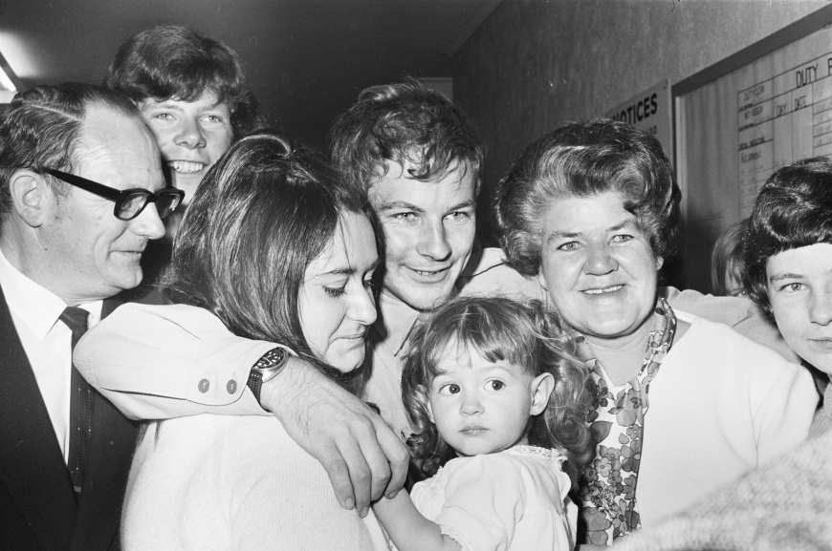

# Purpose of the study

Through the Department of Veterans’ Affairs, the Australian Government has over the years funded a variety of research projects aimed at exploring the experiences of Vietnam veterans and implemented special programs of care and compensation to assist veterans in the event of need. But veteran groups continued to argue that a specific study of the effects of military service on the health of families of Vietnam veterans was necessary.

In 2008 the department formed the Family Studies Program, a research program designed to study the health and wellbeing of families of Vietnam veterans and veterans of subsequent deployments, such as Timor‑Leste. The Vietnam Veterans Family Study was the first study launched under the Family Studies Program.

The aim of this research is to gain a comprehensive understanding of the health and wellbeing of the families of Vietnam veterans. The research involves investigating the physical, mental and social health of veterans’ families and seeks to augment our understanding of the longer term effects of serving in Vietnam for veterans and their family members. The factors that build resilience in families of veterans are examined, as are the factors that adversely affect the health and wellbeing of Vietnam veterans and their families.

For many years, the children and I blamed ourselves. When the changes in [my husband] started to affect us as a family, I sought professional help but there was none available. We continued to trundle along on life’s journey together, making the best of it, not understanding—this was our life. We didn’t consider leaving, despite the difficulties we faced. Put simply, we loved our man.

As the children grew, I soon became a buffer between them and their Dad. We were organised as if we were in the Army, caught up in the aftermath of the trauma that can be attributed to [my husband’s] service in Vietnam. We will never really know what went on over there but we know only too well what happened when he came back. The person my husband was when he went away returned to me different somehow. So we muddled along together through his nightmares and the regimentation of our household, even his reluctance to mix socially. We kept the outside world at bay; not even our families knew what we were going through. (Australian Partners and Families of Veterans National Quilt Project 2006)

# Structure of the report

The results of the Vietnam Veterans Family Study are presented in four volumes, as follows.

* Volume 1, *Introduction and Summary of the Studies of Vietnam Veteran Families*, consists of two parts:
  + Part One, ‘Report summary’, brings together the results of the entire study.
  + Part Two, ‘Background to the study’, provides background information and briefly describes the research approach.
* Volume 2, *A Study of Health and Social Issues in Vietnam Veteran Sons and Daughters*, reports on the analysis of the Main Survey, which was designed to allow comparison between the health and wellbeing of families of veterans who served in Vietnam and that of families of Vietnam‑era service personnel who did not deploy to Vietnam.
* Volume 3, *A Study of Mortality Patterns of Vietnam Veteran Families*, investigates the mortality rates and causes of death for children of Vietnam veterans and compares these with those for children of Vietnam-era service personnel and the Australian population in general.
* Volume 4, *Supplementary Studies of Vietnam Veteran Families’ Experiences*, consists of five parts:
  + Part One, ‘Social factors that impact on sons and daughters of Vietnam veterans and Vietnam-era servicemen’, examines the family dynamics affecting the health and quality of life of the sons and daughters of Vietnam veterans and others who served at that time but did not deploy to Vietnam.
  + Part Two, ‘Re-analysis of the Sons and Daughters Project’, reviews the data collected for the then Vietnam Veterans Counselling Service for the original Vietnam Veterans Sons and Daughters Project in 2001. The re‑analysis reports on the outcomes and main themes arising from the existing data and information relating to the wellbeing of the sons and daughters of Vietnam veterans and on best practice for investigating their resilience and their difficulties.
  + Part Three, ‘The lived experiences of sons and daughters of Vietnam veterans and Vietnam-era servicemen’, deals with the self-reported experience of daily life as a son or daughter of a Vietnam veteran or Vietnam-era member of the Australian Defence Force.
  + Part Four, ‘Intergenerational effects of service in the Vietnam War: the stories of six families’, explores the health status risk and protective factors for six families of Vietnam veterans.
  + Part Five, ‘Qualitative study summary’, summarises the qualitative research reports dealt with in Parts One to Four and their methodologies and findings.

# Previous research into Vietnam veterans

There have been numerous studies of Vietnam veterans. This chapter reviews the main findings of some of the Australian studies.

## Department of Veterans’ Affairs studies of the health of Australian Vietnam veterans

The Department of Veterans’ Affairs has funded several studies of mortality, cancer incidence and other health concerns among Vietnam veterans.

### The Australian Veterans Health Studies

In 1984 the Department of Veterans’ Affairs commissioned the Australian Veterans Health Studies, which investigated the factors influencing mortality rates for Australian National Servicemen of the Vietnam conflict era (O’Toole et al. 1984). The researchers found that, after adjusting for any effects resulting from the Army corps in which individuals served, mortality rates for National Servicemen who served in Vietnam were not statistically higher than those for National Servicemen who served in Australia. The period of follow-up was, however, relatively short to allow for conclusive results, and further research was recommended.

### The Mortality of Vietnam Veterans Study

In 1997 the department commissioned a second Vietnam veteran mortality study consisting of two parts:

* a mortality study comparing Vietnam veterans with the Australian community (Crane et al. 1997b)
* a mortality study comparing National Servicemen who served in Vietnam with National Servicemen who did not serve in Vietnam (Crane et al. 1997a).

As part of this second study a comprehensive listing of Vietnam veterans, male and female, was compiled; it also included civilians, medical personnel and entertainers.

Mortality was assessed for the period from 1980 to 1994, the earlier date reflecting the establishment of the National Death Index. Among all Vietnam veterans, higher than expected mortality was noted for all causes and particularly for the following:

* cancer—specifically prostate and lung cancer
* ischaemic heart disease
* suicide.

Navy veterans had the highest mortality rate, followed by Army and Air Force veterans.

The study of National Servicemen found that overall mortality for those who served in Vietnam was significantly elevated compared with that for those who did not. In addition, the lung cancer rate was twice that of non–Vietnam veterans and the rate of cirrhosis of the liver was nearly three times higher. The study did not provide data on the risk factors relating to deaths from either of these diseases, but ‘20 of the 21 cirrhosis deaths among [Vietnam] veterans were recorded in a manner which indicated that excess alcohol consumption was the cause of the cirrhosis’ (Crane et al. 1997a, p. 8).

### The Morbidity of Vietnam Veterans Studies

In 1998 the Department of Veterans’ Affairs in conjunction with the Australian Institute of Health and Welfare conducted a large survey of morbidity among Australian Vietnam veterans (DVA 1988a).

For this study a questionnaire was distributed to 49,944 male Vietnam veterans; they were asked to describe their current health status and provide details of their medical history and marital status and the health of their partner and children. The results were compared with those from the 1995 National Health Survey, conducted by the Australian Bureau of Statistics. These self-reported study results suggested that the health of Vietnam veterans and their families was worse than that of the general Australian population.

Because of the lack of certainty inherent in self-reported information, in the year 2000 a series of validation studies was carried out in order to medically confirm selected conditions among Vietnam veterans and their children, compare them with Australian community standards, and establish whether there was a higher prevalence of the conditions among the veterans and their children (DVA 1998b). The validation studies revealed that the prevalence of melanoma, non‑Hodgkin’s lymphoma and prostate cancer was significantly higher among Vietnam veterans compared with the Australian male community. All other cancers assessed showed either no significant difference in prevalence or a significantly lower prevalence than expected when compared with the general community.

Validation of the conditions reported among veterans’ children showed a higher than expected prevalence of spina bifida maxima and cleft lip and/or palate. Suicide rates were also higher than expected among the children of Vietnam veterans. As a result of this particular study, the Department of Veterans’ Affairs implemented the Vietnam Veterans’ Children Support Program for special health care. The then-named Vietnam Veterans Counselling Service also extended its counselling and group programs to family members and introduced a number of initiatives aimed at providing services for the sons and daughters of Vietnam veterans.

### The Third Australian Vietnam Veterans Mortality Study

In 2005 the results of three follow-up studies were published: *Cancer Incidence in Australian Vietnam Veterans Study 2005*, *The Third Australian Vietnam Veterans Mortality Study 2005* and *Australian National Service Vietnam Veterans: mortality and cancer incidence 2005* (Wilson et al. 2005b, 2005c, 2005a).

Taken together, the results showed that as a group Vietnam veterans generally had a lower mortality rate when compared with the general Australian male community. This could be a consequence of the ‘healthy soldier effect’—the observation that servicemen usually exhibit lower rates of morbidity than the general population because particular health and fitness standards must be met for military selection. There were, however, a number of diseases for which mortality or incidence was more common among male Vietnam veterans. This included the following cancers:

* lung
* head and neck
* prostate
* melanoma
* chronic lymphoid leukaemia
* Hodgkin’s disease.

Rates varied between Services, Navy veterans generally having higher rates of mortality or cancer incidence, followed by Army and then Air Force veterans.

The 2005 Australian National Service Vietnam Veterans Mortality and Cancer Incidence study controlled for the healthy soldier effect and demonstrated that veterans who had served in Vietnam experienced higher than expected mortality and cancer incidence compared with their colleagues who had not served in Vietnam. Higher than expected mortality was seen for diseases of the digestive system (primarily liver diseases), lung and pancreatic cancer, and death from external causes such as suicide and motor vehicle accidents. The incidence of lung, pancreatic, and head and neck cancers was also higher than expected.

### Dapsone exposure, Vietnam service and cancer incidence

After their Vietnam service many veterans expressed concern about the long-term health consequences of taking the anti-malarial drug dapsone. The Department of Veterans’ Affairs funded two studies in this regard. The first report, published in 1992, examined the relationship between dapsone exposure, Vietnam service and cancer incidence in 40,274 Vietnam veterans and a comparison group of 75,133 members of the Australian Defence Force who served elsewhere during the Vietnam era (AIHW 1992). The study concluded that there was no definite evidence to support an association between either dapsone exposure or Vietnam service and overall cancer incidence (Wilson et al. 2005a).

The second report, published in 2007, extended the first study to include analysis of mortality and cancer incidence (Wilson et al. 2007). Mortality was assessed for a period of over 30 years since exposure, and cancer incidence was followed up for a period of 19 years since exposure. The study found no statistically significant difference in non-cancer mortality between those who took dapsone and those who did not. There was a modest but statistically significant lower than expected overall cancer incidence for the dapsone-exposed group. The study concluded that those who took dapsone had not experienced adverse health consequences as measured by mortality and cancer incidence.

## Other Australian studies of Vietnam veterans

Between 1984 and 1993 the Australian Vietnam Veterans’ Health Study examined a selected group of Vietnam veterans to investigate their overall physical and psychological health since their return from deployment in Vietnam (Crane et al. 1997b). The researchers found that the veterans reported higher than average use of health services and increased physical and mental illness compared with their counterparts in the general Australian population.

In 2004 a longitudinal follow-up study of these veterans was carried out. The findings demonstrated a continuation of high use of health services and poorer general health among Vietnam veterans and showed that posttraumatic stress disorder was associated with a range of illnesses (O’Toole & Catts 2008; O’Toole et al. 2009, 2010a).

The longitudinal study also investigated the effects of veterans’ health on their wives and partners, as well as the women’s reproductive history and major illnesses and the survival of their children. The conclusion was that female partners of Vietnam veterans had high rates of mental disorders compared with the general Australian population and that this was associated with the veterans’ war service and subsequent mental health (O’Toole et al. 2010b).

There have been numerous other reports on the health of Vietnam veterans, dealing with, for example, help-seeking for posttraumatic stress disorder and other mental health problems (Creamer et al. 1996), treatment regimes (Humphreys et al. 1999; Forbes et al. 2001, 2003; Elliott et al. 2005), and the effect of service on families (Westerink & Giarratano 1999; Biddle et al. 2002; Outram et al. 2009).

# The Vietnam Veterans Family Study: history and approach

Veteran groups have for many years put forward strong anecdotal evidence that the children of Vietnam veterans have a higher rate of chronic physical and psychological conditions compared with their counterparts in the general community. Veteran groups believe that war service in general, and in Vietnam in particular, has had and continues to have adverse physical and psychological effects on the men and women involved and, as a consequence, on their families. A number of veteran groups have lobbied the Australian Government, seeking investigation of these effects. One such group—the Children of Vietnam Veterans Health Study Inc., or COVVHS, formed in 2003—is concerned with the health difficulties faced by many sons and daughters of Vietnam veterans. The group’s primary objective is as follows:

To promote policy change at Government level for improved services to those sons and daughters who have health problems which have arisen due to their parent’s active service. An integral part of this is to undertake a medical study into children’s health problems and to evaluate the services available. (COVVHS Inc. n.d.)

In 2004 COVVHS representatives met with the then Minister for Veterans’ Affairs, the Hon. Danna Vale MP, seeking her support for further investigation of the health of Vietnam veterans’ children. At this meeting it was agreed that it would be unwise to proceed to a full study without first carrying out a feasibility study in order to determine if it was possible to conduct a valid study of the health of children of Vietnam veterans.

On 31 August 2004 the Australian Government announced that it would commission a literature review and investigate the feasibility of conducting a new study of the health of Vietnam veterans’ children.

## The feasibility of a study of the health of the children of Vietnam veterans

In January 2006 a report to the Repatriation Commission, entitled *The Feasibility of a Study into the Health of the Children of Vietnam Veterans*, was published (DVA 2006).

The study concluded that an investigation of the health of the children of Vietnam veterans was feasible. It made recommendations about a preferred study design that would offer a way of assessing differences in the mental and physical health of children of Vietnam veterans compared with children of Vietnam-era service personnel not deployed to Vietnam.

The feasibility study also determined that, although the Department of Veterans’ Affairs has a strategic research area that already performs health studies, the size of the study groups for a family health study, and the complexity of the relationships, necessitated the establishment of a separate administration team to oversee the Vietnam Veterans Family Study and other relevant studies of the families of military personnel. The Family Studies Program team was drawn together as a result.

On 16 August 2007 the Australian Government announced $13.5 million in funding for a study program to assess the impact of military service on the health and wellbeing of families of veterans. Under the program the health and wellbeing of the sons and daughters of Vietnam veterans and Timor-Leste veterans would be investigated. In the media announcement the then Minister for Veterans’ Affairs, the Hon. Bruce Billson MP, said:

Australia is at the forefront of veteran health and compensation, but we have limited knowledge about the intergenerational effects of war service. A study of this kind has never been done and Australia will lead the rest of the world in this field. (Billson 2007)

The purpose of the program was to examine the risk factors that might adversely affect health as well as the protective factors that are conducive to physical, mental and social wellbeing. The initial focus was to be Vietnam veterans and their families.

## The Research Protocol

In response to the outcomes of the feasibility study, the Department of Veterans’ Affairs had appointed the (then) Centre for Military and Veterans’ Health to develop a Research Protocol to frame the Vietnam Veterans Family Study.

Initially the proposal was for a study of the health of the children of Vietnam veterans in line with the wishes of the Vietnam veteran population. A literature review carried out as part of the Research Protocol showed that mental health problems in parents and family disruption associated with military deployment had negative effects on children’s health (Centre for Military and Veterans’ Health 2007, p. 11). As a result, the team of experts brought together by the Centre for Military and Veterans’ Health for research into intergenerational health effects of service in the military made a decision to expand the scope of the research to include all family members—a family study rather than a study of sons and daughters alone. This allowed the emphasis to be on family dynamics and the social health and wellbeing of the family unit.

The Research Protocol took account of a broad range of health outcomes and allowed for a ‘tiered’ research approach, with independent reports for each tier. In the protocol it was anticipated that different independent research institutions would carry out different elements of the research, determined on the basis of specific expertise and capability.

## Study design

The design of the Vietnam Veterans Family Study was based on a comparative model, looking at the physical, mental and social health of the families of veterans and that of comparison groups.

Initially the research objectives concentrated on comparing the mental and physical health of the children of Vietnam veterans with that of the children of Australian Defence Force personnel who served in the same era but did not deploy to Vietnam. Resilience and protective factors exhibited by children were also included in the study. The literature review for the Research Protocol had, however, used an adaptation of a holistic model of health—the Lynch Ecological Model of Health—as a framework for investigating the health and wellbeing of the families of Vietnam veterans:

This model utilises both multiple environmental and individual contexts and a lifespan perspective … Thus it is acknowledged that military service may impact on family and children at various levels with social, economic policy and cultural environment being distal to the more proximal individual and biological characteristics. (Centre for Military and Veterans’ Health 2007, p. 8)

The Research Protocol therefore included a recommendation to broaden the research objectives to include other factors that might affect the health of children—for example, the role of other family members and environmental influences.

### Research questions

The following research questions were identified for investigation in the study:

* What effect has involvement in the Vietnam conflict had on the families of returned veterans compared to the veterans who served in the Australian military during this time but who did not deploy to Vietnam?
* Are there any differences between these groups and the general Australian population on selected variables?
* What is the degree of association between key physical, mental and social health characteristics of fathers, mothers and children and the active Vietnam service of the father or the non-Vietnam military service of the father?
* Does the physical, mental and social health of Vietnam veterans and their families differ from that of Vietnam-era servicemen who served in the military but did not go to Vietnam and their families?
* What are the risk, protective and mediating factors associated with these differences—especially those which have implications for service delivery?
* Does the physical, mental and social health of families of Vietnam veterans and Vietnam-era veterans and their families differ from that of the general Australian population?

### The Research Panel

In September 2007 the Department of Veterans’ Affairs advertised for expressions of interest to form a panel of research organisations. It then evaluated each of the research organisations that responded on the basis of skills, experience, and understanding of research methodology. The successful research organisations then became members of the Research Panel (see Appendix A).

The panel members tendered for individual components of the study, and the department evaluated each tender on the basis of skills, experience, understanding of the component, and cost.

## Study participants

Study participants were randomly selected.[2] They made up three groups:

* Army Vietnam veterans and their families—partners, ex-partners, children and stepchildren

and, for comparison,

* Army personnel who had served between 1962 and 1975 but did not deploy to Vietnam and their partners, ex-partners, children and stepchildren
* siblings of Vietnam veterans and their partners, ex-partners, children and stepchildren.

In order to best identify the effects of service on the families of Vietnam veterans, the formation of a comparison group was essential. Initially, a non-military comparison group drawn from the general community was considered as the control group. Ultimately, though, this was abandoned because of the likelihood of poor participation rates from an unrelated community group that had no commitment to the research and no immediate interest in the results.

Military personnel who served during the Vietnam era but were not deployed to Vietnam were chosen as a comparison group because they were more likely to have many of the same characteristics of military service and family life as those who were deployed to Vietnam. Siblings of Vietnam veterans were also selected to provide a good comparison as a non-military group: having a personal interest in the research, they were more likely to participate. Selection of these groups would allow the study to better identify effects directly related to the veterans’ Vietnam War service.

Navy, Air Force and female Defence personnel were not included in the randomly selected group because of the differences in exposure between Services and because, relative to Army personnel, only a small number of personnel from these Services are Vietnam veterans or served during the Vietnam era. In addition, no National Servicemen served in the Navy or Air Force, making comparison groups less representative.

Members of these excluded groups, along with non–randomly selected Army Vietnam veterans, their families and the families of deceased veterans, were encouraged to nominate themselves (self-select) to participate in the study. These self-select participants would receive the same survey as the randomly selected groups, but for scientific reasons their results would be analysed separately.

Although people aged less than 18 years were not able to register, data about their health were captured if their parents participated in the study.

### Randomly selected participants

The Department of Veterans’ Affairs did the sampling for the study by randomly selecting 11,175 Vietnam veterans from the Nominal Roll of Vietnam Veterans and about 13,000 comparison group members from Department of Defence data obtained from the Australian Institute of Health and Welfare. National Servicemen and regular soldiers were included in the randomly selected group. Their rank was not taken into account during the selection process.

To develop a scientifically robust study, participants were randomly sampled to ensure that they were representative of the relevant population and to minimise any potential bias. Matching against the National Death Index was done to ensure the selection of living veterans only, avoiding the risk of unnecessarily distressing the families of deceased veterans.

After this, the remaining 10,662 Vietnam veterans and 12,486 comparison group members were matched against the department’s client database and the Australian Electoral Roll so as to confirm their most recent address. These prospective participants were then sent invitation packages asking them to participate in the study.

All participants were encouraged to approach their family members and ask for their participation. Family members were also recruited through advertising in articles in the department’s publication *Vetaffairs* and through members of the Consultative Forum (see Section 11.5.2) approaching their constituents.

### Recruitment of the randomly selected group

The invitation packages sent to all members of the randomly selected group to ask them to register for the study consisted of the following:

* a letter of invitation to register for the study, signed by the then Minister for Veterans’ Affairs, the Hon. Alan Griffin MP (see Appendix B)
* Vietnam Veterans Family Study brochures
* a combined registration and consent form
* a Reply Paid envelope
* an attachment providing detailed information about the study.

The information sent explained the purpose of the research and asked recipients to encourage their family members to register.

People were able to register using the study website or telephone, mail or fax. Only those who gave their consent to the study were officially registered to participate.

Despite an initially enthusiastic response, registration rates declined in the first quarter of 2009. As a result, a recruitment campaign was conducted by telephoning non-registered invitees where possible. This exercise, which concluded in mid-June 2009, led to a large increase in the number of registered participants.

### Registration and participant rates for the randomly selected and self-select groups

Table 11.1 shows details of the responses of the randomly selected individuals who were invited to participate in the study.

It should be noted that if a veteran died while the study was being carried out they were removed from the participant database but their family members were able to continue to participate if they wished.

Table 11.1 Number of randomly selected study participants, by response

|  |  |  |
| --- | --- | --- |
| **Status** | **Vietnam veterans** | **Vietnam-era personnel** |
| No response | 5,254 | 6,114 |
| Declined | 1,016 | 2,077 |
| Withdrawn following registration (including those who died during the study) | 403 | 230 |
| Registered | 3,956 | 4,039 |
| **Total** | **10,629** | **12,460** |

Note: Figures are as at August 2011.

Tables 11.2 and 11.3 show the registration and response rates for the randomly selected and self-select groups.

Table 11.2 Randomly selected study participants: registration and response rates

|  |  |  |  |  |
| --- | --- | --- | --- | --- |
| **Status** | **Number of participants** | | | |
| **Vietnam veteran group** | | **Vietnam-era personnel** | |
| **Member** | **Family** | **Member** | **Family** |
| Registered | 3,948 | 8,090 | 3,980 | 3,907 |
| Responded | 3,009 | 5,363 | 2,535 | 2,132 |
| **Percentage complete** | **76.22** | **66.29** | **63.69** | **54.57** |

Note: Figures are as at 1 August 2011.

Table 11.3 Self-select study participants: registration and response rates

|  |  |  |  |  |
| --- | --- | --- | --- | --- |
| **Status** | **Number of participants** | | | |
| **Vietnam veteran group** | | **Vietnam-era personnel** | |
| **Member** | **Family** | **Member** | **Family** |
| Registered | 2,569 | 4,147 | 418 | 283 |
| Responded | 2,203 | 3,011 | 343 | 159 |
| **Percentage complete** | **85.75** | **72.61** | **82.06** | **56.18** |

Note: Figures are as at August 2011.

Figure 11.1 shows the registration and response rates for both the randomly selected and the self-select groups across all participants. The response rates for those who registered were 65 per cent for the randomly selected group (*n* = 19,925) and 77 per cent for the self-select group (*n* = 7,417).



Figure 11.1 Registered participants and respondents: randomly selected and self-select groups

Appendix C provides a summary of participant numbers across all groups.

## Governance and contributors

### Ethics committees

Ethics committees in Australia operate under guidelines published by the National Health and Medical Research Council, Australia’s pre-eminent funding body for medical research. The guidelines were established in order that health research standards could be established and maintained.

To ensure that the welfare and rights of the Vietnam Veterans Family Study participants were protected, the research methodology was approved by three committees:

* the Department of Veterans’ Affairs Human Research Ethics Committee
* the Australian Defence Human Research Ethics Committee
* the Australian Institute of Health and Welfare Human Research Ethics Committee.

These committees evaluated the ethical aspects of the research as well as the social and moral implications for study participants. Researchers provided progress reports to the committees to ensure adherence to the approved Research Protocol (Centre for Military and Veterans’ Health 2007).

The protocol required that all identifying information participants provided to the study be kept confidential and stored securely, in compliance with relevant Australian privacy legislation and protocols. Participant information was used only for the purposes of the research. Assurances were given that participation did not in any way affect Department of Veterans’ Affairs pensions, benefits or health services to which participants were entitled, either at the time of the study or in the future. Participants were also informed that their involvement in the study was entirely voluntary and they could withdraw at any time.

The Australian Government’s Information Privacy Principles preclude a direct approach to family members of Vietnam veterans, so the study relied on participants and ex-service organisations to encourage family involvement.

### The consultancy framework

Historically, large-scale studies carried out by the Department of Veterans’ Affairs have developed a consultancy framework so that all aspects of the studies remain transparent to both the veteran and the scientific communities via the formation of a consultative forum and a scientific advisory committee.

The Consultative Forum for the Vietnam Veterans Family Study consisted of members of the veteran community and, in particular, representatives of Vietnam veterans’ ex-service organisations and their families, ensuring that a veteran community perspective provided a valuable contextual framework for the Scientific Advisory Committee. Forum members kept their constituents informed of the progress of the study and encouraged them to maintain their commitment to it.

The Scientific Advisory Committee was established to provide advice on scientific and methodological matters associated with the research in order to ensure the study’s scientific validity. It consisted of six eminent researchers with experience in a range of relevant fields, among them family relationships and mental health, child and adolescent mental health, social policy, statistical services, and service delivery. The duties of the chair of the committee, who also acted as the Independent Scientific Adviser, included regularly briefing the Consultative Forum to ensure that its members received scientific advice about the progress of the study and to ensure that the Scientific Advisory Committee took into account the Consultative Forum’s concerns and advice.

Appendix D lists the members of the Scientific Advisory Committee and the Consultative Forum.

# Research components of the study

The Vietnam Veterans Family Study used both qualitative and quantitative research methods. Qualitative research is done to gain insight into the factors underlying a topic by gathering non-numerical data on people’s perceptions and values, often from small samples. In contrast, quantitative research involves collecting numerical data that can be statistically analysed, often from large samples.

For this study various qualitative research components entailed reporting on the outcomes of the investigation into resilience, protective factors, family dynamics, families’ use of health services, and the life experiences of Vietnam veterans and their families. The research was divided into four components—telephone interviews, a re‑analysis of focus group data collected for the Vietnam Veterans Sons and Daughters Project, case histories, and an ethnographic study of six families. These components were intended to identify the common themes for the Main Survey, to ensure that its design was both robust and valid.

The Research Protocol determined that the Main Survey would be designed to use quantitative research methods involving the administration of a self-report questionnaire to all registered study participants. This research aimed to compare the effects of service in Vietnam on the physical, mental and social health of the families, siblings, nieces and nephews of Vietnam veterans with the effects of being in the military on the families of Vietnam-era personnel who did not deploy to Vietnam.

Two further research components of the study used the following:

* qualitative research method to explore in greater detail the risk and protective factors for a number of respondents to the Main Survey
* quantitative statistical research method to investigate mortality rates and causes of death for children of Vietnam veterans and compare them with those for deceased children of the relevant comparison groups.

After these various components had been determined and the release of their results as stand-alone reports had been decided on, it became apparent that an overarching Vietnam Veterans Family Study report—incorporating the reports from all study components and a final summation—would be necessary.

Table 12.1 provides an overview of the each of the research components of the study, presented as Volumes 2, 3 and 4. This current volume introduces and summarises the study as a whole.

Table 12.1 Research components of the Vietnam Veterans Family Study, by volume

| **Volume and component** | **Research organisation responsible** | **Summary of component** |
| --- | --- | --- |
| **Volume 2**—A Study of Health and Social Issues in Vietnam Veteran Sons and Daughters (the Main Survey) | Colmar Brunton Social Research Pty Ltd  Australian Institute of Family Studies | Purpose: to compare the effects of service in Vietnam on the families of Vietnam veterans with relevant comparison groups  Comparison groups: Army personnel (and their families) who served between 1962 and 1975 but did not deploy to Vietnam  Instrument: quantitative questionnaire comprising measures of physical, mental and social health |
| **Volume 3**—A Study of Mortality Patterns of Vietnam Veteran Families (the Mortality Study) | Taylor Nelson Sofres Research Australia Pty Ltd, May 2009 to July 2011—initial data entry and validation and initial analysis  Australian Institute of Health and Welfare, November 2011 to March 2014—final data validation, analysis and reporting  Australian Institute of Family Studies, March 2014 to completion | Purpose: to investigate mortality rates and causes of death for the children of Vietnam veterans and compare these with mortality rates and causes of death for the children of relevant comparison groups  Instrument: quantitative survey that collected the name, gender, date of birth and parental relationship of children and an indication of children who are deceased. The information provided was then matched to the National Death Index and other repositories of death information |
| **Volume 4**—Social Factors that Impact on Sons and Daughters of Vietnam Veterans and Vietnam-era Servicemen | Centre for Military and Veterans’ Health, contracted through Uniquest Pty Ltd | Purpose: to identify health risk and protective factors   * qualitative research * 173 children from three cohorts—veterans, comparison groups, and nieces and nephews   Instrument: semi-structured telephone interviews |
| **Volume 4**—Re-analysis of the Sons and Daughters Project | Enhance Management Pty Ltd | Purpose: to identify difficulties experienced by sons and daughters of Vietnam veterans   * qualitative re-analysis of clinical audit, focus groups and national publication * data collected from 2000 to 2005 for the then Vietnam Veterans Counselling Service |
| **Volume 4**—The Lived Experiences of Sons and Daughters of Vietnam Veterans and Vietnam-era Servicemen | Open Mind Research Group Pty Ltd | Purpose: to identify health status risk and protective factors   * qualitative research * 30 children from the three cohorts   Instrument: interview format with open-ended questions |
| **Volume 4**—Intergenerational Effects of Service in the Vietnam War: the stories of six families | Taylor Nelson Sofres Research Australia Pty Ltd | Purpose: to explore health status risk and protective factors   * qualitative research * six groups from Vietnam veteran and comparison group families   Instrument: conversational, relaxed interviews, no predetermined questions |

# Study time frame

The original intention was to release the final report of the Vietnam Veterans Family Study in 2016. It became apparent, however, that the study was at risk of reduced participation over this time frame because of the potentially long gap between participants’ recruitment and completion of the Main Survey.

Following discussions with the Scientific Advisory Committee and the Consultative Forum, and in consultation with the Minister, the department decided to run the quantitative study components concurrently rather than consecutively. This shortened the study time frame, and the estimate for release of the final research findings was brought forward to late in 2012. This was based on assurances that the rigour of the research would not be adversely affected by the concurrency.

Following receipt of the initial report, it was determined that more analysis was needed in order to further investigate the intergenerational health effects of deployment. Discussions were held with the Scientific Advisory Committee and the Consultative Forum and the additional analyses were done. The time frame for completion of the final research findings was revised to 2014, two years ahead of the original scheduled completion date.

# Conclusion

The Vietnam Veterans Family Study is a complex, multi-faceted study. The study report is further complicated by separate analysis and reporting on randomly selected and self-select participants.

The Department of Veterans’ Affairs takes this opportunity to again thank all participants for helping the Vietnam Veterans Family Study produce a valuable picture of the health and wellbeing of Australia’s Vietnam veterans and their families.

Appendix A Members of the Research Panel

The following organisations were represented on the Research Panel:

* the Australian Centre for Posttraumatic Mental Health
* the Centre for Military and Veterans’ Health (now called the Centre for Australian Military and Veterans’ Health)—contracted through Uniquest Pty Ltd
* Colmar Brunton Social Research Pty Ltd
* Elliott & Shanahan Research
* Enhance Management Pty Ltd
* Newspoll Market Research
* Open Mind Research Group Holdings Pty Ltd
* Taylor Nelson Sofres Australia Pty Ltd
* the University of Sydney
* Urbis Pty Ltd.

Appendix B Invitations to register for the study

B.1 Invitation to Vietnam veterans

The following form letter was sent to randomly selected Vietnam veterans, inviting them to register for the Vietnam Veterans Family Study.

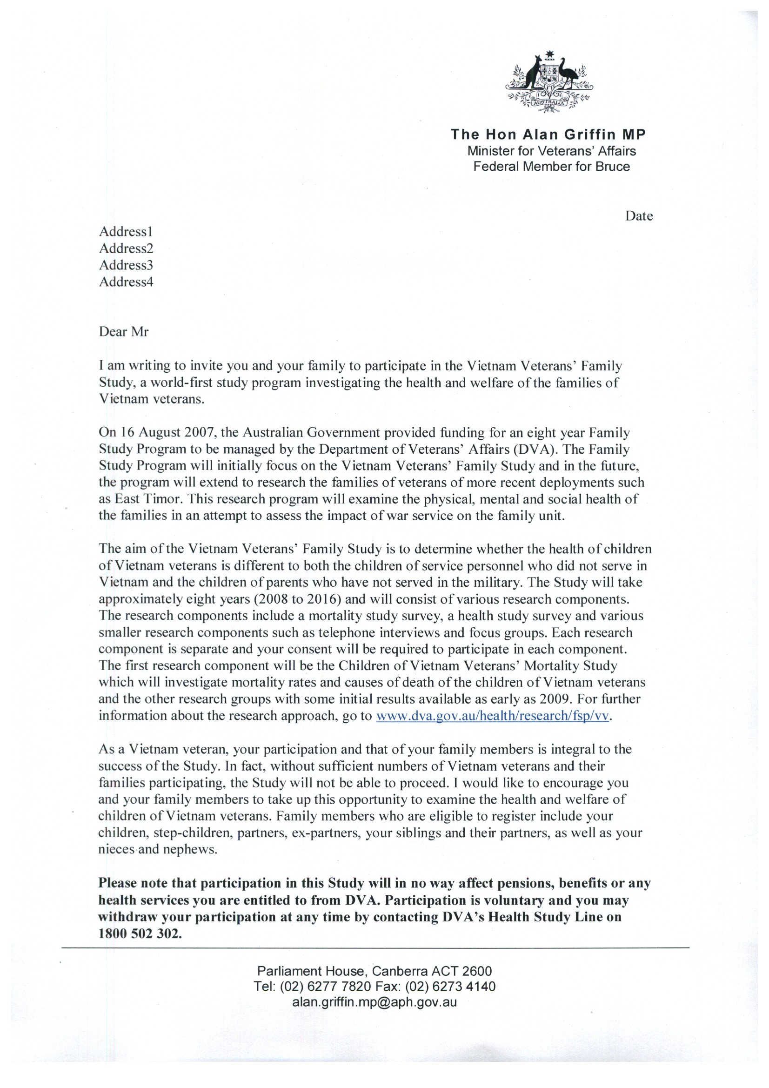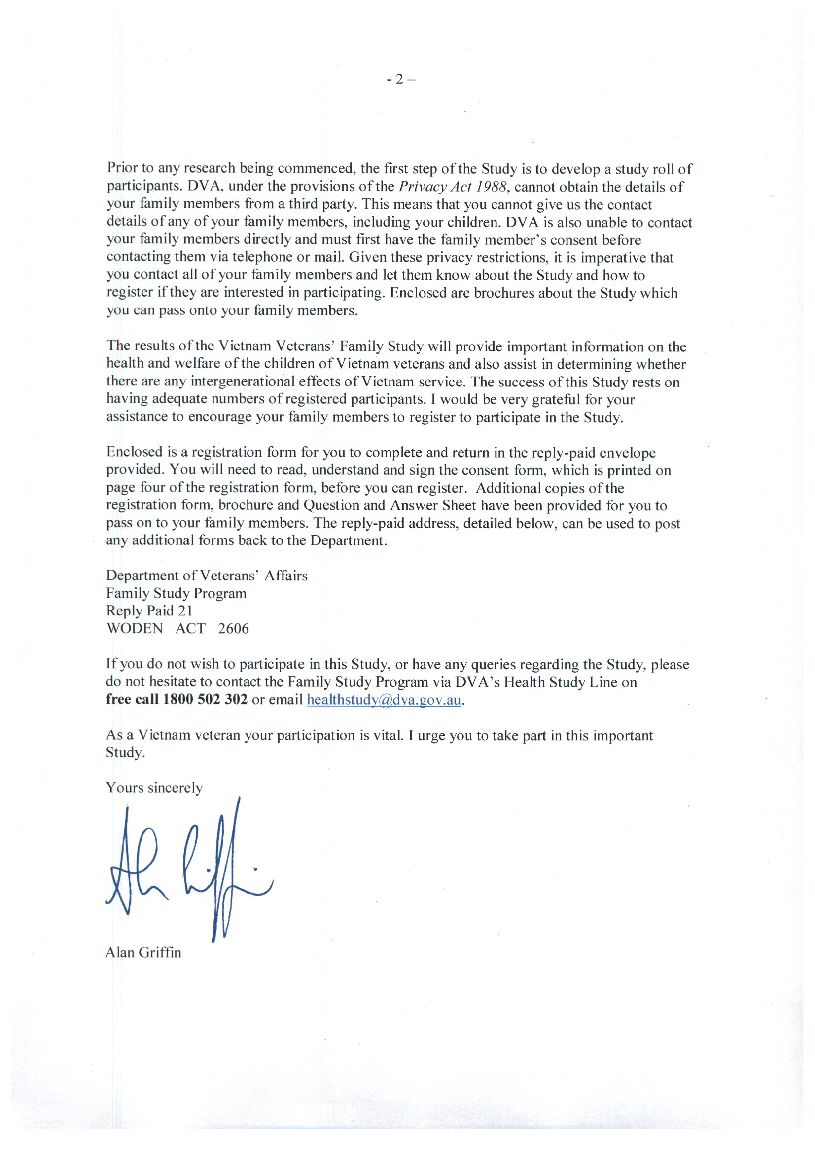

B.2 Invitation to Vietnam-era members

The following form letter was sent to randomly selected Vietnam-era members, inviting them to register for the Vietnam Veterans Family Study.

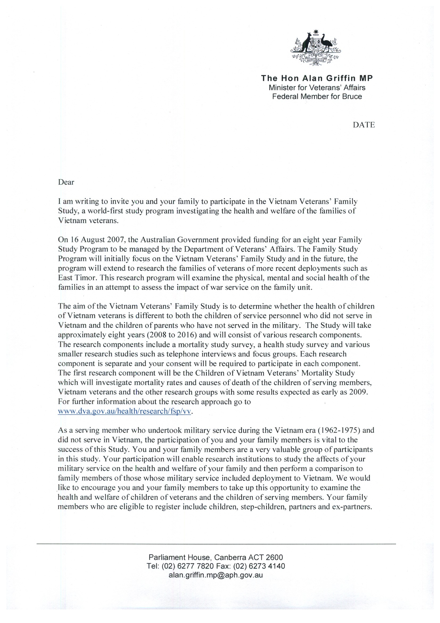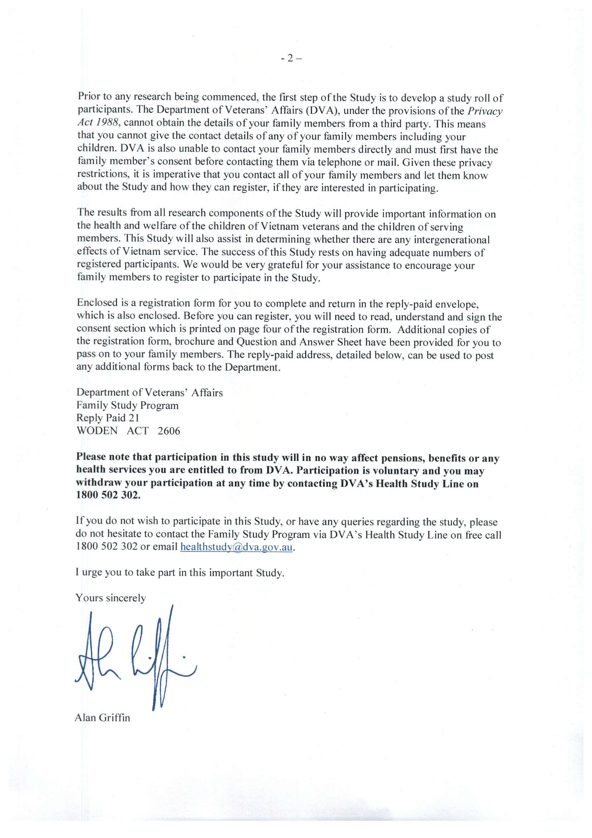

Appendix C Study participants: a summary

Table C.1 Study participants, by participant type, 2 February 2012

|  |  |  |  |  |  |  |  |  |  |  |  |  |  |  |  |
| --- | --- | --- | --- | --- | --- | --- | --- | --- | --- | --- | --- | --- | --- | --- | --- |
| **Participant** | **Randomly selected Vietnam veteran group** | | | **Self-select Vietnam veteran group** | | | **Randomly selected Vietnam-era group** | | | **Self-select Vietnam-era group** | | | **Grand total** | | |
| **Registered participants** | **Respondents** | **% complete** | **Registered participants** | **Respondents** | **% complete** | **Registered participants** | **Respondents** | **% complete** | **Registered participants** | **Respondents** | **% complete** | **Registered participants** | **Respondents** | **% complete** |
| Member survey total | 3,964 | 3,009 | 76.22 | 2,683 | 2,203 | 85.75 | 3,984 | 2,535 | 63.69 | 439 | 343 | 76.54 | 11,070 | 7,983 | 72.11 |
| Child/niece/ nephew survey total | 4,387 | 2,513 | 57.28 | 2,772 | 1,607 | 57.97 | 2,196 | 1,059 | 48.22 | 159 | 63 | 39.62 | 9,514 | 5,242 | 55.10 |
| Son | 1,477 | 733 | 49.63 | 927 | 474 | 51.13 | 882 | 374 | 42.40 | 57 | 22 | 38.60 | 3,343 | 1,603 | 47.95 |
| Daughter | 2,291 | 1,438 | 62.77 | 1,792 | 1,105 | 61.66 | 1,314 | 685 | 52.13 | 102 | 41 | 40.20 | 5,499 | 3,269 | 59.45 |
| Nephew | 260 | 135 | 51.92 | 22 | 7 | 31.82 | – | – | – | – | – | – | 282 | 142 | 50.35 |
| Niece | 359 | 207 | 57.66 | 31 | 21 | 67.74 | – | – | – | – | – | – | 390 | 228 | 58.46 |
| Spouse/sibling survey total | 3,872 | 2,573 | 66.45 | 1,595 | 1,190 | 74.61 | 1,718 | 963 | 56.05 | 132 | 89 | 67.42 | 7,317 | 4,815 | 65.81 |
| Spouse | 2,457 | 1,758 | 71.55 | 1,430 | 1,096 | 76.64 | 1,718 | 963 | 56.05 | 132 | 89 | 67.42 | 5,737 | 3,906 | 68.08 |
| Brother | 589 | 303 | 51.44 | 71 | 37 | 52.11 | – | – | – | – | – | – | 660 | 340 | 51.52 |
| Sister | 757 | 484 | 63.94 | 60 | 43 | 71.67 | – | – | – | – | – | – | 817 | 527 | 64.50 |
| Brother-in-law | 34 | 9 | 26.47 | 17 | 6 | 35.29 | – | – | – | – | – | – | 51 | 15 | 29.41 |
| Sister-in-law | 35 | 19 | 54.29 | 17 | 8 | 47.06 | – | – | – | – | – | – | 52 | 27 | 51.91 |
| Total | 12,223 | 8,061 | 65.95 | 7,050 | 4,969 | 70.48 | 7,898 | 4,522 | 57.26 | 730 | 488 | 66.85 | 27,901 | 18,040 | 64.66 |

Source: Colmar Brunton Social Research Pty Ltd.

Appendix D Consultative Forum and Scientific Advisory Committee membership

D.1 The Consultative Forum

The following individuals were members of the Vietnam Veterans Family Study Consultative Forum:

* Major General Mark A Kelly AO, DSC, Chair—Commissioner, Repatriation Commission and Military Rehabilitation and Compensation Commission—2010 to 2014
* Brigadier Bill Rolfe AO (Ret’d), former Chair—former Commissioner, Repatriation Commission and Military Rehabilitation and Compensation Commission—2008 to 2010
* Dr Roderick Bain—Returned and Services League of Australia and Australian Veterans and Defence Services Council—2008 to 2014
* Mrs Pat Cleggett—Partners of Veterans Association of Australia—2008 to 2014
* Dr David Cockram—Vietnam Veterans Association of Australia—2008 to 2014
* Mr Paul Copeland OAM—Australian Peacekeepers and Peacemakers Association and son of a Vietnam veteran—2008 to 2014
* Reverend Graeme Davis CSM—Vietnam Veterans Federation of Australia—2008 to 2014
* Commodore Mike Dowsett AM (Ret’d)—Defence Force Welfare Association—2008 to 2014
* Mrs Tiffany Naughton (Lane)—daughter of a Vietnam veteran—2008 to 2013
* Dr Ken O’Brien—Vietnam Veterans Association of Australia and son of a Vietnam veteran—2008 to 2014
* Mr Geoff Parker—Children of Vietnam Veterans Health Study Inc.—2008 to 2014
* Mrs Sue Parker—Partners of Veterans Association of Australia—2008
* Mr David Penson CSM—Australian Peacekeepers and Peacemakers Association—2011 (proxy)
* Mrs Janice Properjohn—Vietnam Veterans Association of Australia—2008 to 2014
* Mr John Vincent OAM—The Australian Federation of Totally and Permanently Incapacitated Ex Servicemen and Women Ltd—2008 to 2014
* Mr William (Bill) Wallace—Children of Vietnam Veterans Health Study Inc.—2008 to 2014.

D.2 The Scientific Advisory Committee

The following individuals were members of the Vietnam Veterans Family Study Scientific Advisory Committee:

* Professor Bryan Rodgers, Chair—Australian National University. Expertise: social policy, family and household studies, and mental health
* Dr Paul Jelfs—Australian Bureau of Statistics. Expertise: statistical services, information management, and service delivery
* Professor Ilan Katz—University of New South Wales. Expertise: social policy, family and household studies, and program evaluation and social impact assessment
* Professor Michael Sawyer—University of Adelaide. Expertise: psychology and psychiatry and child and adolescent mental health
* Dr Lyndall Strazdins—Australian National University. Expertise: social policy, family and household studies, and mental health
* Professor Elizabeth Waters—University of Melbourne. Expertise: public health research, with a particular interest in child health.

Shortened forms

|  |  |
| --- | --- |
| ADF | Australian Defence Force |
| AIHW | Australian Institute of Health and Welfare |
| Anzac | Australian and New Zealand Army Corps |
| CATI | computer-assisted telephone interview |
| CMVH | Centre for Military and Veterans’ Health (now the Centre for Australian Military and Veterans’ Health) |
| COVVHS | Children of Vietnam Veterans Health Study Inc. |
| DVA | Department of Veterans’ Affairs |
| ESO | ex-service organisation |
| FSP | Family Studies Program |
| ISA | Independent Scientific Adviser |
| NDI | National Death Index |
| NHMRC | National Health and Medical Research Council |
| PTSD | posttraumatic stress disorder |
| RAAF | Royal Australian Air Force |
| RAN | Royal Australian Navy |
| RSL | Returned and Services League of Australia |
| TPI | Special (Totally and Permanently Incapacitated) Rate of disability pension |
| VVCS | Veterans and Veterans Families Counselling Service—previously known as the Vietnam Veterans Counselling Service |
| VVFS | Vietnam Veterans Family Study |

Glossary

|  |  |
| --- | --- |
| Age standardisation | A method of adjusting the crude mortality rate to eliminate the effect of differences in population age structures when comparing crude rates for different periods, different geographic areas and/or different population subgroups |
| Cohort | A group of subjects who have shared a particular event together at a particular time. Cohorts can be tracked over extended periods in a cohort study |
| Confounding | The distortion of the effect of an exposure on the risk of an outcome as a result of other factors influencing the outcome |
| Conscript | A 20-year-old male civilian registered with the Department of Labour and National Service whose birth date was drawn in a ballot. This made him liable for military service, including ‘special overseas service’, between November 1964 and December 1972. The period of service was two years of full-time military service (later 18 months) and three years on the active reserve list. Men compelled into service in this way were also referred to as National Servicemen |
| Control group | A group of subjects or conditions that is matched as closely as possible with an experimental group (in this instance, Vietnam veterans and their family) but is not exposed to any experimental event (in this instance, service in the Vietnam War). The results are compared in order to determine the changes that may occur as a result of the experimental event (in this instance, operational service in Vietnam) |
| Crude mortality rate | The number of deaths from all causes in an entire population in a given period. Usually expressed as a number per 1,000 or 100,000 population |
| Cumulative hazards | A measure of the risk of dying within a small interval of time, conditional on survival of the individual to the beginning of that period |
| Ethnographic study | The scientific study and description of a group of people and their culture |
| Evidence-based research | Application of the best available scientific research results (evidence) when making decisions about programs and services |
| Exposure | In this instance, a father who experienced operational service in Vietnam |
| Gold Card | Repatriation Health Card for All Conditions (Gold). Entitles the holder to the full range of approved health care services at the Department of Veterans’ Affairs’ expense. This includes medical and allied health care, assistance in the home and support services through arrangements with registered health care service providers and hospitals, both public and private |
| Key participant | Army Vietnam veteran or Army Vietnam-era person who did not deploy to Vietnam |
| Main Survey | In this instance, refers to the quantitative research method involving the administration of a self-report questionnaire |
| Morbidity | The incidence of ill-health in a population |
| Mortality | The incidence of death in a population |
| Mortality curve | A visual representation of data from life tables. Life tables describe the pattern of age-specific mortality and survival rates for a population over a lifetime or a period of study |
| National Death Index | Australian database, held at the Australian Institute of Health and Welfare, that contains records of all deaths occurring in Australia since 1980. The data are obtained from the registrars of births, deaths and marriages in each state and territory |
| National Serviceman | See *Conscript* |
| Nominal Roll of Vietnam Veterans | A database containing information about approximately 61,000 Australian service personnel who experienced operational service in Vietnam |
| Propensity score matching | A statistical matching technique that attempts to estimate the effect of a treatment, policy or other intervention by accounting for the covariates that predict receiving the treatment |
| Proportional mortality | The number of deaths for a given cause of death as a proportion of all deaths |
| Qualitative research | A research technique used to gain insight into the factors underlying a topic through the analysis of non-numerical data gathered through methods such as interviews and open-ended surveys. The aim is to gain an understanding of people’s opinions, feelings, attitudes, motivations, values and perceptions |
| Quantitative research | A research technique in which numerical data are gathered and statistically analysed. The aim is to provide a connection between empirical observation and statistical relationships |
| Randomly selected | In this instance, refers to people who were randomly invited to participate in the Vietnam Veterans Family Study. This ensured that the study sample was representative of the population of Vietnam veterans and their families and minimised any potential bias in the research outcomes |
| Regulars | Men and women who volunteer to join the Australian Defence Force |
| Relative risk | The ratio of the probability of death among the study group (exposed) to the probability of death among a comparison group (non-exposed) |
| Research Protocol | The protocol developed by the Centre for Military and Veterans’ Health to guide the development of research undertaken through the Family Studies Program and, in particular, the Vietnam Veterans Family Study |
| Sample | A set of people whose characteristics represent, as accurately as possible, a broader group of people in a larger population |
| Self-select | In this instance, refers to people who nominated themselves to take part in the Vietnam Veterans Family Study |
| Standardised mortality ratio | A comparison of the number of deaths in an observed population with number of deaths expected in a standard or common population |
| Statistically significant | A pivotal element of statistical hypothesis testing. Used to determine whether a null hypothesis (default position) should be rejected or retained |
| Survey | A research technique that involves asking questions of a sample of respondents using a questionnaire or an interview |
| Unconfirmed deaths | In this instance, reported deaths of children that could not be verified after investigation by the Australian Institute of Health and Welfare |
| Vietnam veteran | For the purposes of this study, a person who served in the Australian armed forces in Vietnam at any time between 1962 and 1975. In this instance, refers to Army personnel only |
| Vietnam War: years of Australian involvement | Australia’s military involvement in Vietnam spanned the period 1962 to 1972, when the last Australian combat forces were withdrawn. Some Australian military personnel, the Embassy Guard, remained in South Vietnam after this but were not engaged in operations. The Vietnam War continued until April 1975, when South Vietnam surrendered to North Vietnam. During the final weeks of the war RAAF personnel were involved in relief operations and evacuations. The war’s end date is therefore 1975, but Australia’s combat involvement ended in 1972 |
| Vietnam-era personnel | For the purposes of this study, people who served in the Australian Defence Force at any time between 1962 and 1975 but did not deploy to Vietnam |
| White Card | Repatriation Health Card for Specific Conditions (White). Entitles the holder to the full range of health care services at the Department of Veterans’ Affairs’ expense but generally only for those disabilities or illnesses accepted as service-related |

References

AIHW 1992, *Dapsone Exposure, Vietnam Service and Cancer Incidence*, Australian Institute of Health and Welfare, Canberra.

AIHW 2000, *Morbidity of Vietnam Veterans: suicide in Vietnam veterans’ children*, Supplementary report no. 1, AIHW cat. no. PHE 25, Australian Institute of Health and Welfare, Canberra.

AIHW 2013, ‘Causes of death’. <http://www.aihw.gov.au/deaths/causes-of-death/>.

Australian Partners and Families of Veterans National Quilt Project 2006, *Pe-ac-ed with Love: transgenerational quilts and stories by widows, partners and families of Australian war veterans*, Australian Partners and Families of Veterans National Quilt Project.

Biddle D, Elliott P, Creamer M, Forbes D & Devilly GJ 2002, ‘Self-reported problems: a comparison between PTSD-diagnosed veterans, their spouses and clinicians’, *Behaviour Research and Therapy*, vol. 40, no. 7, pp. 853–65.

Billson B (Minister for Veterans’ Affairs) 2007, ‘World-first study to examine health of children of Vietnam veterans’, Media release, Parliament House, Canberra, 16 August.

Centre for Military and Veterans’ Health 2007, ‘The intergenerational health effects of service in the military: Research Protocol July 2007’, CMVH, Herston, Queensland, p. 11.

Copeland W, Adair C, Smetanin P, Stiff D, Briante C, Colman I et al. 2013, ‘Diagnostic transitions from childhood to adolescence to early adulthood’, *Journal of Child Psychology and Psychiatry*, vol. 54, pp. 791–9.

COVVHS n.d., Information sheet; 20 September 2003 [cited 13 April 2012]. Available from http://www.covvhs.org.au/New%20Information/Info%20Sheet%2020%20Sept%202003.pdf.

Crane PJ, Barnard DL, Horsley KD & Adena MA 1997a, *Mortality of National Service Vietnam Veterans. A report of the 1996 retrospective cohort study of Australian Vietnam veterans*, Department of Veterans’ Affairs, Canberra.

Crane PJ, Barnard DL, Horsley KD & Adena MA 1997b, *Mortality of Vietnam Veterans: the veteran cohort study. A report of the 1996 retrospective cohort study of Australian Vietnam veterans*, Department of Veterans’ Affairs, Canberra.

Creamer M, Jackson A & Ball R 1996, ‘A profile of help-seeking Australian veterans’, *Journal of Traumatic Stress*, vol. 9, no. 3, pp. 569–75.

DVA 1988a, *Morbidity of Vietnam Veterans: a study of the health of Australia’s Vietnam veteran community*, vol. 1, *Male Vietnam veterans’ survey and community comparison outcomes*, Department of Veterans’ Affairs, Canberra.

DVA 1988b, *Morbidity of Vietnam Veterans: a study of the health of Australia’s Vietnam veteran community*, vol. 3, *Validation study*, Department of Veterans’ Affairs, Canberra.

DVA 2000, *Morbidity of Vietnam Veterans: supplementary report no.1, Suicide in Vietnam veterans’ children*, August, Department of Veterans’ Affairs, Canberra.

DVA 2001a, *Morbidity of Vietnam Veterans: supplementary report no. 2, Adrenal gland cancer, leukaemia and non-Hodgkin’s lymphoma*, rev. edn, October, Department of Veterans’ Affairs, Canberra.

DVA 2001b, *Morbidity of Vietnam veterans: supplementary report no. 3, Multiple sclerosis and motor neurone disease in Vietnam veterans*, May, Department of Veterans’ Affairs, Canberra.

DVA 2006, *The Feasibility of a Study into the Health of Children of Vietnam Veterans*, Commonwealth of Australia, Canberra.

Elliott P, Biddle D, Hawthorne G, Forbes D, Creamer M 2005, ‘Patterns of treatment response in chronic posttraumatic stress disorder: an application of latent growth mixture modelling’, *Journal of Traumatic Stress*, vol. 18, no. 4, pp. 303–11.

Forbes D, Phelps A & McHugh T 2001, ‘Treatment of combat-related nightmares using imagery rehearsal: a pilot study’, *Journal of Traumatic Stress*, vol. 14, no. 2, pp. 433–42.

Forbes D, Phelps AJ, McHugh AF, Debenham P, Hopwood M & Creamer M 2003, ‘Imagery rehearsal in the treatment of posttraumatic nightmares in Australian veterans with chronic combat-related PTSD: 12-month follow-up data’, *Journal of Traumatic Stress*, vol. 16, no. 5, pp. 509–13.

Humphreys L, Westerink J, Giarratano L & Brooks R 1999, ‘An intensive treatment program for chronic posttraumatic stress disorder: 2-year outcome data’, *Australian and New Zealand Journal of Psychiatry*, vol. 33, no. 6, pp. 848–54.

O’Toole BI, Adena, MA & Fett, MJ 1984, *The Australian Veterans Health Studies: the mortality report*, Part II, *Factors influencing mortality rates of Australian National Servicemen of the Vietnam conflict era*, Department of Veterans’ Affairs, Canberra.

O’Toole BI & Catts SV 2008, ‘Trauma, PTSD and physical health: an epidemiological study of Australian Vietnam veterans’, *Journal of Psychosomatic Research*, vol. 64, no. 1, pp. 33–40.

O’Toole BI, Catts SV, Outram S, Pierse KR & Cockburn J 2009, ‘The physical and mental health of Australian Vietnam veterans 3 decades after the war and its relation to military service, combat, and post-traumatic stress disorder’, *American Journal of Epidemiology*, vol. 170, no. 3, pp. 318–30.

O’Toole BI, Catts SV, Outram S, Pierse KR & Cockburn J 2010a, ‘Factors associated with civilian mortality in Australian Vietnam veterans three decades after the war’, *Military Medicine*, vol. 175, no. 2, pp. 88–95.

O’Toole BI, Catts SV, Outram S & Pierse KR 2010b, ‘The mental health of partners of Australian Vietnam veterans three decades after the war and its relation to veteran military service, combat and PTSD’, *Journal of Nervous and Mental Disease*, vol. 198, no. 11, pp. 841–5.

O’Toole BI, Marshall RP, Grayson DA, Schureck RJ, Dobson M, Ffrench M et al. 1996a, ‘The Australian Vietnam veterans health study: I. Study design and response bias’, *International Journal of Epidemiology*, vol. 25, no. 2, pp. 307–18.

O’Toole BI, Marshall RP, Grayson DA, Schureck RJ, Dobson M, Ffrench M et al. 1996b, ‘The Australian Vietnam veterans health study: II. Self-reported health of veterans compared with the Australian population’, *International Journal of Epidemiology*, vol. 25, no. 2, pp. 319–30.

O’Toole BI, Marshall RP, Grayson DA, Schureck RJ, Dobson M, Ffrench M et al. 1996c, ‘The Australian Vietnam veterans health study: III. Psychological health of Australian Vietnam veterans and its relationship to combat’, *International Journal of Epidemiology*, vol. 25, no. 2, pp. 331–40.

Outram S, Hansen V, MacDonell G, Cockburn JD & Adams J 2009, ‘Still living in a war zone: perceived health and wellbeing of partners of Vietnam veterans attending partners’ support groups in New South Wales, Australia’, *Australian Psychologist*, vol. 44, no. 2, pp. 128–35.

Watts B, Schnurr P, Mayo L, Young-Xu Y, Weeks W & Friedman M 2013, ‘Meta-analysis of the efficacy of treatments for posttraumatic stress disorder’, *Journal of Clinical Psychiatry*, vol. 74, pp. e541–e550, <http://www.ptsd.va.gov/Public/understanding_TX/CourseList/Course_NCPTSD_Treatment_1435/assets/00015006.PDF>

Westerink J & Giarratano L 1999, ‘The impact of posttraumatic stress disorder on partners and children of Australian Vietnam veterans’, *Australian and New Zealand Journal of Psychiatry*, vol. 33, no. 6, pp. 841–7.

Wilson EJ, Horsley KW & van der Hoek R 2005a, *Australian National Service Vietnam Veterans: mortality and cancer incidence 2005*, Department of Veterans’ Affairs, Canberra.

Wilson EJ, Horsley KW & van der Hoek R 2005b, *Cancer Incidence in Australian Vietnam Veterans Study 2005*, Department of Veterans’ Affairs, Canberra.

Wilson EJ, Horsley KW & van der Hoek R 2005c. *The Third Australian Vietnam Veterans Mortality Study 2005*, Department of Veterans’ Affairs, Canberra.

Wilson EJ, Horsley KW & van der Hoek R 2007, *Dapsone Exposure and Australian Vietnam Service: mortality and cancer incidence*, Department of Veterans’ Affairs, Canberra.

1. These percentages are based on the sons and daughters in the study because there were fewer fathers than there were sons and daughters. Siblings from the same family were each linked to their father’s information.
2. This was done in order to ensure that the study sample was representative of the population of Vietnam veterans and their families and to minimise any potential bias in the research results.