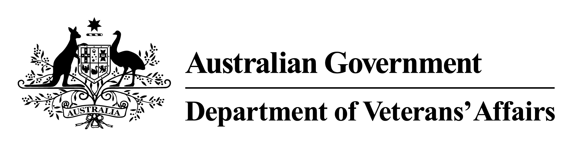

Vietnam Veterans Family Study

VOLUME 3

A Study of Mortality Patterns of Vietnam Veteran Families

October 2014

© Commonwealth of Australia 2014

This work is copyright. Apart from any use as permitted under the *Copyright Act 1968*, no part may be reproduced by any process without prior written permission from the Commonwealth. Requests and inquiries concerning reproduction and rights should be addressed to the publications section, Department of Veterans’ Affairs or emailed to [publications@dva.gov.au](mailto:publications@dva.gov.au).

Published by the Department of Veterans’ Affairs, Canberra, 2014. Publication no. P02092

ISBN 978-0-9941961-0-1 (Volume 1)  
 978-0-9941961-1-8 (Volume 2)  
 978-0-9941961-2-5 (Volume 3)  
 978-0-9941961-3-2 (Volume 4)  
 978-0-9941961-4-9 (full set)  
 978-0-9941961-5-6 (electronic version)

**Suggested citations**

Volume 3, Part One:  
Commonwealth of Australia 2014, *Vietnam Veterans Health Study*. Volume 3, Part One, *A Study of Mortality Patterns of Vietnam Veteran Families*, Canberra.

Volume 3, Part Two  
Forrest W, Edwards B & Daraganova G 2014, *Vietnam Veterans Health Study.* Volume 3, Part Two, *A Study of Mortality Patterns of Vietnam Veteran Families*,Australian Institute of Family Studies, Melbourne.

Copies of this report can be found on the DVA website: [www.dva.gov.au](http://www.dva.gov.au/)

Special note

It is important to remember that this study represents a snapshot of a specific period in the lives of participants, whose health and welfare might well have changed since the time of their involvement. Regrettably, it is not possible to take account of any changed circumstances in the report.

Contents

Summary ix

Part One Analysis of the study data 1

Outline 3

1 Background to the study 9

1.1 Overview of the Mortality Study 9

1.2 Outline of the report 11

2 The study data 13

2.1 Response rates 13

2.2 Preparing the data file for linkage 15

2.3 Linkage to the National Death Index 16

2.4 Unlinked records 20

2.5 Summary and discussion 21

3 Characteristics of the study groups 23

3.1 Descriptive characteristics 23

3.2 Differences in baseline characteristics of the main comparison groups 25

3.3 Differences in baseline characteristics of the study groups by selection method 27

3.4 Summary and discussion 31

4 Mortality rates 33

4.1 Crude rates 33

4.2 Causes of death 35

4.3 Standardised mortality ratios 37

4.4 Relative risk ratios 41

4.5 Life table mortality curves 44

4.6 Sensitivity analysis of unconfirmed deaths 48

4.7 Summary and discussion 52

5 Cumulative hazards of specific causes of death and associated rates 55

5.1 Cumulative hazards of specific causes of death 55

5.2 Summary and discussion 61

6 Discussion 63

6.1 The mortality results 63

6.2 Features of the study 66

6.3 Summary and conclusions 71

Part Two Supplementary analysis of the study data 73

7 Introduction 75

7.1 Propensity score analysis: estimating the impact of Vietnam War service 76

7.2 Representativeness of the Vietnam Veterans Family Study veterans subsample 89

7.3 Differences in crude mortality rates 93

7.4 Conclusion 98

Appendix A Supplementary analysis of unconfirmed deaths 107

Appendix B Mortality Study registration form 111

Appendix C External causes of death: ICD‑10 115

Shortened forms 119

Glossary 121

Bibliography 125

Tables

Table 2.1 Mortality Study response rates 14

Table 2.2 2012 National Death Index linkage results, by sex 20

Table 2.3 Child’s year of birth: unconfirmed deaths 21

Table 2.4 Unconfirmed deaths, by participation group, selection method and sex 21

Table 3.1 Relational characteristics of children 23

Table 3.2 Characteristics of the study population—alive 24

Table 3.3 Characteristics of the study population—deceased 25

Table 3.4 Test for differences in proportion of males between comparison groups 26

Table 3.5 Test for differences in year of birth between comparison groups 26

Table 3.6 Test for differences in age at death between comparison groups 26

Table 3.7 Tests for differences in the proportion of males, by study group and selection method 28

Table 3.8 Tests for differences in age of death, by study group and selection method 28

Table 3.9 Tests for differences in year of birth, by study group and selection method 29

Table 4.1 Mortality outcome of participation groups, by selection method 34

Table 4.2 Number of deaths, by sex and study group: randomly selected groups 35

Table 4.3 Proportion of deaths, by sex and study group: randomly selected groups 36

Table 4.4 Proportional causes of death: randomly selected groups 36

Table 4.5 SMRs for randomly selected children, by sex and participation group: all deaths 39

Table 4.6 SMRs for randomly selected children, by sex and participation group: cancer deaths 39

Table 4.7 SMRs for randomly selected children, by sex and participation group: external deaths 39

Table 4.8 SMRs for randomly selected children, by sex and participation group: suicide 40

Table 4.9 SMRs for randomly selected children, by sex and participation group: other causes 40

Table 4.10 SMRs for self-select children: all deaths 41

Table 4.11 RRs for randomly selected children, by sex and participation group: all deaths 42

Table 4.12 RRs for randomly selected children, by sex and participation group: cancer deaths 43

Table 4.13 RRs for randomly selected children, by sex and participation group: external causes 43

Table 4.14 RRs for randomly selected children, by sex and participation group: suicide 43

Table 4.15 RRs for randomly selected children, by sex and participation group: other causes 44

Table 4.16 RRs for self-select children, by sex and participation group: all deaths 44

Table 4.17 SMR and RR for randomly selected children: deaths at age 5 to 49 years 50

Table 5.1 Mortality rates, by age and sex: all deaths 57

Table 5.2 Mortality rates, by age and sex: cancer deaths 57

Table 5.3 Mortality rates, by age and sex: external deaths 57

Table 5.4 Mortality rates, by age and sex: suicide 58

Table 5.5 Mortality rates, by age and sex: other causes 58

Table 7.1 Variables included in the propensity score analysis 78

Table 7.2 Comparability of VV and VEP subsamples before propensity score weighting 83

Table 7.3 Comparability of VV and VEP subsamples after propensity score weighting 88

Table 7.4 Vietnam veterans in the VVFS sample compared to Vietnam veterans on the Nominal Roll 92

Table 7.5 Unweighted estimates of the percentage of sons and daughters of VV and VEP fathers who have died, by cause of death 95

Table 7.6 Sex-specific differences between the crude mortality rates of sons and daughters of VV and VEP fathers before propensity score analysis, by cause of death 96

Table 7.7 Weighted estimates of the percentage of sons and daughters of VV and VEP fathers who have died, by cause of death 97

Table 7.8 Sex-specific differences between the crude mortality rates of sons and daughters of VV and VEP fathers after propensity score analysis, by cause of death 97

Table A1.1 Logistic regression coefficients of the probability of belonging to the Vietnam veterans subsample 103

Table A1.2 Predicted deployment for both VV and VEP fathers 106

Table A.1 Numbers of confirmed and unconfirmed deaths, by possible cause 107

Table A.2 Numbers of confirmed and unconfirmed deaths, by possible cause: randomly selected sample 108

Table A.3 Numbers of confirmed and unconfirmed deaths, by possible cause: self-select sample 109

Figures

Figure 2.1 Details of the data file compiled from the mortality forms 17

Figure 2.2 Link weights for the study cohort 18

Figure 2.3 Results of National Death Index matching 19

Figure 3.1 Size of study group, by selection method 28

Figure 3.2 Year of birth of children, by participation group and selection method 30

Figure 4.1 Crude mortality rate of participation groups, by selection method 34

Figure 4.2 Mortality curve: all randomly selected female children 46

Figure 4.3 Mortality curve: all randomly selected male children 46

Figure 4.4 Mortality curve: randomly selected female children of Vietnam veterans 47

Figure 4.5 Mortality curve: randomly selected female children of Vietnam-era personnel 47

Figure 4.6 Mortality curve: randomly selected male children of Vietnam veterans 49

Figure 4.7 Mortality curve: randomly selected male children of Vietnam-era personnel 49

Figure 4.8 Mortality curve: female participants assuming unconfirmed deaths occurred before age 5 years 51

Figure 4.9 Mortality curve: male participants assuming unconfirmed deaths occurred before age 5 years 51

Figure 5.1 Cumulative hazards, by sex and study group: all deaths 58

Figure 5.2 Cumulative hazards, by sex and participation group: cancer deaths 59

Figure 5.3 Cumulative hazards, by sex and participation group: external deaths 59

Figure 5.4 Cumulative hazards, by sex and participation group: suicide 60

Figure 5.5 Cumulative hazards, by sex and participation group: other causes of death 60

Summary

The Children of Vietnam Veterans Mortality Study had two primary aims: to establish whether mortality rates for the children of Vietnam veterans were similar to or different from those for children in the general Australian population; and to determine whether the children of Vietnam veterans had an increased risk of mortality compared with the children of Australian Defence Force personnel of that time who were not deployed to the Vietnam War (referred to here as Vietnam-era personnel).

At the time of registration for the Vietnam Veterans Family Study (2008 to 2010) the median year of birth of children of Vietnam veterans enrolled in the study was 1974 (that is, roughly equal numbers were born before 1974 and after 1974). A surviving child born in 1974 would have been 35 years old by 2009, which is well before one would expect to see many deaths from the coronary heart disease, adult cancers, cerebrovascular disease and chronic respiratory disease that bring most lives to an end. Deaths in this earlier period are more likely to be caused by birth complications, congenital problems, SIDS (sudden unexpected death in infancy), early onset cancers, accidents, poisoning and suicide.

The Mortality Study was based on information provided for over 25,000 children born to families enrolled in the Vietnam Veterans Family Study; 738 of these sons and daughters were reported to have died (631 of the deaths being confirmed through linkage to the National Death Index and registers held by the states and territories). The number of confirmed deaths represents less than 3 per cent of the children for whom information was provided, and it was difficult to derive accurate estimates from the data because of the small numbers involved. When different causes of death and the ages of children at the time of their death are considered, the task becomes even more complex.

The findings from the Mortality Study are reported in this volume in two parts, the analyses having been performed by two separate research groups. Part One deals with analyses carried out for the eight groups in the Vietnam Veterans Family Study—that is, the families of randomly selected and self-select Vietnam veterans, randomly selected and self-select Vietnam-era personnel, randomly selected and self-select brothers of Vietnam veterans, and randomly selected and self-select sisters of Vietnam veterans. The initial work had the advantage of covering all the deaths that were confirmed from the various registers, and several different techniques were applied to the analysis of this information. In particular, the Australian Institute of Health and Welfare was able to estimate mortality rates that could be compared with those for the general Australian population and was able to investigate the ages at which the deaths occurred.

The follow-up work, reported in Part Two of this volume, was done by the Australian Institute of Family Studies and focused on a comparison between children of Vietnam veterans and children of Vietnam-era personnel. There were too few children of brothers and sisters of Vietnam veterans—that is, the veterans’ nephews and nieces—to enable meaningful comparison. It was also established that the self-select participants in the study differed in a number of respects from their randomly selected counterparts, such that inclusion of these groups in the comparison between Vietnam veteran and Vietnam-era families could bias the findings. Part Two is based on the randomly selected groups, and its main strength is that it was able to take account of many factors that were found to differ between the fathers in the two groups, even before their military service. These differences were known from the information provided in response to the Vietnam Veterans Family Study Main Survey (reported in Volume 2). In order to make use of this important information, the analysis was restricted to families in which the fathers completed the questionnaire for the Main Survey.

It should be borne in mind that the analyses reported in the two parts of this volume are based on different samples and different numbers of deaths, so the findings cannot be compared directly. Crucially, the two approaches each have their own strengths and weaknesses, and any overall interpretation must take account of this.

Part One

Among the most important findings from Part One are those detailing standardised mortality ratios since these provide the basis for comparison with death rates in the general Australian population. The ‘standardisation’ involved means that the proportion of deaths for any group is expressed by reference to the expected proportion of deaths in an equivalent group (born during the same period) in the general population. When the standardised mortality ratio for a particular group is greater than 1.0, this shows that the group has a higher mortality rate than that in the general population; an SMR less than 1.0 is indicative of lower mortality. The overall death rates for all the children from randomly selected groups in the study—the (randomly selected) sons and daughters of Vietnam veterans, of Vietnam-era personnel, and of siblings of Vietnam veterans—were significantly lower than those for the general population. The SMRs for the sons and the daughters of Vietnam veterans (0.75 and 0.73 respectively) both showed about 25 per cent fewer deaths than expected. It is important to note that the ‘unconfirmed deaths’ (deaths that were not matched to records in the National Death Index or the state and territory registers) were not included in the estimation of standardised mortality ratios. Even if all of these were assumed to be actual deaths, though—and there were reasons for doubting this, as discussed in Appendix A—the SMRs for the Vietnam veterans’ sons and daughters would still be lower than 1.0. When the analysis was extended to take into account the causes of death, it was the mortality rate from ‘other causes’ (that is, neither cancer nor external causes) that was especially low. Deaths from cancers and external causes, including suicides, were closer to the rates in the general population.

Other important findings from Part One arose from direct comparisons of death rates among the children of Vietnam veterans and the children of Vietnam-era personnel. This analysis found no overall differences for cancer deaths or for deaths resulting from ‘other causes’. The deaths attributable to external causes for sons, but not daughters, were significantly higher in the Vietnam veteran group compared with the offspring of Vietnam-era personnel (a relative risk of 1.540 and 0.875 respectively). Here, it is important to note that the numbers of deaths attributable to external causes (78 in the case of sons of Vietnam veterans) were such that findings were at the margins of statistical significance. When suicides specifically were analysed, the differences in rates between sons and daughters of Vietnam veterans and those of Vietnam-era personnel were not statistically significant. Nevertheless, deaths from suicide accounted for a substantial proportion of the deaths from external causes in the sons of Vietnam veterans (24 of the 78 deaths) and thus contributed to the total difference found for external causes. Again, the statistical power of the study places limitations on interpretation of the findings.

The final part of the Australian Institute of Health and Welfare analyses that is pertinent to the difference between offspring of Vietnam veterans and those of Vietnam-era personnel is the estimation of cumulative mortality by age. This can identify the period of risk in which differences in death rates are seen. In the comparisons between the offspring of Vietnam veterans and those of Vietnam-era personnel, there were several instances in which differences did not emerge until the late teenage or adult years, and each of these instances was for sons rather than daughters. This pattern applied to total deaths (all causes), external deaths and deaths from ‘other causes’.

Part Two

The results reported for the Australian Institute of Family Studies analyses need to be considered in the context of two factors: the strengths and weaknesses of the different approaches taken to analysing the mortality data; and the background information on servicemen who enrolled in the Vietnam Veterans Family Study and those who participated in the study’s Main Survey.

One outcome of these additional analyses was that the Vietnam veterans who enrolled in the Family Study and completed the Mortality Study form were in many respects representative of the population of veterans from which they came. Even when statistically significant differences were found, most of these were small. The largest difference found was that 46 per cent of Vietnam veterans who completed the Mortality Study form were National Servicemen compared with about 44 per cent of those on the Nominal Roll of Vietnam Veterans. This could have implications for the standardised mortality ratio estimates in Part One of this volume since National Servicemen were more likely to have higher educational qualifications—as were their children (as reported in Volume 2)— so the SMRs estimated for children of Vietnam veterans could have been biased downwards. This bias does not have the same relevance for comparisons between offspring of Vietnam veterans and those of Vietnam-era personnel because that analysis was designed to adjust for the many differences found between the fathers in the two groups (including whether they were conscripted into the Army under the National Service scheme).

The main analyses reported by the Australian Institute of Family Studies in Part Two concern the adjustments to differences in the mortality of sons and daughters of Vietnam veterans and Vietnam-era personnel, which could have been influenced by the many differences between the fathers in these two groups, even before their military service. For example, the Vietnam veterans were on average about three years older than the Vietnam-era personnel, they were much less likely to have been conscripted into the Army (46 compared with 69 per cent), and they rated their own parents as having been less affectionate and caring during their childhoods than did the sons and daughters in the Vietnam-era group. Such differences were taken into account when comparing the death rates for the sons and daughters using the technique of applying propensity score weights, as used in the Main Survey analyses reported in Volume 2.

The Australian Institute of Family Studies results found that overall death rates (for all causes) were greater among the offspring of Vietnam veterans after the weighting technique was applied, that the Vietnam veteran offspring had higher suicide rates, and that this difference was seen in the sons but not the daughters of the Vietnam veterans. The number of deaths from suicide in both groups of daughters was low compared with the rates for sons, a pattern seen in the general Australian population. Again, it must be emphasised that these findings are at the margins of statistical significance, and the same applies to some of the differences for the broad categories of cause of death that were examined. In view of the period during which these sons and daughters were born, it was to be expected that the very large majority were still living in 2008 to 2010, when the data were collected for the Vietnam Veterans Family Study. It would be informative to see whether more definitive findings emerge if deaths among these sons and daughters are investigated in the future, when mortality rates will be higher.

Conclusion

Taken together, the findings from Parts One and Two, each of which used differing methods of data analysis, provide some broad indications of the mortality outcomes for children of Vietnam veterans. First, the offspring of both groups of veterans—Vietnam War veterans and Vietnam-era personnel who were not deployed to Vietnam—had lower mortality rates than males and females in the general population who were born during the same period. These low death rates compared with the general population were most evident for deaths other than those arising from cancers and external causes. Second, the comparisons between the offspring of Vietnam veterans and those of Vietnam-era personnel gave no indication that the Vietnam veterans’ sons and daughters had any greater likelihood of dying during their childhood years (ages 0 to 14 years). Third, there were indications that the sons and daughters of Vietnam veterans had higher mortality rates than their Vietnam-era counterparts from the late teenage years into adulthood, this trend being more evident among the sons. The elevated mortality rates for sons at older ages were seen across a range of causes of death (but not cancer deaths). Finally, analyses that took account of background information on the fathers in the two key comparison groups suggested that differences between the families even before the fathers’ military service could have contributed to the differences in mortality rates for the sons. This was not, however, the explanation for the elevated suicide rates among the sons of Vietnam veterans. These differences in mortality rates were at the margins of statistical significance, though, and the findings might be clearer if deaths occurring after the 2008 to 2010 data collection period could be investigated in the future.

Part One   
  
Analysis of the study data

# Outline

The Children of Vietnam Veterans Mortality Study is a retrospective cohort study investigating the intergenerational mortality experience of children and siblings of Vietnam veterans and children of a military control group (Vietnam-era personnel). It constitutes one component of a larger multi-tiered study made up of qualitative and quantitative components—the Vietnam Veterans Family Study. Although this report on the Mortality Study is a stand-alone document, it should be read in conjunction with the other volumes reporting on the Vietnam Veterans Family Study in order to understand more fully the health and wellbeing of children of Vietnam veterans.

Study design

After they had registered for the broader Vietnam Veterans Family Study all Vietnam veterans, Vietnam-era personnel and Vietnam veterans’ siblings were sent a Mortality Study form to complete and return to the Department of Veterans’ Affairs. The registration form asked the participant to provide the names and date of birth of all their children (living or dead) and, if dead, the date of death. The children thus identified make up the cohort for the Mortality Study and are from the following participation groups:

* randomly selected Vietnam veterans, or RSVV
* randomly selected Vietnam-era personnel, or RSVEP
* self-select Vietnam veterans, or SSVV
* self-select Vietnam-era personnel, or SSVEP
* the randomly selected Vietnam veterans’ brother group, or RSVVBR
* the randomly selected Vietnam veterans’ sister group, or RSVVSI
* the self-select Vietnam veterans’ brother group, or SSVVBR
* the self-select Vietnam veterans’ sister group, or SSVVSI.

Participants’ names were matched to the National Death Index so as to identify deaths occurring between 1980 and 2009. Registries of birth, deaths and marriages were searched in order to identify deaths occurring before 1980. The period of observation spanned more than 80 years.

Analysis

The Mortality Study used six different types of analysis to assess the mortality experience of children of Vietnam veterans:

* the crude mortality rate
* proportional mortality
* the standardised mortality ratio
* relative risk
* life table mortality curves
* cumulative hazards analysis.

Each type of analysis focused on a slightly different aspect of assessing mortality and builds in complexity from a simple counting of deaths in the crude mortality rate to controlling for age, sex and time over the life course of the participant in the cumulative hazards analysis. Five causes of death were investigated—all causes, cancer, external causes, suicide (a subset of external causes) and an aggregated grouping of all other causes.

Depending on the analysis method, the mortality of children of Vietnam veterans and children of siblings of Vietnam veterans was compared with that of the general Australian population or that of the children of Vietnam-era personnel.

Results

The response rate for the Mortality Study was good. Overall, 75 per cent of those registered for the Vietnam Veterans Family Study completed the mortality form. The cohort consisted of 25,832 children divided into the eight study groups. The number of children in each study group ranged from 78 in the self-select Vietnam veterans’ brother group to 9,181 in the randomly selected Vietnam veterans group.

The analyses show that, compared with the general Australian population, the children of Vietnam veterans and their siblings and the children of the Vietnam-era serving personnel group had lower than expected mortality for all causes of death. This lower than expected overall mortality was largely a result of fewer than expected deaths from the aggregated grouping of all other conditions (apart from cancer or external causes) and from external causes for the male children of Vietnam-era personnel. There were no statistically significant differences for the other causes of death analysed—cancer, external causes and suicide—for any of the other study groups.

In comparing the mortality of children of Vietnam veterans with that of children of fathers who served at the time of the Vietnam War but did not deploy to Vietnam, a difference in mortality was, however, observed. Male children of Vietnam veterans had increased mortality from external causes, including suicide, compared with male children of Vietnam-era personnel. The effect is best demonstrated using cumulative hazards analysis, which shows that the increased mortality seen in male children of Vietnam veterans is confined to those male children over the age of 15 years and is the result of higher than expected mortality due to external causes and other causes that are not external or cancer. There was no difference in mortality for the randomly selected female children of Vietnam veterans compared with the randomly selected female children of Vietnam-era personnel. Similarly, there was no statistically significant difference in mortality for children of the siblings of Vietnam veterans and children of Vietnam-era personnel.

**Mortality rates, by age and sex: external deaths**

|  |  |  |  |  |  |
| --- | --- | --- | --- | --- | --- |
| **Sex** | **Age (years)** | **Vietnam-era personnel** | **Vietnam veterans** | **Relative risk** | **Relative risk 95% CI** |
| Male | All | 0.54 | 0.84 | 1.540 | 1.025, 2.314 |
|  | 0–14 | 0.64 | 0.37 | 0.582 | 0.197, 1.722 |
|  | 15 | 0.52 | 0.93 | 1.791 | 1.141, 2.810 |
| Female | All | 0.94 | 0.82 | 0.875 | 0.477, 1.605 |
|  | 0–14 | 0.91 | 0.53 | 0.579 | 0.178, 1.883 |
|  | 15 | 0.95 | 0.96 | 1.011 | 0.493, 2.073 |

Note: ‘External deaths’ includes suicide.

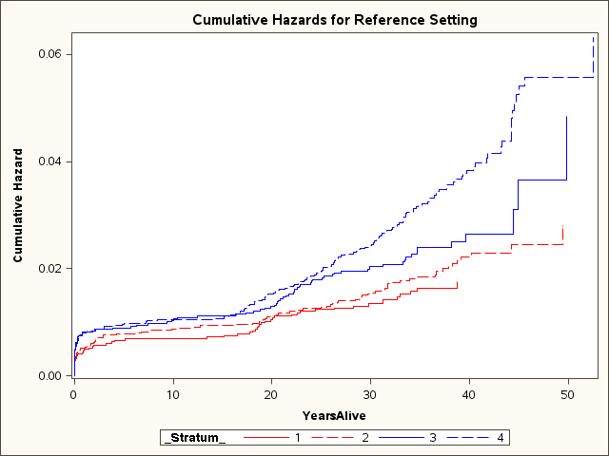

Note: Red = female; blue = male; solid = control; dash = Vietnam veteran.

**Cumulative hazard, by sex and study group: all deaths**

Discussion

The Mortality Study has a number of strengths and limitations. As with any such study, many diseases, disabilities and health conditions are not captured. A mortality study can report only on the extreme endpoint of death, not on the general health of a population that might or might not have a high level of illness (morbidity). Furthermore, the majority of the children in this study were aged less than 60 years and so had not yet lived through the period of major risk for mortality from many physical diseases, including most cancers and cardiovascular diseases.

A randomised selection design was used to obtain the study cohort for the assessment of mortality. The aim of randomisation in selection of a study cohort is to obtain a subgroup that is representative of the whole population. Although the response rate for the Mortality Study was good, the level of registration for the Vietnam Veterans Family Study was low and the representativeness of the study findings needs to be considered. The size of the study groups determined that only the major causes of death could be investigated; no conclusions can be drawn about rarer causes of death. Even so, the number of expected deaths for some of the major causes of death analysed was too small for meaningful analysis or conclusive results.

Because of incomplete data, a number of deaths submitted in the mortality form could not be confirmed. This could result in an underestimation of the mortality rates for the study cohort.

The data from the Mortality Study cannot provide any causal link for the observed increase in mortality. Rather, the study describes an observed association of mortality with a specific study group.

Conclusion

The Children of Vietnam Veterans Mortality Study demonstrates that Vietnam veterans’ male children aged more than 15 years have a higher than expected mortality rate compared with male children of Vietnam-era personnel. The higher observed mortality is created by deaths from external causes and all other conditions (apart from external causes or cancer).

A supplementary analysis carried out by the Australian Institute of Family Studies lends weight to the conclusions of the Mortality Study—see Part Two of this volume.

# Background to the study

The Vietnam Veterans Family Study, a multi-tiered intergenerational health study consisting of qualitative and quantitative components, was established in order to gain a better understanding of the effects of Vietnam War service on the physical, mental and social health of the family members of Australian Vietnam veterans. The work is intended to guide Australian Government policy and initiatives in support of past, present and future military personnel and their families. Volume 1 of the Vietnam Veterans Family Study report describes the origins and nature of the study.

## Overview of the Mortality Study

The Children of Vietnam Veterans Mortality Study is one component of the Vietnam Veterans Family Study. It investigates the mortality rates and causes of death for children of Vietnam veterans and compares these with those for children of Vietnam-era service personnel and the general Australian population.

Overall, the study participants for the Vietnam Veterans Family Study fell into three groups:

* Army Vietnam veterans and their partners, ex-partners, children and stepchildren
* Army personnel who had served between 1962 and 1975 but did not deploy to Vietnam and their partners, ex-partners, children and stepchildren
* siblings of Vietnam veterans and their partners, ex-partners, children and stepchildren.

The study therefore allows for comparison of Vietnam veteran families with other Army families who served during the same era and with their own extended families, thus controlling for military and familial factors.

Volume 1 of the Vietnam Veterans Family Study report provides details of the recruitment process and response rates for the overall study. In brief, potential participants were identified from a random sample of over 10,000 individuals selected from the Nominal Roll of Vietnam Veterans for participation in the veteran group and over 12,000 individuals selected from Army records for the Vietnam-era group. (Oversampling of the Vietnam-era group was to compensate for the expected lower response rate for this group.) Prospective participants were then sent invitation packages, asking them to register for participation in the study. All participants were encouraged to approach their family members (their children, siblings and siblings’ children) and ask them to participate. The Vietnam veteran and Vietnam-era groups were the index participants through whom all other participants were recruited. Between 32 and 37 per cent of index veterans and Vietnam-era personnel invited to participate in the study chose to register. The registration period for the study began in June 2008 and closed in April 2010.

Because of the high degree of community interest in the study, a self-selected group of Vietnam veteran families and Vietnam-era personnel were allowed to register for the study in addition to the randomly selected cohort. These participants were identified and recorded in separate groups. Such separation was necessary in order to avoid introducing a potential bias into the randomised study design and was important for the rigour of the study, especially if there were any systematic differences between the randomly selected participants and the self-selected participants.

Following registration for the broader Vietnam Veterans Family Study, all Vietnam veterans, Vietnam-era personnel and Vietnam veteran siblings were sent a Mortality Study registration form to complete and return to the Department of Veterans’ Affairs. The registration form asked participants to provide the names and date of birth of all their children (living or dead) and, if dead, the date of death. The children thus identified make up the cohort for the Mortality Study and are from the following participation groups:

* randomly selected Vietnam veterans, or RSVV
* randomly selected Vietnam-era personnel, or RSVEP
* self-select Vietnam veterans, or SSVV
* self-select Vietnam-era personnel, or SSVEP
* the randomly selected Vietnam veterans’ brother group, or RSVVBR
* the randomly selected Vietnam veterans’ sister group, or RSVVSI
* the self-select Vietnam veterans’ brother group, or SSVVBR
* the self-select Vietnam veterans’ sister group, or SSVVSI.

Note that, because of the timing of the Mortality Study, deaths occurring after February 2012 are not captured.

Some initial work was done on the Mortality Study by an organisation from the original panel of research organisations drawn together for the Vietnam Veterans Family Study. The Australian Institute of Health and Welfare was also commissioned to match the Mortality Study cohort to the National Death Index and perform the statistical analysis for the study. An independent scientific writer was commissioned to write the final report of the study.

## Outline of the report

Chapter 2 describes the response rate for participants, the development of the cohort database used in the linkage, and the results of linking the cohort data to the National Death Index.

Chapter 3 deals with the characteristics of the study groups and analyses any baseline differences among the groups, consideration being given to the main comparison groups and the two selection methods (random selection versus self-selection).

Chapter 4 examines the overall mortality of the cohort. This analysis has several measurement components:

* *Crude mortality rate.* This is the number of deaths from all causes in an entire population in a given period. It is usually expressed as a number per 1,000 or 100,000 population. The rates are calculated without regard to the characteristics of the population, such as age structure or sex.
* *Proportional mortality.* This calculates the number of deaths for a given cause of death as a proportional of all deaths.
* *Standardised mortality ratio.* This compares the number of deaths in an observed population with the number of deaths expected in a standard population—in this instance, the general Australian population. The method adjusts for time and the age and gender profile of the study population.
* *Relative risk.* This is the ratio of the probability of death among the study group (exposed) to the probability of death among a comparison group (non-exposed).
* *Mortality curves.* These are a visual representation of data from life tables. Life tables describe the pattern of age-specific mortality and survival rates for a population over a lifetime or a period of study.

Chapter 5 investigates the cumulative mortality among the study population and analyses and compares the death rates of the study groups, taking into account changes over time, the cause of death, age, sex and participation group.

Chapter 6 interprets and discusses the findings and their implications.

Part Two provides the results of a supplementary analysis carried out by the Australian Institute of Family Studies; the results of the analysis lend weight to the Mortality Study results.

Appendix A provides the results of a supplementary analysis of unconfirmed deaths, also carried out by the Australian Institute of Family Studies.

Appendix B presents the registration form for the Mortality Study.

# The study data

The data for the Mortality Study were collected from participant families during the nearly two-year registration period for the main Vietnam Veterans Family Study. After children’s names had been obtained from the parents, extensive clerical searches were done in order to identify any pre-1980 deaths. The National Death Index does not contain information on deaths before 1980, so information on these deaths must be obtained from the registries of birth, deaths and marriages or other sources. Several preliminary linkages were done against the National Death Index but, because of methodological problems, a complete re-linkage was performed by the Australian Institute of Health and Welfare in February 2012. This chapter details the recruitment response and data preparation and linkage results for the Mortality Study.

## Response rates

As noted in Chapter 1, more than 10,000 Vietnam veterans and more than 12,000 Vietnam-era personnel were invited to recruit their families into the Vietnam Veterans Family Study. In response to this invitation 3,938 Vietnam veterans and 4,006 Vietnam-era personnel registered for the study and were asked to ask their children, siblings and siblings’ children to also register. In addition, a number of veterans and Vietnam-era personnel who were not randomly selected asked to participate in the study (the self-select participants). All who registered for the study were sent a Mortality Study form so that the study team could develop a list of names and dates of birth for all the children, living and dead, of the registered participants. Table 2.1 details the response rates for the Mortality Study.

The table shows that, overall, 75 per cent of those who registered for the Vietnam Veterans Family Study provided information for the Mortality Study. For the main study’s randomly selected Vietnam veteran group, 83 per cent of those registered provided information about their children for the Mortality Study. The 3,275 Vietnam veterans who responded to the Mortality Study (the index families) represent 30.7 per cent of those randomly selected veterans invited to participate in the main study. Similarly, the 2,612 Vietnam-era control group members who responded to the Mortality Study represent 20.9 per cent of those randomly selected to participate in the main study.

Table 2.1 Mortality Study response rates

|  |  |  |  |  |  |
| --- | --- | --- | --- | --- | --- |
| **Parent participation group** | **Number sent mortality forms (registered for the main study)** | **Number of respondents** | **Response rate (%)** | **Total number of children per group** | **Number of children per family (mean, range)** |
| RSVV | 3,938 | 3,275 | 83.2 | 9,181 | 2.80 (1–9) |
| RSVEP | 4,006 | 2,612 | 65.2 | 7,053 | 2.70 (1–10) |
| SSVV | 2,569 | 2,118 | 82.4 | 5,908 | 2.79 (1–10) |
| SSVEP | 418 | 372 | 89.0 | 1,019 | 2.74 (1–8) |
| RSVVBR | 589 | 380 | 64.5 | 1,069 | 2.81 (1–9) |
| RSVVSI | 750 | 507 | 67.6 | 1,411 | 2.78 (1–9) |
| SSVVBR | 80 | 27 | 33.7 | 78 | 2.89 (1–5) |
| SSVVSI | 76 | 36 | 47.4 | 113 | 3.14 (1–10) |
| **Total** | **12,426** | **9,327** | **75.1** | **25,832** | **2.77 (1–10)** |

The 1,339 randomly selected siblings who registered for the study represent the siblings of 20.7 per cent of the randomly selected Vietnam veteran index families who registered. Of those veterans whose siblings registered, over half had only one sibling registered, there being a range of one to six siblings per family. Thus the 2,480 nieces and nephews in the Mortality Study constitute a small percentage of the children of siblings of all Vietnam veterans.

The self-select sibling group was made up of 191 nieces and nephews from 5.3 per cent of the registered self-select veteran families, there being a range of one to four siblings per family.

The response rate for the main study has implications for the representativeness of the study results in terms of the whole population of children of Vietnam veterans and Vietnam-era personnel. This question of representativeness needs to be borne in mind when interpreting the results, as is discussed more fully in Chapter 6.

## Preparing the data file for linkage

The Department of Veterans’ Affairs supplied the data to the Australian Institute of Health and Welfare in two groups: the ‘living’ children data had 25,319 records; the ‘deceased’ children data contained 838 records. The total number of names compiled on the initial database was thus 26,157. The ‘deceased’ data consisted of those children who were shown as deceased on the survey form or were confirmed dead as a result of the department searching the registries of births, deaths and marriages and other databases; of these 838 records, 197 had a confirmed death status.

Clerical review of the initial databases revealed some anomalies, and the database was corrected. Figure 2.1 shows the process of preparing the data file for linkage.

The database corrections dealt with a number of details. Dates of death for some records were before their dates of birth; these records were amended to insert the correct information obtained from the department. The anomaly also revealed one duplicate record in the ‘deceased’ file.

The data set was then de-duplicated. This involved removing records that had the same family identifier, first and second given names and date of birth, resulting in 55 records being removed from the ‘living’ children file. Analysis of these 55 records showed that they were clear duplicates of other records. This brought the final number in the cohort to 26,101.

Other amendments were also made to the files:

* Many records with missing information on sex were assigned a sex on the basis of their given names. There were only two records for which sex could not be determined from the information provided.
* Four records with an invalid participation group were assigned a valid classification level by the department after an examination of other data files.
* Three records had their date of birth changed from the 1920s to the 1970s. It was assumed the number 7 had been incorrectly entered as a 2 because other siblings in the family were born between 1970 and 1990.
* Some other invalid dates of birth were updated with valid dates of birth provided by the department.
* Sixty-four records had cause of death information added after the original two files had been supplied.

The variables used in the analysis from the cohort were date of birth, sex and participation group. For survival analysis, records with missing information were excluded, as follows:

* Date of birth determines the age of the child; 267 records had been deleted from the cohort for the analysis.
* Sex is a known factor for mortality. The two records for which sex could not be determined were deleted from the cohort for the analysis.

The final cohort file size used in the analysis was 25,832 names, with 25,015 in the ‘living’ file and 817 in the ‘deceased’ file (see Figure 2.1). All results presented here were derived from this reduced file.

## Linkage to the National Death Index

For any mortality study it is necessary to confirm deaths and determine the cause of death by matching with the National Death Index. A database located at the Australian Institute of Health and Welfare, the NDI contains identified records of all deaths in Australia registered after 1980. There are more than 2.5 million records. The registrars of births, deaths and marriages in each Australian state and territory supply the information for the database and, because registration of death is a legal requirement, the database is virtually complete. The data available for matching in the NDI covered all registered deaths for the period from 1980 to January 2012 for all states and territories. For identification of deaths occurring before 1980 the individual births, deaths and marriages registries were searched.

The method used for linking the cohort to the NDI to determine those who have died was probabilistic matching, which involves linking records that are believed to relate to the same individual. The process is described as ‘probabilistic’ because for each linkage there is an associated degree of certainty that the records are correctly paired, just as if the process had been carried out manually. The software package[1] used for the probabilistic matching calculates the likelihood of a correct linkage—that is, the likelihood that the records represent the same individual. The higher the likelihood of a correct linkage, the higher the weight accorded the match. Below a designated cut-off value the weight of the match is deemed too low to be considered a correct linkage, and the records linked are considered to be different individuals.

|  |  |  |
| --- | --- | --- |
| **Total names submitted**  26,157 | | |
| Submitted as living |  | Submitted as deceased |
| 25,319 |  | 838 |
| (–55 duplicates) |  | (–1 duplicate) |
| 25,264 | 26,101 | 837 |
| (–248 no DOB) |  | (–19 no date of birth) |
| 25,016 | 25,834 | 818 |
| (–1 no sex) |  | (–1 no sex) |
| 25,015 | 25,832 | 817 |

Figure 2.1 Details of the data file compiled from the mortality forms

Figure 2.2 shows the link weights to the NDI for the database of the children in the cohort. All records with a link weight of 35 and over were declared links and thus an identified death (the light blue block in Figure 2.2), while all record pairs with a link weight less than 20 were declared non-links—that is, the person is assumed to be alive (the dark blue block in Figure 2.2). Record pairs with weights between 20 and 35 were declared links or non-links by clerically reviewing the pairs.



Note: 21,583 non-links and 191 Department of Veterans’ Affairs deaths excluded.

Figure 2.2 Link weights for the study cohort

A number of previous linkages to the NDI were performed, but several methodological problems were encountered. The Scientific Advisory Committee for the Vietnam Veterans Family Study recommended that a complete re-linkage be done by the Australian Institute of Health and Welfare’s Data Linkage Unit using an improved methodology. The AIHW completed the linkage to the NDI in February 2012, and 434 matches were obtained. Along with the 197 confirmed deaths provided by the Department of Veterans’ Affairs, this meant a total of 631 deaths were identified. The results of these linkages are outlined in Figure 2.3; Table 2.2 details the linkages by sex.

|  |  |  |
| --- | --- | --- |
| **Study roll**  25,832 | | |
| Submitted as living |  | Submitted as deceased |
|  |  |  |
| 25,015 |  | 817 |
|  | (+186)  Confirmed by BD&M or other clerical search |  |
| Incorrect previous match  79 | Confirmed NDI link |
|  |  |
| Unconfirmed deaths  107 | 434 |
|  | 197 |  |
| Alive  25,201 |  | Confirmed deaths  631 |

Note: BD&M = births, deaths and marriages.

Figure 2.3 Results of National Death Index matching

As is evident, of the 817 names listed in the initial ‘deceased’ file, 107 records could not be confirmed as deaths, either by clerical searching or by matching with the NDI. The characteristics of these records are explored in Section 2.4.

Table 2.2 2012 National Death Index linkage results, by sex

|  |  |  |  |  |  |  |
| --- | --- | --- | --- | --- | --- | --- |
| **Sex** | **DVA confirmed deaths** | **Links accepted** | **Links not accepted** | **Records not linked** | **Total** | **Links accepted (%)** |
| Female | 85 | 139 | 1,481 | 11,047 | 12,752 | 1.106 |
| Male | 112 | 295 | 2,157 | 10,516 | 13,080 | 2.286 |
| **Total** | **197** | **434** | **3,638** | **21,563** | **25,832** | **1.703** |

Table 2.2 shows an unusually low percentage of female links compared with what would be expected from community life tables. A possible reason for this is a large number of females changing their family name (as a result of marriage, for example). Another possible reason is that it could reflect a real effect in differences in mortality rates between the males and the females. The low linkage rate has implications for estimating the female mortality rate through possible under-representation*.*

## Unlinked records

One hundred and seven records were submitted to the Department of Veterans’ Affairs as names of deceased children on the survey form but without a date of death accompanying the submission. These names could not be confirmed as either alive or deceased after an extensive follow-up by the department and linkage to the NDI by the Australian Institute of Health and Welfare. Since no official records of these deaths were located, the names were treated as alive throughout the analysis.

Table 2.3 shows that 100 of the 107 unconfirmed deaths had a year of birth before 1980. The NDI only contains comprehensive death records from 1980, so if most of these 107 children died at a young age it would be unlikely that the death could be confirmed through linkage with the NDI.

Table 2.4 shows the distribution of the unconfirmed deaths by participation group, selection method and sex. The analysis in the table is for the randomly selected group only and tests whether the number of unconfirmed deaths is greater in the Vietnam veteran or sibling group compared with the Vietnam-era personnel. The analysis reveals more unconfirmed deaths among the children of Vietnam veterans, although this is significant only for the female children of Vietnam veterans (p-value less than 0.05). To put it another way, 62.6 per cent of the 107 unconfirmed deaths are among the randomly selected participants and, of these, 70.1 per cent (47) are among the children of Vietnam veterans, even though the children of Vietnam veterans group makes up 49.3 per cent (9,181 out of 18,714—see Table 2.1) of the randomly selected study cohort.

Table 2.3 Child’s year of birth: unconfirmed deaths

|  |  |
| --- | --- |
| **Year of birth** | **Frequency** |
| 1951–1959 | 2 |
| 1960–1964 | 11 |
| 1965–1969 | 15 |
| 1970–1974 | 41 |
| 1975–1979 | 31 |
| ≥1980 | 7 |
| **Total** | **107** |

Table 2.4 Unconfirmed deaths, by participation group, selection method and sex

|  |  |  |  |  |  |  |
| --- | --- | --- | --- | --- | --- | --- |
|  |  | **Count** | | | **Random select only** | |
| **Sex** | **Participation group** | **Total** | **Self-select** | **Random select** | **Chi square** | **p-value** |
| Female | Vietnam-era personnel | 5 | 1 | 4 |  |  |
|  | Vietnam veterans | 30 | 12 | 18 | 5.75 | 0.0165 |
|  | Vietnam veterans’ siblings | 2 | 1 | 1 | 0.09 | 0.7682 |
| Male | Vietnam-era personnel | 17 | 5 | 12 |  |  |
|  | Vietnam veterans | 50 | 21 | 29 | 3.35 | 0.0673 |
|  | Vietnam veterans’ siblings | 3 | 0 | 3 | 0.30 | 0.5812 |
| **Total** |  | **107** | **40** | **67** |  |  |

## Summary and discussion

This chapter describes the Children of Vietnam Veterans Mortality Study as consisting of 25,832 names of children from 12,426 index families. About three-quarters of the study participants were from the randomly selected group invited to participate; about a quarter were those who were not randomly selected for the study but wished to provide information to the Mortality Study team.

The response rate for the main study (the Vietnam Veterans Family Study) was poor, with about 35 per cent of those invited to participate registering. In contrast, the response rate for the Mortality Study was good, with 75 per cent of those who registered providing information about their children. Nevertheless, the participants in the Mortality Study constitute only a small proportion of the potential randomly selected study cohort. The implications of the response rate for the representativeness of the study are discussed in Chapter 6.

Clerical review and linking of the 25,832 names to the NDI database confirmed 631 deaths among the cohort of children. There were 107 names that were submitted as deceased but could not be confirmed by clerical review or linkage to the NDI. These names did not have a date of death shown. Because no date of death was supplied, these children could not be confirmed as dead and were assumed to be alive for the purposes of the study. There are two possible reasons why the 107 names submitted had no date of death supplied on the mortality form:

* The wrong box on the mortality form was inadvertently ticked and the child was alive.
* The child had died but the date of death was inadvertently omitted on the mortality form.

If the child had died but the death occurred before 1980, the death could not be detected through the NDI linkage procedure. Similarly, if there is no date of death clerical searching of registries of births, deaths and marriages cannot be done.

The problem of the unconfirmed deaths and how they could affect the final results is explored further in Chapter 4. Understanding other aspects of the study cohort, such as age and sex characteristics, can also provide insights.

# Characteristics of the study groups

As outlined in Chapter 1, there were eight study groups in the Children of Vietnam Veterans Mortality Study. This chapter describes the baseline characteristics of the eight groups and explores any differences in characteristics between the main comparison groups and the randomly selected and self-select groups.

## Descriptive characteristics

The mortality form sent to all registered parent participants sought information for all children in the family—biological, adopted and stepchildren. Table 3.1 provides details of the relational characteristics of the children in the Mortality Study cohort.

Overall, 88.7 per cent of the children in the study were the biological offspring of the parent participants, 2.0 per cent were adopted and 8.4 per cent were stepchildren. One per cent of submitted names of children did not show the nature of the relationship to the parent. The randomly selected Vietnam veterans group and the self-select groups tended to have a higher proportion of stepchildren (approximately 9 per cent) compared with the randomly selected Vietnam-era personnel and the randomly selected combined sibling groups (7.7 and 5.5 per cent respectively).

Table 3.1 Relational characteristics of children

|  |  |  |  |  |  |
| --- | --- | --- | --- | --- | --- |
| **Parent participation group** | **Number of children per group** | **Number (%)** | | | |
| **Biological** | **Adopted** | **Stepchild** | **Unknown** |
| RSVV | 9,181 | 8,045 (87.6) | 196 (2.1) | 847 (9.2) | 93 (1.0) |
| RSVEP | 7,053 | 6,300 (89.3) | 138 (2.0) | 542 (7.7) | 73 (1.0) |
| SSVV | 5,908 | 5,241 (88.7) | 103 (1.7) | 516 (8.7) | 48 (0.8) |
| SSVEP | 1,019 | 882 (86.6) | 35 (3.3) | 99 (9.7) | 3 (0.3) |
| RSVVBR | 1,069 | 962 (90.0) | 22 (2.1) | 63 (5.9) | 22 (2.1) |
| RSVVSI | 1,411 | 1,307 (92.6) | 22 (1.6) | 73 (5.2) | 9 (0.6) |
| SSVVBR | 78 | 74 (94.9) | 0 | 3 (3.8) | 1 (1.3) |
| SSVVSI | 113 | 94 (83.2) | 1 (0.9) | 16(14.1) | 2 (1.8) |
| **Total** | **25,832** | **22,905 (88.7)** | **517 (2.0)** | **2,159 (8.4)** | **251 (1.0)** |

The other baseline characteristics for the Mortality Study cohort were sex, year of birth and, for those who died, year of death. Table 3.2 shows that the median year of birth for the study participants was between 1974 and 1977. There was, however, a wide range of birth years between the study groups. The year of birth for the children of self-select Vietnam veterans spans 77 years between the oldest and youngest child, whereas the year of birth for the children of the self-selected brothers of Vietnam veterans spans 39 years.

As expected, the overall proportion of male children is approximately 52 per cent. The self-select Vietnam veteran and Vietnam-era personnel groups did, however, contain fewer male children than female children.

Table 3.2 Characteristics of the study population—alive

|  |  |  |  |
| --- | --- | --- | --- |
| **Participation group** | **Number** | **Proportion male (%)** | **Median year of birth (range)** |
| RSVV | 8,925 | 50.99 | 1974 (1938–2009) |
| RSCG | 6,919 | 50.89 | 1977 (1937–2009) |
| SSVV | 5,749 | 49.81 | 1974 (1931–2008) |
| SSCG | 998 | 48.18 | 1975 (1949–2006) |
| RSVVBR | 1,044 | 52.48 | 1975 (1945–2006) |
| RSVVSI | 1,377 | 50.82 | 1974 (1949–2008) |
| SSVVBR | 77 | 50.00 | 1977 (1962–2001) |
| SSVVSI | 112 | 52.21 | 1977 (1954–2000) |
| **Total** | **25,201** | **51.90** | **1975 (1931–2009)** |

Table 3.3 details the characteristics of the deceased cohort. Male children are over-represented among the 631 deceased children. The median age of death for the deceased cohort is just under 20 years, with a range from infancy to 53 years. The median age of death for the randomly selected Vietnam-era group is several years younger than for the other study groups.

Table 3.3 Characteristics of the study population—deceased

|  |  |  |  |  |
| --- | --- | --- | --- | --- |
| **Participation group** | **Number** | **Proportion male (%)** | **Median year of birth (range)** | **Median age of death (range)** |
| RSVV | 256 | 65.52 | 1973 (1951–1994) | 21.24 (0–52.54) |
| RSVEP | 134 | 61.16 | 1975 (1954–2003) | 16.42 (0–49.83) |
| SSVV | 159 | 64.78 | 1972 (1956–1986) | 20.13 (0–50.58) |
| SSVEP | 21 | 57.14 | 1971 (1962–1996) | 18.35 (0–43.08) |
| RSVVBR | 25 | 72.00 | 1970 (1945–1985) | 25.17 (0–45.25) |
| RSVVSI | 34 | 70.59 | 1970 (1954–1987) | 20.08 (0–53.12) |
| SSVVBR | 1 | .. | .. | .. |
| SSVVSI | 1 | .. | .. | .. |
| **Total** | **631** | **64.50** | **1973 (1945–2003)** | **19.82 (0–53.12)** |

.. Confidential.

## Differences in baseline characteristics of the main comparison groups

The Mortality Study used a randomised design to select participants from the Nominal Roll of Vietnam Veterans and a list of Vietnam-era personnel. Randomisation should help limit any biases between the group of interest and the control group (the Vietnam-era personnel), so that the effect of deployment to Vietnam can best be assessed. Nevertheless, it is necessary to check if the randomisation process resulted in groups that do not have significant differences in baseline characteristics. A second study group—the children of the brothers and sisters (siblings) of the randomly selected Vietnam veterans—was used in the study to assess any familial effects on mortality.

Tables 3.4 to 3.6 assess for any differences between the main comparison groups. For the following analysis the randomly selected brothers and sisters groups are combined to form a randomly selected sibling group. A maximum-likelihood chi-squared test was used to determine if there was a statistically significant difference between the RSVEP and the RSVV and sibling groups for the sex ratio of the children. For the analysis in Table 3.4, p‑values greater than 0.5 demonstrate that there is no significant difference in the sex ratios between the groups.

Table 3.4 Test for differences in proportion of males between comparison groups

|  |  |  |  |  |
| --- | --- | --- | --- | --- |
| **Group** | **Number** | **Proportion male (%)** | **2 statistic** | **p-value** |
| RSVEP | 7,053 | 50.89 |  |  |
| RSVV | 9,181 | 50.99 | 0.0158 | 0.8999 |
| RSVV siblings | 2,480 | 51.53 | 0.3065 | 0.5798 |

A non-parametric Kolmogorov–Smirnov test was used to determine if the year of birth differed between the comparison groups. The Kolmogorov–Smirnov test is sensitive to any differences in shape, spread or median in the distribution of two groups. Table 3.5 demonstrates a statistically significant difference in age structure between the RSVEP and the RSVV and sibling groups, the RSVEP group being younger (born later) than the other two groups.

Table 3.5 Test for differences in year of birth between comparison groups

|  |  |  |  |  |  |  |  |  |
| --- | --- | --- | --- | --- | --- | --- | --- | --- |
| **Group** | **Number** | **Minimum** | **Quartile 1** | **Median** | **Quartile 3** | **Maximum** | **K–S statistic** | **p-value** |
| RSVEP | 7,053 | 1937 | 1973 | 1977 | 1981 | 2009 |  |  |
| RSVV | 9,181 | 1938 | 1970 | 1974 | 1978 | 2009 | 12.306 | <.0001 |
| RSVV siblings | 2,480 | 1945 | 1969 | 1974 | 1981 | 2008 | 8.5075 | <.0001 |

Note: K–S = Kolmogorov–Smirnov test.

A non-parametric Kolmogorov–Smirnov test was used to determine whether the age at death differed between the comparison groups (see Table 3.6). Among those who died, the median age at death in the RSVEP was several years earlier than that for the RSVV or the sibling group.

Table 3.6 Test for differences in age at death between comparison groups

|  |  |  |  |  |  |  |  |  |
| --- | --- | --- | --- | --- | --- | --- | --- | --- |
| **Group** | **Number** | **Minimum** | **Quartile 1** | **Median** | **Quartile 3** | **Maximum** | **K–S statistic** | **p-value** |
| RSVEP | 134 | 0 | 0.23 | 16.42 | 22.89 | 49.83 |  |  |
| RSVV | 256 | 0 | 1.43 | 21.42 | 31.63 | 52.54 | 2.1101 | 0.0003 |
| RSVV siblings | 59 | 0 | 0.98 | 20.56 | 33.07 | 53.12 | 1.5697 | 0.0145 |

Note: K–S = Kolmogorov–Smirnov test.

## Differences in baseline characteristics of the study groups by selection method

Random selection is considered a preferred method for ensuring an unbiased representative sample of the whole population of interest. Before combining the randomly selected and self-select groups it was necessary to assess whether the self-select group differed from the randomly selected group in any fundamental characteristics. If such a difference is observed, combining the groups without proper adjustments in the analysis could introduce bias into the study and potentially produce inaccurate results that are not representative of the rest of the population. The following analysis examines whether there are differences between groups as a result of the selection method.

Figure 3.1 shows the distribution of children in each participation group. As is evident, the proportional contribution of the self-select participants to each study group varies. An additional 39 per cent of participants are self-selected in the Vietnam veteran group, whereas only 12.6 per cent are self-selected in the VEP group and approximately 7 per cent are self-selected in the sibling groups.

A maximum-likelihood chi-squared test was used to determine if the sex ratio of the children differed between the randomly selected and self-select groups. Although the proportion of males for the self-select VV, VEP and VVBR groups was lower than for the randomly selected group, the p-value in Table 3.7 is greater than 0.05 for all groups, which means there is no statistically significant difference in sex ratios among the groups based on the selection method.

A non-parametric Kolmogorov–Smirnov test was used to determine if the age at death of the children differed between the randomly selected and self-select groups. The p-value in Table 3.8 is greater than 0.05 for all groups, which means there is no statistically significant difference between the age at death based on the selection method.



Note: Zero missing observations.

Figure 3.1 Size of study group, by selection method

Table 3.7 Tests for differences in the proportion of males, by study group and selection method

|  |  |  |  |  |  |  |
| --- | --- | --- | --- | --- | --- | --- |
| **Group: children of** | **Random select (*N* total)** | **Self-select (*N* total)** | **Random select (%)** | **Self-select (%)** | **2 statistic** | **p-value** |
| VV | 9,181 | 5,908 | 51.0 | 48.8 | 1.9750 | 0.1599 |
| VEP | 7,053 | 1,019 | 50.9 | 48.2 | 2.5998 | 0.1069 |
| VVBR | 1,069 | 78 | 52.5 | 50.0 | 0.1791 | 0.6722 |
| VVSI | 1,411 | 113 | 50.8 | 52.2 | 0.0817 | 0.7750 |

Table 3.8 Tests for differences in age of death, by study group and selection method

|  |  |  |  |  |  |  |
| --- | --- | --- | --- | --- | --- | --- |
| **Group: children of** | **Random select (*N* total)** | **Self-select (*N* total)** | **Random median year (range)** | **Self-select median year (range)** | **K–S statistic** | **p-value** |
| VV | 256 | 159 | 21.42 (0–52.5) | 20.13 (0–50.6) | 0.5484 | 0.9244 |
| VEP | 134 | 21 | 16.42 (0–49.8) | 18.35 (0–43.1) | 0.6465 | 0.7973 |
| VVBR | 25 | 1 | 25.17 (0–45.3) | .. | 0.7452 | 0.6352 |
| VVSI | 34 | 1 | 20.08 (0–53.1) | .. | 0.6957 | 0.7183 |

.. Confidential.  
Note: K–S = Kolmogorov–Smirnov test.

A non-parametric Kolmogorov–Smirnov test was used to determine if the year of birth for the children differed between the randomly selected and self-select groups. The p-value in Table 3.9 is less than 0.05 for all groups, which means there is a statistically significant difference for the year of birth between the groups based on the selection method. Any analysis of life expectancy needs to take this into account since survival rates change over time.

Table 3.9 Tests for differences in year of birth, by study group and selection method

|  |  |  |  |  |  |  |
| --- | --- | --- | --- | --- | --- | --- |
| **Group: children of** | **Random select (*N* total)** | **Self-select (*N* total)** | **Random median year (range)** | **Self-select median year (range)** | **K–S statistic** | **p-value** |
| VV | 9,181 | 5,908 | 1974 (1938–2009) | 1974 (1931–2008) | 2.4230 | <0.0001 |
| VEP | 7,053 | 1,019 | 1977 (1937–2009) | 1975 (1949–2006) | 5.0942 | <0.0001 |
| VVBR | 1,069 | 78 | 1975 (1945–2006) | 1977 (1962–2001) | 1.4541 | 0.0291 |
| VVSI | 1,411 | 113 | 1974 (1949–2008) | 1977 (1954–2000) | 2.4854 | <0.0001 |

Note: K–S = Kolmogorov–Smirnov test.

The difference in age structure between the study groups for both the randomly selected and self-select groups and the main comparison groups is shown in Figure 3.2. The histograms overlay years of birth for randomly selected children and self-select children by participation group. The children of brothers and sisters of Vietnam veterans are combined into a sibling group. The height of the bars shows the number of children in an age group.

The histograms illustrate a number of points about the differences in the age structure of the study groups. In the panel for the children of Vietnam-era personnel, the shape of the histogram for the self-select children is flatter and shifted to the left of the graph compared with the histogram for the randomly selected group. This means the self-select children are born earlier (are older) than the randomly selected children. The height of the self-select histogram also shows the relatively small contribution of self-select participants to the control group (that is, the Vietnam-era personnel).

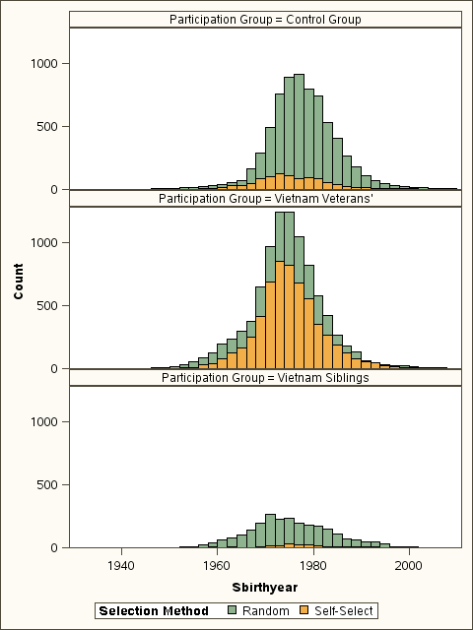

Figure 3.2 Year of birth of children, by participation group and selection method

In the children of Vietnam veterans panel, both the randomly selected and the self-select histograms show a similar shape. The spread of the range of birth dates is, however, broader for the self-select group (71 versus 77 years—see Table 3.9) and thus indicates a differing age structure. The height of the self-select histogram also shows the relatively large contribution of self-select participants to the children of Vietnam veteran group.

In the children of Vietnam veterans’ siblings panel, the self-select children are born later (are younger) than the randomly selected children and contribute a small number of children to this participation group.

Differences in age structure between the children of the randomly selected Vietnam veteran and Vietnam-era personnel groups—the main comparison groups for the study—can also be seen by comparing the top two histograms. The histogram for the birth year distribution for the children of randomly selected Vietnam veterans is narrower and to the left of the histogram for the children of the randomly selected Vietnam-era personnel. This means the children of Vietnam veterans are older and a greater proportion are in a narrower age range compared with the children of the Vietnam-era personnel.

## Summary and discussion

There are several important differences in the baseline characteristics of the study groups. Among the main randomly selected groups there tends to be a higher proportion of children of Vietnam veterans who are part of a blended family compared with the Vietnam-era comparison group and the nieces and nephews of Vietnam veterans. The children of the Vietnam-era personnel are younger and have a younger age at death than the children of Vietnam veterans, and these differences are statistically significant.

The self-select participants have an age structure that differs from that of their randomly selected counterparts. These differences are all statistically significant, but the nature of the difference varies between groups. The self-select participants in the Vietnam-era comparison group are significantly older than the corresponding randomly selected group, whereas the children of siblings in the self-select group are significantly younger than those in the corresponding randomly selected group.

The age structure of a study population is a major confounding factor for the mortality experience of that population. It will affect the number of deaths observed, the mortality rate, and the conditions that cause death. For example, for every 100,000 boys under the age of 5 years in Australia in 1955, 42 could be expected to die of an infectious disease. Twenty years later only 14 boys in that age group would die from this condition. The overall death rate for children under 5 nearly halved during the same period. As another example, in 1960 young men between the ages of 15 and 24 years incurred a rate of 70 deaths from motor vehicle accidents for every 100,000 men; 10 years later that rate had increased to 97 (AIHW 2004).

The different age structures among the study groups, as shown in Figure 3.2 and confirmed by statistical analysis, have important implications for the analysis of the mortality experience among this cohort and the interpretation of the results. The following chapters present several different mortality analyses. Each of them deals with, in different ways, the various parameters (age, sex, time and comparison group) that can influence the mortality experience in a study population. Use of multiple analysis methods allows a more coherent picture of the mortality experience for children of Vietnam veterans to be provided.

# Mortality rates

This chapter analyses the mortality experience of the study cohort using several different but related methods. Although each method has its strengths and limitations, all of them contribute to a greater understanding of the cohort.

## Crude rates

As noted in Chapter 1, the crude mortality rate is a calculation of the number of deaths from all causes across an entire population; in this study the population is the individual participation group. It is a simple measure that does not take into account any of the many factors that can influence mortality.

Table 4.1 gives the raw counts for the calculation of crude mortality rates for all the participation groups. This information is also shown in Figure 4.1. The crude death rates are similar between the randomly selected and self-select groups within a participation group. Among the randomly selected groups, children of the Vietnam-era personnel exhibit a lower crude death rate than children in the Vietnam veteran or sibling group. The results for the brother and sister groups for the self-select children should be viewed with caution since the number of deaths is too small to be meaningful in this analysis. For example, if the relevant cell in Table 4.1 had increased by one death, the crude death rate would double.

A crude mortality rate is easy to obtain and a useful measure when comparing similar populations, but it is not adjusted for sex or year of birth. Sex and age are major factors that can influence mortality. As shown in Chapter 3, the participation groups in this study have significantly different age structures. Thus, crude mortality rates should be seen as only the first step in understanding the mortality experience in a study group.

Table 4.1 Mortality outcome of participation groups, by selection method

|  |  |  |  |
| --- | --- | --- | --- |
| **Group: children of** |  | **Random** | **Self-select** |
| Vietnam veteran member | Accepted link/death | 256 | 159 |
|  | Population size | 9,181 | 5,908 |
|  | Crude death rate | 0.0279 | 0.0269 |
| Vietnam-era member | Accepted link/death | 134 | 21 |
|  | Population size | 7,053 | 1,019 |
|  | Crude death rate | 0.0190 | 0.0206 |
| Vietnam veteran brother | Accepted link/death | 25 | 1 |
|  | Population size | 1,069 | 78 |
|  | Crude death rate | 0.0234 | 0.0128 |
| Vietnam veteran sister | Accepted link/death | 34 | 1 |
|  | Population size | 1,411 | 113 |
|  | Crude death rate | 0.0241 | 0.0088 |



Note: Zero missing observations.

Figure 4.1 Crude mortality rate of participation groups, by selection method

## Causes of death

Of the 25,832 records in the study cohort, 631 children had a death record. There were 27 records for which the cause of death, or CoD, was unknown. Twenty of these children died after 2010 and their CoD was not available at the time of preparing this report. Of the 604 records with a known CoD, 80 deaths were related to cancer, 258 deaths were related to an external cause (74 of them suicide) and 273 deaths were related to other causes. (‘Other’ CoD is one that is not cancer or an external cause.)

Some records fell into more than one category. For example, a person would be considered to have died from multiple causes of death if they died of cancer and an external cause. The CoD would be attributed to both cancer and external causes.

Of the 604 deaths with a known cause, 449 occurred in the randomly selected groups. In keeping with the original study protocol, the majority of analyses in this chapter focus on the randomly selected participants only. Table 4.2 gives a breakdown of the different causes of death by sex and participation group for the randomly selected groups only. Table 4.3 shows the proportion of deaths for each of the major causes of death, and Table 4.4 provides the details of the other causes of death for the randomly selected study population.

Table 4.2 Number of deaths, by sex and study group: randomly selected groups

|  |  |  |  |  |  |  |  |
| --- | --- | --- | --- | --- | --- | --- | --- |
| **Sex** | **Group** | **Deceased** | **Cancer** | **External** | | **Other causes** | **Unknown** |
| **Suicide** | **Other** |
| Male | VEP | 82 | 11 | 9 | 23 | 34 | 5 |
|  | VV | 167 | 15 | 24 | 54 | 71 | 5 |
|  | VV siblings | 42 | 5 | 3 | 19 | 14 | 2 |
| Female | VEP | 52 | 7 | 2 | 16 | 25 | 2 |
|  | VV | 89 | 18 | 6 | 18 | 46 | 4 |
|  | VV siblings | 17 | 3 | 0 | 3 | 9 | 2 |
| **Total** |  | **449** | **59** | **44** | **133** | **199** | **20** |

Note: Columns are not additive: people can have multiple causes of death.

Table 4.3 Proportion of deaths, by sex and study group: randomly selected groups

|  |  |  |  |  |  |  |  |
| --- | --- | --- | --- | --- | --- | --- | --- |
| **Sex** | **Group** | **Deceased** | **Cancer** | **External** | | **Other causes** | **Unknown** |
| **Suicide** | **Other** |
| Male | VEP | 0.0228 | 0.0031 | 0.0025 | 0.0064 | 0.0095 | 0.0014 |
|  | VV | 0.0357 | 0.0032 | 0.0051 | 0.0115 | 0.0152 | 0.0011 |
|  | VV siblings | 0.0329 | 0.0039 | 0.0023 | 0.0149 | 0.0110 | 0.0016 |
| Female | VEP | 0.0150 | 0.0020 | 0.0006 | 0.0046 | 0.0072 | 0.0006 |
|  | VV | 0.0198 | 0.0040 | 0.0013 | 0.0040 | 0.0102 | 0.0009 |
|  | VV siblings | 0.0141 | 0.0025 | 0.0000 | 0.0025 | 0.0075 | 0.0017 |
| **Total** |  | **0.0240** | **0.0032** | **0.0024** | **0.0071** | **0.0106** | **0.0011** |

Note: Columns are not additive: people can have multiple causes of death.

Table 4.4 Proportional causes of death: randomly selected groups

|  |  |
| --- | --- |
| **Cause** | **Per cent** |
| External other | 31 |
| Cancer | 14 |
| Congenital malformations, deformations and chromosomal abnormalities | 11 |
| Certain conditions originating in the perinatal period | 10 |
| Suicide | 10 |
| Disease of the circulatory system | 6 |
| Diseases of the respiratory system | 4 |
| Symptoms, signs and abnormal clinical and laboratory findings, not elsewhere classified | 4 |
| Certain infectious and parasitic disease | 3 |
| Diseases of the nervous system | 3 |
| Endocrine, nutritional and metabolic disease | 2 |
| Diseases of the digestive system | 1 |
| Mental and behavioural disorders | 1 |

The majority of deaths in the study groups were the result of external causes, such as motor vehicle accidents and injuries. There were 44 suicides identified, half of these occurring among the male children of Vietnam veterans. As would be expected in this relatively young cohort, there were relatively few cancer-related deaths. Among the most common conditions included in other causes of death were perinatal conditions, congenital malformations, and diseases of the respiratory or circulatory systems.

This information represents raw death counts and is not adjusted for the statistically significant difference in the age structure of the different study groups in the cohort. The following analyses adjust for this age difference in investigating the mortality of children of Vietnam veterans.

## Standardised mortality ratios

In order to determine if mortality patterns in the children of the veterans cohort differ from those experienced in the Australian population, a standardised mortality ratio approach was taken. This method compares the number of deaths among children of Vietnam veterans, children of siblings of Vietnam veterans and children of Vietnam-era personnel with the number expected if the Australian mortality pattern was applied to the population at risk. The expected number of deaths was derived by multiplying the person-years for each age and calendar year in the cohort by the corresponding Australian mortality rate. Standardised mortality ratio analysis has been used in past studies of Vietnam veterans’ mortality (Wilson et al. 2005b).

The standardised mortality ratio, or SMR, is a measure of the relative mortality rate between the cohort and the reference population (in this instance, the Australian population). An SMR greater than 1.0 indicates higher death rates in the cohort compared with the Australian population, adjusted for age and calendar year; an SMR less than 1.0 reflects lower death rates in the cohort than in the comparison population. On its own, the SMR is not sufficient to say whether the group of interest experienced significantly higher or lower rates of mortality than might be expected: differences can arise by chance. The SMR is, however, the best estimate of the difference between the cohort group and the Australian population, and the 95 per cent confidence interval gives an indication of the precision of that estimate. A narrow 95 per cent confidence interval is indicative of good precision: the true SMR is likely to lie within a narrow range of values. A wide 95 per cent confidence interval is indicative of poor precision.

An SMR of 1.0 shows there is no difference in mortality between the children of Vietnam veterans and the Australian community. A 95 per cent confidence interval that does not include the value 1.0 shows that the calculated SMR is significantly different from 1.0 and therefore unlikely to be due to chance; in other words, there could be a real difference between the study group and the Australian population. For example, an SMR of 1.22 with a 95 per cent confidence interval of 1.1 to 1.4 is statistically significant because the interval does not include 1.0; if the 95 per cent confidence interval was 0.9 to 1.5 the difference would not be statistically significant because the interval includes 1.0.

### SMRs for the randomly selected cohort

Table 4.5 shows that for male and female children from all participation groups the overall mortality rate for all causes is less than that for the same-aged Australian population. The 95 per cent confidence intervals exclude 1.0, and the results are therefore statistically significant.

Among the randomly selected study participants the rate of death from cancer was not significantly different from that in the Australian population, as shown in Table 4.6. Any participation group for which the expected number of deaths is five or fewer is excluded from the tables because the number is too small to be meaningful in this analysis.

Table 4.7 shows that male children of randomly selected Vietnam-era personnel had a statistically significant lower death rate from external causes. The death rate from external causes for all other randomly selected participation groups did not differ from that of the Australian population.

For the children of Vietnam-era personnel and children of Vietnam veterans the rate of death from suicide was not statistically different from that among the Australian population (see Table 4.8). The number of deaths from suicide is, however, relatively small, and there is limited power to detect a significant difference in this type of analysis.

The rate of death from all other causes was lower than expected for all participation groups compared with the same-aged Australian population, and these results are statistically significant (see Table 4.9).

Table 4.5 SMRs for randomly selected children, by sex and participation group: all deaths

|  |  |  |  |  |  |
| --- | --- | --- | --- | --- | --- |
| **Sex** | **Group** | **Observed deaths** | **Expected number** | **SMR** | **95% CI** |
| Male | Vietnam-era personnel | 82 | 140.14 | **0.59** | **0.46, 0.71** |
|  | Vietnam veteran | 167 | 223.20 | **0.75** | **0.63, 0.86** |
|  | VV siblings | 42 | 59.22 | **0.71** | **0.49, 0.92** |
| Female | Vietnam-era personnel | 52 | 78.57 | **0.66** | **0.48, 0.84** |
|  | Vietnam veteran | 89 | 121.30 | **0.73** | **0.58, 0.89** |
|  | VV siblings | 17 | 31.70 | **0.54** | **0.31, 0.86** |

Table 4.6 SMRs for randomly selected children, by sex and participation group: cancer deaths

|  |  |  |  |  |  |
| --- | --- | --- | --- | --- | --- |
| **Sex** | **Group** | **Observed deaths** | **Expected number** | **SMR** | **95% CI** |
| Male | Vietnam-era personnel | 11 | 10.20 | 1.08 | 0.54, 1.93 |
|  | Vietnam veteran | 15 | 17.99 | 0.83 | 0.47, 1.37 |
| Female | Vietnam-era personnel | 7 | 9.13 | 0.77 | 0.31, 1.58 |
|  | Vietnam veteran | 18 | 16.19 | 1.11 | 0.66, 1.76 |

Table 4.7 SMRs for randomly selected children, by sex and participation group: external deaths

|  |  |  |  |  |  |
| --- | --- | --- | --- | --- | --- |
| **Sex** | **Group** | **Observed deaths** | **Expected number** | **SMR** | **95% CI** |
| Male | Vietnam-era personnel | 32 | 58.89 | **0.54** | **0.36, 0.73** |
|  | Vietnam veteran | 78 | 93.21 | 0.84 | 0.65, 1.02 |
|  | VV siblings | 22 | 24.34 | 0.90 | 0.53, 1.28 |
| Female | Vietnam-era personnel | 18 | 19.25 | 0.94 | 0.55, 1.48 |
|  | Vietnam veteran | 24 | 29.31 | 0.82 | 0.49, 1.15 |
|  | VV siblings | 3 | 7.61 | 0.39 | 0.08, 1.15 |

Table 4.8 SMRs for randomly selected children, by sex and participation group: suicide

|  |  |  |  |  |  |
| --- | --- | --- | --- | --- | --- |
| **Sex** | **Group** | **Observed deaths** | **Expected number** | **SMR** | **95% CI** |
| Male | Vietnam-era personnel | 9 | 16.29 | 0.55 | 0.25, 1.05 |
|  | Vietnam veteran | 24 | 26.10 | 0.92 | 0.55, 1.29 |
|  | VV siblings | 3 | 6.72 | 0.45 | 0.09, 1.31 |
| Female | Vietnam veteran | 6 | 5.64 | 1.06 | 0.39, 2.32 |

Table 4.9 SMRs for randomly selected children, by sex and participation group: other causes

|  |  |  |  |  |  |
| --- | --- | --- | --- | --- | --- |
| **Sex** | **Group** | **Observed deaths** | **Expected number** | **SMR** | **95% CI** |
| Male | Vietnam-era personnel | 34 | 71.06 | **0.48** | **0.32, 0.64** |
|  | Vietnam veteran | 71 | 112.00 | **0.63** | **0.49, 0.78** |
|  | VV siblings | 14 | 30.05 | **0.47** | **0.25, 0.78** |
| Female | Vietnam-era personnel | 25 | 50.19 | **0.50** | **0.30, 0.69** |
|  | Vietnam veteran | 46 | 75.80 | **0.61** | **0.43, 0.78** |
|  | VV siblings | 9 | 19.87 | **0.45** | **0.21, 0.86** |

### SMRs for the self-select cohort

Table 4.10 shows the SMRs for the self-select groups. The sibling group is excluded because the number of deaths was too small for meaningful analysis. The analysis shows that for the male children of self-select participants there was lower than expected mortality compared with the same-aged Australian population. This result is similar to that for the randomly selected male children. A different result is, however, seen for the female children of the self-select group. For the female children of the self-select Vietnam-era personnel group the mortality rate is not statistically different from that for the Australian population. The number of deaths in this group is small, though, so this result should be viewed with caution. For the female children of the self-select Vietnam veteran group, a statistically significant higher mortality rate is evident compared with that for the same-aged female Australian population.

Table 4.10 SMRs for self-select children: all deaths

|  |  |  |  |  |  |
| --- | --- | --- | --- | --- | --- |
| **Sex** | **Group** | **Observed deaths** | **Expected number** | **SMR** | **95% CI** |
| Male | Vietnam-era personnel | 12 | 22.25 | **0.54** | **0.28, 0.94** |
|  | Vietnam veteran | 103 | 133.20 | **0.77** | **0.62, 0.92** |
| Female | Vietnam-era personnel | 9 | 13.84 | 0.65 | 0.30, 1.23 |
|  | Vietnam veteran | 56 | 34.73 | **1.61** | **1.19, 2.03** |

## Relative risk ratios

Another way of understanding the mortality experience of a study cohort is to compare the observed numbers of deaths in the two groups for a direct comparison between the children of the Vietnam veterans and the children of the Vietnam-era personnel. This measure is obtained by dividing the ratio of (observed/expected) numbers of deaths for the children of Vietnam veterans by that for the children of the comparison groups who did not go to Vietnam. This value is called the relative risk ratio, or RR.

An RR of 1.00 means the mortality experience is equal in the two subgroups. An RR of, say, 0.88 means that the rate in the first subgroup (in this study the children of the Vietnam veterans) is 0.88 times, or 12 per cent less than, that in the second subgroup (in this study the children of the Vietnam-era personnel, the comparison group), while an RR of 1.12 indicates an elevation of 12 per cent in the death rate. The precision and statistical significance of the RR is indicated by the 95 per cent confidence interval, as described for the SMR calculations.

### RRs for the randomly selected cohort

Table 4.11 shows that the relative risk of death from all causes was not statistically different for the children of the Vietnam veterans and the children of the siblings of Vietnam veterans compared with the children of the Vietnam-era personnel. The point estimate of RR for the male children of Vietnam veterans is, however, elevated and the 95 per cent confidence interval approaches statistical significance.

Table 4.12 shows that there was not a statistically significant difference in the rate of death from cancer between the children of the Vietnam veterans and those of the Vietnam-era personnel. There were too few expected deaths among the children of the siblings of Vietnam veterans for meaningful analysis, so this group is excluded from the table.

Male children of the Vietnam veterans had a significantly higher rate of death from external causes compared with the male children of the Vietnam-era personnel. There was no statistically significant difference in deaths from all external causes for the other comparisons (see Table 4.13). Deaths from external causes among the female children of the siblings of Vietnam veterans were too few for meaningful analysis and are excluded from the table.

Table 4.14 shows that there were no statistically significant differences in death by suicide for children of Vietnam veterans compared with children of Vietnam-era personnel. The point estimates of the RR for the male and female children of Vietnam veterans are elevated, but the 95 per cent confidence intervals are wide, indicating a lack of precision. Expected deaths from suicide among the female children of the siblings of Vietnam veterans were too few for meaningful analysis and are excluded from the table.

Deaths from all other causes were not statistically different between the children of Vietnam veterans or the children of the siblings of Vietnam veterans compared with the children of the Vietnam-era personnel (see Table 4.15).

Table 4.11 RRs for randomly selected children, by sex and participation group: all deaths

|  |  |  |  |  |  |
| --- | --- | --- | --- | --- | --- |
| **Sex** | **Group** | **Observed deaths** | **Expected number** | **Relative risk** | **95% CI** |
| Male | Vietnam-era personnel | 82 | 140.14 |  |  |
|  | Vietnam veteran | 167 | 223.20 | 1.279 | 0.99, 1.66 |
|  | VV siblings | 42 | 59.22 | 1.212 | 0.84, 1.74 |
| Female | Vietnam-era personnel | 52 | 78.57 |  |  |
|  | Vietnam veteran | 89 | 121.30 | 1.109 | 0.79, 1.55 |
|  | VV siblings | 17 | 31.70 | 0.810 | 0.47, 1.39 |

Table 4.12 RRs for randomly selected children, by sex and participation group: cancer deaths

|  |  |  |  |  |  |
| --- | --- | --- | --- | --- | --- |
| **Sex** | **Group** | **Observed deaths** | **Expected number** | **Relative risk** | **95% CI** |
| Male | Vietnam-era personnel | 11 | 10.20 |  |  |
|  | Vietnam veteran | 15 | 17.99 | 0.773 | 0.36, 1.67 |
| Female | Vietnam-era personnel | 7 | 9.13 |  |  |
|  | Vietnam veteran | 18 | 16.19 | 1.451 | 0.61, 3.45 |

Table 4.13 RRs for randomly selected children, by sex and participation group: external causes

|  |  |  |  |  |  |
| --- | --- | --- | --- | --- | --- |
| **Sex** | **Group** | **Observed deaths** | **Expected number** | **Relative risk** | **95% CI** |
| Male | Vietnam-era personnel | 32 | 58.89 |  |  |
|  | Vietnam veteran | 78 | 93.21 | **1.540** | **1.02, 2.31** |
|  | VV siblings | 22 | 24.34 | 1.663 | 0.97, 2.84 |
| Female | Vietnam-era personnel | 18 | 19.25 |  |  |
|  | Vietnam veteran | 24 | 29.31 | 0.875 | 0.48, 1.60 |
|  | VV siblings | 3 | 7.61 | 0.422 | –1.59, 0.84 |

Table 4.14 RRs for randomly selected children, by sex and participation group: suicide

|  |  |  |  |  |  |
| --- | --- | --- | --- | --- | --- |
| **Sex** | **Group** | **Observed deaths** | **Expected number** | **Relative risk** | **95% CI** |
| Male | Vietnam-era personnel | 9 | 16.29 |  |  |
|  | Vietnam veteran | 24 | 26.10 | 1.664 | 0.78, 3.56 |
|  | VV siblings | 3 | 6.72 | 0.808 | –1.39, 1.21 |
| Female | Vietnam-era personnel | .. | .. |  |  |
|  | Vietnam veterans | 6 | 5.64 | 1.925 | 0.39, 9.45 |

.. Confidential.

Table 4.15 RRs for randomly selected children, by sex and participation group: other causes

|  |  |  |  |  |  |
| --- | --- | --- | --- | --- | --- |
| **Sex** | **Group** | **Observed deaths** | **Expected number** | **Relative risk** | **95% CI** |
| Male | Vietnam-era personnel | 34 | 71.06 |  |  |
|  | Vietnam veteran | 71 | 112.00 | 1.325 | 0.88, 1.98 |
|  | VV siblings | 14 | 30.05 | 0.974 | 0.53, 1.80 |
| Female | Vietnam-era personnel | 25 | 50.19 |  |  |
|  | Vietnam veteran | 46 | 75.80 | 1.218 | 0.75, 1.97 |
|  | VV siblings | 9 | 19.87 | 0.909 | 0.43, 1.94 |

### RRs for the self-select cohort

Table 4.16 shows the RR analysis for the self-select children. Female children of the self-select Vietnam veteran group had a statistically significant higher death rate for all causes compared with the female children of the Vietnam-era personnel.

Table 4.16 RRs for self-select children, by sex and participation group: all deaths

|  |  |  |  |  |  |
| --- | --- | --- | --- | --- | --- |
| **Sex** | **Group** | **Observed deaths** | **Expected number** | **Relative risk** | **95% CI** |
| Male | Vietnam-era personnel | 12 | 22.25 |  |  |
|  | Vietnam veterans | 103 | 133.20 | 1.434 | 0.80, 2.58 |
|  | VV siblings | 1 | 4.03 | 0.460 | 0.06, 3.46 |
| Female | Vietnam-era personnel | 9 | 13.84 |  |  |
|  | Vietnam veterans | 56 | 34.73 | **2.479** | **1.24, 4.96** |
|  | VV siblings | 1 | 2.05 | 0.751 | 0.10, 5.79 |

## Life table mortality curves

Mortality curves derived from life tables represent the mortality experience over the entire lifetime of a cohort of people born during a relatively short period. This method compares the mortality experience of the study population by age during the course of the study period. It controls for age and mortality rates over time. The method is essentially an SMR analysis in five-year age groups.

The figures in this section show a comparison between the observed mortality rate for the randomly selected groups (Vietnam veterans and Vietnam-era personnel) and the Australian population (AIHW 2013). Five-year age categories were used because this provided a large enough number of records for a meaningful comparison. The graphs were not extended past age 50 years due to the small number of records in this age range, resulting in a lack of precision for the analysis. The dotted lines in the figures (red for females and blue for males) are the mortality rates for the Australian population for a given age and time. The asterisk represents the observed mortality rate within a given age range. The vertical bar is the error bar and a representation of the 95 per cent confidence interval, as described. The error intervals are based on a binomial model (probability of dying within the age interval) and the sample size of the study. If the error bar crosses the dotted line (the Australian population mortality rate) the observed mortality rate is not different from that for the Australian population.

The analysis in this section is confined to the randomly selected children of the Vietnam veterans and the Vietnam-era personnel. The sibling groups are too small for meaningful results.

### Overall mortality by sex

Figure 4.2 shows that, for all females in the randomly selected cohort, the 0–4 year age categories had fewer deaths than expected. Figure 4.3 shows that, for all males, the 0–4 and the 10–14 year age ranges had fewer deaths than expected. Mortality rates for all other age categories were not significantly different from those for the Australian population.

### Female mortality by study group

Figures 4.4 and 4.5 compare the observed mortality rate in the study for the randomly selected female children of the Vietnam veterans and Vietnam-era personnel with that in the general Australian population. Figure 4.4 (children of Vietnam veterans) shows that the 0–4 year age category had fewer deaths than expected. Figure 4.5 shows that the 0–4 year age category also had fewer deaths than expected, while the 15–19 year age category had more deaths than expected. All other age categories had mortality rates that were not significantly different from those in the general Australian population.

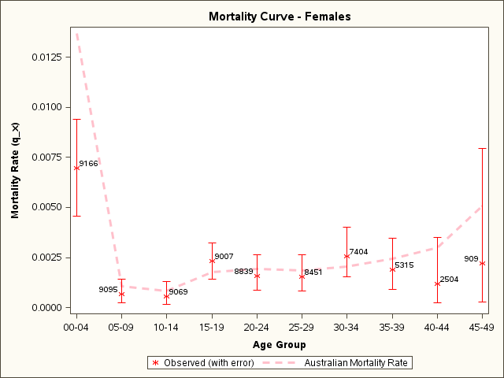

Figure 4.2 Mortality curve: all randomly selected female children

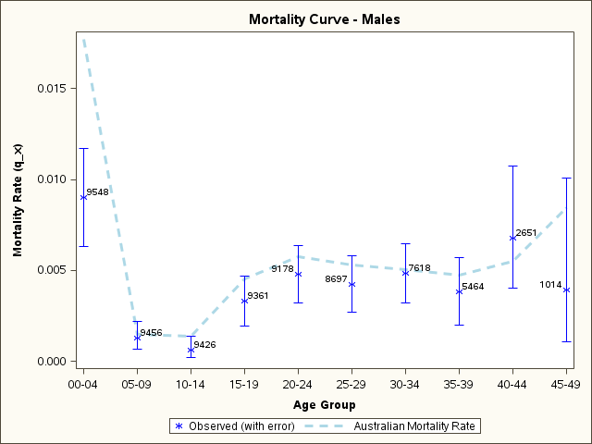

Figure 4.3 Mortality curve: all randomly selected male children

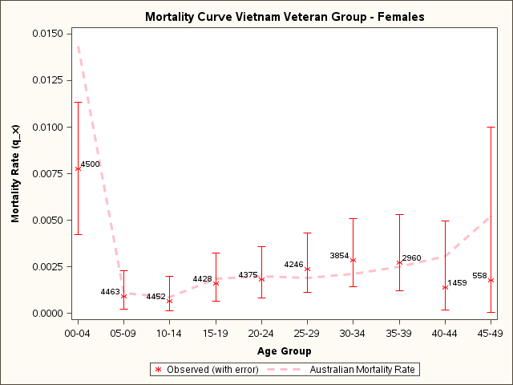

Figure 4.4 Mortality curve: randomly selected female children of Vietnam veterans

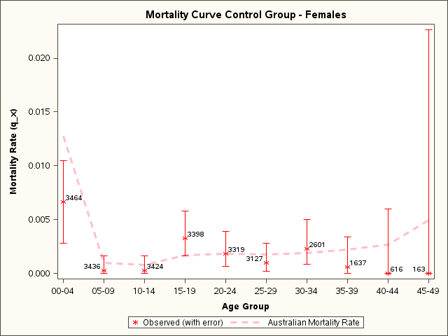

Figure 4.5 Mortality curve: randomly selected female children of Vietnam-era personnel

### Male mortality by study group

Figures 4.6 and 4.7 compare the observed mortality rate for males in the study with that in the general Australian population. Figure 4.6 shows that for male children of Vietnam veterans, the 0–4 and the 10–14 year age categories had fewer deaths than expected. Figure 4.7 shows that, for the children of the Vietnam-era personnel, the 0–4, 15–19 and 25–29 year age categories had fewer deaths than expected. All other age categories had mortality rates that were not significantly different from those in the general Australian population.

## Sensitivity analysis of unconfirmed deaths

The SMR analysis in Section 4.2 shows that for all study groups the mortality rates were significantly lower than in the general Australian population. The mortality curves in Section 4.5 demonstrate that this lower mortality rate seems to be primarily a consequence of fewer than expected deaths in the 0–4 age range. These results, taken together with the unconfirmed deaths discussed in Chapter 2, would suggest that the study is missing some deaths in the 0–4 age category that probably occurred before 1980. If various assumptions about the data are made, a sensitivity analysis can be performed in order to gain an understanding of the probable effect of these missing deaths on the overall results.

Assuming that most of the unconfirmed deaths relate to deaths that occurred before 1980 and therefore could not reliably be found through linkage with the National Death Index, Table 2.3 shows that only seven births (6 per cent) occurred in 1980 or later and any subsequent deaths could be expected to have been captured in the NDI. If the remaining 100 unconfirmed deaths (94 per cent) had all occurred in 1980, the median age of death would have been 5 years while the mean age would have been 9 years. Continuing with this assumption, most of the unconfirmed deaths would have occurred before 1980, rather than in 1980. It can therefore be concluded that the majority of the unconfirmed deaths probably occurred below the age of 5 years.

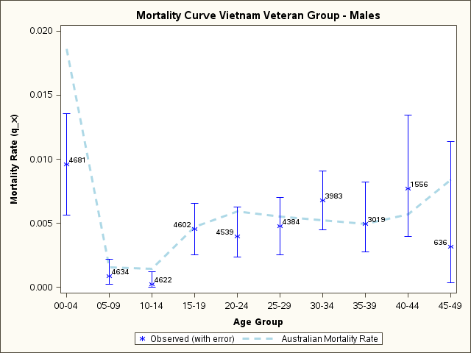

Figure 4.6 Mortality curve: randomly selected male children of Vietnam veterans

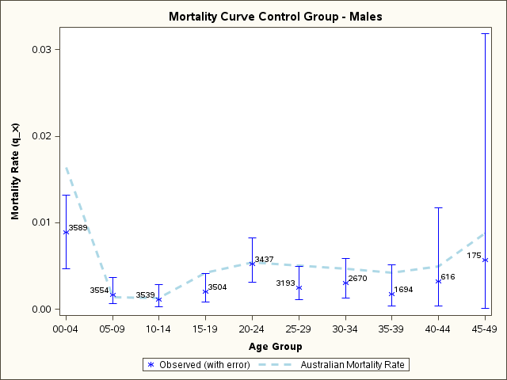

Figure 4.7 Mortality curve: randomly selected male children of Vietnam-era personnel

Assuming that all these 107 deaths occurred before the child reached the age of 5 years, the conclusion can be drawn that the data are most complete for those deaths that occurred after the age of 4 years. The SMR analysis can be done for study participants between the ages of 5 and 49 years. Table 4.17 shows the results of this analysis. As shown in the SMR analysis in Section 4.2, all study groups had a lower than expected mortality rate compared with that for the general Australian population. For those people who were at risk of dying between the ages of 5 and 49 years (inclusive), however, only the male children of the Vietnam-era personnel still have a statistically significant lower mortality rate compared with the Australian population. When compared with the male children of the Vietnam-era personnel in the RR analysis, male children of Vietnam veterans have a significantly higher mortality rate. The mortality rate of all other study groups does not differ significantly from that for the Australian population or the control group.

Table 4.17 SMR and RR for randomly selected children: deaths at age 5 to 49 years

|  |  |  |  |  |  |  |  |
| --- | --- | --- | --- | --- | --- | --- | --- |
| **Sex** | **Group** | **Observed deaths** | **Expected number** | **SMR** | **95% CI** | **RR** | **95% CI** |
| Male | Vietnam-era personnel | 50 | 80.75 | **0.62** | **0.45, 0.79** |  |  |
|  | Vietnam veteran | 121 | 133.60 | 0.91 | 0.74, 1.07 | **1.46** | **1.06, 2.02** |
|  | Siblings | 32 | 35.33 | 0.91 | 0.59, 1.22 | 1.46 | 0.95, 2.26 |
| Female | Vietnam-era personnel | 29 | 34.15 | 0.85 | 0.54, 1.16 |  |  |
|  | Vietnam veteran | 54 | 55.77 | 0.97 | 0.71, 1.23 | 1.14 | 0.79, 1.78 |
|  | Siblings | 10 | 14.70 | 0.68 | 0.33, 1.25 | 0.80 | 0.39, 1.63 |

Another sensitivity analysis can be performed using life table mortality curves. Assuming all these 107 deaths occurred before the child reached 5 years of age, updates to the mortality curves can be made. Figures 4.8 and 4.9 show that for both males and females there are still fewer than expected deaths for children in the first five years of life, although this deficit is not nearly as marked.

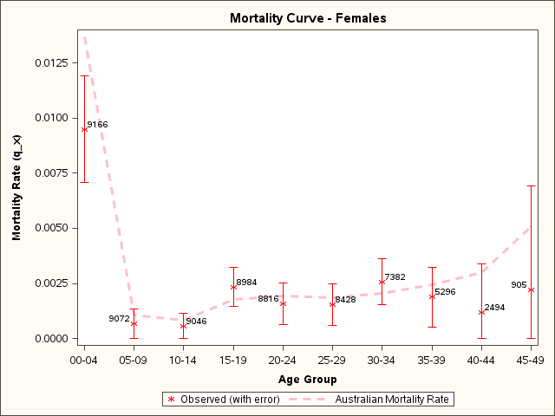

Figure 4.8 Mortality curve: female participants assuming unconfirmed deaths occurred before age 5 years

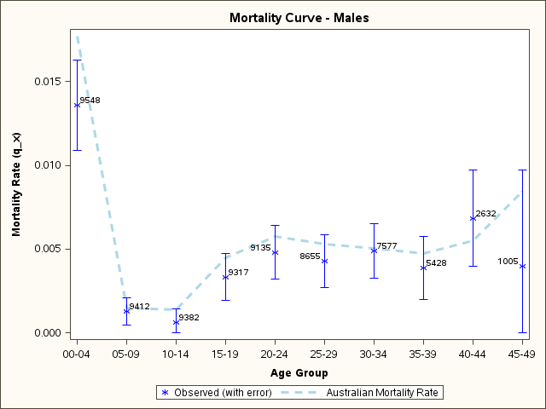

Figure 4.9 Mortality curve: male participants assuming unconfirmed deaths occurred before age 5 years

## Summary and discussion

This chapter uses several methods to investigate the mortality experience among the study cohort. The crude mortality rate looks at the total number of deaths in each study group. The proportional mortality analysis investigates the proportional contribution of the different causes of death to the total number of deaths. For these two methods no adjustments were made for sex or the age structure of each group. The SMR analysis compared the overall mortality of each study group with that in the age- and sex-matched general Australian population for all causes of death, cancer death, death from all external causes, suicide, and an aggregated all other causes of death. The RR analysis compared the overall mortality for the children of Vietnam veterans and Vietnam veteran siblings with that for the children of Vietnam-era personnel for the same causes of death as in the SMR analysis. Finally, mortality rates compared with the general Australian population were investigated over the life course of the study groups in five-year age groups by sex and participation group for all causes of death only.

When compared with the general Australian population, none of the analyses demonstrated a statistically significant elevation in mortality among the randomly selected children of Vietnam veterans or children of siblings of Vietnam veterans for any of the causes of death investigated after adjusting for age and sex. There were, however, a number of analyses that demonstrated a lower than expected overall mortality rate for the study groups. SMR analysis showed that all groups in the study had fewer than expected deaths from all causes compared with the Australian population, and this seemed to be a consequence primarily of a deficit of deaths in the 0–4 age group (as demonstrated by the mortality curves) and a deficit for other causes of death that were not cancer or external causes (as demonstrated in Table 4.9 under the SMR analysis).

When comparing the two main randomly selected comparison groups with each other through the RR analysis, however, mortality from external causes for male children of the Vietnam veterans was higher than expected compared with the mortality experience of the male children of the Vietnam-era personnel. This was demonstrated by a 54 per cent increase in relative risk for death from external causes, which was statistically significant. Furthermore, if mortality was analysed for ages 5–49 only, assuming missing data for deaths before age 5 years, male children of Vietnam veterans had significantly higher mortality from all causes (RR = 1.46; 95% CI 1.06, 2.02). There were no other statistically significant differences in the RR analysis.

A sensitivity analysis showed that the lower than expected mortality for the study cohort compared with the general Australian population could be explained in part, but not completely, by missing data for 107 unconfirmed deaths. The analysis was performed using one assumption—death before the age of 5 years for the 107 unconfirmed deaths. This might not reflect the true nature of the death status of these records because it was not possible to confirm this. Furthermore, the disproportionate number of unconfirmed deaths occurring among the children of Vietnam veterans (discussed in Chapter 2) could be a result of the older age profile of this group (discussed in Chapter 3).

Female children of the self-select Vietnam veterans demonstrated an elevated mortality that was statistically significant for both the SMR and the RR analyses (Tables 4.10 and 4.16). These participants were self-selected, so no conclusions can be drawn about how this result might relate to the entire group of female children of Vietnam veterans.

# Cumulative hazards of specific causes of death and associated rates

Chapter 4 investigates the mortality experience between the various groups in the study using several methods. This chapter extends the analysis to investigate cumulative mortality over the entire period of observation for the participants. This period of observation is the years at risk of dying for each participant. Cumulative mortality is termed ‘cumulative hazards’ and measures the risk of dying within a small interval of time, conditional on survival to the beginning of that period. The method allows for the assessment of changes in mortality rates across the lifetime of the study cohort.

## Cumulative hazards of specific causes of death

The graphs presented throughout this section show estimates of the cumulative proportion of the population that have died. The plotted lines represent the time until death across the life course of the study population. The data are censored to account for those who died in the preceding period and are no longer part of the population at risk. The mortality rates in the tables presented throughout this section are stratified SMR and RR analyses.

### All causes of death

Figure 5.1 shows the cumulative hazard of death due to all causes for the randomly selected participants by sex and study group. The graph shows a divergence in the cumulative mortality between females (red), males (blue), children of Vietnam veterans (dashes) and children of Vietnam-era personnel (solid). This divergence begins at about age 15 and shows a change in mortality rates between the two groups. To assess this change the data are stratified by age. Table 5.1 shows that there is a significant increase in the rate of death for male children of the Vietnam veterans over the age of 15 compared with male children of the Vietnam-era personnel.

### Cancer deaths

Table 5.2 shows that there is no statistically significant difference in death rates as a result of cancer for people of any age based on their sex and participation group (the 95 per cent confidence intervals are wide and include 1.0). This result is supported by the parallel lines for all groups over all ages in Figure 5.2. The differences noted in the previous section for all deaths do not appear to be related to cancer.

### External deaths

Table 5.3 shows that overall there is a statistically significant elevation in death rates due to external causes for male children of Vietnam veterans compared with male children of Vietnam-era personnel and that this increased death rate is driven by male children of Vietnam veterans over the age of 15 years.

### Suicide deaths

Table 5.4 shows that there is no statistically significant difference in death rates as a result of suicide for children of any age on the basis of their sex and participation group. Although the point estimates in the RR analysis are elevated, the confidence intervals are wide. Thus, the number of expected deaths was not high enough for this analysis to have sufficient power to produce a conclusive result. The differences noted in Section 5.1.3 for external deaths cannot be explained by suicide alone.

### Other causes of death

Table 5.5 shows that, although there is a lower than expected death rate due to other causes when compared with the general Australian population, there is a significant increase in death due to other causes for male children of the Vietnam veterans over the age of 15 years compared with male children of the Vietnam-era personnel. This result is supported in Figure 5.5 by the cumulative mortality lines for the male children of Vietnam veterans diverging upwards from the lines for the VEP children. Some of the differences noted previously for all deaths appear to be partially related to other causes of death.

Table 5.1 Mortality rates, by age and sex: all deaths

|  |  |  |  |  |  |
| --- | --- | --- | --- | --- | --- |
| **Sex** | **Age range** | **SMR CG** | **SMR VV** | **Relative risk** | **RR 95% CI** |
| Male | All | 0.59 | 0.75 | 1.279 | 0.987, 1.657 |
|  | 0–14 | 0.60 | 0.50 | 0.840 | 0.557, 1.268 |
|  | >15 | 0.57 | 0.94 | **1.650** | **1.165, 2.337** |
| Female | All | 0.66 | 0.73 | 1.109 | 0.791, 1.554 |
|  | 0–14 | 0.51 | 0.59 | 1.150 | 0.704, 1.879 |
|  | >15 | 0.92 | 0.95 | 1.035 | 0.648, 1.654 |

Table 5.2 Mortality rates, by age and sex: cancer deaths

|  |  |  |  |  |  |
| --- | --- | --- | --- | --- | --- |
| **Sex** | **Age range** | **SMR CG** | **SMR VV** | **Relative risk** | **RR 95% CI** |
| Male | All | 1.08 | 0.83 | 0.773 | 0.357, 1.674 |
|  | 0–14 | 1.03 | 0.24 | 0.233 | 0.025, 2.211 |
|  | >15 | 1.10 | 1.01 | 0.922 | 0.389, 2.186 |
| Female | All | 0.77 | 1.11 | 1.451 | 0.609, 3.454 |
|  | 0–14 | 0.44 | 0.94 | 2.115 | 0.223, 20.093 |
|  | >15 | 0.87 | 1.16 | 1.324 | 0.517, 3.392 |

Table 5.3 Mortality rates, by age and sex: external deaths

|  |  |  |  |  |  |
| --- | --- | --- | --- | --- | --- |
| **Sex** | **Age range** | **SMR CG** | **SMR VV** | **Relative risk** | **RR 95% CI** |
| Male | All | 0.54 | 0.84 | **1.540** | **1.025, 2.314** |
|  | 0–14 | 0.64 | 0.37 | 0.582 | 0.197, 1.722 |
|  | >15 | 0.52 | 0.93 | **1.791** | **1.141, 2.810** |
| Female | All | 0.94 | 0.82 | 0.875 | 0.477, 1.605 |
|  | 0–14 | 0.91 | 0.53 | 0.579 | 0.178, 1.883 |
|  | >15 | 0.95 | 0.96 | 1.011 | 0.493, 2.073 |

Note: Includes suicide.

Table 5.4 Mortality rates, by age and sex: suicide

|  |  |  |  |  |  |
| --- | --- | --- | --- | --- | --- |
| **Sex** | **Age range** | **SMR CG** | **SMR VV** | **Relative risk** | **RR 95% CI** |
| Male | All | 0.55 | 0.92 | 1.664 | 0.778, 3.562 |
|  | 0–14 | 0.00 | 0.00 |  |  |
|  | >15 | 0.56 | 0.93 | 1.661 | 0.776, 3.555 |
| Female | All | 0.55 | 1.06 | 1.925 | 0.392, 9.453 |
|  | 0–14 | 0.00 | 0.00 |  |  |
|  | >15 | 0.56 | 1.07 | 1.917 | 0.390, 9.416 |

Table 5.5 Mortality rates, by age and sex: other causes

|  |  |  |  |  |  |
| --- | --- | --- | --- | --- | --- |
| **Sex** | **Age range** | **SMR CG** | **SMR VV** | **Relative risk** | **RR 95% CI** |
| Male | All | 0.48 | 0.63 | 1.325 | 0.884, 1.985 |
|  | 0–14 | 0.55 | 0.53 | 0.969 | 0.607, 1.549 |
|  | >15 | 0.27 | 0.87 | **3.198** | **1.245, 8.214** |
| Female | All | 0.50 | 0.61 | 1.218 | 0.752, 1.974 |
|  | 0–14 | 0.45 | 0.56 | 1.250 | 0.707, 2.210 |
|  | >15 | 0.70 | 0.77 | 1.100 | 0.442, 2.742 |



Note: Blue = male; red = female; solid = Vietnam-era personnel; dash = Vietnam veteran.

Figure 5.1 Cumulative hazards, by sex and study group: all deaths

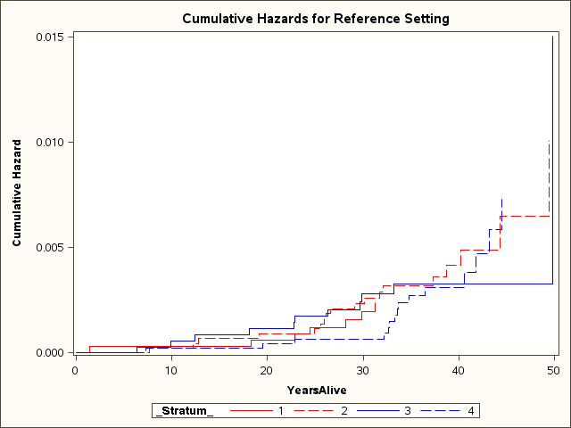

Note: Blue = male; red = female; solid = Vietnam-era personnel; dash = Vietnam veteran.

Figure 5.2 Cumulative hazards, by sex and participation group: cancer deaths

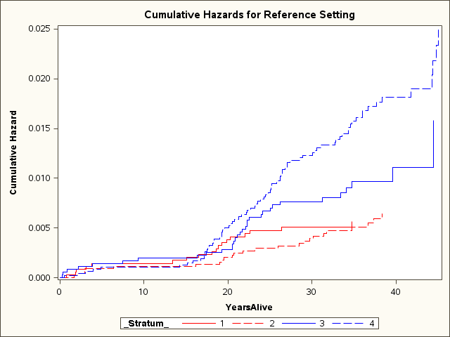

Note: Blue = male; red = female; solid = Vietnam-era personnel; dash = Vietnam veteran.

Figure 5.3 Cumulative hazards, by sex and participation group: external deaths

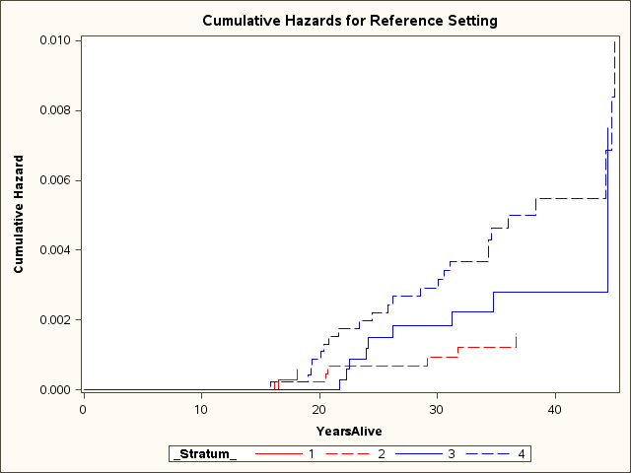

Note: Blue = male; red = female; solid = Vietnam-era personnel; dash = Vietnam veteran.

Figure 5.4 Cumulative hazards, by sex and participation group: suicide

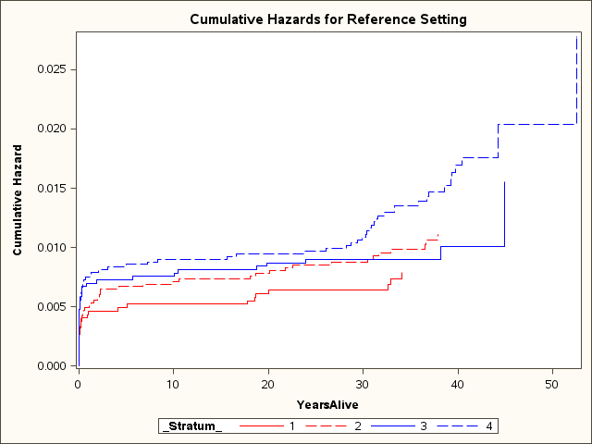

Note: Blue = male; red = female; solid = Vietnam-era personnel; dash = Vietnam veteran.

Figure 5.5 Cumulative hazards, by sex and participation group: other causes of death

## Summary and discussion

This chapter assesses the mortality over time of the children of Vietnam veterans compared with the children of Vietnam-era personnel. The results show a significant change in mortality occurring at about the age of 15 for the randomly selected male children of the Vietnam veterans compared with the corresponding randomly selected male children of the Vietnam-era personnel. The Vietnam veterans’ male children over the age of 15 had a 65 per cent higher relative risk of dying from all causes compared with the male children of the Vietnam-era personnel (RR = 1.65; 95% CI 1.16, 2.34). This increase in risk was the result of an increase in death from external causes (RR = 1.79; 95% CI 1.14, 2.81) and the aggregated all other causes of death that were not external or cancer deaths (RR = 3.2; 95% CI 1.24, 8.21). Although the point estimate of the relative risk for other causes is high, the confidence interval is broad and the result thus lacks precision.

External causes of death are primarily a consequence of motor vehicle accidents, injury and suicide. The analysis for suicide in this chapter shows that, although the relative risk point estimate was elevated compared with that for the children of the Vietnam-era personnel, the analysis did not have sufficient power to detect a statistically significant difference. Other causes of death also contributed to the increase in deaths among male children of the Vietnam veterans over the age of 15 years. The most common causes of death for this aggregated cause of death grouping among those over the age of 15 would be diseases of the circulatory and respiratory systems.

# Discussion

The Children of Vietnam Veterans Mortality Study is a component of the Vietnam Veterans Family Study, which consists of several qualitative investigations, the Mortality Study and a large quantitative survey study. The Mortality Study used multiple methods of analysis to investigate the mortality experience of the children of Vietnam veterans and the children of siblings of Vietnam veterans compared with the mortality of the same-aged general Australian population and the children of a group of Vietnam-era personnel. Although this report on the Mortality Study is a stand-alone document, in order to understand more fully the health and wellbeing of children of Vietnam veterans it should be read in conjunction with the other reports arising from the Vietnam Veterans Family Study.

## The mortality results

As described in Chapter 1, the Mortality Study involved eight different study groups—randomly selected children of Vietnam veterans, children of brothers and sisters of Vietnam veterans and children of Vietnam-era serving members as a control group, and a self-select component of each of these groups. In keeping with the original protocol for the study, the majority of analyses focused on the randomly selected participants.

The study used six different types of analysis to assess the mortality experience of children of Vietnam veterans—crude mortality rate, proportional mortality, standardised mortality ratios, relative risk, life table mortality curves and cumulative hazards analysis. Each type of analysis focuses on a slightly different aspect of assessing mortality and builds in complexity from a simple counting of deaths in the crude mortality rate to controlling for age, sex and time over the entire period of observation for the participants in the cumulative hazards analysis. Deaths from all causes, cancer, external causes, suicide (a subset of external causes) and an aggregated all other causes were investigated.

### Mortality compared with the general Australian population

Taken together, the results show that, compared with the general Australian population, the children of Vietnam veterans and their siblings and the children of the Vietnam-era personnel have lower than expected mortality for all causes of death. This lower than expected overall mortality is largely a result of fewer deaths from the aggregated grouping of all other conditions (not cancer or external causes) and from external causes for the male children of Vietnam-era personnel only. There were no statistically significant differences for the other causes of death analysed—cancer, external causes and suicide—for any of the other study groups.

Although the reason for the lower than expected mortality for the entire study cohort is not known, a number of factors might contribute to this result. The lower than expected mortality compared with the Australian population could be an intergenerational manifestation of the ‘healthy worker (or soldier) effect’. The healthy worker effect is a phenomenon observed in occupational health studies in which those who are employed exhibit a lower mortality rate than the general population. This is often primarily attributed to a selection bias whereby employed people are, on average, healthier than the general population, which includes those who are severely ill or disabled and thus unable to work. There are, however, a number of other factors that contribute to and can modify the healthy worker effect, among them age group, job status, and ethnic background or race (Michael 1976).

The healthy worker effect is often referred to as the ‘healthy soldier effect’ for occupational studies of military cohorts. This distinction acknowledges the fact that military populations are far healthier than other employed populations, which in turn are healthier than the general population consisting of those employed and unemployed. The higher level of health and fitness is a consequence of the active screening for chronic illnesses carried out at the time of enlistment in the military and the ongoing requirement to maintain good physical and mental health while serving (the active worker effect) (Wen et al. 1983). The healthy soldier effect was seen in a previous study of mortality and cancer incidence in Australian Vietnam veterans—the fathers of the children in this Mortality Study (Wilson et al. 2005b)—and further investigated with other Australian military cohorts (Waller & McGuire 2011). It is plausible that these healthier fathers would produce healthier offspring within this study cohort.

Participation bias could be another possible contributor to the lower than expected mortality observed in the cohort. The Vietnam Veterans Family Study had a low response rate: less than a third of those invited to participate in the study did so. Those who chose to participate could have been selectively healthier than those who did not participate. Furthermore, families of deceased veterans were not included in the study roll. Thus families whose fathers died prematurely were excluded from the study, further selecting for healthier families. The question of participation bias is discussed in more detail in the Section 6.2.

### Mortality compared with the Vietnam-era personnel

The standardised mortality ratios and life table mortality curves demonstrate that the study cohort has a lower mortality rate compared with the general Australian population. When one compares the mortality of children of Vietnam veterans with that of children of fathers who served during the time of the Vietnam War but did not deploy to Vietnam, however, a difference in mortality is observed. Male children of Vietnam veterans have an increased rate of mortality from external causes compared with male children of Vietnam-era personnel. The effect is best demonstrated using the detailed life-course approach of cumulative hazards analysis, which shows that the increased mortality seen in male children of Vietnam veterans is confined to those male children over the age of 15 years and is the result of higher than expected mortality due to external causes and other causes that are not external or cancer. There was no difference in mortality for the female children of Vietnam veterans compared with the female children of Vietnam-era personnel. Similarly, there was no statistically significant difference between mortality for the children of the siblings of Vietnam veterans and the children of Vietnam-era personnel. The size of the sibling group was, however, relatively small, and this limited the precision of the analysis.

The Mortality Study data cannot provide any causal link for the observed increased mortality. The primary causes of death contained in external causes are motor vehicle accidents, injury and suicide. Excess deaths resulting from external causes could suggest a propensity to engage in risky behaviour. The most common causes of death in the aggregated other causes are cardiovascular and respiratory diseases. The main risk factors for cardiovascular and respiratory diseases are tobacco use, physical inactivity, harmful use of alcohol, and unhealthy diets (WHO n.d.b). One explanation for the higher mortality among male children of Vietnam veterans over the age of 15 years could thus be a tendency for this group to engage in risky and unhealthy behaviours. The Main Survey component of the Vietnam Veterans Family Study (see Volume 2) supports this and suggests what could be the contributors to such behaviours.

The results of the Mortality Study need to be viewed with the strengths and limitations of the study in mind—in particular, the several biases inherent in the study cohort. The following section discusses these biases and the ability of the study results to confirm the true mortality experience for all children of Vietnam veterans.

## Features of the study

The Mortality Study was a descriptive retrospective cohort study investigating the intergenerational mortality experience of children and siblings of Vietnam veterans and children of a military control group, Vietnam-era personnel. The period of observation spanned more than 80 years. A number of strengths and limitations of the study are attributable both to the innate nature of this type of cohort study and to some of the unique characteristics of the study cohort, as follows.

### Strengths and limitations of mortality studies

There are many diseases, disabilities and health conditions that are not captured by a mortality study. A mortality study can report only on the extreme endpoint of death and not on the general health of a population that might or might not have a high level of illness (morbidity). Furthermore, the majority of the subjects in this study were under 60 years old and had not yet lived through the period of major risk for mortality from many physical diseases, including most cancers and cardiovascular diseases.

In this instance a randomised selection design was used to create the study cohort for the assessment of mortality. The aim of randomisation in selecting the study cohort is to obtain a subgroup that is representative of the population as a whole. Random sampling helps ensure that any variation in characteristics between individuals ‘evens out’ so that the sample is representative of the larger population from which it was drawn.

The choice of a comparison group in a mortality study can influence the conclusions derived from the analysis. This study used two main comparison groups—the general Australian population and children of Vietnam-era personnel. Ideally, the comparison group should be similar in all characteristics other than the factor of interest, which in this study is having a father who served in the Vietnam War. Selection of a ‘matched’ comparison group helps limit the influence of those characteristics unrelated to the study factor of interest that might contribute to spurious results. Nevertheless, random sampling and choice of a matched comparison group do not guarantee that the study groups are equal in baseline characteristics and differ only in the exposure of interest.

The linkage to the National Death Index was done in February 2012 and included all deaths in Australia from 1980 to 2009. Deaths that occurred before 1980 or after 2009 could not be captured by the data linkage. Extensive efforts were made to clerically find deaths before 1980 through searching registries of births, deaths and marriages, but not all deaths could be confirmed.

The study used a number of different methods to assess mortality. The analysis methods built on each other in order to clarify and confirm the results observed and to take into account potential biases from differences in baseline characteristics.

### Study size

The Mortality Study involved 25,832 children divided into eight study groups. The number in each study group ranged from 78 (children of the self-select Vietnam veterans’ brothers) to 9,181 (children of the randomly selected Vietnam veterans). Small group size and few expected deaths limit the statistical power to detect a difference between comparison groups. The number of expected deaths for some specific causes of death was too small for meaningful analysis or conclusive results.

The WHO International Classification of Disease lists over 20 broad chapters or categories of disease or injury that could cause death. Because of the limited sample size in this study, it was possible to do a detailed analysis of mortality for only the most commonly occurring causes of death (see Appendix C).

### Participation bias: low response rate

A major limitation of the Mortality Study was the low registration rate for the main Vietnam Veterans Family Study. Further, as detailed in Section 2.1, only 30.7 per cent of Vietnam veterans and 20.9 per cent of Vietnam-era personnel in the randomly selected cohort invited to register for the Family Study provided information for the Mortality Study. A low response rate can result in a significant participation bias where those who choose to participate tend to differ from subjects who refused to participate.

The index randomly selected families provided names for 16,234 children, with an average of 2.7 children per family—9,181 children of the Vietnam veterans and 7,053 children of the Vietnam-era personnel. It is estimated that there are 47,000 surviving Vietnam veterans from among the approximately 60,000 who served (Department of Veterans’ Affairs 2011). A conservative estimate of the total number of children of surviving Vietnam veterans would be about 100,000 children. The children of randomly selected Vietnam veterans in the Mortality Study thus represent about 10 per cent of the total population of all children of Vietnam veterans. A 10 per cent sample of a population can be sufficient to ensure the external validity of a study if the sample is indeed a representative subgroup of the whole population.

The aim of the study was for the randomly selected sample of children of Vietnam veterans to provide an understanding of the mortality experience for all children of Vietnam veterans. Because of uncertainty about the extent of participation bias and thus the representativeness of the study cohort, however, some caution is necessary in extrapolating the results presented in this report to the entire population of children of Vietnam veterans. Volume 2 of this report investigates the question of representativeness in detail.

### Confounding and effect modification

Confounding is the distortion of the effect of an exposure on the risk of an outcome as a result of other factors influencing the outcome. An inability to control for confounding can bias the observed association between the study group and the mortality outcome, making the observed association either closer to or further from the true effect.

The main comparison groups in this study showed significant differences in age profiles. The age structure of a study population is a primary confounding factor for the mortality experience of a study group. It will affect the number of deaths observed, the mortality rate, conditions that cause death, and the proportion of deaths attributed to a given condition. The overall mortality risk and the risk for specific causes of death were very different for a child born in 1960 compared with a child born in 1980.

Although the period of observation spanned 80 years, the majority of Mortality Study participants were aged between 30 and 45 years at the time of analysis. The total number of deaths observed was relatively small and represents only an early snapshot of the potential mortality experience for this cohort. Furthermore, the most common causes of death observed were those prevalent in a relatively young population. In Australia two-thirds of all deaths occur after the age of 75, and the most common causes of death are circulatory disease followed by cancer (AIHW n.d.). For the 25–45 age group, however, the most common causes of death for males are injury and circulatory disease and for females cancer and injury (AIHW 2004).

Careful controlling for age and age standardisation were necessary in the mortality analysis in order to account for the broad age range for the whole cohort and differences in age profiles for the different study groups.

The age structure of the cohort can affect the interpretation of the study results in other ways. The effect of the father’s Vietnam service on the child could vary greatly depending on the child’s year of birth. The sons and daughters of Vietnam veterans in this study were born at different times in relation to their father’s military service: some were born many years before their father was deployed to Vietnam; others were born shortly after the war; and still others were born many years following service.

The study contained only data on age, sex, the fact of death, and the cause of death. This component of the Vietnam Veterans Family Study did not have data on other characteristics of the participants—such as socio-economic status, education and occupation—that could influence mortality rates. The Mortality Study encompassed a time frame of more than 40 years since the father’s service in Vietnam and 80 years of mortality observation. Many life events and social attributes could have contributed to mortality in the study cohort during this period. Analysis of these factors with the mortality results could help to identify contributing or explanatory factors for any observed differences in mortality or in fact negate or augment the observed differences.

### Information bias: incomplete data

One hundred and seven deaths submitted could not be confirmed through matching with the National Death Index or by clerical searching of the registries of births, deaths and marriages. In keeping with standard practice, because these deaths could not be confirmed, the individuals were assumed to be alive. This could have resulted in a classification bias and might have led to an underestimation of the observed mortality. A sensitivity analysis was performed to assess the potential extent of this underestimation. Under the assumption that the unconfirmed deaths occurred under the age of 5 years and before 1980, the analysis showed that the lower than expected overall mortality compared with the general Australian population could be partially explained.

Another potential source of information bias could lie in the low rate of matching to the National Death Index for the female participants in the study. A possible reason for this is the changing of family names as a result of marriage, or it could reflect a real effect in the difference in mortality rates between males and females. The mortality rates for females in this study are lower than those for males, as would be expected from community rates, but there remains the possibility that some deaths among females were not captured.

### The self-select group

The study involved over 7,000 self-select participants. To prevent the introduction of any biases, the self-select group was analysed separately. The group has a different age structure compared with its randomly selected counterparts, and this difference is statistically significant. The female children of self-select Vietnam veterans demonstrated an elevated mortality that was statistically significant for both the standardised mortality ratio and the relative risk analyses. Although the analyses demonstrated elevated mortality among the self-select female children of Vietnam veterans, the results cannot be extrapolated to the entire population of female children of Vietnam veterans.

## Summary and conclusions

The Mortality Study used information provided by parents registered for the Vietnam Veterans Family Study to compile a list of children in eight different study subgroups. This list was data matched to the National Death Index and other data sources in order to investigate the mortality experience of the cohort. The mortality of children of Vietnam veterans and children of the siblings of Vietnam veterans was compared with that for the general Australian population and that for children of personnel who served in the Army during the time of the Vietnam War but did not deploy to Vietnam.

The response rate for the Mortality Study was good: 75 per cent of those registered for the Vietnam Veterans Family Study provided information for the Mortality Study. Six different analysis methods were used to investigate mortality. The study groups had significant differences in age structure, and four of the six analysis methods controlled for this.

The results show that the overall mortality rate for all study groups was lower than expected compared with the general Australian population. When comparing the mortality of the children of Vietnam veterans with that of the children of Vietnam-era personnel, however, a significantly elevated mortality rate was seen for male children of Vietnam veterans over the age of 15 years. This mortality was primarily the result of a higher than expected number of deaths from external causes and from an aggregated ‘other causes’, which included all deaths not from external causes or cancer.

It is not possible to draw any conclusions about causality, but the study does demonstrate an association of higher than expected mortality among male children over the age of 15 years whose fathers were Vietnam veterans.

Part Two   
  
Supplementary analysis of the study data

In May 2014 the Australian Institute of Family Studies performed a supplementary analysis of the Mortality Study data. The resultant report is reproduced here.

The authors of the report are Walter Forrest, Ben Edwards and Galina Daraganova. They acknowledge the support of the Department of Veterans’ Affairs in providing the data used and in providing helpful advice and comments during planning of the report. The research assistance of Maggie Yu is also acknowledged.

Views expressed are those of the authors and may not reflect those of the Australian Government, the Department of Veterans’ Affairs or the Australian Institute of Family Studies.

# Introduction

This report is intended to supplement Part One of this volume, prepared by Dr Eileen Wilson in collaboration with the Australian Institute of Health and Welfare, which supplied the data.

The Children of Vietnam Veterans Mortality Study is a retrospective study of the mortality of the children of a sample of men who served in the Australian Defence Force during the Vietnam War. As part of the Vietnam Veterans Family Study, it is intended to provide information on the possible intergenerational effects of service in the Vietnam War on mortality. It is based on a survey of registered participants in the Vietnam Veterans Family Study and so is based on a research design in which the families of Vietnam veterans can be compared with the families of other men who served in the Australian military during the Vietnam War (1962 to 1975) but were not deployed to Vietnam—hereafter referred to as Vietnam-era personnel.

The Australian Institute of Family Studies was engaged by the Department of Veterans’ Affairs to conduct supplementary analyses of possible differences in mortality between the children of Vietnam veterans and other Australian Army men who were not deployed to the Vietnam War. Specifically, AIFS was asked to assess the extent of differences in mortality rates between the children of Vietnam veterans and Vietnam-era personnel:

* controlling for observable differences between Vietnam veterans and Vietnam-era personnel that probably preceded the former’s deployment to the war
* investigating the representativeness of the Vietnam Veterans Family Study and Mortality Study surveys.

To that end, the Australian Institute of Family Studies:

* linked responses to the Mortality Study and the Vietnam Veterans Family Study Main Survey for 4,561 servicemen from the randomly selected sample. This enabled us to access information provided by the Vietnam veterans and Vietnam-era personnel in the VVFS in order to control for confounding factors
* conducted a series of analyses of the 4,561 servicemen whose responses to the VVFS and Mortality Study surveys could be linked to identify pre-deployment characteristics that distinguished Vietnam veterans from Vietnam-era personnel. We then used the results of these analyses to calculate propensity score weights that could be used to control for these pre-existing differences between the Vietnam veterans and Vietnam-era personnel in subsequent analyses of the mortality rates among their children
* linked 2,184 Vietnam veterans who completed the Mortality Study survey to the Nominal Roll of Vietnam Veterans. We then conducted a series of analyses to determine whether the Vietnam veterans who participated in the Mortality Study were broadly representative of the population of veterans
* examined differences between the crude mortality rates and sex-specific mortality rates of the sons and daughters of Vietnam veterans and Vietnam-era personnel. Differences in total mortality were examined in addition to differences in the mortality rates attributable to cancers, external causes of death, suicides, and other causes.

## Propensity score analysis: estimating the impact of Vietnam War service

A key feature of the survey was the inclusion of a control group consisting of the families of military personnel who served in the Australian Army during the Vietnam era but were not deployed to Vietnam on active service. Comparisons between the families of Vietnam veterans and Vietnam-era personnel may provide a basis for estimating the effects of war service relative to non-Vietnam military service, provided the two samples did not differ systematically from one another prior to the Vietnam veterans’ service in Vietnam.

It should be noted, however, that veterans were not assigned randomly to serve in Vietnam. Instead, they were assigned to specific corps and units, sometimes on the basis of individual characteristics that might have affected their perceived suitability for specific roles in the military. These corps and units then became the basis for deployment decisions. This means that differences observed between the families of veterans and their Vietnam-era counterparts may not necessarily be due to their service in the Vietnam War; instead, they could be due to any number of factors that also influenced their deployment to Vietnam. Therefore a direct comparison between those who were deployed and the Vietnam-era personnel may be biased by other variables. An empirical strategy to address these differences is required to accurately estimate the intergenerational impact of deployment to Vietnam. We used propensity score analysis for that purpose. To that end, we identified a number of factors that distinguished Vietnam veterans from the Vietnam-era personnel prior to their deployment and then controlled for those differences by effectively matching the servicemen on those pre-deployment characteristics.

### Variables included in the propensity score analysis

We began by searching the Vietnam Veterans Family Study Main Survey to identify factors that might have affected the chances of being deployed to Vietnam. As noted, deployment was based on the corps and the units to which servicemen were assigned rather than their individual characteristics or prior experience. That said, we used individual factors in our analyses for two reasons:

* Some individual characteristics may have influenced the units to which personnel were assigned. This means that some individual-level factors may have indirectly influenced the chances of being deployed, although their influence might have varied across the population.
* Our samples were drawn retrospectively from two larger samples of Defence Force personnel. In modelling deployment to Vietnam, therefore, we are modelling effectively the chances of belonging to either of the two subsamples—veterans or Vietnam-era personnel (conditional on having participated in the Main Survey). This means our analytical approach may help control for possible differences between Vietnam veterans and Vietnam-era personnel in the likelihood of participating in the study.

In total, 39 variables were identified for inclusion in the propensity score analysis. A description of these variables, how they were coded and the questions that comprise them is provided in Table 7.1.

Table 7.1 Variables included in the propensity score analysis

| **Variable** | **Coding** |
| --- | --- |
| **Serviceman’s age** | Binary variables corresponding to ages 60, 61, 62, 63, 64,65, 66, and 67. Servicemen aged 68 and over or 59 and below form the reference category. |
| **Military service** |  |
| Year entered military | Binary indicators x 21 of year military service began (1950–1970). Servicemen who began military service before 1950 or after 1970 form the reference category. |
| Serviceman’s parent served in military | Binary indicator of whether the serviceman’s mother or father had military experience, including as full-time personnel or as a reservist (Yes=1, Otherwise=0). |
| Serviceman’s grandparent served in military | Binary indicator of whether the serviceman’s grandmother or grandfather had military experience, including as full-time personnel or as a reservist (Yes=1, Otherwise=0). |
| National Serviceman (1965–1973) | Binary indicator of whether the serviceman was conscripted into the ADF (Yes=1, 0therwise=0). Missing cases were classified as national servicemen if they were born on a day selected in the national service ballot. |
| **Serviceman’s education** |  |
| Year 9 or above | Binary indicator of whether the serviceman completed his highest level of education, to the level of at least year 9, before he joined the ADF (Yes=0, Otherwise=0). Respondents who earned additional qualifications after the military form the reference category along with those who did not complete year 9. |
| Disciplinary problems | Binary indicator of whether serviceman was suspended or expelled from primary or high school (Yes=1, Other=0). |
| Behavioural problems | Binary indicator of whether serviceman was absent for more than 10% of days in a school year or was bullied at school or institution (Yes=1, Other=0). |
| Gifted and talented | Binary indicator of whether serviceman jumped ahead a year or placed in a gifted class in primary or high school (Yes=1, Other=0). |
| Learning problems | Binary indicator of whether serviceman repeated a year (including failing exams); worked with a psychologist, counsellor, or specialist teacher to assist with a learning difficulty; was placed in a remedial class; or dropped out of a course (Yes=1, Other=0). |
| **Serviceman’s prior employment** | Binary indicators x 4 of the number of jobs held prior to joining the military: None (Yes=1, 0=Otherwise); One (Yes=1, 0=Otherwise); Two (Yes=1, 0=Otherwise); Three or more (Yes=1, 0=Otherwise). None formed the reference category. |
| **Family characteristics** |  |
| Single-parent household | Binary indicator of whether serviceman reported not having either a mother or father figure (Yes=1, Otherwise=0). |
| Parenting (serviceman’s mother) |  |
| Affectionate | Binary indicators x 4 of ‘How affectionate was your mother towards you?’: Not at all (Yes=1, 0=Otherwise); A little (Yes=1, 0=Otherwise); Somewhat (Yes=1, 0=Otherwise); Very (Yes=1, 0=Otherwise). Servicemen who did not have a father figure coded 0 on all indicators. Not at all formed the reference category. |
| Caring | Mean score of 3 items: My mother seemed emotionally cold to me (reverse coded); My mother appeared to understand my problems and worries; and My mother could make me feel better when I was upset. Items recorded on 4-point scale ranging from 0 to 3 and coded so that high scores reflect high parental warmth. |
| Overprotective | Mean score of 4 items: My mother liked me to make my own decisions (reverse coded); My mother tried to control everything I did; My mother tended to baby me and tried to protect me from everything; My mother gave me as much freedom as I wanted (reverse coded). Items recorded on 4-point scale ranging from 0 to 3 and coded so that high scores reflect high protectiveness. |
| Parenting (serviceman’s father) |  |
| Affectionate | Binary indicators x 4 of ‘How affectionate was your father towards you?’: Not at all (Yes=1, 0=Otherwise); A little (Yes=1, 0=Otherwise); Somewhat (Yes=1, 0=Otherwise); Very (Yes=1, 0=Otherwise). Servicemen who did not have a father figure coded 0 on all indicators. Not at all formed the reference category. |
| Caring | Mean score of 3 items: My father seemed emotionally cold to me (reverse coded); My father appeared to understand my problems and worries; and My father could make me feel better when I was upset. Items recorded on 4-point scale ranging from 0 to 3 and coded so that high scores reflect high parental warmth. |
| Overprotective | Mean score of 4 items: My father liked me to make my own decisions (reverse coded); My father tried to control everything I did; My father tended to baby me and tried to protect me from everything; My father gave me as much freedom as I wanted (reverse coded). Items recorded on 4-point scale ranging from 0 to 3 and coded so that high scores reflect high protectiveness. |
| Serviceman’s mother or father had alcohol problem | Binary indicator of whether serviceman’s mother or father had trouble with alcohol or other drug use (Yes=1, Otherwise=0). |
| **Serviceman’s pre-existing medical conditions** | |
| Mental and behavioural | Binary indicator of whether the serviceman was diagnosed with or treated for Depression; Anxiety; or PTSD before he joined the ADF (Yes=1, Otherwise=0). |
| Musculoskeletal system | Binary indicator of whether the serviceman was diagnosed with or treated for Arthritis; Osteoporosis; or Other joint disorders before he joined the ADF (Yes=1; Otherwise=0). |
| Circulatory system | Binary indicator of whether the serviceman was diagnosed with or treated for Stroke; Angina; Hypertension (or high blood pressure); Heart condition (coronary heart disease); or Heart attack (myocardial infarction) before he joined the ADF (Yes=1; Otherwise=0). |
| Neoplasms | Binary indicator of whether the serviceman was diagnosed with or treated for Skin cancer (excluding melanoma); Melanoma; Soft tissue / organ cancer; Blood / bone cancers (other than acute myeloid leukaemia); Acute myeloid leukaemia (AML); or Tumour (cancerous or benign) (Yes=1; Otherwise=0). |
| Endocrine, nutritional and metabolic | Binary indicator of whether the serviceman was diagnosed with or treated for Type 1 Diabetes (childhood onset); Type 2 Diabetes (adult onset) before he joined the ADF (Yes=1; Otherwise=0). |
| Respiratory system | Binary indicator of whether the serviceman was diagnosed with or treated for Asthma or Chronic lung disease (e.g. emphysema, chronic bronchitis) before he joined the ADF (Yes=1; Otherwise=0). |
| Genitourinary system | Binary indicator of whether the serviceman was diagnosed with or treated for Kidney disease before he joined the ADF (Yes=1; Otherwise=0). |
| Digestive system | Binary indicator of whether the serviceman was diagnosed with or treated for Liver disease before he joined the ADF (Yes=1; Otherwise=0). |
| Nervous system | Binary indicator of whether the serviceman was diagnosed with or treated for Epilepsy; Motor Neurone Disease; or Neurological disorders before he joined the ADF (Yes=1; Otherwise=0). |
| **Health conditions of serviceman’s parents** | |
| Musculoskeletal system diseases | Binary indicator of whether the serviceman’s mother or father was diagnosed with or treated for Arthritis; Osteoporosis; or Other joint disorders) (Yes=1; Otherwise=0). |
| Mental and behavioural disorders | Binary indicator of whether the serviceman’s mother or father was diagnosed with or treated for Depression, Anxiety, PTSD, or Other psychological disorders (Yes=1, Otherwise=0). |
| Circulatory system diseases | Binary indicator of whether the serviceman’s mother or father was diagnosed with or treated for Stroke; Angina; Hypertension (or high blood pressure); Heart condition (coronary heart disease); or Heart attack (myocardial infarction) (Yes=1; Otherwise=0). |
| Neoplasms | Binary indicator of whether the serviceman’s mother or father was diagnosed with or treated for Skin cancer (excluding melanoma); Melanoma; Soft tissue / organ cancer; Blood / bone cancers (other than acute myeloid leukaemia); Acute myeloid leukaemia (AML); or Tumour (cancerous or benign). |
| Endocrine, nutritional and metabolic diseases | Binary indicator of whether the serviceman’s mother or father was diagnosed with or treated for: Type 1 Diabetes (childhood onset; Type 2 Diabetes (adult onset) (Yes=1; Otherwise=0). |
| Respiratory system diseases | Binary indicator of whether the serviceman’s mother or father was diagnosed with or treated for Asthma or Chronic lung disease (e.g. emphysema, chronic bronchitis) (Yes=1; Otherwise=0). |
| Digestive system diseases | Binary indicator of whether the serviceman’s mother or father was diagnosed with or treated for Liver disease (Yes=1; Otherwise=0). |
| Nervous system diseases | Binary indicator of whether the serviceman’s mother or father was diagnosed with or treated for Epilepsy; Motor Neurone Disease; or Neurological disorders (Yes=1; Otherwise=0). |
| Genitourinary system diseases | Binary indicator of whether the serviceman’s mother or father was diagnosed with or treated for Kidney disease (Yes=1; Otherwise=0). |
| Infectious and parasitic diseases | Binary indicator of whether the serviceman’s mother or father was diagnosed with or treated for Polio, Tuberculosis, Herpes zoster (Yes=1; Otherwise=0). |
| War-related health conditions | Binary indicator of whether the serviceman’s mother or father was diagnosed with or treated for any medical condition connected to their exposure to war (Yes=1; Otherwise=0). |

Source: Vietnam Veterans Family Study.

### Comparability of Vietnam veteran and Vietnam-era personnel subsamples

Table 7.2 compares the Vietnam veterans and Vietnam-era personnel who completed the Mortality Study survey across a range of pre-deployment characteristics. These include their education experiences, the characteristics of their families, and any medical conditions that preceded their entry into the military. On average, the Vietnam veterans were almost three years older than the Vietnam-era personnel. The average age of enlistment or appointment was the same for both groups—the average serviceman was 20 years old when he joined the military—and the majority of Vietnam veterans and Vietnam-era personnel joined the military during the Vietnam War. Given that the men deployed to the war were marginally older than those who served in other capacities, Vietnam veterans were slightly more likely than their Vietnam-era personnel counterparts to have enlisted or received their appointments during other conflicts (for example, the Malayan Emergency and the Korean War). It is possible, therefore, that the subsample of Vietnam veterans includes a larger percentage of men who were also veterans of those conflicts.

The most notable difference between the Vietnam veterans and the Vietnam-era personnel, however, concerned the disproportionate number of National Servicemen in the VEP subsample. Whereas just under half of the VV sample was conscripted (46 per cent), more than two out of every three Vietnam-era personnel entered the Army through the National Service scheme. These patterns are broadly consistent with actual patterns of service given that the majority of Vietnam veterans entered the military voluntarily and less than one-third of National Servicemen were deployed to the Vietnam War. First, this gives an additional reason to think that a larger percentage of the Vietnam veterans may have served in conflicts prior to their deployment to Vietnam (for example, Malaya and Korea). If so, differences in the mortality rates of the children of Vietnam veterans and Vietnam-era personnel could emerge independently of the effects of their experiences in Indochina. Second, and perhaps more importantly, National Servicemen were selected at random from the registered population of 20-year-old men. As a result, the population of conscripts may have been more representative of the population from which it was drawn than those who entered the military by other means. The fact that there are more National Servicemen in the VEP subsample is reason enough to expect significant differences between the offspring of the VEP and VV even if the service of their fathers had no impact on those differences.

In addition, Table 7.2 reports other differences between the VV and VEP subsamples:

* Vietnam veterans were less educated than the Vietnam-era personnel. They were also less likely to have jumped ahead a year at school or been placed in a class for gifted and talented students.
* Vietnam veterans had more jobs prior to joining the military than did Vietnam-era personnel.
* Vietnam veterans were more likely to have been raised in a single-parent household.
* Vietnam veterans were less likely to describe either of their parents as being affectionate and less likely to describe either parent as caring. They were also more likely to have described their mothers and their fathers as overprotective.
* Almost 30 per cent of Vietnam veterans indicated that at least one of their parents had had a drinking problem compared with 25 per cent of Vietnam-era personnel.
* Vietnam veterans were less likely than Vietnam-era personnel to have had a number of medical conditions prior to joining the military. Specifically, they were less likely to have had cancers, endocrine, nutritional or metabolic diseases, or those of the musculoskeletal or circulatory systems.
* Parents of Vietnam veterans were less likely to have had cancer or diseases of the circulatory system (for example, heart disease) than the parents of the Vietnam-era personnel. At the same time, Vietnam veterans were more likely to report that one or both of their parents had had a mental or behavioural disorder (23 compared to 20 per cent) or a disease of the digestive system (7 compared to 5 per cent).

Table 7.2 Comparability of VV and VEP subsamples before propensity score weighting

|  | **VV (*N* = 2,607)** | **VEP (*N* = 1,954)** | **Difference between means** |
| --- | --- | --- | --- |
|  | **Mean** | |
| **Serviceman’s age** | 67.02 | 64.16 | –2.85*** |
| **Military service** |  |  |  |
| Serviceman’s age entered military | 20.48 | 20.58 | 0.10 |
| Timing of serviceman’s entry into military |  |  |  |
| Second World War | 0.00 | 0.01 | 0.00* |
| Korean War | 0.02 | 0.01 | –0.02*** |
| Malayan Emergency | 0.10 | 0.03 | –0.07*** |
| Vietnam War | 0.85 | 0.91 | 0.07*** |
| Serviceman’s parent served in military | 0.56 | 0.56 | 0.00 |
| Serviceman’s grandparent served in military | 0.29 | 0.29 | 0.00 |
| National Serviceman (1965–1973) | 0.46 | 0.69 | 0.23*** |
| **Serviceman’s education** |  |  |  |
| Highest level of schooling | 0.48 | 0.51 | 0.04** |
| Disciplinary problems | 0.05 | 0.04 | –0.01 |
| Behavioural problems | 0.29 | 0.28 | –0.02 |
| Gifted and talented | 0.09 | 0.12 | 0.02** |
| Learning problems | 0.36 | 0.38 | 0.02 |
| **Serviceman’s prior employment** | 1.66 | 1.48 | –0.19*** |
| **Family characteristics** |  |  |  |
| Single-parent household | 0.06 | 0.04 | –0.02*** |
| Parenting (serviceman’s mother) |  |  |  |
| Affectionate | 3.08 | 3.20 | 0.12*** |
| Caring | 2.05 | 2.17 | 0.12*** |
| Overprotective | 0.92 | 0.89 | –0.04* |
| Parenting (serviceman’s father) |  |  |  |
| Affectionate | 2.18 | 2.36 | 0.19*** |
| Caring | 1.53 | 1.70 | 0.17*** |
| Overprotective | 0.91 | 0.84 | –0.07*** |
| Serviceman’s mother or father had alcohol problem | 0.29 | 0.25 | –0.05*** |
| **Serviceman’s pre-existing medical conditions** |  | | |
| Mental and behavioural | 0.01 | 0.01 | 0.00 |
| Musculoskeletal system | 0.01 | 0.03 | 0.02*** |
| Circulatory system | 0.01 | 0.02 | 0.01*** |
| Neoplasms | 0.01 | 0.01 | 0.01* |
| Endocrine, nutritional and metabolic | 0.00 | 0.01 | 0.01** |
| Respiratory system | 0.03 | 0.03 | 0.01 |
| Genitourinary system | 0.00 | 0.00 | 0.00 |
| Digestive system | 0.00 | 0.00 | 0.00 |
| Nervous system | 0.05 | 0.06 | 0.01 |
| **Health conditions of serviceman’s parents** |  | | |
| Musculoskeletal system diseases | 0.47 | 0.49 | 0.02 |
| Mental and behavioural disorders | 0.23 | 0.20 | –0.03** |
| Circulatory system diseases | 0.70 | 0.73 | 0.03** |
| Neoplasms | 0.47 | 0.53 | 0.06*** |
| Endocrine, nutritional and metabolic diseases | 0.12 | 0.13 | 0.01 |
| Respiratory system diseases | 0.26 | 0.24 | –0.02 |
| Digestive system diseases | 0.07 | 0.05 | –0.01* |
| Nervous system diseases | 0.38 | 0.39 | 0.01 |
| Genitourinary system diseases | 0.07 | 0.08 | 0.00 |
| Infectious and parasitic diseases | 0.01 | 0.01 | –0.00 |
| War-related health conditions | 0.01 | 0.01 | –0.00 |

Note: *** p < .001; ** p < .01; * p < .05.  
Source: Children of Vietnam Veterans Mortality Study, Vietnam Veterans Family Study (*N* = 4,561).

With the exception of the medical conditions experienced by their parents, all of these differences observed between the Vietnam veterans and the Vietnam-era personnel who completed the Mortality Study survey relate to circumstances or characteristics that preceded their military deployment. Differences between the mortality rates of the sons and daughters of the Vietnam veterans and the Vietnam-era personnel, therefore, may not be due to the military service experiences of their fathers. Indeed, the Vietnam veterans and the Vietnam-era personnel differed in several ways that could have affected the health of their children (for example, family history of disease). Failure to take account of these pre-deployment characteristics, therefore, could lead to incorrectly estimating the impact of service in the Vietnam War on the longevity of their children. Multivariate statistical methods may be able to control for some of those differences between the two subsamples, but they may not eliminate the bias sufficiently to correctly estimate the impact of being deployed to the war in Vietnam on their children. The most appropriate solution to this problem is to try to model the deployment process and to use the results of those analyses when estimating the effect of war service.

### Propensity score analysis

Propensity score analysis aims to overcome the selection biases commonly encountered in observational research by estimating and taking into account the conditional probability of experiencing an event or intervention of interest. The method is used to match or pair cases with similar chances of experiencing an event (for example, being deployed to Vietnam) based on the factors that might have influenced the chances of experiencing it. This ensures that people who actually experienced the event are then compared to comparable people who did not (Rosenbaum & Rubin 1983). An alternative approach involves weighting cases by the probability of experiencing the event prior to conducting other multivariate analyses. That approach also enables comparisons to be made between samples that are broadly comparable to one another. We used the latter approach to weight cases. In contrast to propensity score matching, in which only directly comparable pairs of cases are analysed, propensity score weighting makes use of all cases for which the chances of experiencing the event can be estimated. Thus, by using propensity score weighting we were able to maximise the size of the estimation sample and use information from as many participating servicemen as possible.

#### Estimating the probability of belonging to the Vietnam veterans subsample

We conducted a series of statistical analyses on both the randomly selected sample and the full sample (including self-select sample members) and used the results of those analyses to estimate the probability of belonging to the VVFS sample for each serviceman.[2] We concentrated analyses on the randomly selected sample for two reasons:

* The randomly selected sample was likely to be more representative of the general populations of interest.
* The VV and VEP servicemen who joined the self-select sample were far less similar to each other than the VV and VEP servicemen from the randomly selected sample. Although we were able to use the propensity score analyses to identify comparable VV and VEP servicemen from the randomly selected sample, we were not able to pair the Vietnam veterans from the self-select sample with similar Vietnam-era personnel. In other words, we were not able to identify a self-select sample of VEP respondents that was equivalent to the self-select VV sample that participated (in terms of pre-deployment characteristics).

The dependent variable, Vietnam veteran, was binary (coded 1 if the respondent was a member of the VV sample, 0 otherwise). Just over half of the randomly selected sample members who took part in the Mortality Study (57.16 per cent) were deployed to the war. Despite the fact that the VVFS Main Survey asked respondents whether or not they served in Vietnam, we chose to measure deployment based on whether respondents had been selected into the VEP or VV samples because more than 300 respondents (in the full sample) did not complete the question about deployment to Vietnam and because the VV sample was selected from the Nominal Roll of Vietnam Veterans, which provides the most accurate record of veterans who served in the conflict.

#### Calculating propensity scores

We used the results of the logistic regression analyses to estimate the predicted probability of belonging to the VV subsample for both Vietnam veterans and Vietnam-era personnel. We then used these results to create propensity score weights for each respondent equal to the inverse probability of belonging to the VV subsample for the Vietnam veterans and the inverse probability of belonging to the VEP subsample for the Vietnam-era personnel. In effect, this scoring method gives more weight to Vietnam veterans whose deployment (or membership) seemed less likely given their circumstances prior to deployment (for example, they were National Servicemen, their parents had not served in the Army) than it does to those for whom the chances of being deployed were high. In similar respects, it weights Vietnam-era personnel whose pre-deployment characteristics might have made them likely candidates for deployment (for example, they volunteered for the Army and entered before the conflict commenced) higher than those for whom the chances of being sent to Vietnam were very low. At the same time, Vietnam veterans and Vietnam-era personnel with equal probabilities of experiencing the alternative outcome (that is, deployment for VEPs and non-deployment for Vietnam veterans) are weighted equally. These weights were then applied in subsequent analyses to estimate the average intergenerational effects of deployment on the sons and daughters of the Vietnam veterans and Vietnam-era personnel.

#### Balancing

Table 7.3 compares the weighted subsamples of Vietnam veterans and the Vietnam-era personnel who participated in the Mortality Study on the same pre-deployment characteristics examined in Table 7.2. With propensity score weighting, all previously observed differences between the two groups disappeared. This means any subsequent differences between the two groups in terms of the mortality rates of their children cannot be attributed to the pre-deployment differences observed in Table 7.3.

The usefulness of propensity score analysis depends, however, on the extent to which the two groups are genuinely comparable. Unless all known and pre-existing differences between Vietnam veterans and VEPs are eliminated by implementation of the method, any subsequent differences between groups cannot be attributed entirely to the effects of treatment. That said, the use of propensity score analysis enables a substantially more rigorous test of the intergenerational effects of service in the Vietnam War than would be possible using standard multivariate analytical techniques with control variables.

Table 7.3 Comparability of VV and VEP subsamples after propensity score weighting

|  | **VV (*N* = 2,188)** | **VEP (*N* = 1,540)** | **Difference between means** |
| --- | --- | --- | --- |
|  | **Means** | |
| **Serviceman’s age** | 65.77 | 65.94 | –0.17 |
| **Military service** |  |  |  |
| Serviceman’s age entered military | 20.75 | 20.64 | 0.11 |
| Timing of serviceman’s entry into military |  |  |  |
| Second World War | 0.00 | 0.00 | –0.00 |
| Korean War | 0.02 | 0.02 | –0.00 |
| Malayan Emergency | 0.07 | 0.07 | –0.00 |
| Vietnam War | 0.91 | 0.90 | 0.01 |
| Serviceman’s parent served in military | 0.50 | 0.56 | –0.05 |
| Serviceman’s grandparent served in military | 0.26 | 0.29 | –0.03 |
| National Serviceman (1965–1973) | 0.61 | 0.60 | 0.02 |
| **Serviceman’s education** | | | |
| Highest level of schooling | 0.55 | 0.51 | 0.03 |
| Disciplinary problems | 0.04 | 0.04 | –0.00 |
| Behavioural problems | 0.25 | 0.28 | –0.03 |
| Gifted and talented | 0.10 | 0.11 | –0.01 |
| Learning problems | 0.35 | 0.39 | –0.04 |
| **Serviceman’s prior employment** | 1.62 | 1.58 | 0.05 |
| **Family characteristics** | | | |
| Single-parent household | 0.01 | 0.01 | –0.00 |
| Parenting (serviceman’s mother) |  |  |  |
| Affectionate | 3.23 | 3.23 | –0.00 |
| Caring | 2.14 | 2.12 | 0.02 |
| Overprotective | 1.03 | 0.90 | 0.13 |
| Parenting (serviceman’s father) |  |  |  |
| Affectionate | 2.37 | 2.38 | –0.01 |
| Caring | 1.70 | 1.62 | 0.08 |
| Overprotective | 0.87 | 0.86 | 0.01 |
| Mother or father had alcohol problem | 0.24 | 0.25 | –0.01 |
| **Serviceman’s pre-existing medical conditions** | | | |
| Mental and behavioural | 0.00 | 0.00 | –0.00 |
| Musculoskeletal system | 0.01 | 0.01 | –0.00 |
| Circulatory system | 0.00 | 0.00 | –0.00 |
| Neoplasms | 0.00 | 0.00 | 0.00 |
| Endocrine, nutritional and metabolic | - | - | - |
| Respiratory system | 0.02 | 0.03 | –0.00 |
| Genitourinary system | 0.00 | 0.00 | 0.00 |
| Digestive system | 0.00 | 0.00 | –0.00 |
| Nervous system | 0.12 | 0.05 | 0.07 |
| **Health conditions of servicemen’s parents** | | | |
| Musculoskeletal system diseases | 0.47 | 0.51 | –0.04 |
| Mental and behavioural disorders | 0.20 | 0.22 | –0.02 |
| Circulatory system diseases | 0.77 | 0.75 | 0.02 |
| Neoplasms | 0.56 | 0.51 | 0.05 |
| Endocrine, nutritional and metabolic diseases | 0.11 | 0.13 | –0.02 |
| Respiratory system diseases | 0.24 | 0.28 | –0.03 |
| Digestive system diseases | 0.06 | 0.06 | –0.00 |
| Nervous system diseases | 0.45 | 0.40 | 0.05 |
| Genitourinary system diseases | 0.07 | 0.07 | –0.00 |
| Infectious and parasitic diseases | 0.01 | 0.01 | –0.00 |
| War-related health conditions | 0.00 | 0.01 | –0.00 |

Note: *** p < .001; ** p < .01; * p < .05.  
Source: Children of Vietnam Veterans Mortality Study, Vietnam Veterans Family Study (*N* = 3,728).

## Representativeness of the Vietnam Veterans Family Study veterans subsample

Despite the inclusion of the randomly selected sample of veterans in the study, the final sample of Vietnam veterans and Vietnam-era personnel and their families was not chosen at random. Numerous factors might have influenced which families took part in the survey, but if the factors that influenced whether a Service member chose to participate are related to the health of their children then estimates of the effects of Vietnam War service on child mortality could be biased.

To address these concerns, we investigated the extent to which the subsample of veterans was representative of the larger population of men who were in the Army and served in the Vietnam War. In the absence of an independent source that provides information about the full population of VV and VEP families, we relied on the information provided by the study members as part of the Vietnam Veterans Family Study in addition to the Nominal Roll of Vietnam Veterans.

### Are the Vietnam veterans in the VVFS representative compared to the Nominal Roll?

In order to evaluate the selectivity of the Mortality Study sample, we compared 2,184 Vietnam veterans who participated in the Mortality Study and for whom we were able to estimate propensity scores to the remaining male Army veterans listed on the Nominal Roll of Vietnam Veterans.[3] Table 7.4 compares the two groups on a number of personal and service-related characteristics about which information is contained in the Nominal Roll. Comparisons are restricted to male veterans who served in the Army during the Vietnam War to reflect the intended focus of the VVFS sample.

The results indicate several differences between the total population of Vietnam veterans and the sub-population of veterans who took part in the Vietnam Veterans Family Study and the Mortality Study. Relative to the larger population of Vietnam veterans listed on the Nominal Roll, respondents were:

* younger on average (66.78 years compared to 68.19 years)
* marginally more likely to be born in Australia (84 compared to 83 per cent) and, of those born in Australia, more likely to be born in Victoria (25 compared to 23 per cent) and South Australia (12 compared to 10 per cent) and less likely to be born in New South Wales (31 compared to 34 per cent)
* more likely to be National Servicemen (51 compared to 44 per cent). Given that all conscripts were born between 1945 and 1953, the larger number of National Servicemen in the VVFS – Mortality Study sample may account for the apparently younger age composition of the sample
* deployed for marginally longer (315.25 compared to 309.66 days)
* more likely to have served in the Royal Australian Artillery (9 compared to 8 per cent) and the Royal Australian Armoured Corps (5 compared to 4 per cent).

In other respects of their service, the Vietnam veterans who responded to the Main Survey and Mortality Study survey were similar to the larger population of Vietnam veterans listed on the Nominal Roll:

* There were as many respondents who served as privates, non-commissioned officers and officers in the VVFS sample as there are in the Vietnam Veterans Nominal Roll.
* Main Survey respondents were just as likely to have been honoured for their service (for example, mentioned in despatches) as those veterans who were not included in the study.

Although these differences are marginal—the size of the Nominal Roll accounts for their statistical significance—we are unable to rule out the possibility that veterans exposed to greater combat-related harms were more likely to participate in the Vietnam Veterans Family Study and the Mortality Study. As such, any differences in child mortality rates that may emerge between the children of Vietnam veterans and Vietnam-era personnel in subsequent analyses of the VVFS – Mortality Study sample need to be interpreted cautiously.

Table 7.4 Vietnam veterans in the VVFS sample compared to Vietnam veterans on the Nominal Roll

|  | **Veterans in VVFS sample (*N*= 2,174)** | **Vietnam veterans (*N* = 38,823)** | **Difference between means** |
| --- | --- | --- | --- |
| **Characteristics** | **Mean** | |
| **Age** | 66.78 | 68.19 | 1.41*** |
| **Place of birth** | | | |
| ACT | 0.00 | 0.00 | 0.00 |
| New South Wales | 0.31 | 0.34 | 0.04** |
| Northern Territory | 0.00 | 0.00 | 0.00 |
| Queensland | 0.18 | 0.18 | 0.00 |
| South Australia | 0.12 | 0.10 | –0.03*** |
| Tasmania | 0.04 | 0.04 | 0.00 |
| Victoria | 0.25 | 0.23 | –0.02* |
| Western Australia | 0.10 | 0.10 | 0.01 |
| Born overseas | 0.16 | 0.17 | –0.02* |
| **Service record** | | | |
| National Serviceman | 0.51 | 0.44 | –0.06*** |
| Enlisted | 0.54 | 0.53 | –0.01 |
| NCO | 0.36 | 0.37 | 0.02 |
| Officer | 0.10 | 0.09 | –0.01 |
| Corps mortality rate (per 1,000) | 152.20 | 151.46 | –0.74 |
| Honoured | 0.02 | 0.02 | –0.00 |
| Duration of deployments | 315.24 | 309.66 | –5.58* |
| **Army Corps** | | | |
| Royal Australian Infantry | 0.39 | 0.39 | –0.00 |
| Royal Australian Engineers | 0.12 | 0.13 | 0.01 |
| Royal Australian Army Service Corps | 0.08 | 0.09 | 0.01 |
| Royal Australian Artillery | 0.09 | 0.08 | –0.01* |
| Royal Australian Electrical and Mechanical Engineers | 0.08 | 0.07 | –0.01 |
| Royal Australian Corps of Signals | 0.07 | 0.07 | –0.00 |
| Royal Australian Army Ordnance Corps | 0.04 | 0.05 | 0.00 |
| Royal Australian Armoured Corps | 0.05 | 0.04 | –0.01* |
| Australian Army Catering Corps | 0.02 | 0.03 | 0.01** |
| Royal Australian Army Medical Corps | 0.02 | 0.03 | 0.01** |

Note: *** p < .001; ** p < .01; * p < .05. Descriptive statistics and the difference of means tests were based on the unweighted estimation sample because weighted estimates are likely to exaggerate differences between the estimation sample and the total veteran population.[4]  
Source: Vietnam Veterans Family Study (*N* = 2,174), Vietnam Veterans Nominal Roll (*N* = 38,823).

## Differences in crude mortality rates

We examined differences in the crude mortality rates of the children of Vietnam veterans and Vietnam-era personnel in addition to differences in sex-specific mortality rates. The rates that follow are based on crude mortality calculations (that is, the mortality rate is calculated by dividing the number of deceased children by the total number of children). As a result, mortality rates do not adjust for age or other individual-level factors that could contribute to differences in child mortality between VV and VEP families. We control for sex differences, however, by presenting sex-specific mortality rates.

Estimates of the mortality rates presented here and the extent to which they differ between the families of Vietnam veterans and Vietnam-era personnel are likely to differ from those shown in the main body of the report. First, we estimated mortality rates based on the total numbers of children born to the 2,188 Vietnam veterans and 1,539 Vietnam-era personnel that we could match to the Vietnam Veterans Family Study and for whom we could calculate propensity scores (*N* = 10,243). Second, we estimated the number of deceased children as a proportion of the total number of children within each subsample (that is, the children of Vietnam veterans and Vietnam-era personnel) and multiplied those proportions by 1,000. We then calculated the differences between the corresponding mortality rates along with standard errors (and confidence intervals surrounding those estimates) to determine whether those differences were statistically significant at conventional levels. We calculated Taylor-linearised standard errors to take account of the fact that most families included multiple children and that the children from the same family may have had similar probabilities of death. By contrast, the mortality rates in the main body of the report were calculated by totalling the number of deaths in each sub-sample and the tests of significance were based on chi-squared tests of independence. Although that approach takes account of differences in the numbers of deaths in each subsample, it does not take account of the fact that those numbers are estimates that are derived from subsamples of differing sizes.

Table 7.5 reports the crude mortality rates among the sons and daughters of Vietnam veterans and Vietnam-era personnel before propensity score analyses. Rates are based on the total number of deaths in addition to the number of deaths attributed to cancers, external causes (including suicide), suicide, and other causes. To calculate crude mortality rates, we calculated the proportion of children from VV and VEP families that had died and multiplied those numbers by 1,000. These crude mortality rates denote the total number of children of Vietnam veterans and Vietnam-era personnel per 1,000 who have died in addition to the total numbers per 1,000 that have died as a result of each designated cause.[5]

As can be seen, the children of Vietnam veterans appear to be at greater risk of death than the children of men who were not deployed to the war in Vietnam. Across the four causes of death, there were 10.03 more deaths per 1,000 among the children of the Vietnam veterans than among the children of the Vietnam-era personnel. This difference appears to be due primarily to a significantly higher rate of death due to external causes among the offspring of Vietnam veterans. Twice as many children from the families of Vietnam veterans died from external causes as among the families of Australian ex-Army men who did not serve in the Vietnam War, which equates to 5.72 more deaths per 1,000 children. Suicides accounted for some of that difference but not all of it. For every 1,000 children, there were 2.32 more suicides among the sons and daughters of Vietnam veterans—3.43 times the number of children of Vietnam-era personnel who took their own lives. Nonetheless, suicides were not the only (or even the most significant) source of the difference between the external death rates of children from VEP and VV families. The sons and daughters of Vietnam veterans were also more likely than the children of Vietnam-era personnel to have died from external causes other than suicide (for example, assaults, traffic accidents and accidental poisoning). Non-suicides accounted 3.39 more external deaths per 1,000 in the families of Vietnam veterans than among the offspring of the Vietnam-era personnel.

Table 7.5 Unweighted estimates of the percentage of sons and daughters of VV and VEP fathers who have died, by cause of death

|  |  |  |  |
| --- | --- | --- | --- |
| **Cause of death** | **Sons and daughters of Vietnam veterans (*N*= 6,085)** | **Sons and daughters of Vietnam-era personnel (*N* = 4,158)** | **Difference** |
| Cancer | 3.45 | 3.13 | 0.32 |
| External causes (including suicide) | 11.01 | 5.29 | 5.72** |
| External causes (excluding suicide) | 7.72 | 4.33 | 3.39* |
| Suicide | 3.29 | 0.96 | 2.32** |
| Other causes | 12.82 | 8.12 | 4.64** |
| **Total (all causes)** | **26.62** | **16.59** | **10.03\*\*** |

Note: *** p < .001; ** p < .01; * p < .05.  
Source: Children of Vietnam Veterans’ Mortality Study, Vietnam Veterans Family Study, (*N* = 10,243).

Table 7.6 reports differences in the sex-specific death rates for the sons and daughters of Vietnam veterans and Vietnam-era personnel. Total death rates among both the sons and daughters of Vietnam veterans exceeded those for the sons and daughters of Vietnam-era personnel. There were 7.23 more deaths per 1,000 daughters of the Vietnam veterans than there were among the daughters of the Vietnam-era personnel. For male children, the disparity was even greater. The sons of Vietnam veterans were just over one-and-a-half times more likely to have died than the sons of men who were not deployed to the war in Vietnam. This equates to a difference in the death rate of 12.59 more deaths per 1,000 sons.

Despite the higher mortality rate observed among the daughters of the Vietnam veterans, women and girls whose fathers served in Vietnam were just as likely as the daughters of Vietnam-era personnel to have died from any of the specific causes examined (cancers, external causes, suicides, and other). By contrast, the gap between the mortality rate of the sons of Vietnam veterans and Vietnam-era personnel was clearly due to differences in the risk of death from specific causes. In particular, the sons of Vietnam veterans were twice as likely as the sons of the Vietnam-era personnel to die from external causes—resulting in 8.13 more deaths for every 1,000 male children. Almost one in three of those deaths were due to suicide. As such, relative to the male children of servicemen who were not deployed to the war, the sons of Vietnam veterans were 3.03 times more likely to have ended their own lives.

Table 7.6 Sex-specific differences between the crude mortality rates of sons and daughters of VV and VEP fathers before propensity score analysis, by cause of death

|  |  |  |  |  |  |  |
| --- | --- | --- | --- | --- | --- | --- |
|  | **Daughters of** | | | **Sons of** | | |
| **Cause of death** | **Vietnam veterans (*N*= 2,983)** | **Vietnam-era personnel (*N* = 2,072)** | **Difference** | **Vietnam veterans (*N*= 3,102)** | **Vietnam-era personnel (*N* = 2,086)** | **Difference** |
| Cancer | 4.02 | 2.90 | 1.13 | 2.90 | 3.36 | –0.45 |
| External causes (incl.uding suicide) | 6.03 | 2.90 | 3.14 | 15.80 | 7.67 | 8.13** |
| External causes (excluding suicide) | 5.36 | 2.41 | 2.95 | 9.99 | 6.23 | 3.76 |
| Suicide | 0.67 | 0.48 | 0.19 | 5.80 | 1.44 | 4.36** |
| Other causes | 10.72 | 6.76 | 3.97 | 14.83 | 9.59 | 6.76 |
| **Total (all causes)** | **19.78** | **12.55** | **7.23\*** | **33.20** | **20.61** | **12.59\*\*** |

Note: *** p < .001; ** p < .01; * p < .05.  
Source: Children of Vietnam Veterans Mortality Study, Vietnam Veterans Family Study (*N* = 10,243).

### Adjusted differences

As noted, Mortality Study respondents who were deployed to Vietnam differed from their Vietnam-era counterparts in a number of important ways. In particular, those who served in Vietnam were older than the servicemen who were not deployed and were more likely to have volunteered to join the Army. They were also less likely to have grown up with both parents and less likely to describe their relationships with their own parents favourably. Their parents were more likely to have had mental or behavioural problems and were more likely to have abused alcohol. Given these differences, it is possible that the higher death rates observed among their children are due to factors other than their service in the Vietnam War. To assess this possibility, we replicated the analyses reported in Tables 7.5 and 7.6 after applying the propensity score weights as described. The results of these re-analyses are reported in Tables 7.7 and 7.8. Although these results control for the effects of pre-deployment differences between the Vietnam veteran and Vietnam-era personnel subsamples, they do not take account of individual differences between the children (other than sex, as shown in Table 7.8).

Table 7.7 Weighted estimates of the percentage of sons and daughters of VV and VEP fathers who have died, by cause of death

|  |  |  |  |
| --- | --- | --- | --- |
| **Cause of death** | **Sons and daughters of Vietnam veterans  (*N* = 6,085)** | **Sons and daughters of Vietnam-era personnel  (*N* = 4,158)** | **Difference** |
| Cancer | 6.17 | 3.45 | 2.72 |
| External causes (including suicide) | 12.34 | 6.01 | 6.33 |
| External causes (excluding suicide) | 9.52 | 5.01 | 4.51 |
| Suicide | 2.82 | 1.00 | 1.82* |
| Other causes | 11.58 | 6.71 | 4.86* |
| **Total (all causes)** | **26.73** | **16.17** | **10.56\*** |

Note: *** p < .001; ** p < .01; * p < .05.  
Source: Children of Vietnam Veterans’ Mortality Study, Vietnam Veterans Family Study (*N* = 10,243).

Table 7.8 Sex-specific differences between the crude mortality rates of sons and daughters of VV and VEP fathers after propensity score analysis, by cause of death

|  |  |  |  |  |  |  |
| --- | --- | --- | --- | --- | --- | --- |
|  | **Daughters of** | | | **Sons of** | | |
| **Cause of death** | **Vietnam veterans (*N* = 2,983)** | **Vietnam-era personnel (*N* = 2,072)** | **Difference** | **Vietnam veterans (*N* = 3,102)** | **Vietnam-era personnel (*N* = 2,086)** | **Difference** |
| Cancer | 8.99 | 1.52 | 7.47 | 3.56 | 5.39 | –1.83 |
| External causes (including suicide) | 10.98 | 2.71 | 8.27 | 13.60 | 9.33 | 4.27 |
| External causes (excluding suicides) | 10.47 | 2.24 | 8.23 | 8.65 | 7.80 | 0.85 |
| Suicide | 0.51 | 0.47 | 0.05 | 4.96 | 1.53 | 3.42* |
| Other causes | 9.30 | 5.85 | 3.45 | 13.69 | 7.58 | 6.11 |
| **Total (all causes)** | **22.81** | **10.07** | **12.74** | **30.36** | **22.30** | **8.06** |

Note: *** p < .001; ** p < .01; * p < .05.  
Source: Children of Vietnam Veterans’ Mortality Study, Vietnam Veterans Family Study (*N* = 10,243).

As can be seen, even after controlling for pre-existing differences between Vietnam veterans and Vietnam-era personnel, the children of Vietnam veterans appear to have had higher mortality rates than the sons and daughters of the servicemen who were not deployed to Vietnam. In total, there were 1.65 times as many deaths among the offspring of the Vietnam veterans than there were among the children of the Vietnam-era personnel—or 10.56 more deaths for every 1,000 children. After applying propensity score weights, differences between the two groups in terms of the number of deaths attributable to external causes disappeared. Nonetheless, there were more suicides among the children of Vietnam veterans than among the children of Vietnam-era personnel even after taking account of pre-existing differences between the servicemen. There were 2.82 suicides for every 1,000 children among the families of the Vietnam veterans compared to 1.00 death per 1,000 among the sons and daughters of the Vietnam-era personnel. Thus, the suicide rate among the children of Vietnam veterans was almost three times the rate for the sons and daughters of the Vietnam-era personnel.

Table 7.8 provides some additional insight into these patterns. It shows sex-specific differences in the mortality rates of children of Vietnam veterans and Vietnam-era personnel. It indicates that the higher suicide rate observed among the children of Vietnam veterans is largely the result of a higher risk of suicide among their sons. Despite the fact that suicide is very rare among the offspring of either group (accounting for 4.96 and 1.53 deaths per 1,000), the suicide rate among the sons of Vietnam veterans is 3.24 times the suicide rate among the sons of the Vietnam-era personnel.

## Conclusion

Among Mortality Study respondents we identified a number of systematic differences between the servicemen who were deployed to Vietnam and those who served in other roles during the Vietnam War. In particular, compared to Vietnam-era personnel, Vietnam veterans were:

* slightly older
* more likely to have joined the Army voluntarily
* more likely to have joined the Army during earlier conflicts
* less educated
* more likely to have had difficult relationships with their parents
* more likely to have reported that one or both of their parents had an alcohol problem and had a mental or psychological disorder.

These differences suggest that at least some of the disparities (observed in the Main Survey) between the mortality rates of Vietnam veterans’ sons and daughters and the sons and daughters of the Vietnam-era personnel could be due to factors that preceded their involvement in the war in Vietnam. To accurately estimate the impact of military service in Vietnam on the children of the men (and women) who served in that conflict requires that these and other potentially confounding factors be taken into account. To that end, we conducted a series of analyses using propensity score analysis. These analyses aim to control for pre-existing differences between Vietnam veterans and their Vietnam-era counterparts and to enable a more rigorous assessment of the degree to which the sons and daughters of Vietnam veterans have experienced higher rates of mortality relative to the sons and daughters of men who were not deployed to the war. The propensity score analyses eliminated some but not all of the disparities between the mortality rates of the offspring in VV and VEP families.

Suicides were very rare among the offspring of both the Vietnam-era personnel and the Vietnam veterans (1.00 per 1,000 and 2.82 per 1,000 children respectively); nonetheless, the suicide rate among the sons and daughters of the Vietnam veterans was almost three times the rate among the offspring of the Vietnam-era personnel. In addition, our analyses revealed that the total mortality rate was 65 per cent higher among the offspring of the Vietnam veterans, resulting in 10.56 additional deaths for every 1,000 children. Those differences were primarily the result of a significantly higher rate of suicide among the sons of Vietnam veterans; specifically, we found that the suicide rate among the sons of Vietnam veterans was more than three times the suicide rate among the sons of the Vietnam-era personnel. These results are consistent with the findings of previous studies, which show that the rate of suicide among the children of Vietnam veterans is higher than the rate in the general population (Department of Veterans’ Affairs & Australian Institute of Health and Welfare 2000). They are also consistent with the findings of the Vietnam Veterans Family Study, which indicate that the living sons and daughters of Vietnam veterans are more likely to have been diagnosed with or treated for anxiety and depression and more likely to have thought about suicide, even if most have avoided any mental health problems.

It should be noted, however, that these differences do not control for other possible differences between the Vietnam veterans and their Vietnam-era counterparts that were not observed in the Vietnam Veterans Family Study. In addition, although our analyses attempt to take account of possible sex differences in mortality, they do not control for age differences between the sons and daughters of the Vietnam veterans and the Vietnam-era personnel. We conducted some supplementary analyses that controlled for differences in the timing of the births of the sons and daughters of the Vietnam veterans and Vietnam-era personnel. The results of those analyses failed to eliminate the significant differences in their mortality rates; nonetheless, some additional investigation to examine whether mortality rates at each age differ between the children of the VEP and VV servicemen may be required in order to account for the age of sons and daughters as a factor contributing to the disparities reported here. Finally, although our analyses revealed that the Vietnam veterans who participated in the Mortality Study were similar to the broader population of Vietnam veterans who were listed on the Nominal Roll, we did observe some slight differences between the lengths of time for which they were deployed and the corps in which they served. These could indicate that survey respondents were marginally more likely to experience combat-related harms than were other Vietnam veterans; nonetheless, given the size of these differences, they are unlikely to account fully for the differences in mortality rates observed in this study.

Addendum A1 Propensity score analyses: estimating the impact of Vietnam War service

Propensity score analysis has been used extensively to estimate the effects of non-random events or treatments on outcomes of interest. These methods have also been extended to estimate the relative effects of experiencing multiple types of events or treatment alternatives (Imbens 2000; Guo & Fraser 2010). In principle, propensity score analysis is intended to identify cases that differ only in terms of whether they have experienced an event of interest—in this case, deployment to the war in Vietnam. These events are often described in the terminology of the method as ‘treatments’ and the groups that experienced and did not experience them are referred to as the ‘treatment’ and ‘control’ groups respectively.

Researchers begin by estimating the probability of each case experiencing the treatment, conditional on a list of selected covariates, using multivariate regression methods (such as logistic regression). These estimated probabilities or propensities are then used to compare cases from the treatment and control groups. This can be done by weighting cases by the inverse probability of treatment or by matching comparable cases using one of a number of matching algorithms. Provided that comparable cases in the control and treatment groups can be found, use of the propensity score means that differences between the matched groups (in subsequent outcomes) can be attributed to the effects of treatment and not to any pre-existing factors that might have influenced treatment. The explanation is simple: genuine comparability between the control and treatment groups in terms of their actual treatment probabilities, as distinct from their estimated treatment probabilities, means that whether or not each matched case received treatment is due entirely to chance. In that sense, even though an event may not have occurred randomly, cases are analogous to randomly assigned control and treatment groups used in experimental studies. The more accurate the matches—the more closely the estimated treatment probabilities reflect the actual treatment probabilities—the more confident researchers can be that any differences between the control (Vietnam-era personnel) and treatment groups (Vietnam veterans) are due to the effects of experiencing the treatment (service in Vietnam) rather than differences in its likelihood.

It follows, therefore, that the usefulness of propensity score analysis depends on the extent to which genuinely comparable control and treatment sub-populations can be identified. Unless all known and pre-existing differences between Vietnam veterans and Vietnam-era personnel are eliminated by the implementation of propensity score analysis, any subsequent differences between groups cannot be attributed entirely to the effects of treatment. The use of PSA enables a substantially more rigorous test of the intergenerational effects of service in the Vietnam War than would be possible by comparing outcomes for sons and daughters from the VV and VEP subsamples or even by using standard multivariate analytical techniques with a limited number of control variables. But we cannot rule out the possibility that some of the differences observed between the sons and daughters of the Vietnam veterans and those of the Vietnam-era personnel might be due to pre-existing differences between the servicemen that were not observed in the survey. As with any observational study, the current study is not immune to the threat of omitted variable bias.

Table A1.1 shows the results of the logistic regression analysis of deployment on the pre-deployment characteristics. As can be seen, the year in which a serviceman entered the military is strongly related to the likelihood of deployment. Not surprisingly, those who entered the military from 1950 to 1970 were substantially more likely to be deployed than those who entered on either side of that date range. More importantly, the likelihood of deployment varied from year to year, the highest rates of deployment being found among those entering in 1955, 1957 and 1962 to 1964.

Table A1.1 Logistic regression coefficients of the probability of belonging to the Vietnam veterans subsample

| **Variable** | **B** | **t-statistic** |
| --- | --- | --- |
| **Intercept** | –3.45 | (–3.16) |
| **Age** |  |  |
| 60 | –2.81*** | (–5.62) |
| 61 | –1.46*** | (–4.28) |
| 62 | –1.08*** | (–3.30) |
| 63 | –0.68* | (–2.12) |
| 64 | –0.18 | (–0.50) |
| 65 | –0.26 | (–0.72) |
| 66 | –0.63 | (–1.90) |
| 67 | –0.59 | (–1.77) |
| Other | – | – |
| **Military service** |  |  |
| Year entered the military |  |  |
| 1950 | 4.16** | (3.42) |
| 1951 | 4.72*** | (3.77) |
| 1952 | 6.27*** | (4.26) |
| 1953 | 5.27*** | (4.43) |
| 1954 | 3.53** | (2.92) |
| 1955 | 5.01*** | (4.20) |
| 1956 | 4.87*** | (4.32) |
| 1957 | 6.44*** | (4.36) |
| 1958 | 4.43*** | (3.99) |
| 1959 | 5.06*** | (4.46) |
| 1960 | 5.00*** | (4.44) |
| 1961 | 4.72*** | (4.36) |
| 1962 | 5.96*** | (5.37) |
| 1963 | 5.73*** | (5.32) |
| 1964 | 6.38*** | (5.84) |
| 1965 | 5.55*** | (5.38) |
| 1966 | 5.72*** | (5.56) |
| 1967 | 5.43*** | (5.30) |
| 1968 | 5.14*** | (5.03) |
| 1969 | 4.67*** | (4.57) |
| 1970 | 3.92*** | (3.83) |
| Serviceman’s parent served in military | 0.02 | (0.23) |
| Serviceman’s grandparent served in military | 0.25* | (2.55) |
| National Serviceman (1965–1973) | –1.42*** | (–4.68) |
| **Serviceman’s education** |  |  |
| Year 9 | 0.15 | (1.69) |
| Disciplinary problems | 0.31 | (1.40) |
| Behavioural problems | 0.07 | (0.76) |
| Gifted and talented (smart) | –0.37** | (–2.81) |
| Learning problems | 0.00 | (0.02) |
| **Serviceman’s prior employment** |  |  |
| None (reference) | – | – |
| One | 0.62*** | (3.84) |
| Two | 0.70*** | (4.05) |
| Three or more | 0. 75*** | (4.33) |
| **Family characteristics** |  |  |
| Single-parent household | –0.12 | (–0.30) |
| Parenting (mother) |  |  |
| Unaffectionate (reference) | – | – |
| A little affectionate | –0.03 | (–0.12) |
| Somewhat affectionate | –0.09 | (–0.54) |
| Very affectionate | –0.08 | (–0.74) |
| Caring | –0.18* | (–2.09) |
| Overprotective | –0.02 | (–0.25) |
| Parenting (father) |  |  |
| Unaffectionate | – | – |
| A little affectionate | 0.10 | (0.52) |
| Somewhat affectionate | –0.08 | (–0.53) |
| Very affectionate | –0.05 | (–0.36) |
| Caring | –0.17* | (–2.20) |
| Overprotective | 0.07 | (0.86) |
| Parental substance abuse | 0.18 | (1.81) |
| **Serviceman’s pre-existing medical conditions** |  |  |
| Mental and behavioural | 0.29 | (0.53) |
| Musculoskeletal system | –1.10** | (–3.02) |
| Circulatory system | –0.87 | (–1.42) |
| Neoplasms | –0.36 | (–0.56) |
| Endocrine, nutritional and metabolic | - | - |
| Respiratory system | 0.01 | (0.04) |
| Genitourinary system | –0.16 | (–0.23) |
| Digestive system | 0.33 | (0.31) |
| Nervous system | 0.24 | (1.21) |
| **Health conditions of serviceman’s parents** |  |  |
| Musculoskeletal system diseases | 0.04 | (0.47) |
| Mental and behavioural disorders | 0.19 | (1.80) |
| Circulatory system diseases | –0.05 | (–0.52) |
| Neoplasms | –0.05 | (–0.55) |
| Endocrine, nutritional and metabolic diseases | 0.18 | (1.45) |
| Respiratory system diseases | 0.08 | (0.88) |
| Digestive system diseases | 0.28 | (1.54) |
| Nervous system diseases | 0.02 | (0.27) |
| Genitourinary system diseases | –0.13 | (–0.87) |
| Infectious and parasitic diseases | –0.11 | (–0.22) |
| War-related health conditions | 0.14 | (0.24) |
| **National Service x age** |  |  |
| 60 | – | – |
| 61 | –0.54 | (–0.75) |
| 62 | 0.10 | (0.22) |
| 63 | 0.83* | (2.05) |
| 64 | 0.62 | (1.46) |
| 65 | 0.58 | (1.36) |
| 66 | 0.55 | (1.38) |
| 67 | – | – |
| ***N*** | **3,727** |  |

Note: *** p < .001; ** p < .01; * p < .05.  
Source: Vietnam Veterans Family Study.

The results indicate the following:

* Along with age and the year of entry into the military, National Service was also associated with the likelihood of deployment. In addition, servicemen who had a grandparent serve in the military were more likely to be members of the Vietnam veterans subsample.
* Servicemen who had jumped ahead a year or been placed in a gifted class in primary or high school were less likely to have been deployed to Vietnam.
* Servicemen who worked in paid employment before they joined the military were more likely to have been deployed to Vietnam.
* Servicemen who described their mothers and fathers as caring were significantly less likely to be members of the Vietnam veterans subsample.
* Not surprisingly, servicemen who were diagnosed with musculoskeletal problems before their enlistment were significantly less likely to have served in the war, even after controlling for other factors related to the chances of deployment.

When estimating the probability of belonging to the Vietnam veterans subsample, we also tested for possible interactions between National Service and the age of the respondent. This was intended to take account of the lower likelihood of younger conscripts being sent to Vietnam due to the military’s assignment of fewer and fewer conscripts to special service in Vietnam in the latter years of the scheme.[6] Results indicate the impact of National Service on the chances of deployment did vary with age.

Predicted probabilities

Table A1.2 shows the number of cases correctly and incorrectly classified on the basis of the logistic regression analyses. Overall, 75.85 per cent of cases were correctly classified. Based on the results of a specification link test, the model appeared to be correctly specified.

Table A1.2 Predicted deployment for both VV and VEP fathers

|  |  |  |  |
| --- | --- | --- | --- |
|  | **Vietnam veteran** | **Vietnam-era personnel** | **Total** |
| Predicted VV | 1,935 | 657 | 2,592 |
| Predicted VEP | 253 | 882 | 1,135 |
| **Total** | **2,188** | **1,539** | **3,727** |

Appendix A Supplementary analysis of unconfirmed deaths

The Australian Institute of Family Studies conducted an additional analysis of the survey results from the Vietnam Veterans Family Study and the Children of Vietnam Veterans Mortality Study in order to determine whether the 107 deaths reported in the Mortality Study that could not be verified by the Australian Institute of Health and Welfare might have been the result of miscarriages or stillbirths. To answer this question, the Australian Institute of Family Studies examined the numbers of confirmed and unconfirmed deaths of children whose fathers reported a miscarriage or stillbirth in the Vietnam Veterans Family Study.

Of the 107 unconfirmed deaths, 29 could not be matched to a serviceman who participated in the Family Study (either randomly selected or self-select). Five of them were classified as the children of the siblings of servicemen as indicated in the Mortality Study. The remaining 24 were presumably the children of servicemen who completed the Mortality Study survey but did not complete the Main Survey of the Family Study. We removed the unmatched cases, leaving 516 deaths in total. Of those, 438 were confirmed and 78 were unconfirmed.

Table A.1 Numbers of confirmed and unconfirmed deaths, by possible cause

|  |  |  |  |
| --- | --- | --- | --- |
| **Possible cause** | **Confirmed** | **Unconfirmed** | **Total** |
| Stillbirth or miscarriage | 156 | 36 | 192 |
|  | 35.62% | 46.15% | 37.21% |
| Other | 282 | 42 | 324 |
|  | 64.38% | 53.85% | 62.79% |
| Total | 438 | 78 | 516 |
|  | 100.00% | 100.00% | 100.00% |

Table A.1 reports the numbers of unconfirmed deaths by possible cause (among those that could be matched to a Main Survey respondent). At most, the cause of death information refers to the possible cause because it is based on a serviceman’s responses to the Main Survey and has not been confirmed. The information is based also on whether the serviceman reported that at least one of his partners experienced a miscarriage or stillbirth. This means it is not possible to determine whether the stillbirth or miscarriage that the serviceman reported in the Vietnam Veterans Family Study actually relates to the child to which he referred in his response to the Mortality Study survey. Nonetheless, in the absence of other information, it offers the best approximation possible of the number of unconfirmed deaths that could not be verified because they were stillbirths or miscarriages.

Table A.1 shows that two-fifths of the unconfirmed deaths that could be linked to the Vietnam Veterans Family Study were possible stillbirths or miscarriages (46.15 per cent). By contrast, roughly one-third of the confirmed deaths were of the children of servicemen who reported a stillbirth or miscarriage in the Family Study (35.62 per cent). These results suggest that the unconfirmed deaths were more likely to be the children of men who reported a miscarriage or stillbirth; nevertheless, the difference between the percentages of miscarriages and stillbirths among the confirmed and unconfirmed deaths is not statistically significant at the conventional level. In addition, the table suggests that not more than 36 of the 78 unconfirmed deaths that could be matched to respondents from the Family Study may have been miscarriages or stillbirths, meaning that the majority of unconfirmed deaths remain unaccounted for.

Table A.2 Numbers of confirmed and unconfirmed deaths, by possible cause: randomly selected sample

|  |  |  |  |
| --- | --- | --- | --- |
| **Possible cause** | **Confirmed** | **Unconfirmed** | **Total** |
| Stillbirth or miscarriage | 107 | 17 | 124 |
|  | 35.91% | 36.96% | 36.05% |
| Other | 191 | 29 | 220 |
|  | 64.09% | 63.04% | 63.95% |
| **Total** | **298** | **46** | **344** |
|  | 100.00% | 100.00% | 100.00% |

Given that the analysis of mortality rates completed by the Australian Institute of Family Studies was based on the randomly selected sample only, the more important number to consider may be the number of miscarriages or stillbirths reported by members of that sample. Table A.2 reports the numbers of unconfirmed deaths by possible cause for members of the randomly selected sample. Only 344 of the 516 confirmed and unconfirmed deaths were the children of men who were selected at random from the Nominal Rolls (of Vietnam veterans and Vietnam-era personnel) and who participated in the Main Survey and the Mortality Study survey. (The remaining 172 deaths were of children whose fathers were members of the self-select sample.)

Table A.2 shows that similar proportions of confirmed and unconfirmed deaths were of children whose fathers had reported a miscarriage or stillbirth in their responses to the Main Survey (35.91 and 36.96 per cent respectively). These percentages are not significantly different (in a statistical sense). Furthermore, 29 of the 46 unconfirmed deaths were the offspring of men who did not report a miscarriage or stillbirth in response to the Main Survey, meaning that most unconfirmed deaths are likely to be the result of other causes and need to be explained in some other manner (63.04 per cent).

For completeness, Table A.3 shows the numbers of confirmed and unconfirmed deaths by possible cause for the self-select sample.

Table A.3 Numbers of confirmed and unconfirmed deaths, by possible cause: self-select sample

|  |  |  |  |
| --- | --- | --- | --- |
| **Possible cause** | **Confirmed** | **Unconfirmed** | **Total** |
| Stillbirth or miscarriage | 49 | 19 | 68 |
|  | 35.00% | 59.38% | 39.53% |
| Other | 91 | 13 | 104 |
|  | 65.00% | 40.62% | 60.47% |
| **Total** | **140** | **32** | **172** |
|  | 100.00% | 100.00% | 100.00% |

Appendix B Mortality Study registration form

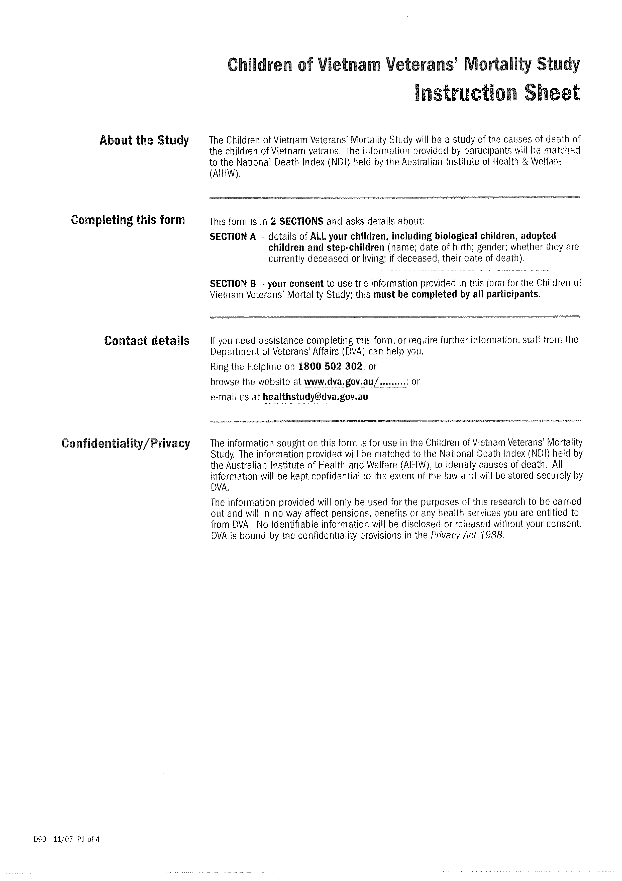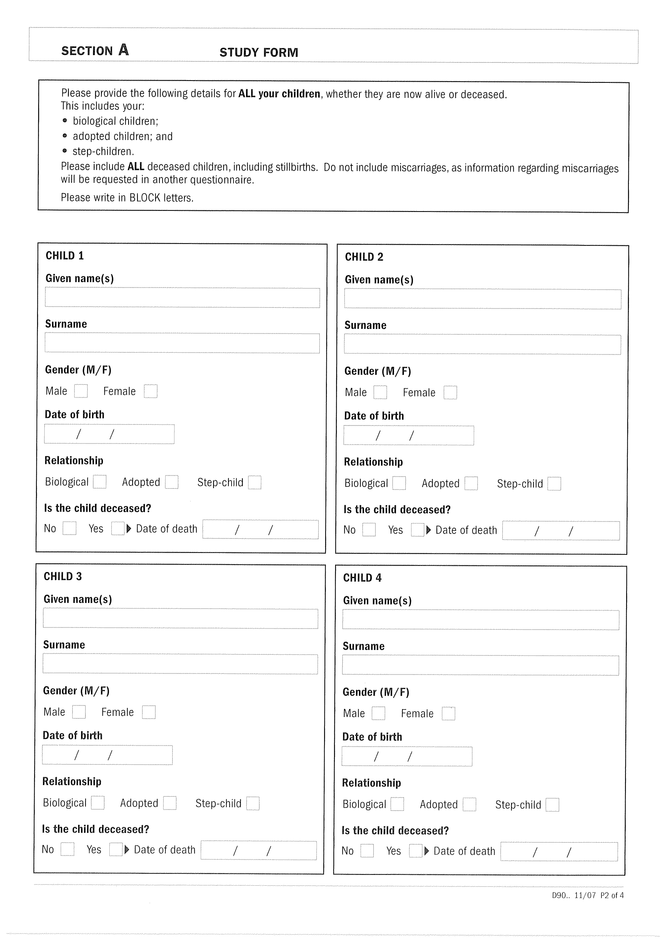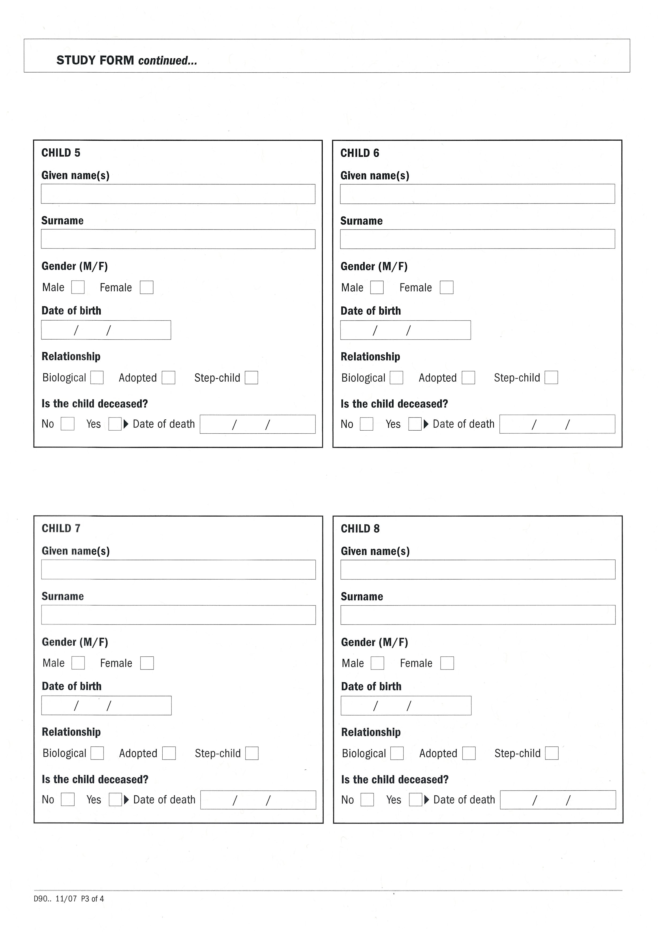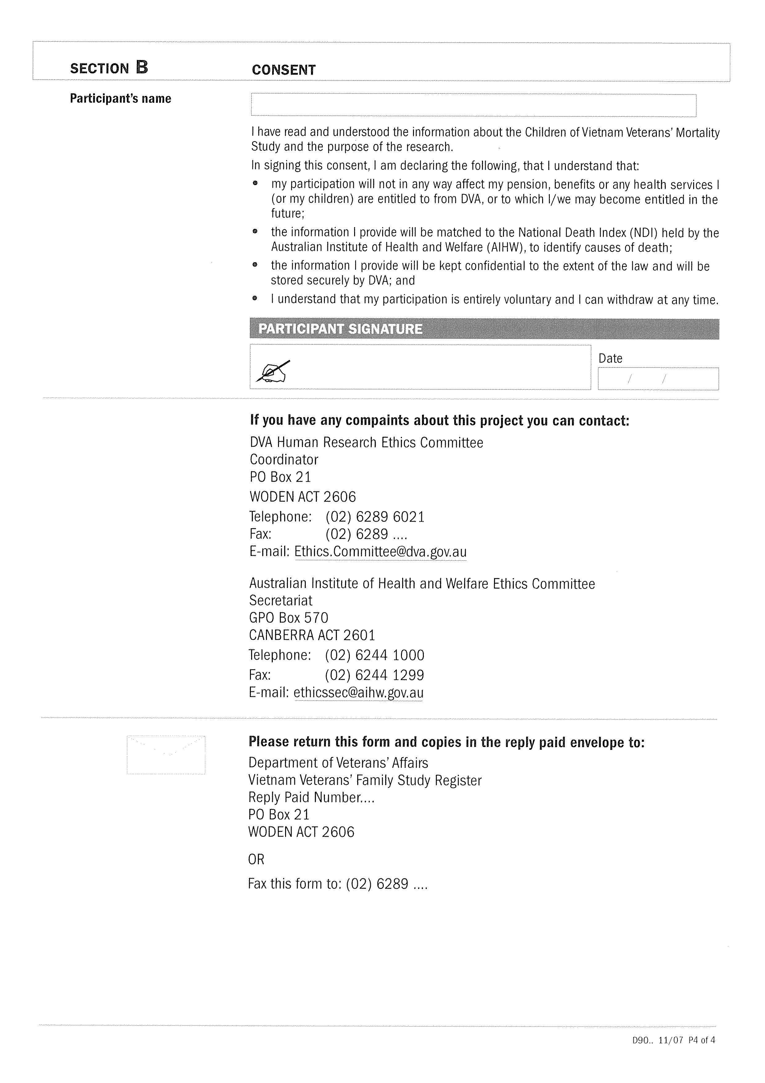

Appendix C External causes of death: ICD‑10

The World Health Organization’s International Classification of Disease, or ICD, lists 22 broad categories of diseases and related health problems. A subset of these categories was used for the Mortality Study, as listed here.

**Accident-related deaths (V01-V99, W00-W99, X00-X59)**

**Transport accidents (V01-V99)**

V01-V09: Pedestrian injured in transport accident

V10-V19: Pedal cyclist injured in transport accident

V20-V29: Motorcycle rider injured in transport accident

V30-V39: Occupant of three-wheeled motor vehicle injured in transport accident

V40-V49: Car occupant injured in transport accident

V50-V59: Occupant of pick-up truck or van injured in transport accident

V60-V69: Occupant of heavy transport vehicle injured in transport accident

V70-V79: Bus occupant injured in transport accident

V80-V89: Other land transport accidents

V90-V94: Water transport accidents

V95-V97: Air and space transport accidents

V98-V99: Other and unspecified transport accidents

**Other external causes of accidental injury (W00-W99, X00-X59)**

W00-W19: Falls

W20-W49: Exposure to inanimate mechanical forces

W50-W64: Exposure to animate mechanical forces

W65-W74: Accidental drowning and submersion

W75-W84: Other accidental threats to breathing

W85-W99: Exposure to electric current, radiation and extreme ambient air temperature and pressure

X00-X09: Exposure to smoke, fire and flames

X10-X19: Contact with heat and hot substances

X20-X29: Contact with venomous animals and plants

X30-X39: Exposure to forces of nature

X40-X49: Accidental poisoning by and exposure to noxious substances

X50-X57: Overexertion, travel and privation

X58-X59: Accidental exposure to other and unspecified factors

**Intentional self-harm (X60-X84)**

X60: Intentional self-poisoning by and exposure to nonopioid analgesics, antipyretics and antirheumatics

X61: Intentional self-poisoning by and exposure to antiepileptic, sedative-hypnotic, antiparkinsonism and psychotropic drugs, not elsewhere classified

X62: Intentional self-poisoning by and exposure to narcotics and psychodysleptics [hallucinogens], not elsewhere classified

X63: Intentional self-poisoning by and exposure to other drugs acting on the autonomic nervous system

X64: Intentional self-poisoning by and exposure to other and unspecified drugs, medicaments and biological substances

X65: Intentional self-poisoning by and exposure to alcohol

X66: Intentional self-poisoning by and exposure to organic solvents and halogenated hydrocarbons and their vapours

X67: Intentional self-poisoning by and exposure to other gases and vapours

X68: Intentional self-poisoning by and exposure to pesticides

X69: Intentional self-poisoning by and exposure to other and unspecified chemicals and noxious substances

X70: Intentional self-harm by hanging, strangulation and suffocation

X71: Intentional self-harm by drowning and submersion

X72: Intentional self-harm by handgun discharge

X73: Intentional self-harm by rifle, shotgun and larger firearm discharge

X74: Intentional self-harm by other and unspecified firearm discharge

X75: Intentional self-harm by explosive material

X76: Intentional self-harm by smoke, fire and flames

X77: Intentional self-harm by steam, hot vapours and hot objects

X78: Intentional self-harm by sharp object

X79: Intentional self-harm by blunt object

X80: Intentional self-harm by jumping from a high place

X81: Intentional self-harm by jumping or lying before moving object

X82: Intentional self-harm by crashing of motor vehicle

X83: Intentional self-harm by other specified means

X84: Intentional self-harm by unspecified means

**Other external causes**

X85-Y09: Assaults

Y10-Y34: Event of undetermined intent

Y35-Y36: Legal intervention and operations of war

Y40-Y84: Complications of medical and surgical care

Y85-Y89: Sequelae of external causes of morbidity and mortality

Y90-Y98: Supplementary factors related to causes of morbidity and mortality classified elsewhere

Source: WHO (n.d.a).

# Shortened forms

|  |  |
| --- | --- |
| AIHW | Australian Institute of Health and Welfare |
| CI | confidence interval |
| CoD | cause of death |
| DVA | Department of Veterans’ Affairs |
| GRM | General Record of Incidence of Mortality |
| ICD | International Classification of Disease |
| K–S | Kolmogorov–Smirnov |
| NDI | National Death Index |
| RR | relative risk |
| RSVEP | randomly selected Vietnam-era personnel |
| RSVV | randomly selected Vietnam veteran |
| RSVVBR | randomly selected Vietnam veterans’ brother group |
| RSVVSI | randomly selected Vietnam veterans’ sister group |
| SMR | standardised mortality ratio |
| SSVEP | self-select Vietnam-era personnel |
| SSVV | self-select Vietnam veteran |
| SSVVBR | self-select Vietnam veterans’ brother group |
| SSVVSI | self-select Vietnam veterans’ sister group |
| VV | Vietnam veteran |
| VVBR | Vietnam veterans’ brother group |
| VVFS | Vietnam Veterans Family Study |
| VVSI | Vietnam veterans’ sister group |
| WHO | World Health Organization |

# Glossary

|  |  |
| --- | --- |
| Age standardisation | A method of adjusting the crude mortality rate to eliminate the effect of differences in population age structures when comparing crude rates for different periods, different geographic areas and/or different population subgroups |
| Cohort | A group of subjects who have shared a particular event together at a particular time. Cohorts can be tracked over extended periods in a cohort study |
| Confounding | The distortion of the effect of an exposure on the risk of an outcome as a result of other factors influencing the outcome |
| Conscript | A 20-year-old male civilian registered with the Department of Labour and National Service whose birth date was drawn in a ballot. This made him liable for military service, including ‘special overseas service’, between November 1964 and December 1972. The period of service was two years of full-time military service (later 18 months) and three years on the active reserve list. Men compelled into service in this way were also referred to as National Servicemen |
| Control group | A group of subjects or conditions that is matched as closely as possible with an experimental group (in this instance, Vietnam veterans and their family) but is not exposed to any experimental event (in this instance, service in the Vietnam War). The results are compared in order to determine the changes that may occur as a result of the experimental event (in this instance, operational service in Vietnam) |
| Crude mortality rate | The number of deaths from all causes in an entire population in a given period. Usually expressed as a number per 1,000 or 100,000 population |
| Cumulative hazards | A measure of the risk of dying within a small interval of time, conditional on survival of the individual to the beginning of that period |
| Ethnographic study | The scientific study and description of a group of people and their culture |
| Evidence-based research | Application of the best available scientific research results (evidence) when making decisions about programs and services |
| Exposure | In this instance, a father who experienced operational service in Vietnam |
| Gold Card | Repatriation Health Card for All Conditions (Gold). Entitles the holder to the full range of approved health care services at the Department of Veterans’ Affairs’ expense. This includes medical and allied health care, assistance in the home and support services through arrangements with registered health care service providers and hospitals, both public and private |
| Key participant | Army Vietnam veteran or Army Vietnam-era person who did not deploy to Vietnam |
| Main Survey | In this instance, refers to the quantitative research method involving the administration of a self-report questionnaire |
| Morbidity | The incidence of ill-health in a population |
| Mortality | The incidence of death in a population |
| Mortality curve | A visual representation of data from life tables. Life tables describe the pattern of age-specific mortality and survival rates for a population over a lifetime or a period of study |
| National Death Index | Australian database, held at the Australian Institute of Health and Welfare, that contains records of all deaths occurring in Australia since 1980. The data are obtained from the registrars of births, deaths and marriages in each state and territory |
| National Serviceman | See *Conscript* |
| Nominal Roll of Vietnam Veterans | A database containing information about approximately 61,000 Australian service personnel who experienced operational service in Vietnam |
| Propensity score matching | A statistical matching technique that attempts to estimate the effect of a treatment, policy or other intervention by accounting for the covariates that predict receiving the treatment |
| Proportional mortality | The number of deaths for a given cause of death as a proportion of all deaths |
| Qualitative research | A research technique used to gain insight into the factors underlying a topic through the analysis of non-numerical data gathered through methods such as interviews and open-ended surveys. The aim is to gain an understanding of people’s opinions, feelings, attitudes, motivations, values and perceptions |
| Quantitative research | A research technique in which numerical data are gathered and statistically analysed. The aim is to provide a connection between empirical observation and statistical relationships |
| Randomly selected | In this instance, refers to people who were randomly invited to participate in the Vietnam Veterans Family Study. This ensured that the study sample was representative of the population of Vietnam veterans and their families and minimised any potential bias in the research outcomes |
| Regulars | Men and women who volunteer to join the Australian Defence Force |
| Relative risk | The ratio of the probability of death among the study group (exposed) to the probability of death among a comparison group (non-exposed) |
| Research Protocol | The protocol developed by the Centre for Military and Veterans’ Health to guide the development of research undertaken through the Family Studies Program and, in particular, the Vietnam Veterans Family Study |
| Sample | A set of people whose characteristics represent, as accurately as possible, a broader group of people in a larger population |
| Self-select | In this instance, refers to people who nominated themselves to take part in the Vietnam Veterans Family Study |
| Standardised mortality ratio | A comparison of the number of deaths in an observed population with number of deaths expected in a standard or common population |
| Statistically significant | A pivotal element of statistical hypothesis testing. Used to determine whether a null hypothesis (default position) should be rejected or retained |
| Survey | A research technique that involves asking questions of a sample of respondents using a questionnaire or an interview |
| Unconfirmed deaths | In this instance, reported deaths of children that could not be verified after investigation by the Australian Institute of Health and Welfare |
| Vietnam veteran | For the purposes of this study, a person who served in the Australian armed forces in Vietnam at any time between 1962 and 1975. In this instance, refers to Army personnel only |
| Vietnam War: years of Australian involvement | Australia’s military involvement in Vietnam spanned the period 1962 to 1972, when the last Australian combat forces were withdrawn. Some Australian military personnel, the Embassy Guard, remained in South Vietnam after this but were not engaged in operations. The Vietnam War continued until April 1975, when South Vietnam surrendered to North Vietnam. During the final weeks of the war RAAF personnel were involved in relief operations and evacuations. The war’s end date is therefore 1975, but Australia’s combat involvement ended in 1972 |
| Vietnam-era personnel | For the purposes of this study, people who served in the Australian Defence Force at any time between 1962 and 1975 but did not deploy to Vietnam |
| White Card | Repatriation Health Card for Specific Conditions (White). Entitles the holder to the full range of health care services at the Department of Veterans’ Affairs’ expense but generally only for those disabilities or illnesses accepted as service-related |

# Bibliography

ABS 2004, *1993–2003: Suicides: recent trends, Australia*, <http://intranet/index.cfm/18,940,c,html/3309_0_55_001.pdf>.

ABS 2010, *2007–2009: Australian Life Tables*, <http://www.abs.gov.au/AUSSTATS/abs@.nsf/allprimarymainfeatures/0FDC2DE33EB6284ECA257943000CFEB6?opendocument>.

ABS Code of Suicide Deaths: <http://www.abs.gov.au/ausstats/abs@.nsf/Products/3303.0~2007~Technical+Note~ABS+Coding+of+Suicide+Deaths+%28Technical+Note%29?OpenDocument>.

AIHW n.d., *Deaths*, AIHW, Canberra, https://www.aihw.gov.au/deaths/.

AIHW 2004, *Mortality over the Twentieth Century in Australia: trends and patterns in major causes of death*, Mortality Surveillance Series no. 4, AIHW cat. no. PHE73, Australian Institute of Health and Welfare, Canberra.

AIHW 2013, *General Record of Incidence of Mortality*, <http://www.aihw.gov.au/aihw-deaths-data/#grim>.

Centre for Military and Veterans’ Health 2007, *The Intergenerational Health Effects of Service in the Military: research protocol*, CMVH, The University of Queensland, Herston.

Department of Veterans’ Affairs 1996, *The Feasibility of a Study into the Health of Children of Vietnam Veterans*, DVA, Canberra.

Department of Veterans’ Affairs 2011, *Annual Report 2010–11*, DVA, Canberra, http://www.dva.gov.au/aboutDVA/publications/corporate/annualreport/2010-2011/Appendixes/Pages/10-1_AppendixA.aspx#tablea1.

Department of Veterans’ Affairs & Australian Institute of Health and Welfare 2000, *Morbidity of Vietnam Veterans: suicide in Vietnam Veterans’ children, supplementary report 1*, Cat. no. PHE 25, AIHW, Canberra.

Guo S & Fraser M 2010, *Propensity Score Analysis: statistical methods and applications*, Sage, Thousand Oaks.

Imbens GW 2000, ‘The role of the propensity score in estimating dose–response functions’, *Biometrika*, vol. 87, no. 3, pp. 706–10.

Knowledge Panel® 2010, *Processes & Procedures Contributing to Sample Representativeness & Tests for Self-selection Bias*, March, <http://www.knowledgenetworks.com/ganp/docs/KnowledgePanelR-Statistical-Methods-Note.pdf>.

Michael AJ 1976, ‘Standardized mortality ratios and the “healthy worker effect”: scratching beneath the surface’, *Journal of Occupational Medicine*, vol. 18, no. 3, pp. 165–8.

Rosenbaum PR & Rubin DB 1983. ‘The central role of the propensity score in observational studies for causal effects’, *Biometrika*, vol. 70, no. 1, pp. 41–55.

Survival analysis using SAS: <http://www.ats.ucla.edu/stat/sas/seminars/sas_survival/default.htm>.

Waller M & McGuire ACL 2011, ‘Changes over time in the “healthy soldier effect”’, *Population Health Metrics*, vol. 9, p. 7.

Wen CP, Tsai SP & Gibson RL 1983, ‘Anatomy of the healthy worker effect: a critical review’, *Journal of Occupational Medicine*, vol. 25, no. 4, pp. 283–9.

WHO n.d.a, *External Sources of Morbidity and Mortality*, <http://apps.who.int/classifications/apps/icd/icd10online/index.htm?gx60.htm>, <http://apps.who.int/classifications/apps/icd/icd10online/gy85.htm>.

WHO n.d.b, *Noncommunicable Diseases*, Fact sheet, www.who.int/mediacentre/factsheets/fs355/en/.

Wilson EJ, Horsley KW & van der Hoek R 2005a, *Australian National Service Vietnam Veterans Mortality and Cancer Incidence Study 2005*, Department of Veterans’ Affairs, Canberra.

Wilson EJ, Horsley KW & van der Hoek R 2005b, *The Third Australian Vietnam Veterans Mortality Study 2005*, Department of Veterans’ Affairs, Canberra.

1. SAS computer code ReMa (Record Matching), developed by the AIHW to link external data to the National Death Index via probabilistic record matching.
2. The analyses were conducted using logistic regression. Details of the analytical method and results are reported in Addendum A1.
3. Only four Vietnam veterans who participated in the VVFS and the Mortality Study and for whom we were able to estimate propensity scores could not be matched to the Nominal Roll of Vietnam Veterans. In most cases, we matched respondents using the confidential identification numbers provided by the Department of Veterans’ Affairs; however, in some cases respondents could not be matched in this manner as they had identification numbers that were not contained in the Nominal Roll. In three of those cases, we were able to match respondents using additional information reported in both the VVFS and the Nominal Roll, including sex, date of birth, branch of the military (that is, Army), rank (that is, enlisted, non-commissioned officer, or commissioned officer), National Service, and correspondences between their primary roles during their deployment (for example, engineer) and the corps in which they served (for example, Royal Australian Engineers). The final matched sample of 2,184 veterans comprises roughly 5.3 per cent of the surviving male Army veterans listed on the Nominal Roll. Non-response by Vietnam-era personnel is of less concern because the VEP members and their family members are included in the study to provide a comparison (or control) group for the Vietnam veterans and their sons and daughters. Given that the Vietnam-era personnel included in the estimation sample are chosen because they are comparable to the Vietnam veterans, it is not necessary that they are representative of the total population of Vietnam-era personnel.
4. Propensity score weights amplify the influence of VVFS respondents who served in Vietnam but who were less likely to serve given their pre-deployment characteristics (for example, age, National Service).
5. The rates reported in Table 7.5 may differ from those reported in the main body of the report because they were based on different samples. Specifically, the rates reported here are restricted to the children of men in the randomly selected sample and who participated in both surveys. By contrast, the main body of the report describes the deaths of the children of all servicemen who completed the Mortality Study survey. To determine whether death rates among the children of the Vietnam veterans exceed those among the children of the Vietnam-era personnel, we estimated the probability of death for each child conditional on the deployment status of his or her father using logistic regression. We then calculated differences between the predicted probabilities of death for each group together and standard errors associated with those differences. We adjusted estimates of the standard errors in all models to take into account the interdependence between observations (that is, sons and daughters of the same serviceman) and control for the clustered nature of the data.
6. By the time of the 14th National Service ballot in September 1971, the government was advising that conscripts (selected in that ballot) would not be committed to Vietnam (*Canberra Times*, 18 September 1971, p. 3).