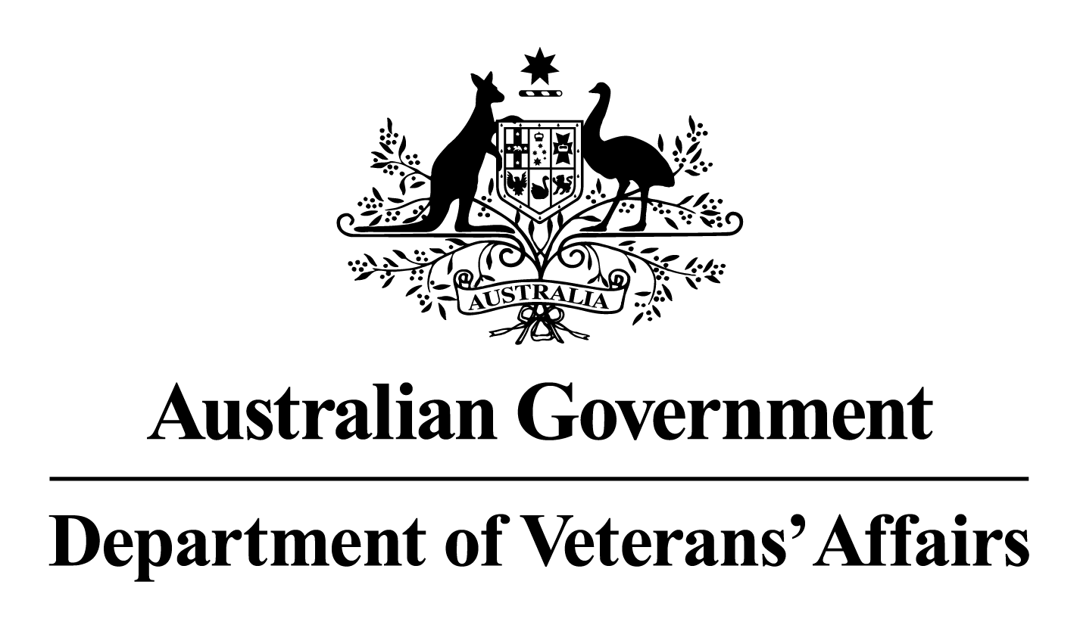

***Deputy Commissioners Consultative forum – Tasmania***

**Meeting Minutes**

***11June 2025***

**Attendees**

|  |  |
| --- | --- |
| **Name** | **Organisation** |
| Sally Dennington | Deputy Commissioner Tasmania |
| Kate Morris | Executive Officer |
| Barry Quinn | RSL Tasmania |
| Sandie Wilson | Mates4Mates |
| Garry Beven | Advocacy Training and Development Program |
| Kevin Evorall | Legacy Launceston |
| LTCOL Neil Grierson | Senior Australian Defence Force Officer |
| Brian Harper | Vietnam Veterans Association Australia – Tas |

**Apologies**

|  |  |
| --- | --- |
| **Name** | **Organisation** |
| Melissa Foale | Women’s Veteran Network Australia - Tasmania |
| Don Ryan | Veterans Reference Group |
| David Waddle | Hobart Legacy |
| Jenny Robertson | RAAF-Association |
| Brian Ellis | Naval Association Australia |
| Ray Williams OAM | Totally & Permanently Incapacitation Association |
| Karelle Logan | Department of Premier and Cabinet |

**Meeting commenced at 1400**

**Business arising:**

Apologies noted.

**Agenda items submitted**:

NIL

**Simon Adler, Director, VEA Compensation Claims**:

Presented on the new claims processing procedure for incomplete claims and the introduction of the MyOrg for Advocates to submit claims on behalf of their Veteran clients. Task card are in the process of being released to assist Advocates in the use of MyOrg.

**Deputy Commissioner update**:

Gwen Cherne (Veteran Family Advocate) is finishing up with the Department and sends her thanks for all the support DCCF members give to Veterans and their families. Recruitment is underway for a replacement Veteran Family Advocate.

The building works at DVA and Open Arms Hobart commences on the 23rd of June 2025 and will be completed by February 2026.

The Garden of Remembrance will be closed in July 2025, with works starting on the replacement of the walls. The new walls will be made of a polished concrete and be raised off the ground by pylons to allow a garden to be planted underneath.

The Deputy Commissioner recently attending an open day at the Veterans’ and Families’ Centre in Burnie where the Governor General was in attendance.

The Deputy Commissioner will be attending the RSL Congress on the 14th of June and providing an update on DVA and the OAWG’s.

**Attendee update:**

**Open Arms (OA):**

As well as the building works in Hobart, OA are currently negotiating leases to move into the Devonport, Launceston and Huon Veteran Hubs.

**Senior Australian Defence Force Officer (SADFO):**

The ADF are finalising their posting cycles for 2026 which will see a new SADFO post into Tasmania.

**Advocacy:**

BAU

**Mates4Mates (M4M)**:

BAU. The renovation of ANZAC house in New Town will see the M4M centre closed for drop in sessions and all in house programs have been moved offsite for the duration of the renovation.

**Returned Services League:**

Barry Quinn is retiring as the President of RSL Tasmania on the 15th of June 2025 with Michael Gallagher taking up the position. Renovations at ANZAC House start next week and are due to be completed within six weeks.

**Legacy Launceston:**

The War Widows lunches are continuing to take place on Wednesdays at Legacy Launceston. Legacy has the junior speaking competition in August 2025.

**Vietnam Veterans Association Australia – Tas:**

BAU

**Meeting closed at 1545**

**Next meeting 13 August 2025, 1400**