

**Strategic Research Framework**

2019 – 2021

**Strategic Research Framework**

**2019 – 2021**

Contents

1. Introduction 1

2. Scope 2

3. Vision 2

4. Mission 2

5. Principles 2

6. Objectives 2

7. Priorities 3

8. Engagement and collaboration 5

9. Governance 5

10. Risk management 5

11. Ethics and social licence 5

12. Benefit realisation 6

13. Translation 6

14. Publications and data 7

15. Review 7

# Introduction

The Department of Veterans’ Affairs (DVA) takes a proactive approach in commissioning research to build an effective evidence base that supports the health and wellbeing needs of Australia’s veterans.

DVA has developed a Strategic Research Framework to detail the analytical and research priorities and principles for DVA, to focus future research and data gathering efforts. Commissioned research must result in actionable outcomes that are translated into policy and program directions.

The primary drivers for DVA research are:

1. To inform policy development, program design and evaluation
2. To support DVA as a data-driven organisation

The primary means of commissioning research within DVA is the Applied Research Program (ARP), which provides around $3.9 million annually for business areas to engage with research activities. A range of other research, evidence and evaluation activities are funded on the basis of business need, through other funding sources, Strategic Partnerships or Memoranda of Understanding.

As outlined in the Australian Institute of Health and Welfare *Profile of Australia’s Veterans* and the Productivity Commission *A Better Way to Support Veterans, Report*; previous research efforts have been primarily health focused. With DVA broadening its scope on wellbeing, research will also look to address key information gaps in the areas of education, employment, justice, housing, safety; finance and social support.

This Framework sets out the principles, objectives and priorities for DVA to facilitate research and evaluation in areas of special strength or need as identified in priority research areas. This targeted research will bridge gaps in our knowledge base, enabling us to better understand the needs of our clients and proactively anticipate future veteran needs and the policies and services to support those needs.

# Scope

The Framework applies to all internal and external research and evaluation, undertaken by, or commissioned on behalf of DVA.

# Vision

To deliver high-quality research and data that underpins effective service delivery and facilitates the move from an illness to a wellbeing model.

# Mission

To build a comprehensive, reliable and accessible evidence base for DVA to formulate policy and business strategy, and to make effective service delivery decisions that supports lifetime wellbeing for Australia’s veterans[1], and their families.

# Principles

Research commissioned by DVA must:

1. Focus on veterans and/or their families
2. Help to build understanding of the impact of military service on veterans and their families
3. Produce actionable and reproducible research outcomes
4. Provide translatable findings and usable data that informs development and improvement of policy, services, guidelines and/or decision making processes

# Objectives

The Objectives of the Framework are:

1. To increase the evidence base and use of data to support DVA services
2. To increase awareness of emerging veteran issues and potential solutions

# Priorities

This Framework will guide the implementation of priority research areas for the next three years, 2019-2021. Early stages of implementation will prioritise studies that capitalise on existing DVA data, and that support horizon scanning of current and emerging issues.

This supports DVA’s Veteran Centric Reform to transform the way DVA does business, putting veterans and their families first. The objective of DVA’s Transformation Agenda is to change from an organisation that focuses on claims; to one that is more agile, responsive and efficient and puts clients at the centre of everything we do.

Research commissioned in accordance with the Framework must support:

1. The changing focus from an illness to a wellbeing model;
2. Improve understanding of clients’ needs, considering health and wellbeing for both veterans and their families; and
3. Improve service delivery.

All proposals will be assessed against this Framework, and must:

1. Be veteran specific
2. Demonstrate use of DVA’s existing datasets, where possible
3. Establish actionable policy objective/s for the proposed research
4. Demonstrate a high level of business engagement in the project
5. Deliver an innovative approach
6. Support evaluation and improvement of DVA services
7. Have completed a needs/design assessment
8. Match policy timeframes

Higher priority will be given to projects that address one or more of DVA’s identified research priorities, as aligned with the veteran’s stages of experience of **Serving Well**, **Living Well** and **Ageing Well**, in Figure 1, in line with DVA’s wellbeing approaches.

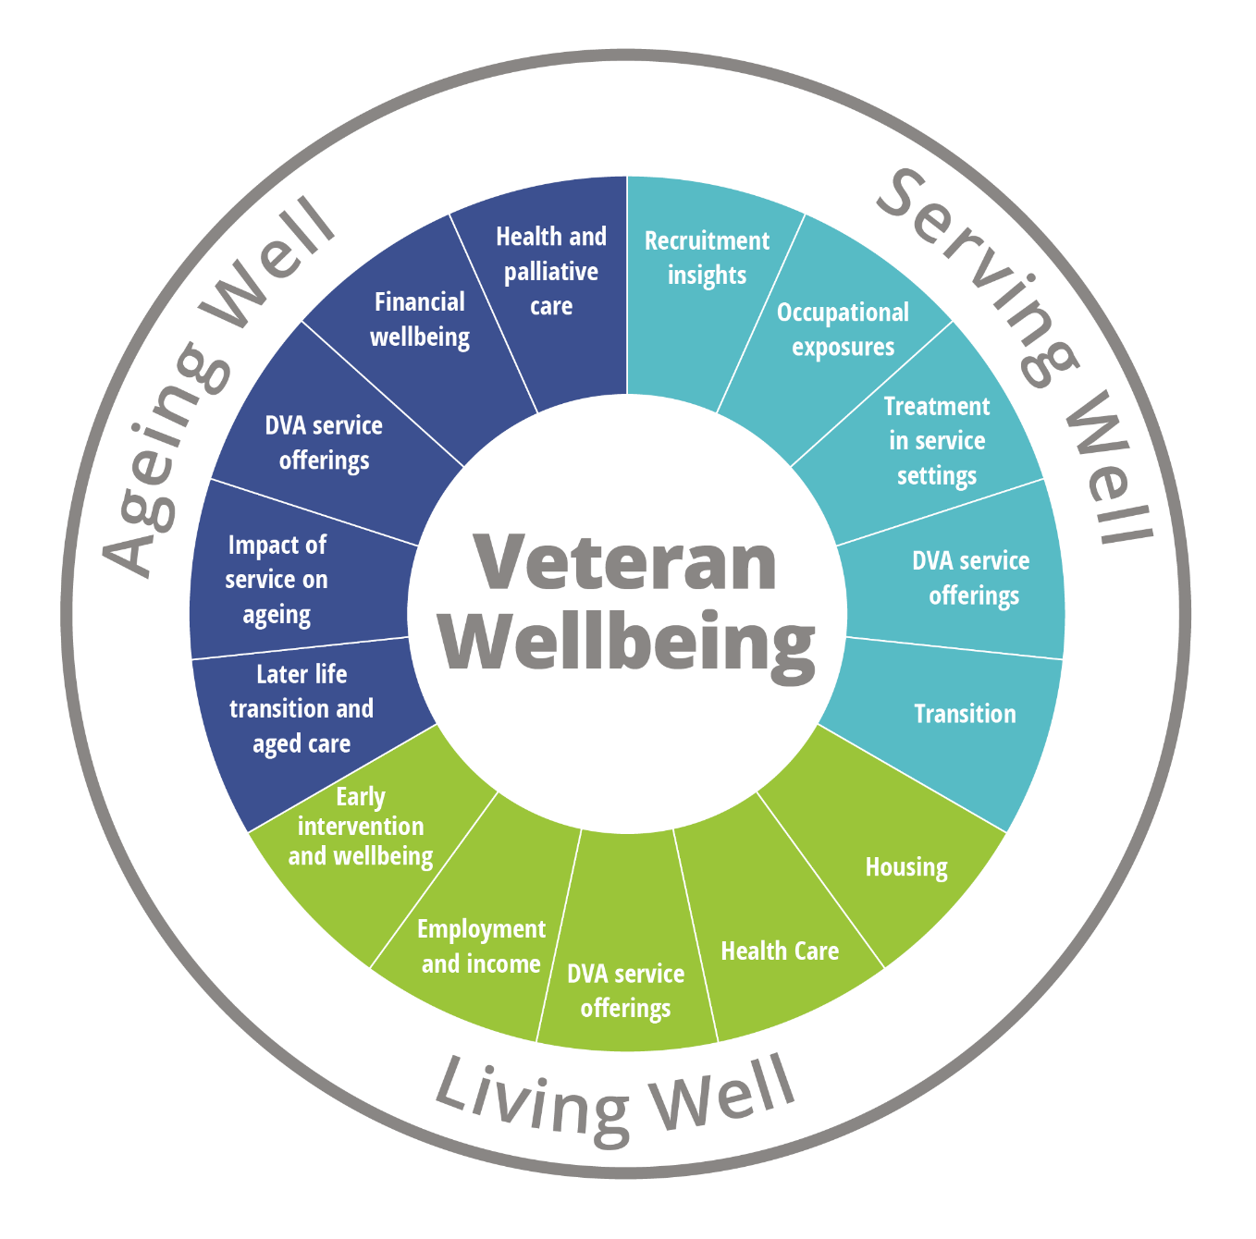

Figure 1 DVA identified research priorities, aligned with the veteran stages of experience in Serving Well, Living Well and Ageing Well

# Engagement and collaboration

DVA commissions research from a range of service providers, and in partnership with a number of key stakeholders including the Department of Defence, the Australian Institute of Health and Welfare, and the Australian Bureau of Statistics.

Better policy outcomes and service design will result from equipping DVA staff with the skills to better understand, extrapolate and use research findings, by:

1. Increasing business area engagement with research design and research outputs
2. Improving business area data literacy and management
3. Increasing strategic research partnerships and promoting innovative research products
4. Leveraging stakeholder knowledge

In the interest of building research sector capability, support for research centres may be considered on a case-by-case basis, and assessed in accordance with this Framework. DVA also undertakes a number of international collaborations across the 5-Eyes Veteran Research Network to benchmark our research and evaluation activities.

# Governance

DVA utilises a procurement methodology to commission research projects across the Department, not limited to the Applied Research Program. DVA commissions new projects through open or limited tender arrangements, with proposals assessed by the DVA Research Board against the Priorities outlined in this Framework.

Revised governance arrangements for the Research Board will be implemented following the review of the Strategic Research Model (SRM) undertaken in 2017. Refer to the DVA Research Board Terms of Reference for details. Strong links between the DVA Research Board and the DVA Policy Committee are important to ensure the Framework continues to meet the strategic policy needs of the Department.

# Risk management

DVA will consider the overall cost-effectiveness of research, any financial or other resources required; including any risks to participants and/or perceived or actual conflict of interest as per the Commonwealth Procurement Rules; as well as potential reputational risks not confined to procurement.

# Ethics and social licence

It is essential to clearly establish the parameters for social licence for use of existing data and new research proposals. This is to ensure a clear understanding of the rationale for use of any data, and to maintain trust with the veteran community and relevant stakeholders.

Where researchers recruit veterans to a study, they must comply with ethical requirements detailed in the Guidelines provided by the Departments of Defence and Veterans' Affairs Human Research Ethics Committee (DDVA HREC), including the Mazengarb clause requirement[2]. Other studies that do not recruit participants, but that use veteran data or are supported by DVA, also need to be conducted ethically, and may require DDVA HREC ethics approval. DVA is developing a more detailed research ethics policy to support this process.

# Benefit realisation

The Framework recognises the challenges faced in bridging the research policy gap and underlines the need for research to realise benefits for DVA. Research proposals must clearly demonstrate measurable benefits to achieve an identifiable policy or service objective.

Project outcomes should be measurable to establish effectiveness of implementation of research findings and recommendations, to guide improvement in program effectiveness and/or inform decisions about future research opportunities.

This can be achieved through, but not limited to:

**Evaluation methodologies**

* *Quantitative*: Post-research surveys, cost-benefit analyses
* *Qualitative:* Interviews and Focus groups, case studies, literature reviews

**Participant studies**

* Veterans, and other research participants such as family members and service providers
* Research providers collaborating closely with policy makers/implementers

# Translation

Research commissioned by DVA must leverage research findings to inform policies and programs, therefore research outcomes must be effectively communicated to end-users, and clearly articulate how research findings can achieve 'real world' impact.

The World Health Organisation defines knowledge translation (KT) as:

“The synthesis, exchange, and application of knowledge by relevant stakeholders to accelerate the benefits of global and local innovation in strengthening health systems and improving people’s health.” [3]

Translation activities should begin during project planning and design, to ensure the project plans address policy needs and are designed to produce findings that can be used in policy and/or practice. Active ongoing collaboration between DVA business areas and researchers during the life of the project is essential; as well as clearly defined mechanisms to provide results accessible to government, industry and the veteran community.

To maximise benefit to the veteran community, research projects must produce user-friendly products for policy decision makers to ensure effective translation of the outcomes of research into initiatives that inform policy and decision making. This could include development of a Policy Impact Statement as an expected project deliverable.

A communication and engagement strategy will be developed to identify:

* end-user engagement and understanding their needs;
* production of end-user friendly products, including research summaries, to ensure research and data are easily accessible and adoptable; and
* communication channels that bring researchers and end-users, particularly DVA business areas, together on a regular basis, for example via research forums, seminars and research/policy workshops supported by skilled facilitators to support evidence-based decision-making.

# Publications and data

The Framework signals a shift in how DVA contemplates research in the context of data analytics, with a focus on innovative, dynamic approaches to identify emerging trends and needs.

DVA holds a range of data that is valued for its scientific research potential and increasingly for internal data analytics projects. This includes both administrative data related to client services and health study data collected as part of commissioned research studies.

This Framework aligns with the DVA Enterprise Data Strategy, and recognises that data is a valuable asset that supports DVA as a data-driven organisation.

# Review

The Research Priorities outlined within this Framework will be reviewed annually, with a full review undertaken at least every three (3) years.

1. Changing focus towards a veteran wellbeing model aligns with the Department’s Transformation agenda; and is explicitly supported in the *Productivity Commission A Better Way to Support Veterans, Draft Report* (2018).
2. The “Mazengarb clause” is a commitment to participants that their involvement in a research project will not have any impact on their access to DVA services or future entitlements.
3. WHO (2018) Knowledge translation [https://www.who.int/ageing/projects/knowledge_translation/en/](https://www.who.int/ageing/projects/knowledge_translation/en/%20) Accessed 16 October 2018