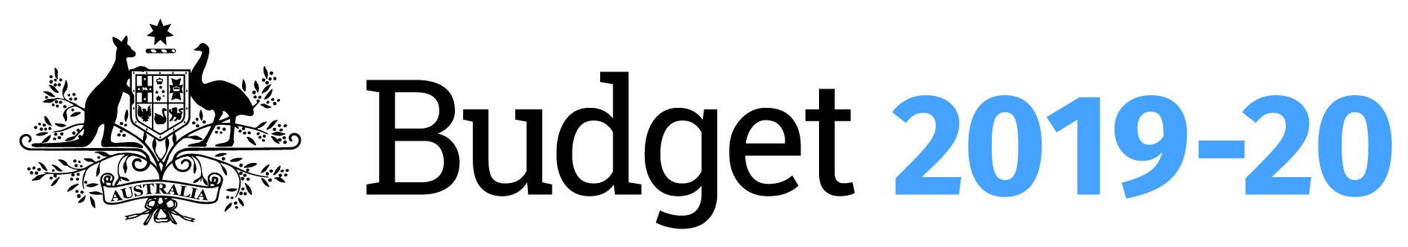

**REPATRIATION PHARMACEUTICAL BENEFITS SCHEME – NEW AND AMENDED LISTINGS**

**REPATRIATION PHARMACEUTICAL BENEFITS SCHEME – NEW AND AMENDED LISTINGS**

The Repatriation Pharmaceutical Benefits Scheme provides medicines and wound care items to Department of Veterans’ Affairs (DVA) entitled clients.

Under this budget measure, the Repatriation Pharmaceutical Benefits Scheme will include funding for nine new items, eight additional generic brands and price variations for items exclusively available to DVA entitled clients.

**WHY IS THIS IMPORTANT?**

New items and price variations ensure that veterans, war widows/ers and eligible dependants can continue to gain access to medicines and wound care items to meet their health care needs.

**WHO WILL BENEFIT?**

DVA clients who gain access to medications under the Repatriation Pharmaceutical Benefits Scheme will benefit from these new listings.

The new listings are for items including skin washes and emollients, wound care dressings and compression systems, as well as additional generic brands. There is also a number of routine price variations to existing items on the Schedule.

DVA clients will also benefit from new and amended items being listed on the Pharmaceutical Benefits Scheme administered by the Department of Health.

**DATE OF EFFECT**

July 2019.

**HOW MUCH WILL THIS COST?**

$0.1 million saving over four years from 2019–20 to 2022–23.