

**FINAL REPORT**

**6 February 2012**

Younger veterans’ transitions to civilian occupations: the role of further education

Kostas Mavromaras

Stéphane Mahuteau

Zhang Wei

**Contents**

Executive Summary i

1 Introduction 1

2 The Data 4

2.1 Data and Definitions 4

2.1.1 Vocational Education and Training (VET) in Australia 4

2.1.2 Student Outcomes Survey (SOS) Data Overview 4

2.1.3 Putting the 10 Waves of SOS Together 5

2.1.4 Population Projections 6

2.1.5 Occupational Information in the SOS 6

2.1.6 Defining ADF and Civilian Employment 6

2.1.7 VET and Labour Turnover for ADF Employees 7

2.1.8 Labour Market Turnover for ADF Employees 8

2.2 Descriptive Statistics 10

2.2.1 Demographic Information 10

2.2.2 Education before Training 14

2.2.3 VET Characteristics 16

2.2.4 Views and Expectations on VET 20

2.2.5 General Labour Market Outcomes 24

2.2.6 Job quality Indicators 29

3 Synthesis and Analysis 34

3.1 Comparing Groups of Interest 34

3.1.1 Comparisons Using Two-way Profiles 34

3.1.2 ADF ‘movers’ against ADF ‘stayers’ 36

3.1.3 ADF ‘leavers’ after VET Depending on Their Employment Outcomes (with or without a job) 39

3.1.4 ADF ‘stayers’ against Civilian ‘stayers’, both after VET 41

3.2 Multivariate Regressions 42

3.2.1 Overview and Questions Asked 42

3.2.2 What is the probability of getting a job after leaving the ADF and going through VET? 44

3.2.3 What are the differences between those VET graduates who stayed with the ADF after their VET and those who left to take a civilian job? 49

3.2.4 How do the wages compare between those VET graduates who left the ADF to take a civilian job and those who stayed in ADF employment? 52

3.2.5 Additional Outcomes after VET Training 57

3.2.5.1 Probability of getting a full-time job 57

3.2.5.2 Probability of getting a casual job 58

3.2.5.3 Probability of getting a skilled job 59

3.3 Predicting Labour Market Outcomes for ADF (ex-) Personnel 62

3.3.1 Sample Estimates of ADF (ex-) Personnel Labour Market Outcomes 63

3.3.2 Probability of Employment: Sample Estimates by Field of Study and Disability 63

3.3.3 Probability to Leave the ADF (change job): Sample Estimates by Field of Study and Disability 65

3.3.4 Earnings per Week: Sample Estimates by Field of Study, Disability and Gender 67

3.4 Scenarios and Incorporation of DVA Clients Characteristics 71

3.4.1 Probability of Finding a Job: Scenarios 73

3.4.2 Probability of Changing Job after Training: Scenarios Comparing ADF-CIV with ADF-ADF 75

3.4.3 Estimated Weekly Earnings after Training: Scenarios 76

3.4.3.1 ADF stayer vs. ADF leavers 76

3.4.3.2 ADF stayer versus ADF leavers: Gender differences in the returns to VET 80

3.4.4 Using the Model Results to Infer Veterans’ Combined Earnings and Employment Outcomes after VET 82

3.4.5 Probability of Obtaining a Skilled Job after VET: Scenarios 86

4 Conclusion 89

5 Appendix 92

**Tables**

Table 1: Student Outcomes Survey data: Number of observations by year 5

Table 2: Post-training labour force status of defence workers 7

Table 3: Pre-training labour force status for defence workers 8

Table 4: Transitions of labour force status 9

Table 5: Average age by year of VET completion and turnover type 11

Table 6: Average age by turnover type 11

Table 7: Gender by turnover type (employed before and after training) 12

Table 8: Gender by turnover type (not employed-ADF and ADF-not employed) 13

Table 9: Disability or long-term condition (employed before and after training) 14

Table 10: Highest school year completion (employed before and after training) 15

Table 11: Highest pre-training qualification (employed before and after training) 16

Table 12: VET course level by turnover category (employed before and after training) 17

Table 13: Sector of education providers (employed before and after training) 18

Table 14: Number of ‘actual’ graduates and module completers (employed before and after training) 19

Table 15: Additional study since undertaking the training (employed before and after training) 20

Table 16: Main reason for doing the training (employed before and after training) 21

Table 17: Was the main reason for training achieved? 21

Table 18: Overall satisfaction with the chosen training (employed before and after training) 22

Table 19: Relevance of training to job after training (employed before and after training) 23

Table 20: When main job commenced after training 25

Table 21: Time taken to find a job after training 25

Table 22: Occupation before training (employed before and after training) 26

Table 23: Occupation after training (employed before and after training) 27

Table 24: Change in occupation (employed before and after training) 28

Table 25: Change in skill level (employed before and after training) 28

Table 26: Average weekly earnings after training over time (employed before and after training) 29

Table 27: Average weekly earnings after training 29

Table 28: Entitled to paid sick leave or holiday leave before training (employed before and after training) 31

Table 29: Entitled to paid sick leave or holiday leave after training (employed-employed) 31

Table 30: Hours worked per week before training (employed before and after training) 32

Table 31: Hours worked per week after training (employed before and after training) 33

Table 32: Profiles of ADF and Civilian employees by transition category 35

Table 33: Probability of employment after training (ADF leavers only) 46

Table 34: Probability of changing job after training: Comparing ADF-CIV with ADF-ADF 50

Table 35: Weekly earnings after training: Comparing ADF-CIV with ADF-ADF 53

Table 36: Probability of getting a full-time job after training: Comparing ADF-CIV with ADF-ADF 57

Table 37: Probability of getting a non-casual job after training: Comparing ADF-CIV with ADF-ADF 58

Table 38: Probability of a skilled job after training: Comparing ADF-CIV with ADF-ADF 60

Table A 1: Number of observed employment transitions by year: Student Outcomes Survey 92

Table A 2: Disability or long-term condition (not employed-ADF & ADF-not employed) 92

Table A 3: Highest school year completion (not employed-ADF & ADF-not employed) 92

Table A 4: Highest pre-training qualification (not employed-ADF & ADF-not employed) 92

Table A 5 : VET course level by turnover category (not employed-ADF & ADF-not employed) 93

Table A 6: Field of VET study by labour turnover category (employed before and after training) 93

Table A 7: Field of VET study by labour turnover category (not employed-ADF & ADF-not employed) 93

Table A 8: Sector of education providers (not employed-ADF & ADF-not employed) 94

Table A 9: Number of “actual” graduates and module completers (not employed-ADF & ADF-not employed) 94

Table A 10: Additional study since undertaking the training (not employed-ADF & ADF-not employed) 94

Table A 11: Main reason for doing the training (not employed-ADF & ADF-not employed) 95

Table A 12: Was the main reason for training achieved? (not employed-ADF & ADF-not employed) 95

Table A 13: Overall satisfaction with the chosen training (not employed-ADF & ADF-not employed) 95

Table A 14: Relevance of training to job after training (not employed-ADF) 95

Table A 15: When main job commenced after training (not employed-ADF) 95

Table A 16: Time taken to find a job after training (not employed-ADF) 96

Table A 17: Occupation before training (ADF-not employed) 96

Table A 18: Occupation after training (not employed-ADF) 96

Table A 19: Entitled to paid sick leave or holiday leave before training (ADF-not employed) 96

Table A 20: Entitled to paid sick leave or holiday leave after training (not employed-ADF) 97

Table A 21: Hours worked per week before training (ADF-not employed) 97

Table A 22: Hours worked per week after training (not employed-ADF) 97

Table A 23: Further scenarios: labour market outcomes of 40 years old males 97

Table A 24: Further scenarios: labour market outcomes of 40 years old females 97

Table A 25: Correlations between explanatory variables used in multivariate regression 98

**Error! No table of contents entries found.**

**Figures**

Figure 1: Distribution of age by turnover type 11

Figure 2: Average age by transition type 11

Figure 3: Gender by turnover type (employed before and after training) 12

Figure 4: Gender by turnover type (not employed-ADF and ADF-not employed) 13

Figure 5: Disability or long-term condition 14

Figure 6: Highest school year completion (employed before and after training) 15

Figure 7: Highest pre-training qualification (employed before and after training) 16

Figure 8: VET course level by turnover category (employed before and after training) 17

Figure 9: Sector of education providers (employed before and after training) 18

Figure 10: Number of ‘actual’ graduates and module completers (employed before and after training) 18

Figure 11: Additional study since undertaking the training (employed before and after training) 19

Figure 12: Main reason for doing the training (employed before and after training) 20

Figure 13: Was the main reason for training achieved? 21

Figure 14: Overall satisfaction with the chosen training (employed before and after training) 22

Figure 15: Relevance of training to job after training (employed before and after training) 23

Figure 16: When main job commenced after training 24

Figure 17: Time taken to find a job after training 25

Figure 18: Occupation before training (employed before and after training) 26

Figure 19: Occupation after training (employed before and after training) 26

Figure 20: Change in occupation (employed before and after training) 27

Figure 21: Change in skill level (employed before and after training) 28

Figure 22: Entitled to paid sick leave or holiday leave before training (employed before and after training) 30

Figure 23: Entitled to paid sick leave or holiday leave after training (employed-employed) 31

Figure 24: Hours worked per week before training (employed before and after training) 32

Figure 25: Hours worked per week after training (employed before and after training) 32

Figure 26: Estimated relationship between age and probability of employment by gender 48

Figure 27: Estimated relationship between age and probability of employment by VET training level 48

Figure 28: Estimated relationship between age and probability of employment by VET training level and gender 48

Figure 29: Estimated relationship between age and probability of leaving the ADF by gender 51

Figure 30: Estimated relationship between age and probability of leaving the ADF by VET training level 51

Figure 31: Estimated relationship between age and probability of leaving the ADF by VET training level and gender 52

Figure 32: Estimated relationship between age and probability of getting a skilled job by VET training level and gender 61

Figure 33: Estimated relationship between age and probability of getting a skilled job by VET training level 61

Figure 34: Estimated relationship between age and probability of getting a skilled job by VET training level and transition type 62

Figure 35: Estimated probabilities of employment by field of study, ADF leavers versus All Sample 64

Figure 36: Estimated Probability of Employment by Disability Status, ADF versus All Sample 65

Figure 37: Estimated probabilities of changing job by field of study (ADF) 66

Figure 38: Estimated probabilities of changing job by disability status, ADF vs. All Sample 67

Figure 39: Estimated weekly earnings by field of study, ADF-ADF & ADF-CIV 67

Figure 40: Estimated earnings by field of study and transition type 68

Figure 41: Estimated earnings by field of study, males vs. females (ADF-ADF & ADF-CIV) 69

Figure 42: Estimated earnings by transition type and disability status 70

Figure 43: Estimated probability of getting a skilled job, All Sample versus ADF-ADF and ADF-CIV 70

Figure 44: Probability of employment by scenarios of DVA client characteristics 73

Figure 45: Probability of employment by scenarios of DVA client characteristics, gender differences 75

Figure 46: Probability of changing job by scenarios of DVA client characteristics 75

Figure 47: Probability of changing job by scenarios of DVA client characteristics, gender differences 76

Figure 48: Weekly earnings by scenarios of DVA client characteristics, stayers (ADF-ADF) 78

Figure 49: Weekly earnings by scenarios of DVA client characteristics, leavers (ADF-CIV) 78

Figure 50: Weekly earnings by scenarios of DVA client characteristics, stayers versus leavers 79

Figure 51: Weekly earnings by scenarios of DVA client characteristics, stayers versus leavers by VET training level 79

Figure 52: Weekly earnings by scenarios of DVA client characteristics, gender differences, stayers (ADF-ADF) 80

Figure 53: Weekly earnings by scenarios of DVA client characteristics, gender differences, stayers (ADF-CIV) 80

Figure 54: Weekly earnings by scenarios of DVA client characteristics, female stayers versus leavers 81

Figure 55: Weekly earnings by scenarios of DVA client characteristics, male stayers versus leavers 82

Figure 56: Combined earnings and employment outcomes by scenarios of DVA client characteristics 85

Figure 57: Combined earnings and employment outcomes by scenarios of DVA client characteristics, gender differences 85

Figure 58: Probability of finding a skilled job by scenarios of DVA client characteristics, stayers versus leavers 87

Figure 59: Probability of finding a skilled job by scenarios of DVA client characteristics by VET level, stayers versus leavers 87

Figure 60: Probability of finding a skilled job by scenarios of DVA client characteristics by VET level, female stayers versus leavers 88

Figure 61: Probability of finding a skilled job by scenarios of DVA client characteristics by VET level, male stayers versus leavers 88

Figure A 1: Sample estimates of Males earnings with 95% confidence intervals around the mean (ADF before training: ADF-ADF + ADF-CIV) 99

Figure A 2: Sample estimates of Females earnings with 95% confidence intervals around the mean (ADF before training: ADF-ADF + ADF-CIV) 99

**Boxes**

Box 1: ADF ‘movers’ versus ADF ‘stayers’ 36

Box 2: ADF ‘leavers’ after VET depending on their employment outcomes (with or without a job) 39

Box 3: ADF ‘stayers’ against Civilian ‘stayers’, both after VET 41

Box 4: Sample used in the estimation of the employment probability 44

Box 5: Probabilistic profiling and multivariate regression 45

Box 6: Sample used for the estimation of the probability to leave the ADF 49

Box 7: Samples used for the estimation of weekly earnings 52

Box 8: Sample used for the estimation of the probability of getting a full-time job 57

Box 9: Sample used in the estimation of the probability of getting a casual job 58

Box 10: Sample used for the estimation of the probability to get a skilled job 59

Box 11: Deriving predictions of individuals’ outcomes 62

Box 12: Definition of policy relevant scenarios 71

Box 13: Building scenarios involves the following calculations 72

Box 14: Combining earnings and employment outcomes 82

Box 15: Computing the expected earnings after VET 83

# Executive Summary

The main objective of the project is to analyse the educational choices made by Australian Defence Force (ADF) veterans. We study the success of their subsequent labour market outcomes, compared to those who returned to the ADF after training, and compared to the broader group of civilians who undertook the same type of training, and with whom they will be competing in the civilian labour market. The project aims to provide young veterans with crucial information on their future labour market prospects arising from investments in further education through Vocational Education and Training (VET). It investigates the extent to which the Department of Veterans’ Affairs (DVA) can be instrumental in facilitating such investments for younger veterans and in improving their chances of success through education-oriented rehabilitation programs.

The project analyses the experiences of those veterans who undertook a VET course prior to entering the civilian labour market, using national data on VET enrolments and completions (from the Student Outcomes Survey, (SOS), undertaken by the National Centre for Vocational Education Research (NCVER)). We compare the differences between veterans and the average (nationally representative) VET student in terms of their characteristics, choices, and subsequent labour market outcomes, and also compared with ADF personnel who undertake a VET course and remain with the ADF after their training. Through multivariate analysis, the project identifies the determinants of students’ labour market outcomes and we estimate the returns to the various VET qualification levels from Certificate I and Certificate II to Diplomas. We evaluate the effects of disability and long-term conditions on labour market outcomes after VET, following the premise that many DVA clients may be suffering from conditions that limit their future work and training possibilities. The methodology of the project enables us to evaluate the penalties faced by veterans transiting to the civilian labour market, and we can measure the relationship between the age at which training is undertaken and subsequent labour market outcomes.

Using limited DVA information on its clients who had claims accepted under the *Military Rehabilitation and Compensation Act 2004*, the project defines scenarios in order to provide an indication of the types of labour market outcomes that can be expected after VET for the typical DVA claimant who may transit to a civilian life.

Our analysis leads to the following main conclusions:

1. **Ability of veterans to find a job in the civilian labour market after VET:**

* ADF leavers experience a penalty in terms of employability—the probability of finding a job.
* Older ADF leavers experience lower employability when competing in the civilian labour market.
* The presence of a disability or long-term health condition does not significantly affect the probability of finding a job after training. This result may not be representative of all DVA clients, as those undertaking VET training may be a select group experiencing the least serious work-limiting conditions.
* Employability increases strongly upon completion of a Certificate III but is not further significantly improved by completing higher-level VET courses.
* There is a gender gap, in the sense that female ADF leavers are 12 per cent less likely to find a job in the civilian labour market after their training.

1. **The weekly earnings of veterans in the civilian labour market after VET:**

* ADF leavers experience a penalty in terms of earnings (weekly earnings) compared to the stayers.
* The transition to a civilian life is accompanied by an almost 30 per cent drop in weekly earnings when compared to those who remain with the ADF. This considerable earnings shock experienced by veterans upon leaving is observed in other countries, such as Canada.
* ADF leavers experience an initial penalty in terms of earnings when compared to their civilian counterparts. However, they overcompensate for this initial disadvantage through their above-average human capital characteristics, including better focused choices of study and better performance, as well as the indications of their strong labour market engagement.
* Our results on wages compensating for initial disadvantage may be suggesting that a part of the weekly earnings differences between individuals remaining with the ADF and ADF leavers (as well as civilians) can be attributed to *compensating differences* between ADF and civilian jobs, whereby ADF weekly earnings may embed compensation for negative job attributes, compared to equivalent civilian jobs. Our results suggest that the part of the earnings gap between stayers and leavers which cannot be explained by compensating differences, may be explained by the job experiences of the leavers that are not transferable to or valued by the civilian labour market.
* There is a gender gap in terms of weekly earnings, whereby female ADF leavers earn about 20 per cent less than male ADF leavers. The gender gap between ADF leavers is comparable to that of the civilians.

1. **Ability to find a skilled job:**

* The majority of those who return to the ADF after their VET qualification do not use their training to get a more skilled job.
* By contrast, ADF leavers are a lot more likely to get a skilled civilian job after training.
* ADF stayers are more likely to be module completers as opposed to completing their entire VET course. This result suggests that part of an ADF stayer’s enrolment in VET corresponds to professional development required by their current job.
* Only qualification levels at and above Certificate IV are associated with an improved ability to find a skilled job after VET.

1. **Returns to VET qualification level and field of study:**

* Certificate III involves a very significant improvement in the returns to training compared to lower or no certificates. Certificate IV provides further returns. The additional returns to a Diploma are found to be fairly small.
* The returns to VET degrees—the percentage by which weekly earnings increase after completion of a course—do not vary significantly by the type of transition investigated. More specifically, whether one remains with the ADF or not after training, or whether one remains in the civilian workforce, the return to each VET qualification remains largely the same. It is evaluated at about 10 per cent for a Certificate III, an added 6 per cent for Certificate IV, and a further 2 per cent for a Diploma.
* When combining both earnings and employment outcomes, Certificate III is associated with the largest return (about 28 per cent), followed by Certificate IV with a 12 per cent additional return. Diplomas do not confer any noticeable additional return using this metric.
* Certificate IV and a Diploma contribute to individuals’ ability to get a skilled job after training. Any qualification level below Certificate IV is found to have no significant effect on getting a skilled job after VET.
* Sample estimates show that the choice of field of study is important in determining the labour market outcomes upon leaving the ADF.
* Fields such as Health and Education and IT, Science, Enginieering & Technology (SET), and Physical Science are associated with the highest (and with the least dispersed) weekly earnings. Physical Science is also associated with the highest probability of finding a job upon leaving the ADF, and to some extent, a higher probability of finding a skilled job (the highest probability of this is associated with Health and Education).

1. **Disability and labour market outcomes after VET:**

* Disability and long-term health conditions are not associated with significant losses in employability among ADF leavers.
* However, they are responsible for a large penalty in terms of weekly earnings, with a loss estimated at 19 per cent compared with VET graduates without a disability or long-term health condition.
* It is notable that the penalties observed are significant, despite the fact that, among all ADF leavers, the individuals in the SOS sample are the least likely to suffer from the most severe disabilities and long-term health conditions.
* Disability and long-term health conditions are associated with higher probabilities of leaving the ADF.

# Introduction

The purpose of this research is to investigate the way younger veterans who leave the Australian Defence Force (ADF), integrate themselves in the civilian workforce. The ADF is composed of the Permanent Forces of the Navy, Army and Air Force, and the Reserves (more than 58,000 and 25,000 respectively in June 2011). There were over 4,500 ADF Permanent Force separations in 2010-11. The Department of Veterans' Affairs (DVA) is the primary service delivery agency of the Australian Government responsible for developing and implementing programs that assist the veteran and defence force communities, including vocational and psychosocial rehabilitation for ADF leavers. As the client base of the DVA becomes increasingly younger, the focus on rehabilitation points increasingly towards education and to the resultant labour market outcomes of DVA veterans who enter the civilian workforce. The younger ADF veterans have many years of potential working life ahead of them, so further education at the point of leaving the ADF is crucial. The project investigates the types of education pathways followed by ADF leavers and their resulting labour market outcomes.

The project focuses on ADF personnel who participate in Vocational Education and Training (VET), and we distinguish between those who stay in the ADF and those who leave the ADF after their VET—stayers and leavers, respectively. The success of a transition into the civilian workforce is measured by several labour market outcomes associated with the move, namely, if one gets a job, if the job is well-paid, and if the job is skilled. Formally, these are measured by the probability of being employed in a civilian job six months after VET graduation, the weekly wages for the job, and whether the job is reported to be a skilled one or not. The changing circumstances in the client base of the DVA motivate several comparisons. The first one is by age and gender (as the client base becomes younger and more female), and the second by health status, measured by the presence of a disability or a long-term health condition. Recent conflicts increase the incidence of disabilities and long-term health conditions of younger DVA veterans.

The emphasis of the project is simple. First, as the DVA veteran client base becomes younger, the need and capacity to engage usefully in upgrading their education and qualifications is obvious. The civilian workforce is becoming increasingly better-qualified, so DVA veterans will need more qualifications to be competitive upon entering the civilian labour market. VET and university education are the two post-school pathways open to them. VET, by its nature, is a flexible and versatile education pathway that is particularly suited to the needs and time constraints of DVA veterans. By contrast, university education can be too lengthy and inflexible and, even after the recent changes, is geared towards typically younger school leavers. DVA veterans leave the ADF at an older age and with considerable work and life experience.

Second, as DVA veterans have a relatively higher probability of entering the civilian workforce with a disability or long-term health condition than their civilian counterparts, there is an increased probability that some form of reskilling may be useful for that entry. Again, VET is an appropriate type of post-school education, because of its flexibility in delivery and participation requirements. The diversity of education offered by VET is reflected in the many fields of study and levels of qualification available to prospective students, as well as the large number of providers who are widely dispersed across Australia.

The project is of a clear statistical nature, as it utilises a large data set of individuals who participated in VET in the last decade, the Student Outcomes Survey (SOS). The SOS data are collected annually by the National Centre for Vocational Education Research (NCVER) and contain about 700,000 individual observations made since 2001. The large sample size allows the project to identify ADF personnel through information on occupation and industry at the 6-digit level. A unique feature of the data set that we use is that it identifies occupation before and after a VET course, so that we can have an accurate identification of the ADF leavers and stayers among VET participants. A main advantage of using such a large data set to analyse the VET and labour market outcomes of DVA clients, is that the analysis allows us to draw nationally representative inferences which include DVA veterans as an identifiable sub-group of the large sample. Simply put, we can make reliable statistical comparisons between the educational and labour market outcomes of DVA veterans with those of their civilian counterparts. There is benefit in these comparisons, as the project is about people who change occupation and sector. The project uses well-tried and robust econometric methodologies which, combined with the large sample size, can be guaranteed to produce statistically reliable results.

The project uses descriptive statistical analysis for a simple presentation of the data. The main comparisons are between ADF stayers and leavers. The project also uses multivariate regression in order to make statistical comparisons between the differences in individual characteristics of ADF stayers and leavers and their labour market outcomes after VET. Most results are also compared with the much larger number of VET participants who have been in the civilian workforce both before and after their VET study. This is done in order to benchmark ADF personnel experiences. The project uses additional, but limited, information on the profile of DVA clients with accepted claims under the *Military Rehabilitation and Compensation Act* *2004* (MRCA), in order to make the modelled scenarios more accurate and/or useful. The *Military Rehabilitation and Compensation Act* *2004* (MRCA) provides rehabilitation, medical treatment and compensation for members and former members of the ADF, their dependants and other eligible persons in respect of injury, disease or death related to service rendered on or after 1 July 2004.

The project focuses on the ability of DVA veterans to find a job, their weekly earnings, and their chances of getting a skilled job. We develop scenarios that explain how these outcomes are related to the choice of the level and field of study. All results are derived taking into account the specific demographics of those concerned. Particular reference is made to the trade-off between the wage and chances of getting a job, as well as on disability and health.

The project finds that VET participation is associated with superior labour market outcomes. It finds different outcomes by field and level of study. While it is clear that the level of qualification achieved matters, the main message is that *having* a qualification is what matters most. The project finds many differences by gender, as well as by disability and long-term health condition, but these are largely in line with the national differences. The project finds a complex picture of the way wages and employability of ADF leavers are influenced by the level of the qualifications that they obtain. We expand on this finding by presenting specific scenarios that portray how the trade-off between getting *any job* (a higher probability choice, but one followed by a lower wage), and getting a *good job* (a lower probability choice, but one that pays a higher wage) can be observed in the data. The scenarios built in the project can be directly translated into specific advice for ADF leavers who are contemplating their future careers.

The project results do not come without caveats. The first caveat is that the results only generalise to all ADF personnel who participated in VET. As the data at hand do not include any information on ADF leavers or stayers who did not participate in VET, a certain self-selection is underlying the data (and all observed choices and resulting outcomes therein). This type of self-selection is common in social science and economic data and is known to produce biases in the statistical results they generate. The project acknowledges this caveat, where it becomes relevant, and the reader should bear it in mind. The direction in which such biases may influence outcomes may be clear in some instances, but the extent of the effect is not. For example, the project finds that ADF leavers with a disability or a long-term health condition perform—in terms of employability after VET—equally well as their full-health counterparts. This could be a true relationship among all ADF leavers (because their training involves becoming prepared to work under severely disadvantageous conditions, so they have an increased capacity to handle the problems that civilian employment presents to them), or it could be because those ADF leavers with the most severe disability levels are less likely to have attempted a VET course; hence they have selected themselves out of the VET sample. (Our uninformed guess would be that it is a mix of both.) The data at hand do not allow us to distinguish between these two possibilities. The main avenue for the removal of such problems is the incorporation of further data. In this particular case, this would entail using additional information that can be drawn from the DVA and the ADF administrative records and then used in the analysis in combination with the education data. The range of choices that could be modelled would be broader, and so would the scenarios that could be generated for analysis.

The remainder of this report is structured as follows. The next section describes the data extensively. Section 3 provides the statistical analysis of the report. Section 4 concludes. An appendix contains material that is essential, but which would disturb the flow of the report. We use Boxes, Figures, and Tables extensively in order to accommodate the needs of a diverse readership.

# The Data[1]

## Data and Definitions

### Vocational Education and Training (VET) in Australia

The Australian VET system provides skills and knowledge for work through a nationally consistent training system, which consists of a network of government, industry, and training providers. Students can choose to study an individual module or a full course that leads to a formal VET qualification. VET providers in Australia include technical and further education (TAFE) institutes, universities, secondary schools, industry organisations, private enterprises, agricultural colleges, community education providers, and other government providers. The Australian VET system is diverse and flexible in its delivery, and it provides training across a wide range of subject areas. The nationally standardised qualifications are available at the levels of Certificate I, Certificate II, Certificate III, Certificate IV, Diploma, and Advanced Diploma. The duration of the studies ranges from Certificate I courses that may be completed within a day, to two-year Advanced Diplomas. The Diplomas are qualifications that can be accredited in either the Higher Education or VET sectors. There have been about 1.6 to 1.8 million VET study enrolments per annum for the years 2001 to 2010. The diversity, short duration, flexible delivery, and practical nature of the education that is imparted through VET courses makes them a very popular means for up-skilling and for changing direction, and they cater to people from diverse backgrounds, all ages, and all previous educational attainment levels. The National Centre for Vocational Education and Training (NCVER) has regularly monitored student enrolments and module and course completions since 2001, with the annual collection of the Student Outcomes Survey (SOS) data, which are the data on which this research is based.

### Student Outcomes Survey (SOS) Data Overview

This project relies exclusively on the SOS data which are collected by the NCVER. The NCVER documents all enrolments of students into VET. The SOS data contain information on students who graduated or completed at least one module of their VET course. The SOS is a collection which is available for research from 2001, with the latest available collection being 2010. We have at our disposal 10 waves. The sampling background is important. There were between 1.6m to 1.8m enrolments in VET courses every year in Australia between 2001 and 2010. The completion rate for these courses is recorded in terms of either module completion (that is, where only part of the full course was completed) or full completion of the VET course. We use the years 2009 and 2010 to describe how sampling is carried out by the SOS. In the years 2009 and 2010, there were 1,707,000 and 1,799,000 enrolments in VET courses in Australia, respectively. About 501,000 and 522,000, respectively, of these enrolled students dropped out during their study for reasons that are not recorded in the data; and 1,260,000 and 1,270,000, respectively, completed either a module or the full VET course. The sample that we use in this research is drawn from the population of 1,260,000 and 1,270,000 module/full VET course completers and is of variable coverage, depending on the year, with a smaller sample drawn in even-numbered years and a larger sample in odd-numbered years. Thus, the 2009 sample size was approximately 300,000 VET students and the 2010 sample size was approximately 105,000. The response rate is also variable, but is typically around the 40 per cent mark, with 107,745 respondents in 2009 and 45,645 in 2010.[2] In some instances, the project uses the information derived from the merged 10 years of data and on other occasions it uses the information by year. The trade off when we use this information is that when we merge all observations over the 10-year period, our analysis has much better statistical properties, but it loses the capacity to enable us to understand what happens over time. In contrast, when we use the information by year, the statistical significance may be weak, but we can examine the additional information that may be contained in the differences between years.

### Putting the 10 Waves of SOS Together

We start by combining the data for each year from 2001 to 2010 to construct a repeated cross-sectional data set and we obtain 664,590 observations in total, as shown in Table 1.

Table : Student Outcomes Survey data: Number of observations by year

|  |  |  |  |  |
| --- | --- | --- | --- | --- |
| Year | Graduates | Module | Combined | Total |
| **2001** | 55,924 | 30,128 | - | 86,052 |
| **2002** | 41,807 | 23,540 | - | 65,347 |
| **2003** | 40,356 | 23,879 | - | 64,235 |
| **2004** | 16,078 | 5,988 | - | 22,066 |
| **2005** | - | - | 100,904 | 100,904 |
| **2006** | - | - | 36,663 | 36,663 |
| **2007** | - | - | 96,633 | 96,633 |
| **2008** | - | - | 39,300 | 39,300 |
| **2009** | - | - | 107,745 | 107,745 |
| **2010** | - | - | 45,645 | 45,645 |
| **All years** |  |  |  | **664,590** |

Source: Student Outcomes Survey 2001-10

The differential rate of sampling between the years is clearly visible in the sample sizes by year. We have no explanation about the small size of the sample in 2004, and we will seek advice from the NCVER about its likely origins. No matter what the response is, the information about the year 2004 will be statistically weak. It is clear that the strength of the sample lies in the years post-2004, where most of the observations are concentrated. This is a weakness of the data for the project, as they may constrain the comparisons before and after 2004-05. In the years 2001 to 2003, module completers and full-course graduates had to fill in different questionnaires. We have retained the common questions between the two types for the analysis. From the year 2004, both module and full-course completers were provided with the same questionnaires. Another possible weakness of the data is that for the years 2001 to 2004, only information on TAFE students was published. It was only from 2005 onwards that the data began to report information on students from the other VET providers, including Adult and Community Education, and private and other government providers. After we put all 10 years of data together, the total number of module and full VET course completers who responded to the survey between 2001 and 2010 is 664,590. Given that the focus of this research is on the type of employment that people report, we are obliged to take out of the data those survey respondents who have completed their VET information but who did not report their employment status either before or after their VET course. After this sample adjustment, the total number of useable observations is 512,307. This is the sample on which this research is based.

### Population Projections

Although it would be desirable to project from the sample sizes and proportions at hand to the population sizes and proportions, the fact that sample sizes are small and response rates differ by year would make this a difficult and probably inaccurate exercise. However, it will be useful to bear in mind that the total size of VET enrolments is roughly between 15 times (for the large sample-size years) to 40 times (for the small sample-size years) the size of the year samples at hand.[3] Although we would not wish to present a statistically robust number, it will be useful to remember the 15 to 40 range for when we consider the overall number of people who are represented by the samples we examine. This will be a relevant point to return to when we discuss the policy implications of the research.

### Occupational Information in the SOS

The SOS provides information on the type of employment of the student six months prior to enrolment, and then six months after completion of the study. This information is accompanied by the 6-digit occupational code of the employed persons, which allows the identification of those respondents who were: (i) in the ADF six months prior to their VET course; (ii) in the ADF six months after the completion of their VET course; and (iii) both (i) and (ii). The Industry and Occupation classifications were coded using the Australian Bureau of Statistics (ABS) Australian Standard Classification of Occupations (ASCO) 1997 (2nd edition) and Australian and New Zealand Standard Industrial Classification (ANZSIC) 1993 for all waves of data between 2001 and 2006; and then the Australian and New Zealand Standard Classification of Occupations (ANZSCO) 2006, and the Australian and New Zealand Standard Industrial Classification (ANZSIC) 2006 for all waves of data between 2007 and 2010. Given the changes to the standard occupation and industry classifications, the data had to be adjusted accordingly in order to account for the transition from the old to the new occupation and industry classifications correctly, as the consistency of this part of the data is crucial for this project.

### Defining ADF and Civilian Employment

We use the industry information reported by each individual to identify the defence workforce. We find that the 2-digit industry classification is sufficient to distinguish accurately the defence workforce from the civil workforce. Despite the changes to the standard industry classification system (ANZSIC 1993 to ANZSIC 2006), a unique 2-digit industry code continued to be used across both standards to represent the defence industry (that is, code 82 in the ANZSIC 1993, and 76 in the ANZSIC 2006). We define an individual as being in defence employment if we observe that they report being employed in industry code 82, for the years 2001 to 2006, or industry code 76 for the years 2007 to 2010. All other employment is classified as civilian employment. The data include employment status (and by extension industry of employment) at two time points; one is before VET and one is after VET. There are also two other categories of employment status that are not associated with any specific industry or occupation, namely those of ‘Unemployment’ and ‘Not in the Labour Force’. The main difference between these two is that the unemployed are actively seeking work, while those who report not being in the labour force are not seeking work.

### VET and Labour Turnover for ADF Employees

In order to give a first picture of how employment that surrounds VET spells develops, we look at two ‘before and after’ scenarios in Table 2 and Table 3. Although the sampling sizes and the response rates are not constant during all sampling years, Table 2 looks at where ADF employees go after they complete their VET training. It contains only those individuals who were in ADF employment before their training and reports their employment status after their training. It shows that the overwhelming majority (72 per cent) of ADF workers who receive VET training remain in ADF employment afterwards.

Table : Post-training labour force status of defence workers

|  |  |  |  |  |  |
| --- | --- | --- | --- | --- | --- |
| **Year** | ADF employees before training | Labour force status after training | | | |
| ADF employee | Civilian employee | Unemployed | Not in the labour force |
| **2001** | 292 | 178 | 82 | 15 | 16 |
| **2002** | 185 | 140 | 33 | 2 | 10 |
| **2003** | 239 | 165 | 58 | 10 | 6 |
| **2004** | 89 | 58 | 25 | 0 | 6 |
| **2005** | 291 | 210 | 54 | 11 | 16 |
| **2006** | 89 | 66 | 19 | 1 | 3 |
| **2007** | 274 | 205 | 59 | 5 | 5 |
| **2008** | 146 | 114 | 25 | 2 | 5 |
| **2009** | 270 | 205 | 51 | 7 | 7 |
| **2010** | 143 | 112 | 27 | 1 | 3 |
| **Total** | **2018** | **1453** | **433** | **54** | **77** |
| ***%*** | ***100*** | ***72*** | ***22*** | ***3*** | ***4*** |

Of all VET students who were ADF employees before their course, a sizeable minority (22 per cent) were not ADF workers after their training. Three per cent of previous ADF employees reported that they were unemployed and seeking work after their VET study and 4 per cent reported that they had left the labour force, and were not seeking work after completing their VET study. We note that the number of those who reported being *unemployed* or *not in the labour force* may be too small for statistical purposes.

Table : Pre-training labour force status for defence workers

|  |  |  |  |  |  |
| --- | --- | --- | --- | --- | --- |
| **Year** | ADF employees after training | Labour force status before training | | | |
| ADF employee | Civilian employee | Unemployed | Not in the labour force |
| **2001** | 261 | 178 | 66 | 11 | 6 |
| **2002** | 200 | 140 | 44 | 8 | 8 |
| **2003** | 234 | 165 | 42 | 11 | 16 |
| **2004** | 78 | 58 | 17 | 0 | 3 |
| **2005** | 280 | 210 | 54 | 11 | 5 |
| **2006** | 97 | 66 | 26 | 2 | 3 |
| **2007** | 273 | 205 | 49 | 12 | 7 |
| **2008** | 143 | 114 | 22 | 2 | 5 |
| **2009** | 295 | 205 | 69 | 12 | 9 |
| **2010** | 144 | 112 | 31 | 1 | 0 |
| **Total** | **2005** | **1453** | **420** | **70** | **62** |
| ***%*** | ***100*** | ***73*** | ***21*** | ***3*** | ***3*** |

In contrast to the previous table, Table 3 reports for people who completed their VET training and ended up as ADF workers, what their employment was before they started their VET course. As in Table 2 (which looked at those who were ADF employees before their VET course), the overwhelming majority (73 per cent) of those who ended up as ADF workers after their training were also ADF workers before their VET training. A large minority, however, is shown to have been in civilian employment before their training (21 per cent), with small, but not negligible, proportions coming from either unemployment (3 per cent) or not in the labour force (3 per cent). Table 2 and Table 3 show that there is considerable movement between ADF and civilian jobs surrounding the VET experience. We examine this further in the next section.

### Labour Market Turnover for ADF Employees

In order to have a sample that is sufficiently large for statistical work, we put together all 10 years of the data and we examine the whole period from 2001 to 2010. At a later stage, we will be making the distinction between pre- and post-2005 (to examine the possible associations between turnover and policy changes) and pre- and post-2008 (to examine the possible effect of the GFC on turnover). These distinctions will be explored using multivariate regression, which is a more suitable statistical tool for dealing with such questions.

In the remainder of this research we focus mainly on the following four possible transitions for those who were employed before and after VET:

|  |  |  |
| --- | --- | --- |
| **Before VET** | **After VET** | **Shorthand** |
| **Defence** | Defence | adf-adf |
| **Defence** | Civilian | adf-civ |
| **Civilian** | Defence | civ-adf |
| **Civilian** | Civilian | civ-civ |

In some instances, people who were not in employment went through VET before joining the ADF, or people who left the ADF and trained ended up not being in employment. These possible combinations of labour market experiences surrounding VET are much less frequently encountered, which makes their study statistically less reliable. These could be summed up in the following four categories. We prepared several tabulations for these people, but we have included them only in the Appendix and have discussed them only briefly. At some level of aggregation, which we cannot determine at this stage, it may be feasible that these categories could be re-entered in the analysis in the context of multivariate regression, as it may be able to handle this type of data better. The relevant categories are:

|  |  |
| --- | --- |
| **Before VET** | **After VET** |
| **Defence** | Unemployed |
| **Defence** | Not in the Labour Force |
| **Unemployed** | Defence |
| **Not in the Labour Force** | Defence |

Table 4 contains the turnover of all categories for the whole period between 2001 and 2010, and we have lightly shaded the four turnover types on which we will mainly focus.

Table : Transitions of labour force status

|  |  |  |  |  |  |
| --- | --- | --- | --- | --- | --- |
| *Labour force status before training* | *Labour force status after training* | | | | |
| ADF employee | Civilian employee | Unemployed | Not in the labour force | Total |
| **ADF employee** | 1,453 | 433 | 54 | 77 | **2,017** |
| **Civilian employee** | 420 | 334,626 | 18,960 | 18,110 | **372,116** |
| **Unemployed** | 70 | 27,583 | 23,651 | 7,390 | **58,694** |
| **Not in the labour force** | 62 | 29,369 | 11,413 | 38,636 | **79,480** |
| **Total** | **2,005** | **392,011** | **54,078** | **64,213** | **512,307** |

The sample contains: 1,453 VET participants who were ADF employees both before and after their VET course; 433 who were ADF before and civilian after; 420 who were civilian before and ADF after; and the very large number of 334,626 who were civilian before and after.[4] In the subsequent analysis, we focus largely on those who were in the ADF before their VET course and we examine the degree to which their characteristics and their VET course characteristics were associated with whether they remained ADF employees or not after their VET course.

***How many people are involved in this?***

Without wishing to attach any statistical precision to the following calculation, it is timely to remind the reader what a very rough population projection would suggest. We are talking about approximately 4,500 individuals per annum (or 45,000 between 2001 and 2010), of whom 3,500 per annum (or 35,000 between 2001 and 2010) are in the ADF both before and after their VET course; and 1,000 per annum (or 10,000 between 2001 and 2010) are in the ADF before and in a civilian job after their VET course. This approximate projection puts the research into the correct perspective regarding its importance for the labour market outcomes of ADF personnel.

## Descriptive Statistics

This section presents the core demographic, education, and labour market information that can be found in the SOS data. Descriptive statistics are indispensable for gaining an overview of all of the data and for obtaining a better understanding of the ‘big picture’ that is represented by the data. However, when it comes to understanding more complex social phenomena that are typically described by multifaceted data, descriptive statistics may offer a limited understanding of the world around us. The reason for this is that in most social, demographic, and economic processes the associations between different factors are too complex to be represented precisely by two-way tabulations. For example, the employment outcome after the completion of a VET course may depend not only on the quality of the VET student, but also on the quality of the course, and on the jobs available at the time of graduation. Where there may be multiple associations, the method of multivariate regression offers a superior means for representing multiple and simultaneous associations between more than two factors. The present section will present a complete set of two-way descriptive tabulations and the next section will deal with profiling and regression analysis.

### Demographic Information

This section provides some basic demographic characteristics of VET participants by the type of employment before and after VET. The information includes age, gender, and disability and (or) long-term health condition. We will investigate how these characteristics are associated with the employment transitions of VET participants.

Table 5 presents the average age of VET participants, by year (2001-10), for the four main employment categories that occurred before and after VET (that is ADF-ADF, ADF-CIV, CIV-ADF, and CIV-CIV)—referred to hereafter as ‘turnover categories’. As would be expected, the average age appears to be largely the same for all waves within each of the turnover categories. The average age of ADF personnel who complete VET and remain in the ADF is the highest in the sample. Those ADF employees who complete VET and leave to take a civilian job are clearly younger by three to six years, the age difference increasing during the two main GFC years (2009-10). By far, the youngest VET participants are the ones who leave a civilian job, complete their VET studies, and then join the ADF.

Figure : Distribution of age by turnover type



Table : Average age by year of VET completion and turnover type

|  |  |  |  |  |  |  |  |  |  |  |
| --- | --- | --- | --- | --- | --- | --- | --- | --- | --- | --- |
| **Before-After** | 2001 | 2002 | 2003 | 2004 | 2005 | 2006 | 2007 | 2008 | 2009 | 2010 |
| **adf-adf** | 37.4 | 35.8 | 37.0 | 37.2 | 39.0 | 39.9 | 38.9 | 39.3 | 38.7 | 37.0 |
| **adf-civ** | 33.9 | 31.4 | 34.9 | 33.3 | 36 | 33.9 | 33.5 | 36.2 | 32.6 | 30.9 |
| **civ-adf** | 26.7 | 27.8 | 26.5 | 23.7 | 31.6 | 30.1 | 26.3 | 27.8 | 32.6 | 29.8 |
| **civ-civ** | 33.8 | 32.7 | 34.6 | 33.7 | 36.0 | 34.8 | 35.7 | 34.7 | 36.0 | 35.4 |

Note: VET completers with employment before and after the VET course

Source: NCVER, SOS data

The average age of the sample suggests that the older ADF personnel (average age approximately 36 to 40 years) who wish to remain in ADF employment use VET as a means for up-skilling. Younger ADF personnel (average age 31 to 36) who wish to move to a civilian job use VET as a means for up-skilling. Those who leave a civilian job and join the ADF after a VET course are by far the youngest group (average age 24 to 33). It is interesting that VET is used for civilian to civilian job transitions by an older group (average age 33 to 36) than the 24 to 33 civilian to ADF transitions.

Figure : Average age by transition type

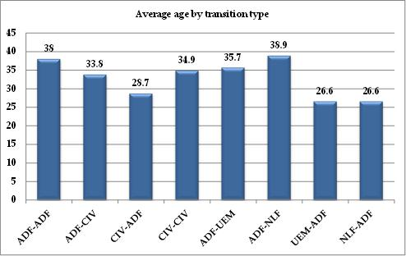

*UEM: Unemployed, looking for a job; NLF: Not in the Labour Force*

Table : Average age by turnover type

|  |  |
| --- | --- |
| **Before-After** | Average age |
| **adf-adf** | 38.0 |
| **adf-civ** | 33.8 |
| **civ-adf** | 28.7 |
| **civ-civ** | 34.9 |
| **adf-uem** | 35.7 |
| **adf-nlf** | 38.9 |
| **uem-adf** | 26.6 |
| **nlf-adf** | 26.6 |

Note: VET completers with employment before and after the VET course; this is the summary of observations for all years, as samples are too small in some categories.

Source: NCVER, SOS data

Again, Table 6 summarises the average age, but it is inclusive of the other four turnover categories of interest (that is the transitions involving those ‘unemployed’ and ‘not in the labour force’). We find that those ADF personnel who complete VET and leave the labour force were the oldest. Their average age was 38.9 years. On the contrary, those who did not work before training and joined the ADF after training were the youngest, aged 26.6 years on average. Moreover, those who joined the ADF after training were much younger than those who left the ADF. In addition, among those ADF leavers, the younger ones were more likely to gain civilian employment.

Table 7 and Figure 3 present the four main employment-to-employment transitions by gender.

Figure : Gender by turnover type (employed before and after training)

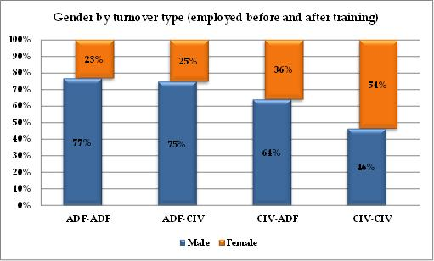

Table : Gender by turnover type (employed before and after training)

|  |  |  |  |  |  |  |
| --- | --- | --- | --- | --- | --- | --- |
|  |  | adf-adf | adf-civ | civ-adf | civ-civ | total |
| **Male** | Cases | 1,115 | 324 | 269 | 155,324 | 157,032 |
|  | ***%*** | ***77*** | ***75*** | ***64*** | ***46*** | ***47*** |
| **Female** | Cases | 336 | 109 | 151 | 179,089 | 179,685 |
|  | ***%*** | ***23*** | ***25*** | ***36*** | ***54*** | ***53*** |
| **Total** | **Cases** | **1,451** | **433** | **420** | **334,413** | **336,717** |

VET training is much more prevalent among males associated with the ADF. All transitions that involved the ADF contained markedly higher male proportions than the CIV-CIV transition.

The proportion of females using VET to enter the ADF from civilian employment was considerably higher (36 per cent for CIV-ADF) than that for females using VET to retrain and either stay in the ADF (23 per cent for ADF-ADF) or leave to take a civilian job (25 per cent for ADF-CIV). The gender split among the civilian workforce was almost equal (47 per cent for males and 53 per cent for females).

Table 8 and Figure 4 show the figures for the other four transition categories. Turnover appears to differ by gender.

Figure : Gender by turnover type (not employed-ADF and ADF-not employed)

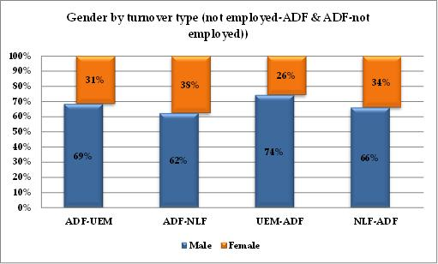

Table : Gender by turnover type (not employed-ADF and ADF-not employed)

|  |  |  |  |  |  |  |
| --- | --- | --- | --- | --- | --- | --- |
|  |  | adf-uem | adf-nlf | uem-adf | nlf-adf | Total |
| **Male** | Cases | 37 | 48 | 52 | 41 | 178 |
|  | ***%*** | ***69*** | ***62*** | ***74*** | ***66*** | ***68*** |
| **Female** | Cases | 17 | 29 | 18 | 21 | 85 |
|  | ***%*** | ***31*** | ***38*** | ***26*** | ***34*** | ***32*** |
| **Total** | **Cases** | **54** | **77** | **70** | **62** | **263** |

Males were more likely than females were to move to unemployment rather than NLF when they exited from the ADF. Similarly, males were also more likely to originate from unemployment than from NLF if they joined the ADF without being previously in employment. The sample sizes in Table 8 are too small and thus the numbers therein will be statistically unreliable.

Figure 5 and Table 9 show that health and disability are widely recognised as important factors for changes in labour market status. Health and disability can influence both employment and education choices and outcomes in terms of the more permanent and long-term health status, as well as in terms of the more short-term and possibly transitory health shocks. Health has been shown to have a wide influence, ranging from the hours of work, choice of employer, job, industry or occupation, capacity to work and train, and much more. The SOS data offer limited information on health through a question on disability, which is only asked once after VET completion:

*‘Do you consider yourself to have a disability impairment or long-term condition?’*

This question can only be answered with ‘yes’ or ‘no’. In the case of yes, the respondent is asked:

*’Please indicate the areas of disability, impairment, or long-term condition’* (where the respondent may answer with multiple responses).

Figure : Disability or long-term condition

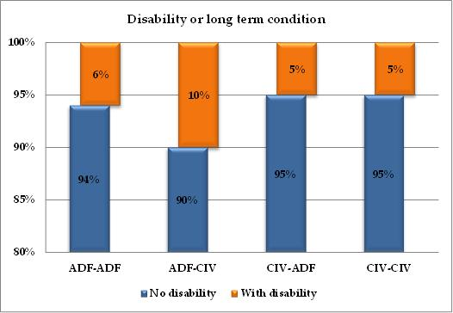

Table : Disability or long-term condition (employed before and after training)

|  |  |  |  |  |  |  |
| --- | --- | --- | --- | --- | --- | --- |
|  |  | adf-adf | adf-civ | civ-adf | civ-civ | Total |
| **With disability** | Cases | 86 | 43 | 21 | 17,757 | 17,907 |
|  | ***%*** | ***6*** | ***10*** | ***5*** | ***5*** | ***5*** |
| **No disability** | Cases | 1,362 | 387 | 395 | 314,600 | 316,744 |
|  | ***%*** | ***94*** | ***90*** | ***95*** | ***95*** | ***95*** |
| **All** | **Cases** | **1,448** | **430** | **416** | **332,357** | **334,651** |

Source: NCVER, SOS data (years 2001-10)

The main difference between the various turnover categories in Table 9 is that the proportion of VET completers with a disability or long-term health condition who leave the ADF for a civilian job (10 per cent) was higher than the proportion of all other VET completers with a disability (ADF-ADF: 6 per cent; CIV-ADF: 5 per cent; and CIV-CIV: 5 per cent).

### Education before Training

In this part, we present and discuss the educational background of VET participants and we examine how their education level before training may be associated with their employment transition after their VET training. We focus on two indicators of education. Table 10 and Figure 6 show the highest year of school completed.

Figure : Highest school year completion (employed before and after training)

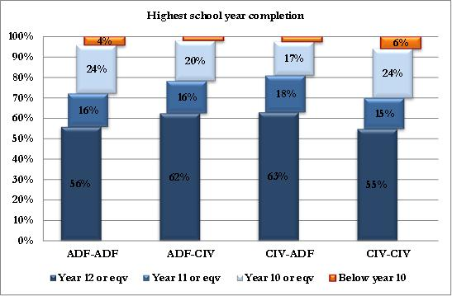

Table : Highest school year completion (employed before and after training)

|  |  |  |  |  |  |  |  |  |  |  |
| --- | --- | --- | --- | --- | --- | --- | --- | --- | --- | --- |
|  | adf-adf | | adf-civ | | civ-adf | | civ-civ | | Total | |
|  | Cases | ***%*** | Cases | ***%*** | Cases | ***%*** | Cases | ***%*** | **Cases** | ***%*** |
| **Year 12 or eqv** | 804 | ***56*** | 268 | ***62*** | 262 | ***63*** | 180,938 | ***55*** | **182,272** | ***55*** |
| **Year 11 or eqv** | 236 | ***16*** | 68 | ***16*** | 75 | ***18*** | 49,904 | ***15*** | **50,283** | ***15*** |
| **Year 10 or eqv** | 342 | ***24*** | 85 | ***20*** | 69 | ***17*** | 80,296 | ***24*** | **80,792** | ***24*** |
| **Below Year 10** | 58 | ***4*** | 8 | ***2*** | 10 | ***2*** | 18,859 | ***6*** | **18,935** | ***6*** |
| **Total** | **1,440** | ***100*** | **429** | ***100*** | **416** | ***100*** | **329,997** | ***100*** | **332,282** | ***100*** |

From the results in Table 10, it was the better-schooled (Year 12 completers) who used VET more successfully to move into or out of the ADF, with a proportion of 63 per cent and 62 per cent, respectively; this accords with the observation that labour market mobility is generally easier for those with a completed school qualification.

Table 11 and Figure 7 show the highest post-school qualification before undertaking VET. Table 11 provides a different picture to Table 10, suggesting that the two staying categories have relatively higher post-school qualifications. In particular, 15 per cent of the ADF-ADF turnover category and 14 per cent of the CIV-CIV turnover category had a bachelor degree or higher qualification.

Figure : Highest pre-training qualification (employed before and after training)

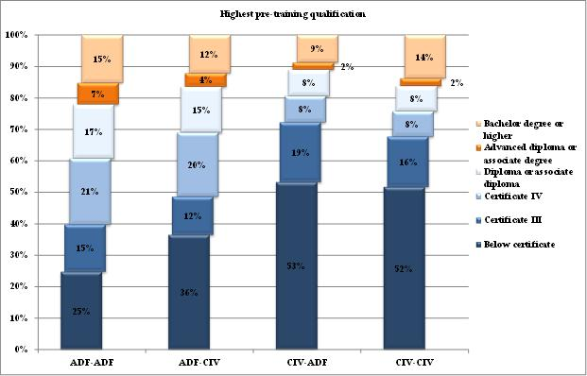

Table : Highest pre-training qualification (employed before and after training)

|  |  |  |  |  |  |  |
| --- | --- | --- | --- | --- | --- | --- |
|  |  | adf-adf | adf-civ | civ-adf | civ-civ | Total |
| **Bachelor degree or higher** | Cases | 147 | 31 | 23 | 29,423 | 29,624 |
| ***%*** | ***15*** | ***12*** | ***9*** | ***14*** | ***14*** |
| **Advanced diploma or associate degree** | Cases | 66 | 11 | 6 | 5,249 | 5,332 |
| ***%*** | ***7*** | ***4*** | ***2*** | ***2*** | ***2*** |
| **Diploma or associate diploma** | Cases | 166 | 37 | 22 | 17,143 | 17,368 |
| ***%*** | ***17*** | ***15*** | ***8*** | ***8*** | ***8*** |
| **Certificate IV** | Cases | 203 | 52 | 22 | 17,247 | 17,524 |
| ***%*** | ***21*** | ***20*** | ***8*** | ***8*** | ***8*** |
| **Certificate III** | Cases | 145 | 31 | 50 | 34,232 | 34,458 |
| ***%*** | ***15*** | ***12*** | ***19*** | ***16*** | ***16*** |
| **Below Certificate III or with no post-school qualification** | Cases | 239 | 93 | 140 | 110,532 | 111,004 |
| *%* | *25* | *36* | *53* | *52* | *52* |
| **All** | **Cases** | **966** | **255** | **263** | **213,826** | **215,310** |
| ***%*** | ***100*** | ***100*** | ***100*** | ***100*** | ***100*** |

Note: Years 2001-03 are excluded due to data incompatibilities.

### VET Characteristics

In this part, we present how several VET characteristics may be associated with employment turnover. We focus on four facets of VET: (i) the VET course level; (ii) the type of VET provider (TAFE or not); (iii) whether VET participants have successfully completed all or part of the courses required; and (iv) whether VET participants have enrolled in any other/additional study between completing the VET study in question and being interviewed (which happens about six months after this completion).

Table 12 presents the level of VET course studied by labour turnover category. The main result is that the higher-attainment parts of VET were more frequently undertaken by ADF personnel, especially by the ADF stayers, in comparison to all the other turnover categories.

Figure : VET course level by turnover category (employed before and after training)

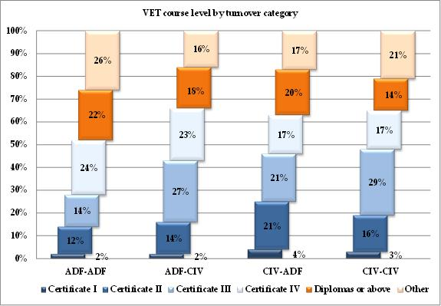

Table : VET course level by turnover category (employed before and after training)

|  |  |  |  |  |  |  |  |  |  |  |
| --- | --- | --- | --- | --- | --- | --- | --- | --- | --- | --- |
|  | adf-adf | | adf-civ | | civ-adf | | civ-civ | | Total | |
|  | **No.** | ***%*** | **No.** | ***%*** | **No.** | ***%*** | **No.** | ***%*** | **No.** | ***%*** |
| Diplomas or above | 319 | ***22*** | 78 | ***18*** | 84 | ***20*** | 48,162 | ***14*** | 48,643 | ***14*** |
| Certificate IV | 350 | ***24*** | 99 | ***23*** | 70 | ***17*** | 56,738 | ***17*** | 57,257 | ***17*** |
| Certificate III | 200 | ***14*** | 115 | ***27*** | 90 | ***21*** | 95,229 | ***29*** | 95,634 | ***28*** |
| Certificate II | 178 | ***12*** | 62 | ***14*** | 90 | ***21*** | 52,802 | ***16*** | 53,132 | ***16*** |
| Certificate I | 27 | ***2*** | 8 | ***2*** | 15 | ***4*** | 10,864 | ***3*** | 10,914 | ***3*** |
| Other | 379 | ***26*** | 71 | ***16*** | 71 | ***17*** | 70831 | ***21*** | 71352 | ***21*** |
| Total | **1,453** | ***100*** | **433** | ***100*** | **420** | ***100*** | **334,626** | ***100*** | **336,932** | ***100*** |

Looking at Table 12, for Diplomas and Certificate IV together, the ADF-ADF and ADF-CIV transition categories comprised 46 and 42 per cent of the total sample respectively, while the CIV-CIV comprised only 31 per cent. The opposite holds for those who studied at the Certificate III level, where the ADF-ADF show 14 per cent against 29 per cent for the CIV-CIV participants. Clearly there are differences between the jobs that these qualifications attempt to facilitate, which differ by sector, and will be worth studying in more depth in the remainder of this research. For example, post-VET jobs with the ADF appear to utilise people who have participated in the highest levels provided by VET (for example both the ADF-ADF and CIV-ADF categories have high percentages for Diploma and Certificate IV courses). At the same time, post-VET jobs in the civilian sector appear to utilise people who have participated in VET at the level of Certificate III (for example ADF-CIV category, but especially the CIV-CIV category where the most prevalent ones are Certificate III courses).

The information on VET providers in Table 13, below, suggests that the vast majority (about 90 per cent) of VET participants in the data studied through TAFE providers. In addition, the ADF-ADF category had a particularly high proportion involved in study at a TAFE institution.

Figure : Sector of education providers (employed before and after training)

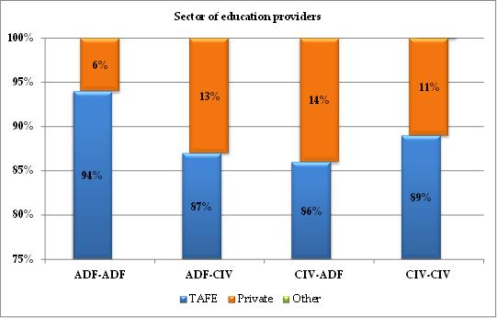

Table : Sector of education providers (employed before and after training)

|  |  |  |  |  |  |  |  |  |  |  |
| --- | --- | --- | --- | --- | --- | --- | --- | --- | --- | --- |
|  | adf-adf | | adf-civ | | civ-adf | | civ-civ | | Total | |
|  | No. | ***%*** | No. | ***%*** | No. | ***%*** | No. | ***%*** | No. | ***%*** |
| **TAFE** | 857 | ***94*** | 205 | ***87*** | 216 | ***86*** | 181,748 | ***89*** | 183,026 | ***89*** |
| **Private** | 54 | ***6*** | 30 | ***13*** | 35 | ***14*** | 22,299 | ***11*** | 22,418 | ***11*** |
| **Other** | 1 | ***0*** | 0 | ***0*** | 0 | ***0*** | 1,069 | ***1*** | 1,070 | ***1*** |
| **Total** | **912** | ***100*** | **235** | ***100*** | **251** | ***100*** | **205,116** | ***100*** | **206,514** | ***100*** |

Note: Data is available only for 2005-2010.

Table 14 and Figure 10 adopt the NCVER definition of VET graduates (that is ‘have finished a complete course and have been awarded the corresponding qualification’) and VET module completers (that is ‘have only completed part of a course, the module’) and shows the proportion of VET participants who have successfully completed all or part of their course, by labour turnover category.

Figure : Number of ‘actual’ graduates and module completers (employed before and after training)

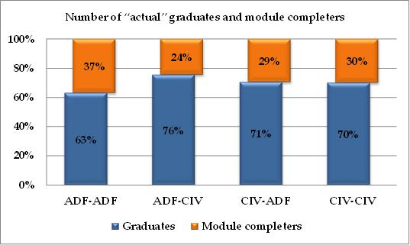

Table : Number of ‘actual’ graduates and module completers (employed before and after training)

|  |  |  |  |  |  |  |
| --- | --- | --- | --- | --- | --- | --- |
|  |  | adf-adf | adf-civ | civ-adf | civ-civ | Total |
| **Graduates** | Cases | 892 | 323 | 286 | 228,765 | 230,266 |
|  | ***%*** | ***63*** | ***76*** | ***71*** | ***70*** | ***70*** |
| **Module completers** | Cases | 520 | 104 | 119 | 97,395 | 98,138 |
|  | ***%*** | ***37*** | ***24*** | ***29*** | ***30*** | ***30*** |
| **All** | **Cases** | **1,408** | **424** | **405** | **316,827** | **319,064** |

Note: SOS years 2001-10

Given that some VET courses consist of more modules than other VET courses (for example a Certificate IV will contain roughly twice the modules of a Certificate III and will also last roughly twice the study time), this difference may not be empirically as important as it appears in the first instance. In the pre-2004 sample, there was a possible indeterminacy and misclassification of module/course completers, as the two categories of VET students were handed different questionnaires (see Table 1), and sometimes course completers ended up being sent a questionnaire as a module completer. However, we removed this problem through our use of the post-2003 universal questionnaires. We find that, overall, 70 per cent of the VET participants completed all the courses required. Moreover, the graduation rate of the ADF stayers was the lowest (63 per cent), while that of the ADF veterans was the highest (76 per cent). In addition, the two transition categories (ADF-CIV and CIV-ADF) had a relatively higher proportion of graduates, which implies that completing VET study is more crucial during the transition of employment.

Table 15 and Figure 11 present whether VET participants enrolled in any other study since undertaking their training—where the additional study could have commenced during or soon after the VET training. It is not necessary for the additional study to be in VET; and it could have been either ongoing or finished. Thus, even if the participants got a job after training, it is still likely that they had completed their study already or that they worked and studied at the same time.

Figure : Additional study since undertaking the training (employed before and after training)

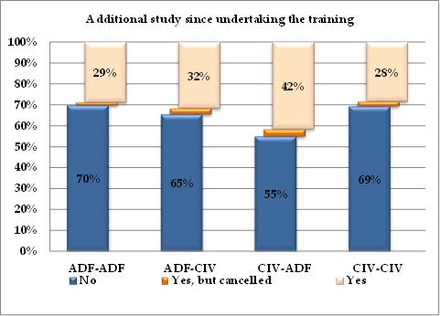

Table : Additional study since undertaking the training (employed before and after training)

|  |  |  |  |  |  |  |
| --- | --- | --- | --- | --- | --- | --- |
|  |  | adf-adf | adf-civ | civ-adf | civ-civ | Total |
| **No** | Cases | 822 | 233 | 191 | 192,223 | 193,469 |
|  | ***%*** | ***69.7*** | ***65.4*** | ***54.9*** | ***69.2*** | ***69.2*** |
| **Yes, but cancelled** | Cases | 17 | 10 | 12 | 6,465 | 6,504 |
|  | ***%*** | ***1.4*** | ***2.8*** | ***3.4*** | ***2.3*** | ***2.3*** |
| **Yes** | Cases | 340 | 113 | 145 | 78,921 | 79,519 |
|  | ***%*** | ***28.8*** | ***31.7*** | ***41.7*** | ***28.5*** | ***28.5*** |
| **All** | **Cases** | **1,179** | **356** | **348** | **277,609** | **279,492** |

Note: SOS years 2001-10

We find that about 30 per cent of the VET participants have enrolled in some other study since undertaking their VET training. Moreover, the two “stayer” categories (ADF-ADF and CIV-CIV) have lower proportions of people who have enrolled in some other study than the two “mover” categories (ADF-CIV and CIV-ADF). This implies that more study and training may be required during the employment transition, which may be either for gaining necessary skills and knowledge to transfer from one sector to the other, or in order to provide an objective signal to the new receiving sector. Both reasons are related to productivity concerns. We note that the ADF inflow has a larger proportion of people with further study than the ADF outflow, indicating that the education requirements for the ADF workforce may be increasing over time.

### Views and Expectations on VET

In this part, we investigate how some of the views and expectations of VET participants may differ by their employment-turnover category. We first consider their main reason for training, and then examine three indicators regarding expectations from the course, namely: (i) whether the main reason for participating in VET has been achieved or not; (ii) their overall satisfaction with the training that was received; and (iii) how relevant the training was for the job after training.

Figure : Main reason for doing the training (employed before and after training)

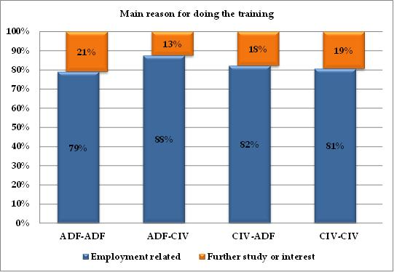

Table : Main reason for doing the training (employed before and after training)

|  |  |  |  |  |  |  |
| --- | --- | --- | --- | --- | --- | --- |
|  |  | adf-adf | adf-civ | civ-adf | civ-civ | Total |
| **Employment related** | Cases | 1,113 | 371 | 333 | 255,466 | 257,283 |
|  | ***%*** | ***79*** | ***88*** | ***82*** | ***81*** | ***81*** |
| **Further study or interest** | Cases | 295 | 53 | 72 | 61,361 | 61,781 |
|  | ***%*** | ***21*** | ***12*** | ***18*** | ***19*** | ***19*** |
| **All** | **Cases** | **1,408** | **424** | **405** | **316,827** | **319,064** |

Note: SOS years 2001-2010

Table 16 and Figure 12 show whether the VET participants do the training for employment-related reasons or for further study, or for interest. We find that employment reasons serve as the motivation for participation for the vast majority of all VET participants (80 per cent). This indicates that most people expect that VET participation will improve their employment-related skills and improve their labour market prospects and outcomes. The proportion of people being motivated to participate in VET for employment reasons is at its highest for the ADF veterans, at 88 per cent. This implies that the ADF veterans consider it more of a necessity that they use VET as a channel to help them find a civilian job. We note that both categories of stayers (ADF-ADF and CIV-CIV) show very similar proportions (of 79 and 81 per cent respectively) for employment-motivated VET choices.

Figure : Was the main reason for training achieved?

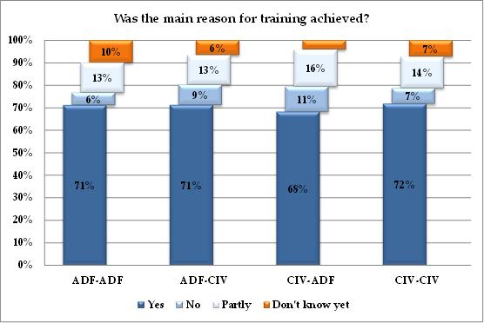

Table : Was the main reason for training achieved?

|  |  |  |  |  |  |  |  |  |  |  |
| --- | --- | --- | --- | --- | --- | --- | --- | --- | --- | --- |
|  | adf-adf | | adf-civ | | civ-adf | | civ-civ | | Total | |
|  | No. | ***%*** | No. | ***%*** | No. | ***%*** | No. | ***%*** | No. | ***%*** |
| **Yes** | 1,031 | ***71*** | 308 | ***71*** | 286 | ***68*** | 239,115 | ***72*** | 240,740 | ***72*** |
| **No** | 81 | ***6*** | 39 | ***9*** | 47 | ***11*** | 23,078 | ***7*** | 23,245 | ***7*** |
| **Partly** | 192 | ***13*** | 57 | ***13*** | 69 | ***17*** | 46,629 | ***14*** | 46,947 | ***14*** |
| **Don’t know yet** | 144 | ***10*** | 28 | ***7*** | 17 | ***4*** | 23,886 | ***7*** | 24,075 | ***7*** |
| **Total** | **1,448** | ***100*** | **432** | ***100*** | **419** | ***100*** | **332,708** | ***100*** | **335,007** | ***100*** |

Table 17 and Figure 13 describe whether or not VET participants believe that their main reason for training was achieved by their training. We find that about three-quarters of the participants acknowledge their main reason for VET to have been achieved and that the proportion does not vary significantly between different turnover categories.

Figure : Overall satisfaction with the chosen training (employed before and after training)

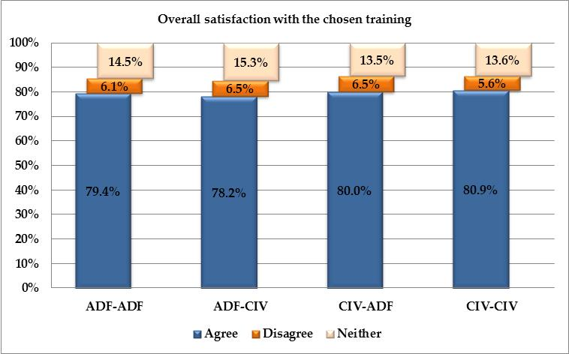

Table : Overall satisfaction with the chosen training (employed before and after training)

|  |  |  |  |  |  |  |  |  |  |  |
| --- | --- | --- | --- | --- | --- | --- | --- | --- | --- | --- |
|  | adf-adf | | adf-civ | | civ-adf | | civ-civ | | Total | |
|  | No. | ***%*** | No. | ***%*** | No. | ***%*** | No. | ***%*** | No. | ***%*** |
| **Agree** | 1,135 | ***79.4*** | 338 | ***78.2*** | 333 | ***80*** | 265,241 | ***80.9*** | 267,047 | ***80.8*** |
| **Disagree** | 87 | ***6.1*** | 28 | ***6.5*** | 27 | ***6.5*** | 18,341 | ***5.6*** | 18,483 | ***5.6*** |
| **Neither** | 207 | ***14.5*** | 66 | ***15.3*** | 56 | ***13.5*** | 44,461 | ***13.6*** | 44,790 | ***13.6*** |
| **Total** | **1,429** | ***100*** | **432** | ***100*** | **416** | ***100*** | **328,043** | ***100*** | **330,320** | ***100*** |

The responses in Table 18 appear to be consistent with what is observed in Table 17 regarding overall satisfaction with the chosen training, which provides another indicator about whether the expectations of VET participants have been achieved or not. It is found that a large majority of all VET participants (about 80 per cent) are satisfied with their choice of training, and that proportion does not vary much by turnover category.

Figure : Relevance of training to job after training (employed before and after training)

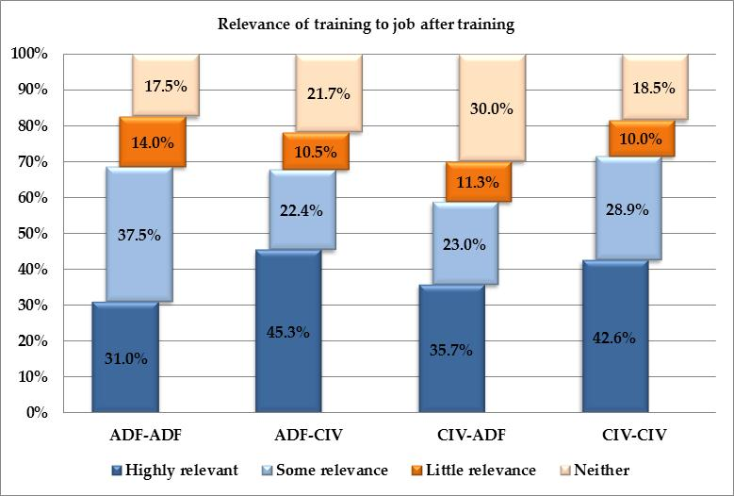

Table : Relevance of training to job after training (employed before and after training)

|  |  |  |  |  |  |  |  |  |  |  |
| --- | --- | --- | --- | --- | --- | --- | --- | --- | --- | --- |
|  | adf-adf | | adf-civ | | civ-adf | | civ-civ | | Total | |
|  | No. | ***%*** | No. | ***%*** | No. | ***%*** | No. | ***%*** | No. | ***%*** |
| **Highly relevant** | 449 | ***31.0*** | 194 | ***45.3*** | 149 | ***35.7*** | 141,179 | ***42.6*** | 141,971 | ***42.5*** |
| **Some relevance** | 544 | ***37.5*** | 96 | ***22.4*** | 96 | ***23.0*** | 95,959 | ***28.9*** | 96,695 | ***28.9*** |
| **Little relevance** | 203 | ***14.0*** | 45 | ***10.5*** | 47 | ***11.3*** | 33,215 | ***10.0*** | 33,510 | ***10.0*** |
| **Not relevant** | 253 | ***17.5*** | 93 | ***21.7*** | 125 | ***30.0*** | 61,440 | ***18.5*** | 61,911 | ***18.5*** |
| **Total** | **1,449** | ***100*** | **428** | ***100*** | **417** | ***100*** | **331,793** | ***100*** | **334,087** | ***100*** |

In contrast, the results in Table 19 (illustrated through Figure 15) suggest that the relevance of VET training to the job afterwards varies substantially by turnover category. We find that workers who end up with a civilian job were more likely to indicate that their training was highly relevant to their job afterwards, compared with those in an ADF job. In particular, the ADF-CIV category had the largest such response rate at 45 per cent. These differences may be an indication that VET training is more suitable for the jobs undertaken by the civilian workforce, than for the jobs undertaken by defence personnel, and that this would make the choice of the appropriate VET course especially important for ADF veterans. However, if we sum up all the participants who state that their training had at least some relevance to their job (this would involve aggregating both relevance categories of ‘highly relevant and ‘somehow relevant’), the two staying turnover categories (CIV-CIV and ADF-ADF) had a higher proportion of overall relevance, with 72 per cent (that is 43 + 29) and 69 per cent (that is 31 + 38) respectively, than the two mover categories (ADF-CIV and CIV-ADF).

One can look at these data differently by examining how many people find their training to have had no relevance at all. The response rates range from 17 per cent for ADF-ADF to 30 per cent for CIV-ADF VET participants. Given that this category is about training not being relevant at all, we find these proportions to be of possible concern, especially given the employment-oriented nature of VET. Although such a large proportion of educational mismatch could be a serious issue in the VET system, we note that 20 per cent of the VET participants undertook training for no employment-related reasons. This is a question that we will attempt to understand better using multivariate regression.

### General Labour Market Outcomes

In the next two parts, we focus on labour market outcomes after training. We first examine several general labour market outcomes, including: (i) the timing of the commencement of employment; and (ii) the occupation category and skill level of the job after training. We compare these outcomes by labour-turnover category. We also compare circumstances before and after training, when the relevant information is available.

Table 20 (Figure 16) and Table 21 (Figure 17) refer to the timing of current job commencement. VET participants were asked whether their post-training (current) job commenced before, during, or after their training commenced. Those who answered ‘After I finished the training’ were further asked: ‘How long did it take to find a job after completing the training? As shown in Table 20, the two stayer turnover categories had much lower proportions of commencing a job after completing their training (7 per cent for the ADF-ADF category and 22 per cent for the CIV-CIV category). These same categories also had much higher proportions of having commenced their job prior to starting their training (89 per cent for the ADF-ADF category and 65 per cent for the CIV-CIV category). By contrast, most participants in the two transition-turnover categories commenced their current job after completing their training and a sizeable minority during their training (59 and 22 per cent for the ADF-CIV category, and 53 and 21 per cent for the CIV-ADF category, respectively). Among those who commenced their job after completing their training, most individuals had spent fewer than 6 months to get the job, with the ADF-CIV category getting their job sooner than all others, with only 22 per cent having spent more than 6 months searching.

Figure : When main job commenced after training

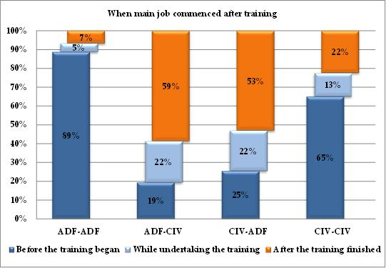

Table : When main job commenced after training

|  |  |  |  |  |  |  |
| --- | --- | --- | --- | --- | --- | --- |
|  |  | adf-adf | adf-civ | civ-adf | civ-civ | Total |
| **Before the training began** | Cases | 806 | 45 | 64 | 132,327 | 133,242 |
| ***%*** | ***89*** | ***19*** | ***26*** | ***65*** | ***65*** |
| **While undertaking the training** | Cases | 41 | 51 | 54 | 25,483 | 25,629 |
| ***%*** | ***5*** | ***22*** | ***21*** | ***13*** | ***13*** |
| **After the training finished** | Cases | 61 | 136 | 133 | 45,541 | 45,871 |
| ***%*** | ***7*** | ***59*** | ***53*** | ***22*** | ***22*** |
| **All** | **Cases** | **908** | **232** | **251** | **203,351** | **204,742** |

Note: SOS years 2005 to 2010 only

Figure : Time taken to find a job after training

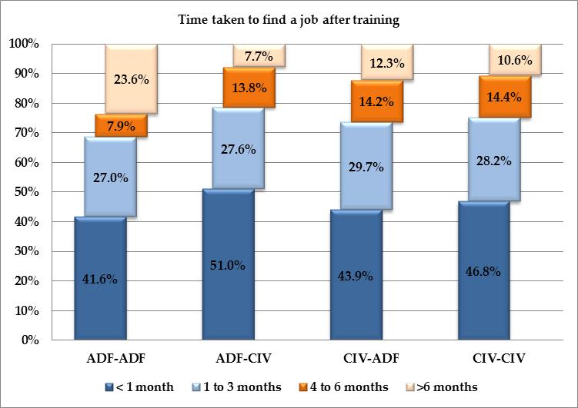

Table : Time taken to find a job after training

|  |  |  |  |  |  |  |  |  |  |  |
| --- | --- | --- | --- | --- | --- | --- | --- | --- | --- | --- |
|  | adf-adf | | adf-civ | | civ-adf | | civ-civ | | Total | |
|  | No. | ***%*** | No. | ***%*** | No. | ***%*** | No. | ***%*** | No. | ***%*** |
| **< 1 month** | 37 | ***41.6*** | 100 | ***51.0*** | 93 | ***43.9*** | 31,841 | ***46.8*** | 32,071 | ***46.78*** |
| **1 to 3 months** | 24 | ***27.0*** | 54 | ***27.6*** | 63 | ***29.7*** | 19,195 | ***28.2*** | 19,336 | ***28.21*** |
| **4 to 6 months** | 7 | ***7.9*** | 27 | ***13.8*** | 30 | ***14.2*** | 9,822 | ***14.4*** | 9,886 | ***14.42*** |
| **>6 months** | 21 | ***23.6*** | 15 | ***7.7*** | 26 | ***12.3*** | 7,198 | ***10.6*** | 7,260 | ***10.59*** |
| **Total** | **89** | ***100*** | **196** | ***100*** | **212** | ***100*** | **68,056** | ***100*** | **68,553** | ***100*** |

The next four tables (Table 22 to Table 25) and their corresponding figures summarise the occupational information about VET participants before and after training. We start by comparing their occupational distribution before and after training in Table 22 (Figure 18) and Table 23 (Figure 19). Looking at all VET participants, irrespective of sector, we see that 68 per cent had a low-skilled job before their training, defined as category 4 or above in both the ANZSCO and ASCO 1-digit occupation lists. The two categories that deviate from the national average are the ADF-ADF stayers, which were well below (54 per cent), and the CIV-ADF movers, which were well above (78 per cent). These differences suggest that the ADF keep their higher-skilled staff and that they also have an intake from civilian employment with a low-skill employment past, who, however, will use VET to up-skill for their new ADF job.

Figure : Occupation before training (employed before and after training)

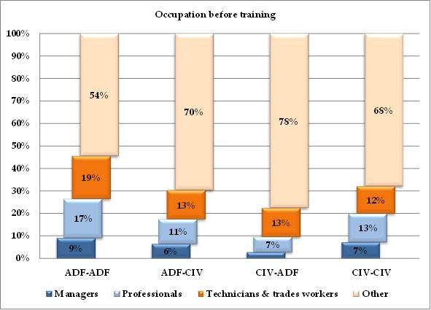

Table : Occupation before training (employed before and after training)

|  |  |  |  |  |  |  |  |  |  |  |
| --- | --- | --- | --- | --- | --- | --- | --- | --- | --- | --- |
|  | adf-adf | | adf-civ | | civ-adf | | civ-civ | | Total | |
|  | No. | ***%*** | No. | ***%*** | No. | ***%*** | No. | ***%*** | No. | ***%*** |
| **Managers** | 131 | ***9*** | 27 | ***7*** | 11 | ***3*** | 23,540 | ***7*** | 23,709 | ***7*** |
| **Professionals** | 250 | ***17*** | 46 | ***11*** | 27 | ***7*** | 41,329 | ***13*** | 41,652 | ***13*** |
| **Technicians & trades workers** | 275 | ***19*** | 54 | ***13*** | 51 | ***13*** | 39,600 | ***12*** | 39,980 | ***12*** |
| **Other** | 784 | ***54*** | 291 | ***70*** | 307 | ***78*** | 220,846 | ***68*** | 222,228 | ***68*** |
| **Total** | **1,440** | ***100*** | **418** | ***100*** | **396** | ***100*** | **325,315** | ***100*** | **327,569** | ***100*** |

Figure : Occupation after training (employed before and after training)

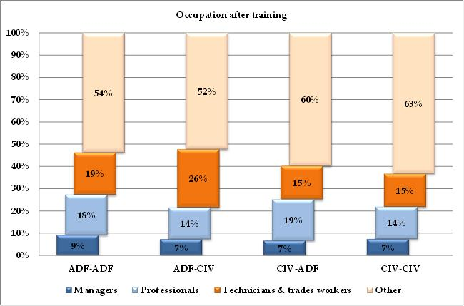

Table : Occupation after training (employed before and after training)

|  |  |  |  |  |  |  |  |  |  |  |
| --- | --- | --- | --- | --- | --- | --- | --- | --- | --- | --- |
|  | adf-adf | | adf-civ | | civ-adf | | civ-civ | | Total | |
|  | No. | ***%*** | No. | ***%*** | No. | ***%*** | No. | ***%*** | No. | ***%*** |
| **Managers** | 132 | ***9*** | 31 | ***7*** | 28 | ***7*** | 24,348 | ***7*** | 24,539 | ***7*** |
| **Professionals** | 261 | ***18*** | 60 | ***14*** | 78 | ***19*** | 47,428 | ***14*** | 47,827 | ***15*** |
| **Technicians & trades workers** | 273 | ***19*** | 111 | ***26*** | 63 | ***15*** | 48,897 | ***15*** | 49,344 | ***15*** |
| **Other** | 774 | ***54*** | 221 | ***52*** | 251 | ***60*** | 207,714 | ***63*** | 208,960 | ***63*** |
| **Total** | **1,440** | ***100*** | **423** | ***100*** | **420** | ***100*** | **328,387** | ***100*** | **330,670** | ***100*** |

We notice that the proportion with a low-skilled job has declined from 68 per cent before training to 63 per cent after training, indicating that VET training may be a channel through which workers can improve their skills. This improvement is much greater for the two transition categories, both of which appear to decrease the proportion of low-skilled workers by 18 percentage points (comparing between Table 22 and Table 23). This significant improvement may be partially due to the large proportions of low-skilled workers initially. Moreover, it is more likely that low-skilled workers had the most to gain from completing their VET studies (that is they experience the largest marginal gain from VET), and also the greatest incentive to study. In contrast, for the ADF-ADF category, the impact from completing VET on the occupation distribution was negligible not only for low-skilled workers, but for all workers. These results indicate that VET study provides ADF veterans with an expanded set of both job and occupation opportunities in comparison to ADF stayers. However, this does not mean that VET study is not relevant or important for ADF stayers regarding their work in the ADF—or possible future civilian employment.

Having compared the occupational distribution of VET participants before and after training, we now examine the occupational and corresponding skill-level change at the individual level—as shown in Table 24 and Table 25, respectively. We find that the results are generally consistent with those observed above.

Figure : Change in occupation (employed before and after training)

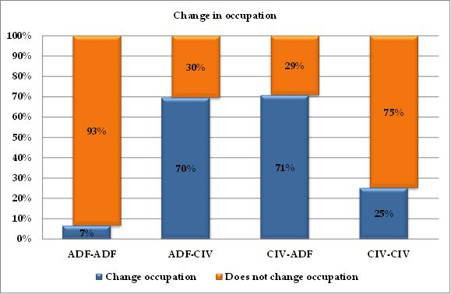

Table : Change in occupation (employed before and after training)

|  |  |  |  |  |  |  |
| --- | --- | --- | --- | --- | --- | --- |
|  |  | adf-adf | adf-civ | civ-adf | civ-civ | Total |
| **Change occupation** | Cases | 94 | 283 | 276 | 80,417 | 81,070 |
| ***%*** | ***7*** | ***70*** | ***71*** | ***25*** | ***25*** |
| **Does not change occupation** | Cases | 1,331 | 124 | 114 | 239,049 | 240,618 |
| ***%*** | ***93*** | ***30*** | ***29*** | ***75*** | ***75*** |
| **All** | **Cases** | **1,425** | **407** | **390** | **319,466** | **321,688** |

Source: NCVER, SOS data, years 2001-10

Change in occupation between before and after training is defined using the 1-digit occupation codes in the SOS and this is presented in Table 24 above. The occupation codes changed between 2006 and 2007, so for the years prior to 2007 occupation changes are derived using the ASCO 1997; for the years from 2007 to 2010 the ANZSCO 2006 is used. It is not surprising that the two transition categories are far more likely to change occupation after training—approximately 70 per cent changed occupation after training. In contrast, only 7 per cent of the ADF-ADF category changed occupation.

Figure : Change in skill level (employed before and after training)

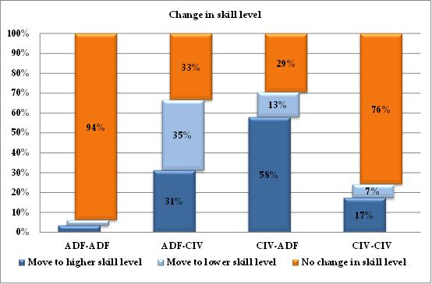

Table : Change in skill level (employed before and after training)

|  |  |  |  |  |  |  |
| --- | --- | --- | --- | --- | --- | --- |
|  |  | adf-adf | adf-civ | civ-adf | civ-civ | Total |
| **Move to higher skill level** | Cases | 50 | 127 | 226 | 55,578 | 55,981 |
| ***%*** | ***4*** | ***31*** | ***58*** | ***17*** | ***17*** |
| **Move to lower skill level** | Cases | 38 | 144 | 49 | 21,768 | 21,999 |
| ***%*** | ***3*** | ***35*** | ***13*** | ***7*** | ***7*** |
| **No change in skill level** | Cases | 1,337 | 136 | 115 | 242,111 | 243,699 |
| ***%*** | ***94*** | ***33*** | ***30*** | ***76*** | ***76*** |
| **All** | **Cases** | **1,425** | **407** | **390** | **319,457** | **321,679** |

Table 25 presents the change in skill level—where the skill level is derived from the ASCO 1997 1-digit level (for the years 2001 to 2006) and ANZSCO 2006 4-digit level (for the years 2007 to 2010).[5] It should be noted that a change in skill level is only possible when there is also a change in occupation; however, a change in occupation does not necessarily lead to a change in skill level. And, in contrast to the previous ‘change in occupation’ measure, the aim of this measure is to determine whether the completion of a VET qualification led to the acquisition of skills.

Due to the high correlation with change in occupation, the change in skill level for the two transition categories (ADF-CIV and CIV-ADF) is again much greater than for the two staying categories (ADF-ADF and CIV-CIV)—where the ADF-ADF category had the lowest proportions of skill-level change after VET completion. Importantly, the results indicate that for those workers who experienced a skill-level change after VET study, the majority had improved their skill set—with the exception of those in the ADF-CIV transition category.

### Job quality Indicators

This section focuses on the more specific issue of labour market outcomes after the completion of VET study—job quality. We consider three conventional measures of job quality in the economics literature, namely: (i) weekly earnings, (ii) casual against non-casual job, and (iii) full-time against part-time job.

Table 26 reports the unadjusted average weekly earnings in the main job, after training, for each turnover category, by year. Not surprisingly, the earnings for all categories rose over time in spite of a couple of significant exemptions between 2009 and 2010. Moreover, the ADF-ADF category persistently had the highest earnings, while the CIV-CIV category had the lowest. In addition, the ADF-CIV category initially had lower earnings than the CIV-ADF category, but exceeded the CIV-ADF category from 2003 onwards.

Table 27 summarises the average weekly earnings including the two additional categories of ADF personnel that either did not participate in the workforce or were unemployed before VET study. The results show that the highest earning category, ADF-ADF, received about 50 per cent more than the lowest earning category, CIV-CIV, while the two transition categories fell in between. Moreover, the individuals who gained employment in the ADF following their training, received higher pay than if they had obtained civilian employment. Among those who joined the ADF, the CIV-ADF category received the highest weekly earnings, while the NLF-ADF category received the lowest.

Table : Average weekly earnings after training over time (employed before and after training)

|  |  |  |  |  |
| --- | --- | --- | --- | --- |
|  | adf-adf | adf-civ | civ-adf | civ-civ |
| **2001** | 804 | 549 | 580 | 509 |
| **2002** | 811 | 539 | 657 | 526 |
| **2003** | 887 | 707 | 644 | 538 |
| **2004** | 1028 | 602 | 590 | 579 |
| **2005** | 1050 | 803 | 750 | 661 |
| **2006** | 1073 | 771 | 773 | 675 |
| **2007** | 1080 | 869 | 770 | 706 |
| **2008** | 1139 | 926 | 803 | 737 |
| **2009** | 1135 | 936 | 940 | 762 |
| 2010 | 1250 | 883 | 796 | 777 |

Table : Average weekly earnings after training

|  |  |
| --- | --- |
| **Before-After** | Average earnings |
| **adf-adf** | 1015 |
| **adf-civ** | 744 |
| **civ-adf** | 736 |
| **civ-civ** | 642 |
| **uem-adf** | 621 |
| **nlf-adf** | 588 |

*UEM: Unemployed looking for work; NLF: Not in the Labour Force*

In addition to earnings, other factors, such as working hours and job security, are measures of job quality. Conventionally, a full-time job, defined as 35 hours or more per week, is superior to a part-time job. Also, permanent employment is more desirable than casual employment. In Australia, a permanent or fixed-term contract usually contains paid sick and holiday leave entitlements, while in casual employment these entitlements are not mandatory. Furthermore, casual employment is a less secure form of employment. In the following, we analyse these additional measures of job quality by comparing the employment circumstance before and after training, by turnover category.

Table 28 and Table 29 (and corresponding figures) report the paid-leave entitlements of VET participants before and after training, respectively. The results show that the overwhelming majority of those employed in the ADF received paid-leave entitlements in comparison those employed by a civilian employer, both before and after training. Compared to the ADF stayers (ADF-ADF), a lower proportion of ADF veterans (ADF-CIV) received paid-leave entitlements before their training; similarly, a lower proportion of new ADF intakes (CIV-ADF) received such entitlements before training in comparison to the civilian stayers (CIV-CIV). It is possible that this partly explains the transition between civilian and ADF employment. Overall, VET training was associated with an improvement in the job quality of participants by increasing the proportion of those receiving paid-leave entitlements from 58 per cent (before training) to 64 per cent (after training). Participants in the CIV-ADF transition category experienced the greatest improvement, while the ADF veterans were substantially worse off.

Figure : Entitled to paid sick leave or holiday leave before training (employed before and after training)

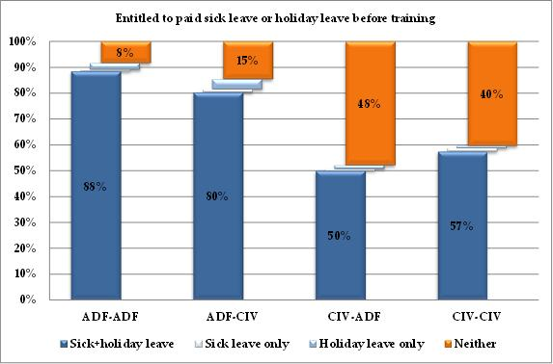

Table : Entitled to paid sick leave or holiday leave before training (employed before and after training)

|  |  |  |  |  |  |  |  |  |  |  |
| --- | --- | --- | --- | --- | --- | --- | --- | --- | --- | --- |
|  | adf-adf | | adf-civ | | civ-adf | | civ-civ | | Total | |
|  | No. | ***%*** | No. | ***%*** | No. | ***%*** | No. | ***%*** | No. | ***%*** |
| **Sick + holiday leave** | 1,281 | ***89*** | 347 | ***80*** | 208 | ***50*** | 190,253 | ***57*** | 192,089 | ***58*** |
| **Sick leave only** | 9 | ***1*** | 5 | ***1*** | 3 | ***1*** | 4,491 | ***1*** | 4,508 | ***1*** |
| **Holiday leave only** | 37 | ***3*** | 17 | ***4*** | 6 | ***1*** | 2,955 | ***1*** | 3,015 | ***1*** |
| **Neither** | 121 | ***8*** | 63 | ***15*** | 199 | ***48*** | 133,692 | ***40*** | 134,075 | ***40*** |
| **Total** | **1,448** | ***100*** | **432** | ***100*** | **416** | ***100*** | **331,391** | ***100*** | **333,687** | ***100*** |

Figure : Entitled to paid sick leave or holiday leave after training (employed-employed)

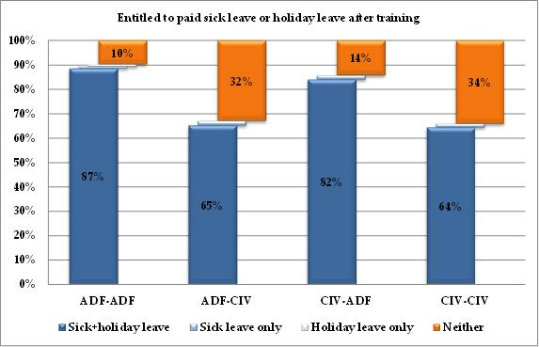

Table : Entitled to paid sick leave or holiday leave after training (employed-employed)

|  |  |  |  |  |  |  |  |  |  |  |
| --- | --- | --- | --- | --- | --- | --- | --- | --- | --- | --- |
|  | adf-adf | | adf-civ | | civ-adf | | civ-civ | | Total | |
|  | No. | ***%*** | No. | ***%*** | No. | ***%*** | No. | ***%*** | No. | ***%*** |
| **Sick + holiday leave** | 1,266 | ***87*** | 278 | ***65*** | 342 | ***82*** | 212,449 | ***64*** | 214,335 | ***64*** |
| **Sick leave only** | 11 | ***1*** | 8 | ***2*** | 7 | ***2*** | 4,925 | ***2*** | 4,951 | ***2*** |
| **Holiday leave only** | 37 | ***3*** | 5 | ***1*** | 12 | ***3*** | 3,094 | ***1*** | 3,148 | ***1*** |
| **Neither** | 139 | ***10*** | 140 | ***33*** | 58 | ***14*** | 112,312 | ***34*** | 112,649 | ***34*** |
| **Total** | **1,453** | ***100*** | **431** | ***100*** | **419** | ***100*** | **332,780** | ***100*** | **335,083** | ***100*** |

A similar story occurs in terms of the hours worked per week, as shown in Table 30 and Table 31. The results show that, before training, the incidence of full-time employment in the ADF sector was much greater than in the civilian sector. For example, the proportion of full-time employment for ADF stayers and ADF veterans was 93 per cent and 87 per cent, respectively; whereas, for those in the civilian employment categories, CIV-ADF and CIV-CIV, the proportion of full-time hours was only 57 per cent and 58 per cent, respectively. After training, the proportion of full-time employment in the ADF sector was similar to the pre-training levels—92 per cent for ADF-ADF and 89 per cent for CIV-ADF—and, again, much greater than in the civilian sector—75 per cent for ADF-CIV and 65 per cent for CIV-CIV. While there is very little change in the incidence of full-time employment for the ADF stayers, the completion of VET study improved the job quality of all other participants, overall. That is, after training, the incidence of full-time employment increased by 32 percentage points for CIV-ADF and 7 percentage points for CIV-CIV. And, while ADF veterans experienced a 12 percentage points decline in full-time employment, after training, this was outweighed by the substantial improvement experienced by the participants in the other CIV-ADF transition category.

Figure : Hours worked per week before training (employed before and after training)

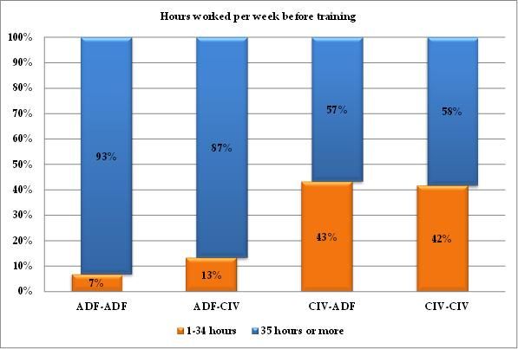

Table : Hours worked per week before training (employed before and after training)

|  |  |  |  |  |  |  |
| --- | --- | --- | --- | --- | --- | --- |
|  |  | adf-adf | adf-civ | civ-adf | civ-civ | Total |
| **35 hours or more** | Cases | 1,352 | 371 | 232 | 191,697 | 193,652 |
| ***%*** | ***93*** | ***87*** | ***57*** | ***58*** | ***59*** |
| **1-34 hours** | Cases | 98 | 57 | 177 | 137,033 | 137,365 |
| ***%*** | ***7*** | ***13*** | ***43*** | ***42*** | ***41*** |
| **All** | **Cases** | **1,450** | **428** | **409** | **328,730** | **331,017** |

Figure : Hours worked per week after training (employed before and after training)

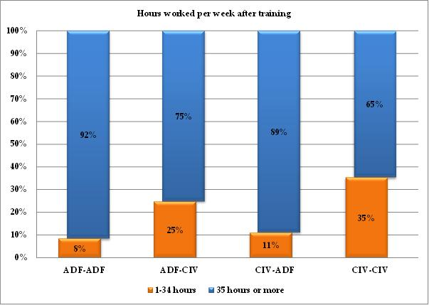

Table : Hours worked per week after training (employed before and after training)

|  |  |  |  |  |  |  |
| --- | --- | --- | --- | --- | --- | --- |
|  |  | adf-adf | adf-civ | civ-adf | civ-civ | Total |
| **35 hours or more** | Cases | 1,302 | 319 | 364 | 211,306 | 213,291 |
| *%* | *92* | *75* | *89* | *65* | *65* |
| **1-34 hours** | Cases | 120 | 105 | 45 | 115,842 | 116,112 |
| *%* | *8* | *25* | *11* | *35* | *35* |
| **All** | **Cases** | **1,422** | **424** | **409** | **327,148** | **329,403** |

# Synthesis and Analysis

## Comparing Groups of Interest

*‘Science is built up with facts, as a house is built with stones. But a collection of facts is not more a science than a heap of stones is a house.’*

― Jules Henri Poincaré

The previous sections have provided an extensive description of the relative position of the ADF personnel who engage in VET. Several patterns have been described and a lot of detail has been presented. This extensive information, however, cannot be of much use unless it is put in context to allow for meaningful comparisons to be made and useful conclusions to be reached. This section begins this process by defining some core categories of employees and then studying the similarities and differences in terms of their characteristics and the labour market outcomes described in the previous sections. We will use two methods for doing this. First, we will use simple two-way descriptive profiling. Simple profiling will not necessitate any further manipulation of the data we presented. It is based on rearranging the data and discussing the bigger picture that arises. Second, we will use multivariate regression. Multivariate regression is a statistical methodology that requires further data calculations and specific assumptions about the shape of the data. It is a validated empirical research tool and it is used extensively for evidence-based policy design.

### Comparisons Using Two-way Profiles

The comparisons we present here are indicative. The data for making these comparisons are derived by combining the contents of all the tables in the preceding sections and are summed up below in Table 32. We compare the following groups:

* ADF ‘movers’ against ADF ‘stayers’
* ADF ‘leavers’ after VET depending on their employment outcomes (with or without a job)
* ADF ‘stayers’ against civilian ‘stayers’, both after VET.

For each of these comparisons, the key details are concisely summarised in boxes preceding the more detailed discussion. The summary boxes briefly outline the motivation for each of the comparisons by explaining exactly which two groups are being compared and why we feel that such comparisons matter. All discussion will be based on Table 32, so the reader will have to keep referring to it throughout this section.

Table : Profiles of ADF and Civilian employees by transition category

|  |  |  |  |  |
| --- | --- | --- | --- | --- |
|  | adf-civ | adf-nem | civ-civ | adf-adf |
| Average age | 33.8 | 37.6 | 34.9 | 38.0 |
| Proportion of males | 75% | 65% | 46% | 77% |
| Proportion of disabled | 10% | 15% | 5% | 6% |
| Proportion of Year 12 completion before training | 63% | 49% | 55% | 56% |
| Proportion with diploma or higher before training (2004-10 only) | 31% | 17% | 24% | 39% |
| Proportion studying Certificate III or higher in VET | 67% | 57% | 60% | 60% |
| *Top three most frequent fields of study in VET (2003-10 only)* |  |  |  |  |
| Engineering and Related Technologies | 1st (31%) | 2nd (22%) | 2nd (17%) | 1st (30%) |
| Management and Commerce | 2nd (16%) | 1st (26%) | 1st (23%) | 2nd (20%) |
| Society and Culture | 3rd (9%) |  | 3rd (12%) |  |
| Agriculture, Environmental and Related |  | 3rd (10%) |  |  |
| Education |  |  |  | 3rd (14%) |
| Total proportion of top three fields | 56% | 58% | 52% | 64% |
| Proportion studying in TAFE (2005-10 only) | 87% | 94% | 89% | 94% |
| Proportion of actual graduates | 76% | 68% | 70% | 63% |
| Proportion doing further study | 32% | 38% | 29% | 29% |
| Proportion with employment-related reason for doing the training | 88% | 70% | 81% | 79% |
| Proportion with main reason for training achieved | 71% | 47% | 72% | 71% |
| Proportion satisfied with the training | 78% | 73% | 81% | 79% |
| *Proportion showing training is relevant to job after training* |  |  |  |  |
| Highly relevant | 45% | N/A | 43% | 31% |
| Some relevance | 22% | N/A | 29% | 38% |
| Total | 67% | N/A | 72% | 69% |
| Proportion with a low-skilled job before training | 70% | 72% | 68% | 54% |
| Proportion with a low-skilled job after training | 52% | N/A | 63% | 54% |
| Proportion with change in occupation | 70% | N/A | 25% | 7% |
| *Proportion with change in skill level* |  |  |  |  |
| Move to higher skill level | 31% | N/A | 17% | 4% |
| Move to lower skill level | 35% | N/A | 7% | 3% |
| Total | 66% | N/A | 24% | 7% |
| Average weekly earnings after training | $617 | N/A | $557 | $841 |
| Proportion that commenced the job after training (2005-10 only) | 59% | N/A | 22% | 7% |
| Proportion that spent more than three months to find the job | 23% | N/A | 25% | 32% |
| Proportion entitled paid sick and holiday leave before training | 80% | 77% | 57% | 89% |
| Proportion entitled paid sick and holiday leave after training | 65% | N/A | 64% | 87% |
| Proportion with a full-time job before training | 87% | 88% | 58% | 93% |
| Proportion with a full-time job after training | 75% | N/A | 65% | 92% |

Source: SOS pooled waves 2001-10. Where only a subset of waves was used we indicate which ones.

### ADF ‘movers’ against ADF ‘stayers’

|  |
| --- |
| Box 1: ADF ‘movers’ versus ADF ‘stayers’ |
| Who we compare: Out of all ADF personnel who completed a VET module or course, and were subsequently employed, we compare those who subsequently continued to work for the ADF (we call them the ADF ‘stayers’, or the ADF-ADF transitions) with those who left the ADF and commenced civilian employment (we call them the ‘movers’, or the ADF-CIV transitions).  Why does the comparison matter: We want to know more about who leaves the ADF and why. Underlying these comparisons is the question of what the reasons and circumstances are for ADF personnel moving into civilian employment. There are different aspects to such comparisons, and the reasons why such decisions were made, including: (i) whether the transition is benefiting the ADF veterans; (ii) the relative strength of pull and push reasons for the move; (iii) the degree of transferability of the skills and knowledge of (especially younger) veterans who enter civilian employment; and (iv) the role of VET in the transition. |

We compare those ADF employees who carried out some VET, and then got a civilian job (the ‘movers’ with an ADF-CIV transition) with those ADF employees who carried out some VET and continued to be ADF employees afterwards (the ‘stayers’ with an ADF-ADF transition).

The movers and the stayers are similar:

* in their gender composition,
* in their perception of having achieved the main reason for their training (although the reasons are different),
* in their reported satisfaction with their training, and
* in the top two most frequent fields of study in VET, which are Engineering and Related Technologies, and Management and Commerce (interestingly the third most popular is Education for the stayers, and Society and Culture for the movers).

About the same proportion of movers and stayers report they are undertaking further study. This is where the similarities between ADF movers and stayers shown by the SOS data end.

There are some notable differences.

* On average, the movers are more than four years younger than the stayers. At 10 per cent, the movers are about twice as likely to have a disability, than the stayers at 6 per cent.
* To the degree that (i) having completed Year 12 at school before training (as opposed to not) indicates a higher level of general human capital, and (ii) having a diploma or higher before training indicates a higher level of specific human capital, we can see that the ‘movers’ have a higher level of general human capital and a lower level of specific human capital, while the stayers are the opposite.
* For all training, TAFE providers are the largest group recorded in the SOS data. Notwithstanding this, the movers use non-TAFE VET providers more often than the stayers do.
* A higher proportion of movers complete their VET course (76 per cent for movers against 63 per cent for stayers). It is interesting that the completion rate of the movers (stayers) is higher (lower) than the national rate of 70 per cent. One can expect that the ‘signal’ value of a VET qualification will be much higher for a mover, as they are moving into another sector and seeking a new employer who may have less concrete information about their productivity. By contrast, the stayers, who are already well-known to their sector and possibly even to their prospective employers, will be more likely to complete only those parts of a VET course that may be relevant to their job, and leave other less relevant parts unfinished with the acquiescence of their employer.

The proportion of employees who, after training, stated that their study was highly relevant to their job was 45 per cent for the movers, but only 31 per cent for the stayers. If high relevance is the measure by which we judge the effectiveness of VET in the transition between jobs and sectors, it is worth noting that 45 per cent is very close to the national average of 43 per cent. So, the ADF employees who wish to move to civilian employment are as well served by the VET system as their civilian counterparts. The same cannot be said about the stayers, where a lower post-training job-relevance of 31 per cent is observed. This raises the question: what was the objective of undertaking training for the remaining 69 per cent, if they could only state that it had some or no relevance to their post-training job.

One could cut the data in a more inclusive way and compare whether a VET course is at all relevant to the job after training. Overall, relevance (that is, either highly relevant or of some relevance) is reported to be almost identical for all groups—at 67 per cent for the movers and 69 per cent for the stayers, in comparison with a national average of 72 per cent. There is one further pertinent observation to be made. One could restate this information and read that between 31 and 33 per cent of all VET participants from the ADF felt unable to state that their course was relevant, and that these proportions are about 10 to 15 per cent higher than the 28 per cent national average. This is a high proportion of failed outcomes for the VET system, given that VET training is designed to be highly job-relevant, and given that the needs of the ADF from such courses will be relatively well-defined prior to undertaking the training.

There are two sets of questions that relate to low-skilled jobs before and after training, as well as whether VET coincided with (or led to?) a move to a higher or lower skill level job. In addition, these questions are associated with the question about whether someone changed their occupation. Beginning with the stayers, it is not surprising that the reported changes in occupation are at a very small 7 per cent. Of the 54 per cent of stayers who report a low-skilled job before training, 4 per cent reported to have moved to a higher skill level and 3 per cent reported to have moved to a lower skill level after their training (that is approximately the same 54 per cent of stayers finding themselves in a low skill level job after training).

By contrast, the skill-level picture of the movers is one of intense change. Given the change in sector, it is not surprising that the reported changes in occupation for the movers are at a very high 70 per cent. This implies that about 30 per cent report that they are doing very similar things in their new civilian jobs, so that their occupational classification changed little. We note that a big majority of movers report a low-skill ADF job (70 per cent) prior to their training, but that this percentage declines considerably (52 per cent) for their civilian job, after their training. The picture is one of ADF personnel moving out of low-skilled ADF jobs, with about three-quarters of them moving into low-skilled civilian jobs and one-quarter into high-skilled civilian jobs. This is a clear picture of selective improvement, and further analysis will be carried out to understand in greater detail the factors that influence skills utilisation in the context of ADF movers.[6]

The wages obtained in employment following the completion of their training indicate that the stayers enjoy much higher average weekly wages, at $817, than the movers, at $617. This difference, however, may be misleading, as the underlying characteristics of the two subsamples vary by several factors that are well known to determine wages—including age, education, and the skill level of the job. To explore the wage differences we will employ appropriate multivariate regression methods in the next sections. The contractual arrangements surrounding employment are also different between the movers and the stayers. The entitlement for paid sick and holiday leave remains the same after training for the stayers, while the movers drop from 80 per cent, as a proportion of ADF employees, down to a 65 per cent, as a proportion of civilian employees. We also observe a reduction in the proportion of those in full-time employment among the movers (from 87 per cent before training to 75 per cent after training).

To sum up, when we compare the ADF stayers with the ADF movers, we see that the movers are a younger group, possessing more transferable knowledge and skills, training seriously for high value-adding courses, such as engineering and management, and completing their VET courses at above national rates. They focus on employment-related courses and training that prove to be highly relevant for their jobs post-training. We see that the movers generally leave lower-skilled jobs at the ADF, are more successful in quickly securing civilian employment, and manage to improve the skill level of their job after completing VET. We see that all this, however, does not come without sacrifices. The movers are paid considerably less than the stayers (the data unfortunately do not offer any before-after training comparison for earnings) and many move to lower-quality jobs in the civilian sector (with regard to their employment entitlements and contractual arrangements). That is, loss of either (or) sick and holiday leave entitlements, and (or) full-time work status.

### ADF ‘leavers’ after VET Depending on Their Employment Outcomes (with or without a job)

|  |
| --- |
| Box 2: ADF ‘leavers’ after VET depending on their employment outcomes (with or without a job) |
| Who we compare: Of all ADF personnel who we know to have left the ADF after their VET module or course, we compare those who went into employment (ADF-CIV transition) with those who were without employment after VET (ADF-NEM transition).  Why does the comparison matter: A transition that leads to successful employment is a very different indicator of future prospects in the labour market than is a transition that leads into non-employment. Gaining and retaining employment is one of the best predictors of individual success, including material wealth, physical health, and mental well-being. A transition into non-employment may in itself not be the cause of hardship, but it is an indicator that is clearly recognisable and is therefore used extensively in economic and social policy for identifying people in vulnerable circumstances. From the point of view of VET provision, completing a VET module or course without achieving employment afterwards, does raise questions about the underlying reasons why VET was undertaken and its effectiveness in achieving its prime goal: the employability of the student. |

The next comparison is between those who left the ADF, undertook a VET course or module, and then either found a civilian job or reported not being in employment as their status, following their training. An important distinction about the group that did not gain employment after their training is whether they reported themselves as ‘looking for employment’ or ‘being out of the labour force’. While this may be an important macroeconomic indicator (for example those not looking for employment will not exert any pressure on the labour market) it may not be as useful an indicator in the present context. For instance, we do not know whether someone declaring themselves as not in the labour force is someone who tried unsuccessfully to obtain employment but gave up, or someone who could obtain employment but is not seeking it. We will examine this distinction in the multivariate regression analysis.

The non-employed group is distinct from the group of ADF veterans who were employed after their training. This is seen in ways that resemble the general labour market indicators of less success including:

* being about four years older;
* more likely to be female;
* have a long-term health condition and (or) disability; and
* exited the ADF and entered training from a lower schooling and post-schooling education level, and also enrolled in VET courses that led to lower training qualifications.

Furthermore, their choice of top fields of study—Engineering and Related Technologies, and Management and Commerce—are the same as those of the veterans who obtain employment with very similar proportions (46 per cent against 48 per cent), so presumably the differences in employability must be related to differences among the remaining chosen fields of study. A marginally higher proportion, 94 per cent, of the not employed studied in a TAFE, compared with 87 per cent of the employed. A smaller proportion graduated (68 per cent against 76 per cent); a marginally higher proportion went on to further study (38 per cent against 32 per cent); and a much lower proportion reported to have done their training for employer-related reasons (70 per cent against 88 per cent). This last difference can be closely related to the distinction between being ‘non-employed and looking for work’ and ‘non- employed and not looking for work’.

Faced with the question of whether the main reason for their training was achieved, less than half of those who were not employed after their training (47 per cent) answered ‘yes’, which is in contrast to the 71 per cent response rate for those who gained employment. This raises many questions about the effectiveness of VET for this particular group of ADF veterans. The picture, however, becomes more complex when we look at the next question of satisfaction with their training, where both the employed (78 per cent) and the not employed (73 per cent) report similar levels of satisfaction with their training. When the two issues of ‘relevance’ and ‘satisfaction’ with training are looked at together, they suggest that the non-employed may be thinking that the training itself was delivered well, but that their choice of training may not have been optimal for whatever their original reasons for undertaking VET may have been. The weak link in this particular chain would then be the accuracy of the information about specific training routes and their post-training effects, and how well this is matched with the actual needs of the prospective VET students. This is another instance where we have a clear indication that those who are not looking for work, at all, may be fundamentally different from those who are looking for work (but have not found any, as yet). As we do not have any information about the types of jobs that would be acceptable and the main reasons why some ADF veterans will not look for work, the distinction becomes difficult to interpret.

To summarise the main differences between the ADF veterans who obtain employment and those who do not, we see that some of the demographic markers of those who do not obtain employment are against them, especially their past educational achievements. Questions about the transferability of their skills and knowledge from ADF to civilian employment may need to be asked about this group. There are indications that the VET system may not be serving them as well as it could, but the signals are mixed in terms of achievement and satisfaction.

### ADF ‘stayers’ against Civilian ‘stayers’, both after VET

|  |
| --- |
| Box 3: ADF ‘stayers’ against Civilian ‘stayers’, both after VET |
| Who we compare: We compare all ADF personnel who go through a VET module or course and continue their employment with the ADF, with all those civilian employees who go through a VET module or course and continue their civilian employment. The latter group could be thought of as representing the national average, and the differences between the two groups could be thought of as the differences between ADF employees who undertake VET and the national average employee who undertakes VET.  Why does the comparison matter: It is always useful to have a comparison between those who stay with the ADF and undertake a VET course, with the civilian workforce that undertook a VET course more generally. Notwithstanding the intuitive appeal of such comparisons, it should be borne in mind that the two groups of employees will be doing different jobs and the differences will be difficult to establish through the use of the simple two-way comparisons utilised in this section. In essence, this comparison will tell us about the differences in the characteristics between those who utilise the Australian VET system within the ADF, and the rest of the workforce (the civilian workforce) that utilise the VET system. One could always make more specific comparisons at a targeted occupational level, which would indeed be more desirable. |

The age of ADF VET students is about three years older than that of civilian students. A much higher proportion of males in the ADF is not unexpected and it reflects the overall ADF-civilian workforce differences. The proportion of those with a long-term health condition or disability is almost identical. The level of Year 12 completion before training is also identical; the proportion of employees with a Diploma or higher qualification before training is much higher for ADF employees (39 per cent against 24 per cent for civilians). The proportion studying Certificate III courses or higher is identical, at 60 per cent. Engineering and Related Technologies, and Management and Commerce are the two most frequently chosen fields of VET study, presumably reflecting commonalities in the production needs in the two sectors, although the ADF give more emphasis to the Engineering and Related Technologies VET courses. All in all, the ADF choice of educational fields appears to be more focused than in the civilian sector (for example the top three educational fields selected are undertaken by 64 per cent of ADF stayers; whereas, only 52 per cent are undertaken by civilian stayers), presumably reflecting the focus of ADF production against the diversity of the whole economy.

ADF students use TAFE institutions (94 per cent, against 89 per cent for civilians) and fewer complete their VET courses (63 per cent, against 70 per cent for civilians). The proportions of those who undertake further study, who participate in VET for employment reasons, whose main reason for training was achieved, and who are satisfied with their training, are almost identical for the two groups.

The proportion of civilians who find their training ‘highly relevant’ in their job after training is much greater (43 per cent) in comparison to the ADF employees (31 per cent); whereas, the proportion of civilians who find their training only has ‘some relevance’ is much lower (29 per cent) compared with 38 per cent for ADF employees. The implication here is that the participants perceive their VET study to be more sharply designed and relevant in their post-training civilian sector jobs than for ADF jobs.

Interestingly, the proportion of ADF employees in low-skilled jobs appears to be both much lower than the proportions for civilians (before and after training), and these levels remain unchanged by the reported training (for example there are 54 per cent of ADF employees in low skilled jobs before training and also 54 per cent after). In contrast, there is considerable improvement in the skilled jobs gained in the civilian sector, post-training (for example are 68 per cent of civilian employees are in low-skilled jobs before training, but only 63 per cent after). About one-quarter of civilians change their occupation after their VET course. The picture of up-skilling as a consequence of VET is more prominent in the civilian sector, but then the way these questions are interpreted may be sector-specific, which would make their comparison difficult to interpret.

The wages for ADF employees, post-training, are considerably higher than for civilian employees, while the time it took for ADF employees to get the job was longer. Both of these figures need further investigation, some of which will happen naturally within the multivariate regression analysis framework. Regarding the employment conditions, we can see that sick and holiday leave entitlements, as well as full-time versus part-time work respectively, are much more prevalent among ADF employees (89 and 93 per cent) than among civilian employees (57 and 58 per cent). However, for the ADF employees, these figures do not improve after training (-2 and -1 percentage points); they do improve for civilian employees (+7 and +7 percentage points).

## Multivariate Regressions

### Overview and Questions Asked

A major limitation of the descriptive methodology we have used in this report, to this point, is that it can only reveal associations between the different education and labour market outcomes and one characteristic of interest in each of the tabulations presented. One implication is that it ignores any possible correlations between other characteristics, and that it also ignores any simultaneous correlations between any set of characteristics with each outcome of interest. In our examination of employment outcomes, and how they may vary by the level of education prior to training, the tabulations we presented implicitly assumed that only education influenced employment outcomes. But in reality, it is rarely that simple and we know that there are other factors that will influence employment outcomes, such as age, gender, health, type of training, and others. Thus, we need to extend our simple two-way descriptive methodology to cover situations involving the simultaneous influence of more than one factor on employment or other outcomes of interest. Such models allow for the possibility that factors which influence employment outcomes simultaneously are also often correlated with each other. We can see this through using multivariate regression. Using the example of the probability of employment after training, and how this may be influenced by education prior to training and age, multivariate regression provides us with a statistical method that can accommodate: (i) the reality that education and age may both influence the employment probability; (ii) that education and age are known to be correlated with each other and that therefore they may also jointly influence the probability of employment. There is a vast literature that tells us that it is wrong to assume that these interrelationships do not exist, and that if we do so we are very likely to bias our understanding of labour market processes in a seriously misleading way—which would also lead to incorrect policy conclusions. The use of multivariate regression overcomes many of the shortcomings of simple descriptive analysis, and it is an indispensable technical tool for the analysis of large data sets and is thus widely used for empirical labour market research.

Before we start the analysis, it is always useful to examine the extent of correlation between the individual variables that will be used for the analysis. The best tool for this is a correlation matrix, which in essence tells us whether:

* higher (lower) values in one variable are more likely to be found when there are higher (lower) values in another, which we call a positive correlation; or
* higher (lower) values in one variable are more likely to be found when there are lower (higher) values in another, which we call a negative correlation; or
* the values of one variable are completely independent from the values of another variable, which we call zero correlation.

The correlation coefficient between any two variables ranges from -1 (for perfect negative correlation, to zero (for no correlation), to +1 (for perfect positive correlation).[7]

A complete correlation coefficient matrix, for all the variables used in the analysis, can be found at the end of the appendix, Table A 25.

An examination of the correlation matrix reveals that the factors which we would expect to influence the outcomes that we study are often clearly correlated with each other. For example, the VET module completers, with a prior Year 12 schooling level of education and working in a skilled job prior to training are more likely to be older; whereas, participants undertaking further study, employed in casual or in part-time employment prior to training are more likely to be younger. The highest correlation is between casual job and part-time job before training. It is important to recognise—through the correlation matrix—the high degree of interdependence of all the factors we examine, as these correlations provide us with a clear message, namely, that if we want to understand our data well, we need to use multivariate regression.

We use several types of estimation depending on the type of outcomes we wish to model. In most cases in this research, we are interested in the probability of an event happening or not (for example the probability of employment or not), in which case we use the method of Maximum Likelihood to estimate a Probit equation—which models outcomes that either happen or do not happen (we call them binary outcomes, or zero/one outcomes)—in order to estimate the underlying (and inherently unobservable) probability process which links the outcome in question with the factors associated with it. Where the outcome of interest is a continuous variable (for example earnings, which takes values from zero to large positive numbers), we will use the method of Ordinary Least Squares (OLS). Both OLS and Probit methodologies are well behaved and extensively used statistical estimation methods, principally chosen for their robustness and, especially the OLS, for its capacity to handle relatively small sample sizes with remarkable statistical accuracy. All regressions have been carried out using the statistical software STATA, which is widely available and is the market leader for multivariate regression analysis.

In the remainder of this section we present multivariate regression results regarding the following six questions.

Question 1: *What is the probability of getting a job after leaving the ADF and going through VET? (*Table 33*)*

Question 2: *Taking all VET graduates who were ADF employees prior to training, what are the differences between those VET graduates who stayed with the ADF after their VET study and those who left to take a civilian job? (*Table 34*)*

Question 3: *How do the wages compare between those VET graduates who left the ADF to take a civilian job and those who stayed in ADF employment? (*Table 35*)*

Question 4: *What is the probability of getting a full-time job after training, and how does it differ between ADF-ADF and ADF-CIV? (*Table 36*)*

Question 5: *What is the probability of getting a non-casual job after training and how does it differ between ADF-ADF and ADF-CIV? (*Table 37*)*

Question 6: *What is the probability of getting a skilled job after training and how does it differ between ADF-ADF and ADF-CIV? (*Table 38*)*

### What is the probability of getting a job after leaving the ADF and going through VET?

|  |
| --- |
| Box 4: Sample used in the estimation of the employment probability |
| This regression uses the subsample of all ADF employees who participated in VET and who subsequently left the ADF. Results are in Table 33 below. The main objective of this estimation is to trace the factors with the strongest association with the probability of getting a job after training or not. |

We use this question and the associated results in Table 33 to explain how we set up the regressions, and how we present and interpret their results. Each regression can be represented using a precise mathematical equation, but here we will only table the results and discuss their intuitive meaning in the context of the project. In each regression we have one variable that we are trying to explain (for example in Table 33, this is the probability of being employed)—this is often referred to as the Left Hand Side (LHS), or Dependent, or Explained variable. In each regression we also have a set of factors or variables, which we use to explain the portrayed relationship (for example in Table 33, these would be age, education, type of training, and all other factors which we think may be influencing the chances of someone getting a job or not)—these are often referred to as the Right Hand Side (RHS), or Independent, or Explanatory variables. The job of a multivariate regression is to estimate the simultaneous statistical associations between each and all of the explanatory (RHS) variables with the one explained (LHS) variable. The way a RHS variable is associated with the LHS variable is represented by a number called the coefficient of the specific RHS/explanatory variable. The way that we can interpret the coefficients depends on the statistical method, as in some instances they have a direct and intuitive interpretation (OLS), and in others they need to undergo a mathematical transformation to become meaningful (for example in the Probit estimation, the coefficients are transformed into probability estimates called the marginal effects). Finally, it is necessary that with each statistical result, we present appropriate diagnostic tests, which give the reader a measure of the precision of the estimation. We use two such measures: (i) an overall fit of the regression measure, called the R-square or the pseudo R-square statistic, which measures the percentage of the variation of the dependent variable that can be ‘explained’ by all the independent variables (ranging between 0 and 100 per cent); and (ii) a z-score which measures the precision of the estimate. Higher R-square and z-scores are indicators of better estimation quality.

We now use this information to present and interpret the results in Table 33. The dependent variable is the actual post-training employment status of all VET students who were ADF employees prior to training. It takes the value 1 when employed and 0 when not. Since the Probit method is used, we present both the original coefficients and also their more meaningful transformation, the Marginal Effects (ME).[8] Using the variable ‘Male’ to illustrate, we have an ME of 0.12. This means that, on average, we estimate that a male individual will be 12 per cent more likely to be in employment rather than not employed, after their VET experience. The estimate is very precise (that is of good statistical quality) with a z-score of -2.4.[9] Alternatively, the variable age needs to be interpreted differently. With an ME of -1 per cent, the estimation tells us that for every unit increase in age (that is each additional year) the probability of employment reduces by 1 per cent.

|  |
| --- |
| Box 5: Probabilistic profiling and multivariate regression |
| Let us assume we estimated a model which said that only gender, prior qualifications, and age determine the probability of employment and that we found the same results as those presented in Table 33. According to them, a man is 12 per cent more likely to be employed after their training than a woman. Someone without completing Year 12 is 9 per cent less likely to be employed than someone with Year 12 or higher. And, on average, someone who is one year younger has 1 per cent higher probability of employment. These are statements that make good sense on their own, but earlier we argued that we wanted to use multivariate regression because it allows us to estimate the simultaneous association of all these variables with one core outcome (in the case of Table 33, the probability of employment after VET for ADF leavers). So, how does multivariate regression do it? And what does it do?  First, when we say that a qualified person is 9 per cent more likely to be employed than an unqualified person, this statement takes a special meaning: we do not refer to any person. We refer to the average person in our sample. In our simple example, that person would be 34 years and 7 months old (the average age in our sample), and would also be 71 per cent man and 29 per cent woman (the ‘average’ gender in our sample). The special meaning of our estimated associations is that that they have been calculated for the average person, which we can use as a clear benchmark for whichever comparisons we wish to make. For example, if we want to know the employment probability of a qualified (average gendered) person aged 45 years and 7 months, we know that this person will have +9 percentage points because of their qualifications and -11 percentage points because they are 11 years older than the average-aged sample member, netting -2 per cent less than the unqualified aged 34 years and 7 months person. There are many such comparisons to make, but this method allows us to define specific profiles that will be relevant to the questions we wish to have answered and will enable us to compare their predicted outcomes. |

Table : Probability of employment after training (ADF leavers only)

|  |  |  |
| --- | --- | --- |
| **Variables** | **Coefficients** | **Marginal effects** |
| **Age** | -0.02** | -0.005** |
|  | (0.01) | (0.00) |
| **Male** | 0.42*** | 0.12** |
|  | (0.16) | (0.05) |
| **Disability** | -0.03 | -0.01 |
|  | (0.24) | (0.07) |
| **Below Year 12** | -0.32** | -0.09** |
|  | (0.15) | (0.04) |
| **Certificate III** | 0.36* | 0.09* |
|  | (0.20) | (0.05) |
| **Certificate IV** | 0.32 | 0.08* |
|  | (0.20) | (0.05) |
| **Diploma or above** | 0.32 | 0.08 |
|  | (0.23) | (0.05) |
| **Module completer** | 0.05 | 0.01 |
|  | (0.20) | (0.05) |
| **Study for employment reason** | 0.56*** | 0.18** |
|  | (0.20) | (0.07) |
| **Reason for study achieved** | 0.54*** | 0.16*** |
|  | (0.16) | (0.05) |
| **Not satisfied with training** | -0.02 | -0.01 |
|  | (0.18) | (0.05) |
| **Further study** | -0.16 | -0.04 |
|  | (0.16) | (0.05) |
| **Skilled job before training** | 0.01 | 0.00 |
|  | (0.16) | (0.04) |
| **Casual job before training** | -0.13 | -0.04 |
|  | (0.22) | (0.06) |
| **Part-time job before training** | 0.31 | 0.08 |
|  | (0.27) | (0.06) |
| **Constant** | 0.23 |  |
|  | (0.42) |  |
| **Observations** | 408 |  |
| **Pseudo R2** | 0.116 |  |
| **Log likelihood** | -191.5 |  |

Note: Standard errors in parentheses; *** p<0.01, ** p<0.05, * p<0.1.

Source: Student Outcomes Survey pooled waves 2001-10. Probit estimation is used.

The dependent variable takes the value of 1 for employed and 0 for not employed after training.

First, when we say that a qualified person is 9 per cent more likely to be employed than an unqualified one, this statement takes a special meaning: we do not refer to any person. We refer to the average person in our sample. In our simple example, that person would be 34 years and 7 months old (the average age in our sample), and would also be 71per cent man and 29 per cent woman (the ‘average’ gender in our sample). The special meaning of our estimated associations is that that they have been calculated for the average person, which we can use as a clear benchmark for whichever comparisons we wish to make. For example, if we want to know the employment probability of a qualified (average gendered) person aged 45 years and 7 months, we know that this person will have +9 percentage points because of their qualifications and -11 percentage points because they are 11 years older than the average-aged sample member, netting -2 per cent less than the unqualified person aged 34 years and 7 months. There are many such comparisons to make, but this method allows us to define specific profiles that will be relevant to the questions we wish to have answered and compare their predicted outcomes.

As age is measured in years, we can, for example, say that a 35 year old person will be 10 per cent more likely to be employed than a 45 year old, after their VET. As this estimate has a very high z-score, we can make this statement with some confidence. Going first through those estimates that are statistically significant, we can see that a person with below Year 12 schooling before VET will have a 9 per cent lower probability of employment (note that the comparison is with those who have schooling Year 12 or more, called the ‘reference category’).

Those who studied with employment as their main reason are 18 per cent more likely to be employed, and those who reported that their main purpose for studying was achieved are 16 per cent more likely to be employed. We note that some variables have to be interpreted as a group, such as those who studied for a Certificate III/IV and those who studied for a Diploma or above, as they both have the same reference category for comparison: those who studied below Certificate III/IV. We note that compared with those who studied for less than Certificate III/IV, the Certificate III/IV graduates are 10 per cent more likely to be employed afterwards with some statistical confidence (z-score=1.98), while those with Diploma or above cannot generate a conclusion with any statistical confidence (although the estimated ME is large, its z-score (1.49) is not supportive of making any confident statistical statements).

Finally, we find that the estimation does not show any statistically significant association between the employment probability and health/disability, satisfaction with training, further study, and the employment situation prior to training. Our speculation would be that the lack of significance of the health/disability variable has been determined by two factors. First, there are only few people in the sample who reported poor health (a total of 46 out of 408). With less than 10 per cent of the sample reporting health problems, the effect of health must be extremely strong for each one of them for it to establish a statistically significant association, on average. Second, there are reasons why those who are in this sample are more likely to be the ones with the milder health problems. Those with the more acute health problems will be less likely to participate in VET, as they are more likely to have less need to work (for example due to the provision of a better pension), and less capacity to work (because of their acute condition). Hence, the sample will be biased towards those with lesser health problems who are less likely to produce statistically significant estimates.

The following three figures give a graphical illustration of the estimation results. The first figure shows the relationship between an individual’s age and the estimated probability of obtaining employment upon leaving the ADF. It also shows how this relationship varies with gender, highlighting the presence of a gender gap to the detriment of females.

Figure : Estimated relationship between age and probability of employment by gender

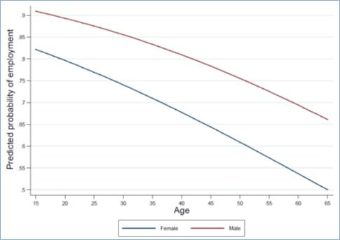

The next figure illustrates the relationship between age at VET training and the probability to obtain employment upon leaving the ADF, this time, decomposing between different VET training levels. It illustrates the significant returns associated with Certificate III and IV and the absence of significant improvement in the probability of finding a job beyond these levels.

Figure : Estimated relationship between age and probability of employment by VET training level

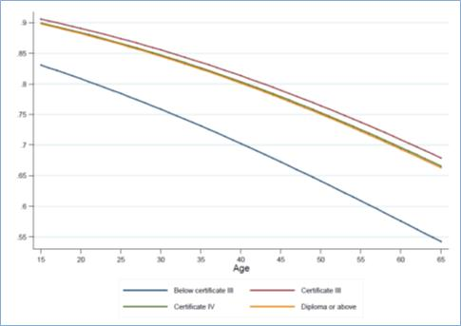

The third figure displays the same type of information, distinguishing females from males to illustrate the presence of a gender gap.

Figure : Estimated relationship between age and probability of employment by VET training level and gender

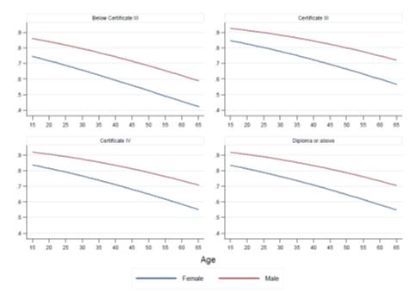

### What are the differences between those VET graduates who stayed with the ADF after their VET and those who left to take a civilian job?

|  |
| --- |
| Box 6: Sample used for the estimation of the probability to leave the ADF |
| This regression uses the subsample of all ADF employees who participated in VET and presents their choice to either stay with or leave ADF employment after their VET completion, presented in Table 34 below. The main objective of this estimation is to trace the factors with the strongest association with the choice to leave the sector or not. We use the same set of variables as in the previous regression, although there could be good reasons for enriching the set of explanatory variables. |

Older workers are less likely to leave the ADF, by about 1 per cent less for each year. Males are equally as likely as females (note the very low z-score of 0.25). People with disabilities are 16 per cent more likely to leave the ADF after training, while people with less education are less likely to leave the ADF after training. Previous education qualifications do not seem to influence the decision; presumably their effect has already been worked into the present employment arrangements. Module completers (compared to those who completed the full course) are 11 per cent less likely to leave the ADF. This is a strong association, and may be explained by the pre-existing relationship that ADF employees have with their employer, so that they do not need to produce a new formal qualification. If the reason they studied can be accomplished through a module only, then they will stop. By contrast, those who plan to leave the ADF will attain their course certificate as a proof of retraining and (or) commitment to new employers who will need some signal to judge the quality of an unknown prospective employee. Those who participate in VET for employment reasons are 8 per cent more likely to leave the ADF. The outcome of the study in terms of achievement, satisfaction, or further study, appears to play no role in the choice to leave the ADF or stay with the ADF. Finally, those with less-skilled jobs in the ADF are 9 per cent less likely to leave the ADF, and those who were working part time for the ADF are 11 per cent more likely to leave the ADF, after training.

The interesting observation from this regression is that many of the estimated strong associations suggest that the decision to change sector, or not, was made first and the appropriate VET route was chosen to suit the already chosen career path. A good example is the choice to complete a module only, or to complete the course. Although we have no direct evidence on the sequence of these events and choices, the results suggest that the choice of between module and full course completion is often made after the decision to leave the ADF or not, and in order to suit that decision to stay or not.

Table : Probability of changing job after training: Comparing ADF-CIV with ADF-ADF

|  |  |  |
| --- | --- | --- |
| **Variables** | **Coefficients** | **Marginal effects** |
| **Age** | -0.02*** | -0.01*** |
|  | (0.00) | (0.00) |
| **Male** | 0.03 | 0.01 |
|  | (0.09) | (0.03) |
| **Disability** | 0.48*** | 0.16*** |
|  | (0.15) | (0.06) |
| **Below Year 12** | -0.20** | -0.06** |
|  | (0.08) | (0.02) |
| **Certificate III** | 0.33*** | 0.10*** |
|  | (0.12) | (0.04) |
| **Certificate IV** | -0.05 | -0.02 |
|  | (0.12) | (0.03) |
| **Diploma or above** | -0.20 | -0.05* |
|  | (0.12) | (0.03) |
| **Module completer** | -0.43*** | -0.11*** |
|  | (0.11) | (0.03) |
| **Study for employment reason** | 0.31*** | 0.08*** |
|  | (0.12) | (0.03) |
| **Reason for study achieved** | -0.02 | -0.01 |
|  | (0.09) | (0.03) |
| **Not satisfied with training** | 0.01 | 0.002 |
|  | (0.10) | (0.03) |
| **Further study** | 0.02 | 0.01 |
|  | (0.09) | (0.03) |
| **Skilled job before training** | -0.29*** | -0.08*** |
|  | (0.08) | (0.02) |
| **Casual job before training** | 0.15 | 0.05 |
|  | (0.13) | (0.04) |
| **Part-time job before training** | 0.34** | 0.11* |
|  | (0.16) | (0.06) |
| **Constant** | -0.01 |  |
|  | (0.23) |  |
| **Observations** | 1357 |  |
| **Pseudo R2** | 0.099 |  |
| **Log likelihood** | -664.6 |  |

Note: Standard errors in parentheses; *** p<0.01, ** p<0.05, * p<0.1.

Source: Student Outcomes Survey pooled waves 2001-10. Probit estimation is used.  
The dependent variable takes the value of 1 for leaving the ADF to a civilian job and 0 for staying with the ADF after training.

The following three figures illustrate the estimation results through graphs showing the relationship between age and estimated probabilities, decomposed either by gender, level of VET training, or both.

The first figure makes it clear that we do not find a gender gap with respect to the probabilities of leaving the ADF. The profile of the relationship between age and probability of leaving the ADF is decreasing at a decreasing rate, in a hyperbolic shape which contrasts with the parabolic shape found in the estimation of the probability to find a job (see above).

Figure : Estimated relationship between age and probability of leaving the ADF by gender

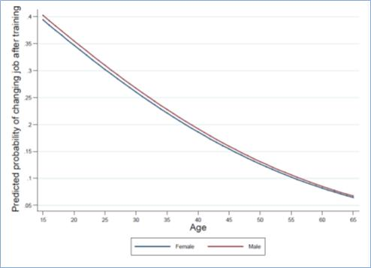

The next figure illustrates the relationship between age at training and the probability of leaving the ADF. The figure shows that individuals who undertake a Diploma level course are the least likely to leave the ADF after training. On the contrary, people who opt for a Certificate III are significantly more likely to leave the ADF. The other two categories are not significantly different from each other. Note that this result emerges even after controlling for whether individuals are course or module completers. Therefore, the result that a Diploma is associated with lower probabilities of leaving the ADF cannot be attributed to the fact that one finds more module completers only among those enrolled in Diplomas. At this stage, we would require some additional information coming from the ADF to be able to give an explanation as to why those enrolled in a diploma are more likely to stay with the ADF. It may be because diploma completion may be associated with promotions or a widening of the spectrum of opportunities inside the ADF, so that people are more likely to stay. It can also be due to the fact that the enrolment into a diploma may have been a prerequisite to stay in their job and may concern more specialised types of positions inside the ADF.

The third figure simply displays the previous results, further illustrating the absence of a significant gender gap.

Figure : Estimated relationship between age and probability of leaving the ADF by VET training level

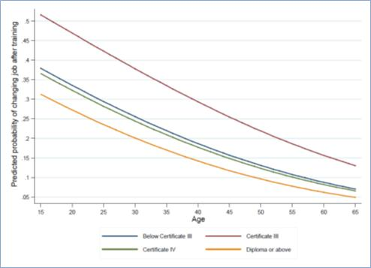

Figure : Estimated relationship between age and probability of leaving the ADF by VET training level and gender

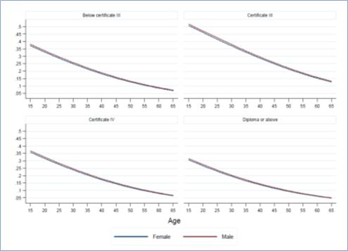

### How do the wages compare between those VET graduates who left the ADF to take a civilian job and those who stayed in ADF employment?

|  |
| --- |
| Box 7: Samples used for the estimation of weekly earnings |
| This regression first uses the subsample of all ADF employees who participated in VET and got a paid job after leaving VET (model I). We then generalise the estimation to the subsample of all individuals who participated in VET and got a paid job after leaving, in order to investigate the differences across transition types, including civilians (models II and III).  Results are presented in Table 35. The main objective of this estimation is to evaluate the wage differences across transition types through the inclusion of indicator variables that distinguish the movers from the stayers among the ADF personnel, the civilians who remain so, and the civilians who join the ADF after VET. The objective of the last model (model III) is to check whether the returns to VET are significantly different across transition types. |

The role of wages is always important in understanding why labour market turnover happens. Although wages tend to present only a single dimension of employment (and we know that people value employment for many more reasons than just their pay), the wage offers very valuable information about why people move between jobs and sectors in the economy. Wages are also considered to be a good indicator of productivity, but this is more so for jobs in the private sector, where decentralised wage bargaining is more prevalent and where the profitability of production (and, by extension, the market value of the output of work) is in many instances easier to measure than in the public sector. The market value of public sector wages is inherently difficult to determine, as the most up-to-date Atkinson Report[10] from the United Kingdom testifies. The reason is that for some of the production of the public sector, there is no clear market to allow prices to develop, so the benefit from the production has to be defined otherwise.

The international literature, including Australian research, suggests that public sector wages tend to be on average higher than private sector wages. However, comparing averages may be misleading, as the composition of the workforces in the two sectors may be different in the attributes that determine wages. For example, there is considerable evidence that part of the public-private sector wage difference can be attributed to the fact that the average public sector employee is better qualified in comparison to the average private sector employee. This implies that at least part of the higher public sector wages can be attributed to a public sector workforce with an above national average level of qualifications (and, by extension, pay). Notwithstanding these reservations, wages gain a special meaning in the context of the present research, as they represent the alternative pay for those who contemplate leaving the ADF.

Table : Weekly earnings after training: Comparing ADF-CIV with ADF-ADF

|  |  |  |  |
| --- | --- | --- | --- |
| **Variables** |  | **Coefficients** |  |
| ***Model I*** | ***Model II*** | ***Model III*** |
|  |  |  |  |
| **ADF-CIV** | -0.31*** | -0.31*** | -0.38*** |
|  | (0.03) | (0.04) | (0.08) |
| **CIV-ADF** | - | 0.05 | 0.14** |
|  |  | (0.04) | (0.07) |
| **CIV-CIV** | - | -0.23*** | -0.22*** |
|  |  | (0.02) | (0.04) |
| **ADF-CIV*Certificate III** | - | - | 0.06 |
|  |  |  | (0.12) |
| **ADF-CIV*Certificate IV** | - | - | 0.14 |
|  |  |  | (0.12) |
| **ADF-CIV*Diploma or above** | - | - | 0.14 |
|  |  |  | (0.12) |
| **CIV-ADF*Certificate III** | - | - | -0.10 |
|  |  |  | (0.12) |
| **CIV-ADF*Certificate IV** | - | - | -0.21* |
|  |  |  | (0.12) |
| **CIV-ADF*Diploma or above** | - | - | -0.12 |
|  |  |  | (0.12) |
| **CIV-CIV*Certificate III** | - | - | -0.003 |
|  |  |  | (0.06) |
| **CIV-CIV*Certificate IV** | - | - | -0.03 |
|  |  |  | (0.05) |
| **CIV-CIV*Diploma or above** | - | - | -0.002 |
|  |  |  | (0.06) |
| **Age** | 0.01*** | 0.01*** | 0.01*** |
|  | (0.00) | (0.00) | (0.00) |
| **Male** | 0.18*** | 0.22*** | 0.22*** |
|  | (0.03) | (0.00) | (0.00) |
| **Disability** | -0.11* | -0.19*** | -0.19*** |
|  | (0.06) | (0.01) | (0.01) |
| **Below Year 12** | -0.05* | -0.13*** | -0.13*** |
|  | (0.03) | (0.00) | (0.00) |
| **Certificate III** | 0.14*** | 0.09*** | 0.10 |
|  | (0.04) | (0.00) | (0.06) |
| **Certificate IV** | 0.26*** | 0.16*** | 0.19*** |
|  | (0.04) | (0.00) | (0.05) |
| **Diploma or above** | 0.27*** | 0.18*** | 0.18*** |
|  | (0.04) | (0.00) | (0.05) |
| **Module completer** | 0.13*** | 0.10*** | 0.10*** |
|  | (0.04) | (0.00) | (0.00) |
| **Study for employment reason** | -0.03 | 0.17*** | 0.17*** |
|  | (0.04) | (0.00) | (0.00) |
| **Reason for study achieved** | 0.10*** | 0.16*** | 0.16*** |
|  | (0.03) | (0.00) | (0.00) |
| **Not satisfied with training** | -0.14*** | -0.01*** | -0.01*** |
|  | (0.04) | (0.00) | (0.00) |
| **Further study** | -0.08** | -0.15*** | -0.15*** |
|  | (0.03) | (0.00) | (0.00) |
| **Skilled job before training** | 0.11*** | 0.17*** | 0.17*** |
|  | (0.03) | (0.00) | (0.00) |
| **Casual job before training** | -0.18*** | -0.27*** | -0.27*** |
|  | (0.05) | (0.00) | (0.00) |
| **Part-time job before training** | -0.63*** | -0.50*** | -0.50*** |
|  | (0.06) | (0.00) | (0.00) |
| **Constant** | 6.39*** | 6.11*** | 6.10*** |
|  | (0.08) | (0.02) | (0.04) |
| **Observations** | 1,290 | 222,190 | 222,190 |
| **R2** | 0.334 | 0.382 | 0.382 |

Note: Standard errors in parentheses; *** p<0.01, ** p<0.05, * p<0.1.

Source: Student Outcomes Survey 2001-10. OLS estimation is used.

The dependent variable is the log of weekly usual earnings in main job after training.

The raw wage differential between ADF leavers and stayers in the sample at hand for model I is 36.3 per cent, with the average weekly earnings for the ADF-ADF VET participants being $841 and the corresponding average weekly earnings for the ADF-CIV VET participants being $617. We can refine this comparison using multiple regression, by estimating the wage gap between these two groups after controlling for all other differences between those who stay with the ADF and those who move to the civilian workforce. The coefficient of the ADF-CIV variable is -0.32, which means that after we have controlled for all the differences represented by the rest of the variables in the estimation, the ADF stayers are paid 32 per cent more than the ADF leavers. We think that this percentage is very high and, as such, is worth further discussion and investigation.

First, we should note that the overall fit of the estimation is about 33 per cent, which is about right for a regression of this type and of this sample size. Although 33 per cent may appear to be too low, this compares well with wage estimations and we would consider this estimation to have provided a good overall fit for our data. Second, we note a closely related observation, namely that the list of variables used to explain wages covers well what the literature, and our experience, suggests to be core determinants of wages. We have the core demographics of age, gender, and health; we have education before and during training; we have a couple of attitudinal variables to reflect some of the personal attributes and attitudes that are harder to observe; and we also have some valuable information on the previous job characteristics (that is skills utilisation, the type of contract, and the hours worked prior to training). By all relevant standards of good research practice, this is a comprehensive list of control variables for estimating wages. Of course, one will always wish for better quality data with more information, but the richness of this set of variables is not the main limitation of the data set.

It is worth noting that the raw gap between the ADF veterans and the VET graduates who originated from the civilian workforce is about 10 per cent in favour of the ADF veterans, so the picture is nowhere near as clear as we would like it to be. For now, it is worth noting that the closest example we can find to well-structured and well-performed statistical research is by Veteran Affairs Canada (Income study: regular force veteran report, 2011[11]), which finds that income declines by about 21 to 30 per cent over the first three-year period after leaving the Canadian defence force—results that are similar to our initial estimates.[12] Still, the data used in that study are not comparable to the data used here, as the Canadian study has repeated observations over a longer period of time (superior data quality), which allows the researchers to investigate the wages of veterans over a longer period and is a much better measure of labour market performance. By contrast, we have a single observation per person, which limits the questions we can ask in a statistically meaningful way.

Another important limitation of our data, which may skew our results, is that the sample we investigate may be self-selected in ways that are related to the individuals’ earning capabilities. This can happen in ways and directions that cannot be easily determined without having access to more information. For example, it could be that the ADF leavers who choose to take part in VET are the ones with the poorest skills and, possibly, skill-development potential. As a consequence, they may have been among the lowest paid whilst they were in the ADF, which may be perhaps why they decided to leave. By contrast, the ones who decide to stay may be the ones who are showing promise for promotion and are participating in VET in order to facilitate that promotion. One would expect these stayers to have been among the better-paid ADF employees.

Aside from the potential data issues that may be responsible for part of the observed differences between leavers and stayers, economic theory and the applied literature on the determinants of earnings suggest that a large part of these differences may be related to what is termed *compensating differences*. We discuss this term further in the subsection dedicated to sample estimates and scenarios. In brief, compensating wage differences arise between two identical individuals who occupy two different jobs as a result of labour market adjustments that compensate for attributes of the jobs. Everything else held constant[13], undesirable job attributes such as health risks, frequent mobility requirements, time spent away from family, and so on are compensated for by the labour market in the form of a higher wage relative to jobs that do not have these undesirable attributes. ADF jobs certainly have a number of such undesirable attributes that justify part of the differentials observed between civilians and servicemen. The comparable figures observed by Veterans Affairs Canada further support such a hypothesis.

The first model in Table 35 is based on the subsample of ADF personnel who undertook VET training and serves as a first approach in our investigation of the determinants of earnings. The coefficient obtained for ADF-CIV is a benchmark that can be compared to the other models to check for the quality of the results. Models II and III are based on the whole sample of individuals who undertook training and were in regular employment at the time of the SOS. In model III we introduce three binary variables capturing the estimated wage differences across transition types expressed with reference to ADF-ADF. Since the hourly wages are expressed in logarithms in the estimation, the estimated coefficients for these three variables can be interpreted as percentage differences compared to ADF-ADF. In model II we observe that the estimated wage drop after transition to a civilian job is 31 per cent, remaining the same in comparison to model I. Model II also shows that civilians who remain civilians after training (CIV-CIV) have an estimated wage 23 per cent lower than ADF-ADF. This is an important result, because it suggests that ADF veterans (ADF-CIV) would experience a wage penalty compared to civilians of about 8 per cent. In other words, given identical individual characteristics, a veteran receives a significantly lower wage than a civilian. In the next subsection we investigate this result further by looking at the sample estimates for these two transition types by field of study. More specifically, the sample estimates allow us to investigate whether sample differences between veterans’ and civilians’ characteristics help the veterans improve on the initial wage penalty of 8 per cent or not. We find that they more than overcome their initial penalty (see below).

Model II results also enable us to evaluate the returns to each of the VET degrees. The estimates are expressed with reference to Certificate I or II (below Certificate III). We see that the return to Certificate III is about 9 per cent. It is respectively 16 per cent and 18 per cent for Certificate IV and Diploma. In other words, the greatest return is obtained through Certificate III. Investing in a Certificate IV brings about a 7 per cent increase in weekly wages while a diploma adds only 2 per cent to Certificate IV.

In model III we test the hypothesis that the returns to a VET degree may differ by transition type. To do so, we introduce a new set of variables which represent interactions between the transition types and the VET degree. The estimated coefficient associated with these variables indicates whether, for some of the transitions considered, there is an added return to a particular VET degree. The fact that we find these coefficients to be non-significantly different from zero[14] indicates this is not the case. For instance a Certificate III does not bring additional benefits to a civilian compared to a veteran.

### Additional Outcomes after VET Training

#### Probability of getting a full-time job

|  |
| --- |
| Box 8: Sample used for the estimation of the probability of getting a full-time job |
| This regression uses the subsample of all ADF employees who participated in VET and got a paid job after leaving VET. Results are in Table 36 below. The main objective of this estimation is to estimate the difference in the probability of getting a full-time job as opposed to a part-time job between those who left the ADF and those who stayed with the ADF, through the inclusion of an indicator variable that distinguishes movers from stayers. |

Table : Probability of getting a full-time job after training: Comparing ADF-CIV with ADF-ADF

|  |  |  |
| --- | --- | --- |
| **Variables** | **Coefficients** | **Marginal effects** |
| **ADF-CIV** | -0.73*** | -0.11*** |
|  | (0.12) | (0.02) |
| **Age** | 0.002 | 0.0002 |
|  | (0.01) | (0.00) |
| **Male** | 0.48*** | 0.07*** |
|  | (0.12) | (0.02) |
| **Disability** | -0.49** | -0.08* |
|  | (0.19) | (0.04) |
| **Below Year 12** | -0.01 | -0.002 |
|  | (0.12) | (0.01) |
| **Certificate III** | 0.002 | 0.0002 |
|  | (0.16) | (0.02) |
| **Certificate IV** | 0.44** | 0.04*** |
|  | (0.17) | (0.01) |
| **Diploma or above** | 0.31* | 0.03** |
|  | (0.17) | (0.02) |
| **Module completer** | 0.04 | 0.004 |
|  | (0.15) | (0.02) |
| **Study for employment reason** | 0.05 | 0.01 |
|  | (0.15) | (0.02) |
| **Reason for study achieved** | 0.21* | 0.03 |
|  | (0.13) | (0.02) |
| **Not satisfied with training** | -0.08 | -0.01 |
|  | (0.15) | (0.02) |
| **Further study** | -0.44*** | -0.06*** |
|  | (0.12) | (0.02) |
| **Skilled job before training** | -0.02 | -0.002 |
|  | (0.12) | (0.01) |
| **Casual job before training** | 0.03 | 0.003 |
|  | (0.18) | (0.02) |
| **Part-time job before training** | -1.94*** | -0.54*** |
|  | (0.18) | (0.07) |
| **Constant** | 1.24*** |  |
|  | (0.33) |  |
| **Observations** | 1323 |  |
| **Pseudo R2** | 0.352 |  |
| **Log likelihood** | -300.4 |  |

Note: Standard errors in parentheses; *** p<0.01, ** p<0.05, * p<0.1.

Source: Student Outcomes Survey pooled waves 2001-10.

Probit estimation is used.

The dependent variable is 1 if employed full time after training and 0 otherwise.

#### Probability of getting a non-casual job

|  |
| --- |
| Box 9: Sample used in the estimation of the probability of getting a non-casual job |
| This regression uses the subsample of all ADF employees who participated in VET and got a paid job after leaving VET. Results are presented in Table 37 below. The main objective of this is to estimate the difference in the probability of getting a casual job as opposed to a job with paid sick and holiday leave entitlements, between those who left the ADF and those who stayed with the ADF, through the inclusion of an indicator variable that distinguishes the movers from the stayers. |

Table : Probability of getting a non-casual job after training: Comparing ADF-CIV with ADF-ADF

|  |  |  |
| --- | --- | --- |
| **Variables** | **Coefficients** | **Marginal effects** |
| **ADF-CIV** | -0.74*** | -0.18*** |
|  | (0.11) | (0.03) |
| **Age** | -0.004 | -0.0007 |
|  | (0.00) | (0.00) |
| **Male** | 0.11 | 0.02 |
|  | (0.12) | (0.02) |
| **Disability** | -0.14 | -0.03 |
|  | (0.18) | (0.04) |
| **Below Year 12** | -0.04 | -0.01 |
|  | (0.10) | (0.02) |
| **Certificate III** | 0.15 | 0.03 |
|  | (0.14) | (0.02) |
| **Certificate IV** | 0.39*** | 0.07*** |
|  | (0.14) | (0.02) |
| **Diploma or above** | 0.42*** | 0.07*** |
|  | (0.15) | (0.02) |
| **Module completer** | 0.21 | 0.04* |
|  | (0.13) | (0.02) |
| **Study for employment reason** | 0.04 | 0.01 |
|  | (0.13) | (0.03) |
| **Reason for study achieved** | 0.23** | 0.05** |
|  | (0.11) | (0.02) |
| **Not satisfied with training** | -0.01 | -0.003 |
|  | (0.13) | (0.02) |
| **Further study** | -0.02 | -0.003 |
|  | (0.11) | (0.02) |
| **Skilled job before training** | -0.10 | -0.02 |
|  | (0.10) | (0.02) |
| **Casual job before training** | -1.95*** | -0.61*** |
|  | (0.14) | (0.04) |
| **Part-time job before training** | -0.12 | -0.02 |
|  | (0.17) | (0.04) |
| **Constant** | 1.28*** |  |
|  | (0.29) |  |
| **Observations** | 1356 |  |
| **Pseudo R2** | 0.327 |  |
| **Log likelihood** | -412.2 |  |

Note: Standard errors in parentheses; *** p<0.01, ** p<0.05, * p<0.1.

Source: Student Outcomes Survey pooled waves 2001-10.

Probit estimation is used.

The dependent variable takes the value of 1 for employed with an entitlement to sick and holiday leave after training, and 0 otherwise.

#### Probability of getting a skilled job

|  |
| --- |
| Box 10: Sample used for the estimation of the probability to get a skilled job |
| This regression uses the subsample of all ADF employees who participated in VET and got a paid job after leaving VET. Results are presented in Table 38 below. The main objective of this is to estimate the difference in the probability of getting a skilled job between those who left the ADF and those who stayed with the ADF, through the inclusion of an indicator variable that distinguishes the movers from the stayers. |

Table : Probability of a skilled job after training: Comparing ADF-CIV with ADF-ADF

|  |  |  |
| --- | --- | --- |
| **Variables** | **Coefficients** | **Marginal effects** |
| **ADF-CIV** | 0.56*** | 0.22*** |
|  | (0.11) | (0.04) |
| **Age** | 0.0006 | 0.0002 |
|  | (0.00) | (0.00) |
| **Male** | 0.23** | 0.09** |
|  | (0.11) | (0.04) |
| **Disability** | 0.05 | 0.02 |
|  | (0.19) | (0.07) |
| **Below Year 12** | -0.10 | -0.04 |
|  | (0.10) | (0.04) |
| **Certificate III** | -0.10 | -0.04 |
|  | (0.14) | (0.06) |
| **Certificate IV** | 0.32** | 0.12** |
|  | (0.14) | (0.05) |
| **Diploma or above** | 0.49*** | 0.19*** |
|  | (0.14) | (0.05) |
| **Module completer** | 0.14 | 0.06 |
|  | (0.13) | (0.05) |
| **Study for employment reason** | 0.24* | 0.10* |
|  | (0.13) | (0.05) |
| **Reason for study achieved** | 0.38*** | 0.15*** |
|  | (0.11) | (0.04) |
| **Not satisfied with training** | 0.13 | 0.05 |
|  | (0.12) | (0.05) |
| **Further study** | 0.23** | 0.09** |
|  | (0.10) | (0.04) |
| **Skilled job before training** | 2.51*** | 0.78*** |
|  | (0.10) | (0.02) |
| **Casual job before training** | -0.18 | -0.07 |
|  | (0.16) | (0.06) |
| **Part-time job before training** | 0.21 | 0.08 |
|  | (0.20) | (0.08) |
| **Constant** | -2.16*** |  |
|  | (0.29) |  |
| **Observations** | 1349 |  |
| **Pseudo R2** | 0.515 |  |
| **Log likelihood** | -453.5 |  |

Note: Standard errors in parentheses; *** p<0.01, ** p<0.05, * p<0.1.

Source: Student Outcomes Survey pooled waves 2001-10. Probit estimation is used.

The dependent variable is 1 if employed in a skilled occupation after training and 0 otherwise.

Skilled occupations defines as 1, 2, and 3 in the ANZSCO (ASCO) 1-digit occupation list.

The next three figures illustrate the estimation results through displaying the relationship between age and the estimated probability, distinguishing between gender, training level, and both. The first figure shows the positive relationship between age and the probability of finding a skilled job after training. It illustrates the presence of a gender gap of about 9 per cent between males and females at all levels of training.

Figure : Estimated relationship between age and probability of getting a skilled job by VET training level and gender

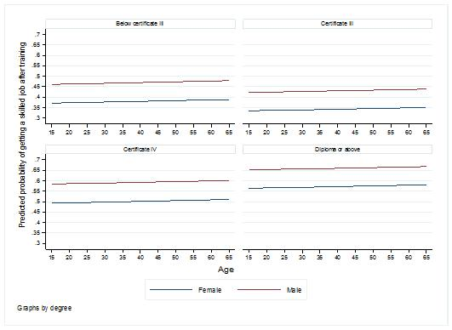

The next figure shows the extent to which Certificate IV and Diplomas set themselves apart with regard to the probability of getting a skilled job after training. It shows that Certificate III is not significantly different to a lower level of training with respect to this probability.

Figure : Estimated relationship between age and probability of getting a skilled job by VET training level

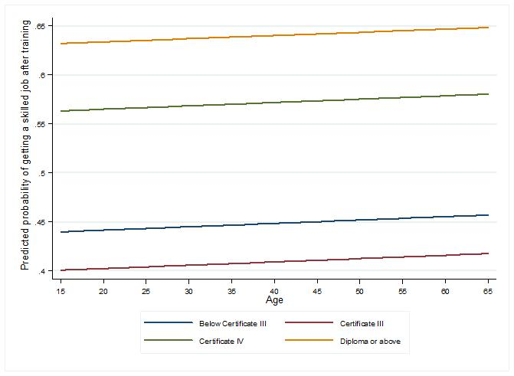

The final figure in this part illustrates the gap that exists between ADF stayers and leavers at all level of training in favour of the leavers. Leavers are more likely to find a skilled job upon leaving than ADF stayers who return to their former job.

Figure : Estimated relationship between age and probability of getting a skilled job by VET training level and transition type

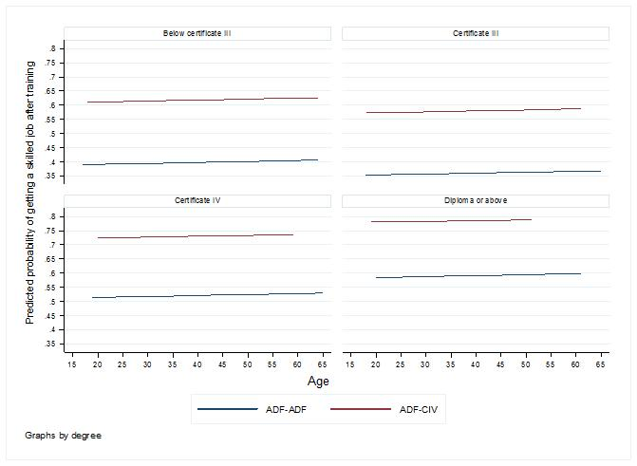

## Predicting Labour Market Outcomes for ADF (ex-) Personnel

|  |
| --- |
| Box 11: Deriving predictions of individuals’ outcomes |
| We use the results of the underlying statistical model that we presented in the previous section to build policy-relevant predictions. The principle is simple and powerful. The model allows us to derive an estimated prediction for each outcome of interest and for each individual in the sample. These individual predictions can be summed up for different subgroups to allow us to focus the results of the model on people and circumstances that are at the forefront of policy relevance. This section focuses on the ‘typical’ DVA client with a claim under the *Military Rehabilitation and Compensation Act 2004* (MRCA). |

The next two sections use the estimation results of the underlying econometric model in order to build specific predictions for DVA clients who leave the ADF (this section) and to build scenarios for DVA clients who lodged a claim under the *Military Rehabilitation and Compensation Act 2004* (MRCA) since 1 July 2004 (the next section).

This section is organised as follows. First, we use the model predictions in order to determine the expected labour market outcomes for ADF personnel undertaking a VET course. We focus on the role of the field of study undertaken and whether or not an individual suffers from a disability or chronic condition. Where the data allow this, we compare these estimates to the overall sample used for the estimations, including both ADF personnel and civilians.

Second, we use the underlying model estimates in order to build scenarios that will represent the characteristics of DVA MRCA clients and study their potential labour market outcomes. We focus on the labour market outcome differentials that arise after the transition from ADF to civilian employment, the expected returns from various VET degree types, the labour market *penalties* due to disability, and the gender differences in the resulting outcomes. This exercise aims to generate a focused picture of what ADF personnel about to transit to civilian life can expect from VET training.

### Sample Estimates of ADF (ex-) Personnel Labour Market Outcomes

We use the estimated models to derive specific predicted outcomes for each individual in the sample. For this we combine the individual’s observed characteristics with the information provided by the model in the form of the estimated relationship between characteristics and circumstances, and labour market outcomes.

We then group all individuals in the sample according to categories of interest, and derive the average predicted outcomes for each group. For example, suppose we wish to know how post-VET labour market outcomes may vary by field of study undertaken through VET.[15] If we group individuals by their field of study and calculate their average predicted outcomes we can have an informed picture of the returns associated with each field of study undertaken through VET by the relevant DVA clients. If we wish to focus our picture more, we can subdivide the data and calculate further average predictions (for example, we may wish to know whether there are any differences in the returns to VET by field of study between those below and those above the age of 30).

When using the resulting predictions, one must bear in mind that the individuals undertaking each field of study may have different characteristics which will influence the predicted outcomes. For example, the data suggest that more males undertake VET courses in Engineering, than females. However, the data also suggest that males have a higher probability of gaining employment after VET and are also more likely to be paid higher wages in their job (irrespective of their field of study). It is worth noting that higher predicted earnings for Engineering may be partly due to the actual field of study, but also partly due to variations in demographic characteristics between those choosing this field (in this case more males) and those choosing other fields. One must keep this in mind when interpreting average predicted outcomes by field of study. Further down the line, we derive scenarios which compare two types of people, who differ by only one characteristic, in order to get a clear picture about the way observed differences in labour market outcomes may be associated with specific characteristics.

### Probability of Employment: Sample Estimates by Field of Study and Disability

Figure 35 shows the probability of employment by field of study. We compare ADF leavers (in blue) with the sample of all VET graduates (in orange). We restrict the comparison to those who reported having a job before their VET training, in order to avoid the biases that previous participation differences and differences in labour market experience may cause. The restricted group is more comparable to ADF leavers, in the sense that both groups were previously employed and had, thus, labour market experience.

Figure 35 suggests that ADF leavers experience a penalty in terms of a reduced probability of employment when they transit to a civilian occupation after VET and that this penalty is present, irrespective of the chosen field of study. Figure 35 also shows that the penalty associated with leaving the ADF can differ considerably by field of study. For instance, those in Architecture and Building experience fairly similarly employment probabilities compared to the whole sample with an estimate of 0.9 compared to 0.93. By contrast, those in Management and Commerce, Food Hospitality, and Personal Services experience a much higher penalty with probabilities estimated at around 0.73 for both fields compared to 0.9 for all other individuals.

Figure : Estimated probabilities of employment by field of study, ADF leavers versus All Sample

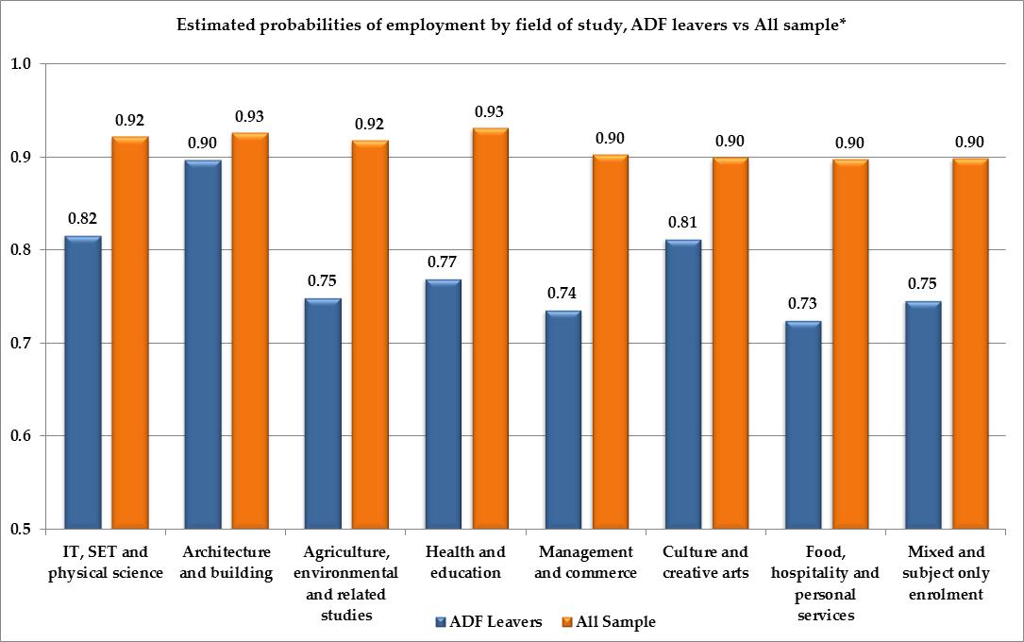

Note: * Category ‘All Sample’ refers to estimations of the probabilities to find employment after VET on the sample of all VET graduates (and module completers) restricted to those who had a job before training.

The different employment rates by field of study are minimal for the whole population, but can be very large for some ADF leavers, indicating the riskiness of the transition. For some occupational groups only three-quarters of the ADF leavers get a job after VET completion, which is a very low proportion by national standards. Without further information regarding the specific type of employment within the ADF and the specific reasons for leaving the ADF (neither type of information is recorded in the SOS data collection), it is hard to conclude anything about the causes of this occupational penalty. One possible explanation could be the higher proportion of people with health impairments, but Figure 36 suggests this is not the main explanation.

Figure : Estimated Probability of Employment by Disability Status, ADF versus All Sample

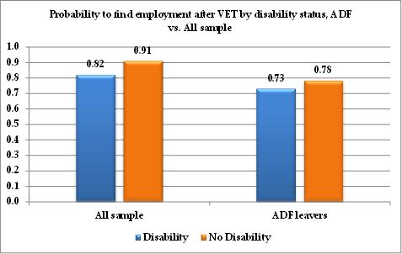

Figure 36 shows the predicted employment probabilities for VET graduates (and module completers) according to whether they have a disability or chronic condition or not. The right bar is for ADF leavers and the left bar for the full sample of VET graduates (as previously, restricted to those who reported having a job before VET). The overall penalty that ADF leavers experience is present; the penalty is almost half for people with a disability (0.78−0.73 = 0.05) than for people without (0.91−0.82 = 0.09). It is worth noting by way of benchmarking with the national picture, that the All Sample probability of employment for those with a disability is 82 per cent, and is higher than the ADF leavers without a disability probability at 78 per cent. It is also worth noting that the selection into employment by those with an MRCA support background (ADF leavers) and those with a possible Disability Support Payment background (All Sample) will probably be different, as their disabilities may be of a different nature and the two schemes that cover them are also different in the support they offer.

### Probability to Leave the ADF (change job): Sample Estimates by Field of Study and Disability

Figure 37 gives presents the probability of changing sector by field of study. In the present context, this is the probability of transiting to a civilian job as opposed to staying in the ADF after training. There are few differences across field of study, and their interpretation should be that the choice of study of those who plan to leave the ADF will be geared towards qualifications that are useful in the civilian workforce, and those who plan to stay in the ADF will be geared towards ADF-relevant qualifications. There will be cases where a qualification would be useful in both sectors, in which case the statistics in Figure 37 cannot be clearly interpreted.

Figure : Estimated probabilities of changing job by field of study (ADF)

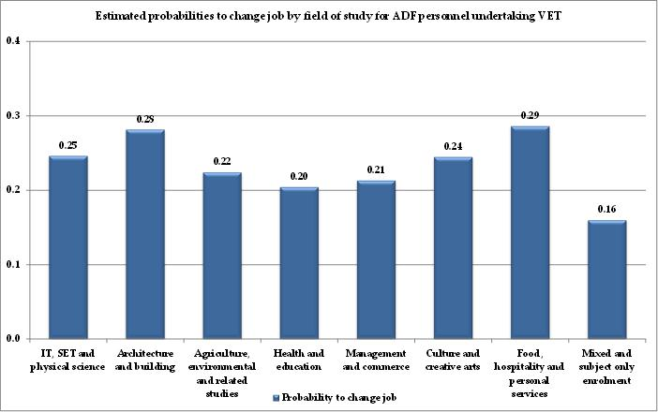

One possible extension and improvement of this analysis would be to investigate not only the additional qualification obtained in the VET course specified in the SOS data, but also the qualifications already possessed and how the new qualification complements these in the context of the competing possibilities of a new career in the civilian workforce or of staying in the ADF. The closest we get to this thinking is by looking at subject-only enrolments which we expect would be more useful in the context of an ADF stayer. Indeed, we see that subject-only enrolments—which do not result in a full VET qualification and that are known to be used by people who have a job and only need a part of the full VET qualification for that job—are associated with a significantly lower probability of leaving the ADF. This thinking is also consistent with the estimated model for module completers, only they are identified as being more likely to remain with the ADF. We would speculate that this educational pathway would probably be encountered among ADF stayers who may be sent by the ADF to take a VET course that is relevant to their present job, or to a prospective new job within the ADF. In such cases, it is more likely that the requirement would be to complete only the necessary module or subject before coming back to their ADF job.

Figure 38 presents the probability of changing job by disability status, and compares the relevant probabilities for ADF personnel and for the whole workforce, at least as this is represented in the full SOS sample. People with a disability or long-term health condition are more likely to change jobs after a VET completion. This is a general trend which reflects the fact that VET can be supportive of people with a disability or long-term health condition regarding readjusting their employment career through changing sector and job. Our results suggest that the same relationship between disability, VET, and change is found among ADF personnel, but the percentages are lower for people both with and without a disability or long-term health condition.

Figure : Estimated probabilities of changing job by disability status, ADF vs. All Sample

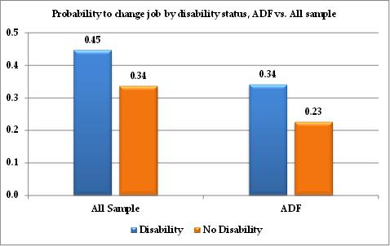

### Earnings per Week: Sample Estimates by Field of Study, Disability and Gender

Figures 39 and 40 present the earnings per field of study after VET completion. Figure 39 shows the mean weekly earnings estimate by field of study (within a 95 per cent confidence interval) for all ADF personnel, which includes those who stay and those who leave the ADF. Figure 40 presents the earning differences of the complete sample by transition type (ADF-ADF, ADF-CIV, CIV-ADF, and CIV-CIV) and field of study in order to offer a broader set of benchmark figures.

Figure 39 suggests that Health and Education, Management and Commerce, and Architecture and Building are associated with higher earnings estimates. ADF personnel who became VET graduates in the Food, Hospitality, and Personal Services field of study experience significantly lower earnings in their employment subsequent to VET.

Figure : Estimated weekly earnings by field of study, ADF-ADF & ADF-CIV

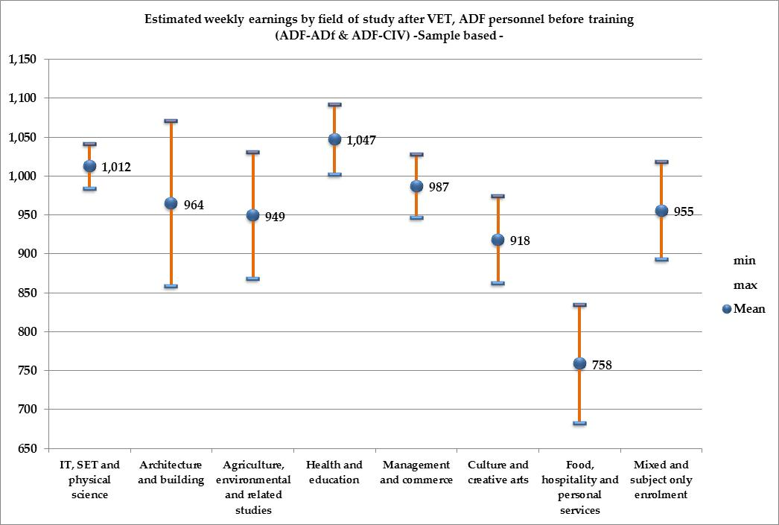

Figure 40 suggests overwhelmingly that ADF personnel remaining with the ADF (ADF-ADF) after training obtain higher earnings than anyone else, including ADF recruits (CIV-ADF). One explanation is that they retain their sector-specific skills and knowledge, which is lost by those who leave the ADF to join the civilian workforce (ADF-CIV). One should note here that the picture we have is incomplete in the sense that we do not know the labour market position of those ADF-CIV who did not go through the VET system upon leaving the ADF. To this purpose, one would have to use complete ADF records of all ADF leavers and be able to distinguish between the leavers who went through VET from those who did not.

Figure 40 also suggests that ADF leavers (ADF-CIV) and civilian stayers (CIV-CIV) have very similar earnings outcomes after VET, which one could take to imply that ADF leavers enter the civilian workforce without an earnings disadvantage. Indeed, some types of VET ADF leavers appear to be doing better than their civilian stayer counterparts, with a pay premium of about 3 per cent. However, contrary to this evidence, the multivariate regression results in Table 35 suggest that ADF leavers suffer an 8 per cent penalty when compared with their civilian stayer counterparts.[16] Hence, we have two pieces of information from our estimations that need to be explained and jointly interpreted.

Multivariate regression says that when we estimate the difference between ADF-CIV earnings and CIV-CIV earnings, the ADF-CIV suffer a penalty. This result has discounted all differences in observed characteristics (such as human capital) as well as unobserved characteristics (such as motivation or past experience) and tells us what is happening over and above all these characteristics. The result is clear. If we pick repeatedly a pair of two identical individuals, one from the ADF-CIV pool and one from the CIV-CIV pool, we would expect that after several pairs have been picked the earnings of the CIV-CIV group would be 8 per cent higher than those of the ADF-CIV group.

Figure : Estimated earnings by field of study and transition type

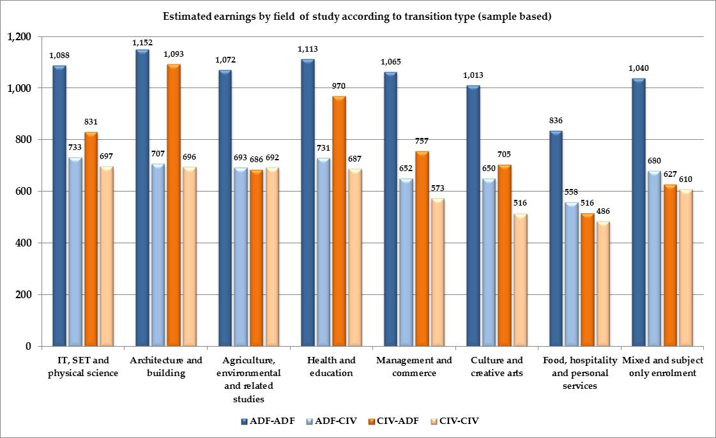

However, the two pools of ADF-CIV and CIV-CIV individuals are not the same. The data tell us that the observed characteristics of the ADF-CIV group are superior to those of the CIV-CIV group in the sample of all those who took part in VET. As a result, the overall prediction of the model (as in Figure 40) suggests that ADF-CIV individuals earn more. Combining our results suggests that ADF-CIV individuals are disadvantaged by the market by an 8 per cent earnings penalty, but at the same time they possess above average observed human capital characteristics that confer on them an advantage of about 11 per cent higher earnings. The observed net outcome is the modestly higher earnings suggested by Figure 40.

Simply put, our model suggests that ADF-CIV individuals suffer an 8 per cent earnings penalty that our data cannot explain, but at the same time our data suggest that they possess above average human capital which translates into an 11 per cent earnings advantage. The net effect is the modest advantage portrayed in favour of ADF-CIV individuals in Figure 40. It is worth noting that Table 35 and Figure 40 jointly suggest that both disadvantage and advantage are directly related to the choice of VET course.

Figure 41 compares the estimated earnings of males and females by field of study. In the field of Architecture and Building, the sample only had two females with very high hourly wages which seemed not to be representative of what actually takes place in this field of study. We opted to remove these observations in order to avoid potentially misleading conclusions. Altogether, these estimates illustrate the existence of a gender gap to the detriment of females. Figures for each gender displaying both the mean estimates and the corresponding 95 per cent confidence intervals are found in the appendices (Figures A24-A25). The figures in the appendices further show that with the exception of the field of Culture and Creative Arts and, to a lesser extent, Food Hospitality and Personal Services, females obtain a significantly lower weekly wage than men. Beside the previous observation, we can see that the gaps narrow for such fields of study as Management and Commerce and Agriculture, Environmental and Related and are widest in Health and Education.

Figure : Estimated earnings by field of study, males vs. females (ADF-ADF & ADF-CIV)

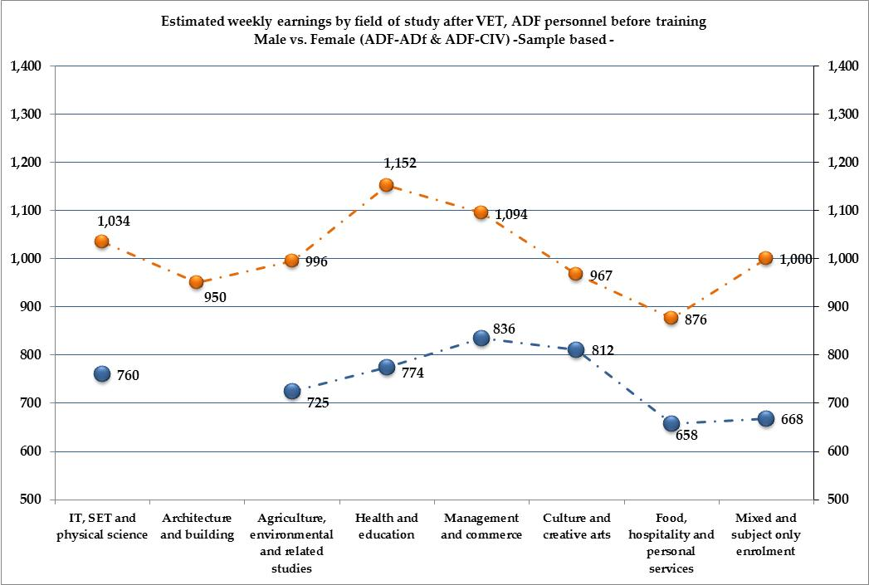

Figure 42 compares sample estimates of earnings by transition type and by disability status using model II from Table 35. The existence of a disability or a chronic condition is associated with a penalty in terms of lower wages, whatever the type of transition considered.

Figure : Estimated earnings by transition type and disability status

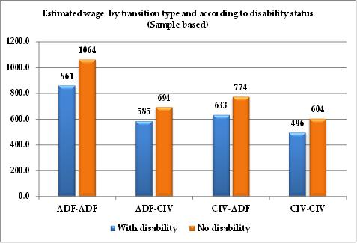

Figure 43 gives the estimates of the probabilities of obtaining a skilled job by field of study, distinguishing between the ADF stayers (ADF-ADF) and leavers (ADF-CIV), and comparing them to the other VET graduates. As in the previous figures, we see that graduates (and module completers) in the Food, Hospitality and Personal Services field have the lowest outcomes compared to the other fields. However, in this field, along with the Health and Education, Culture and Creative Arts, ADF leavers have a higher probability of finding a skilled job compared to the All Sample group and the ADF stayers. The differences are fairly small (except for the Food, Hospitality and Personal Services field) but worth noting. One may conjecture that ex-ADF personnel share some stereotypical characteristics such as organisational abilities, rigorousness, and so on, which are particularly valued by the market employing VET graduates in these fields.

With the exception of the Food and Hospitality fields, the probabilities of getting a skilled job after VET are between 50 and 60 per cent, even in the more technical fields of IT, SET, and Physical Science. The ADF leavers seem to be fairly well on a par with the other transition categories.

Figure : Estimated probability of getting a skilled job, All Sample versus ADF-ADF and ADF-CIV

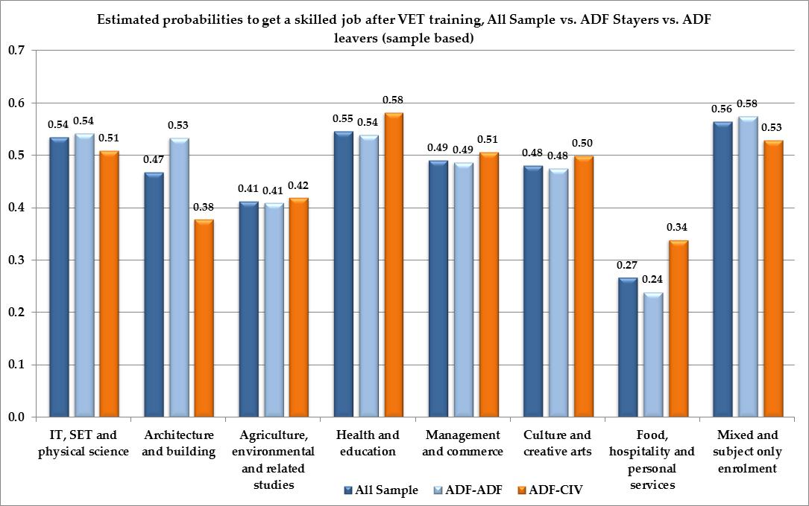

## Scenarios and Incorporation of DVA Clients Characteristics

|  |
| --- |
| Box 12: Definition of policy relevant scenarios |
| This section uses the results of the underlying statistical model to construct policy-relevant scenarios. We use the same individual predictions as in the previous section in order to define specific types of people and (or) circumstances. We focus on the ‘typical’ DVA client with a claim under the MRCA, as this is defined by combining information provided by the DVA and by the sample. This is the most targeted way to use the econometric results derived from the estimations and offers useful policy insights. The choice of policy-relevant scenarios is crucial and has been made in consultation with the DVA. |

This section focuses on scenarios about DVA clients who have left the ADF and have lodged a claim under the MRCA since July 1 2004. These would be clients who have had injuries and (or) diseases accepted by DVA under the MRCA, and who are younger (about 35 years of age on average) compared to other DVA clients under previous compensation and rehabilitation schemes. (The latter were mostly veterans and their widows, from older theatres of operation, such as World War II, Vietnam, and so on.). The scenario focus is justified on several grounds. First, the fact that DVA clients under the MRCA are more likely to be of working age makes the investigation of their potential labour market outcomes upon leaving the ADF highly relevant. Second, the fact that DVA clients under the MRCA are also more likely to have some form of health impairment upon leaving the ADF adds considerable complexity to their transition into the civilian workforce. It is at the time of an ADF to civilian employment transition that an investment in further education through VET may be at its most useful, as the role of VET in facilitating labour market transitions and, in particular, the transitions of people with health impairments is well-documented in the literature[17].

The method used to build a scenario combines the estimation results with the information on DVA clients, especially those under the MRCA program, to look at the outcomes they would be most likely to have after investing in further education through VET. The models enable us to distinguish between ADF leavers and stayers and also to look at gender differences in those outcomes.

We use the DVA data to determine the appropriate clients’ age distribution by gender, concentrating on individuals making claims through the MRCA program which started in 2004. We use this information to compute the probability of being employed, the predicted wage associated with employment, and the probability of obtaining a skilled job. For those variables contained in our underlying statistical model, but which are not currently available through DVA data, we use the sample information that pertains to the appropriate mix of gender and age. Intuitively put, what we do is to mix and match both DVA and SOS information to define the closest possible profile to the DVA clients with MRCA claims. We then combine this profile with the estimates from our statistical model in order to compute the expected outcomes that are as tailored as possible to the current DVA client population with MRCA claims. Since the SOS data contain information on whether VET graduates (and module completers) who belonged to the ADF actually return to the ADF, or leave, we can compare the outcomes between leavers and stayers. Box 11 contains a technical description of how this is done.

|  |
| --- |
| Box 13: Building scenarios involves the following calculations |
| We first determine the expected outcomes from VET training for the whole population (males and females) using the age information of DVA clients and the observed proportion of females among them. We provide three estimates of individuals’ outcomes. The central estimate corresponds to the expected outcomes of a DVA client whose age corresponds to the mean observed age among the DVA clients. Then we compute the same expected outcomes for individuals whose age would correspond to half a standard deviation above and below this mean age. The rest of the variables included in the model are set to the sample mean, unless we look at expected outcomes for males versus females, in which case the gender variable of the models is appropriately changed. Likewise, when we look at the expected outcomes associated with a particular type of VET training or level of education in general, we replace the sample mean with the appropriate dichotomous value for the level of education considered. For the general population of DVA clients under the MRCA, we compute the outcomes for people whose ages are respectively 30.9, 35.9 and 40.9 years. The gender variable is assumed to be 84.8 per cent male. Hence, when computing the expected outcomes of the general DVA population when they complete a Certificate III from VET, we substitute, in the models, the ADF personnel SOS sample mean for the non-DVA variables in the model, 0.848 for gender, and 0 for all education levels except Certificate III which assumes a value of 1.  We then conduct the same computations distinguishing between genders. Hence, instead of using the mean DVA client gender, we either set this variable to 0 for females or 1 for males. When computing the estimates for females we also alter the three values for age, taking instead the DVA clients’ mean and lower and higher bounds (half a standard deviation above and below) which are specific to the gender considered. In the DVA data, the mean age of female claimants is 33.8, with higher and lower bounds of, respectively, 29.1 and 38.5 years. The gender-specific estimates are provided in the second figures of each sub-paragraph  Finally, for models that include a variable indicating whether individuals leave or stay in the ADF after VET training, we provide the two sets of figures for both leavers and stayers. |

We investigate the following core outcomes with our scenarios, namely, the probability of employment after a VET course, the probability of changing occupation (that is leaving the ADF), earnings after VET, and the probability of finding a skilled job.

In building the scenarios, we provide an additional computation of the *Economic* expected earnings for each scenario. Expected earnings represent a weighted average of the earnings attached to each situation an individual may be in, weighted by the probability that the individual may be in each situation. We use the concept of expected earnings to indicate our expectations regarding the earnings of a VET trainee upon completion of their training. These earnings will depend on whether the person will remain with the ADF or not, whether they obtains a job if they leave the ADF and become a civilian, whether or not they may receive DVA incapacity payments if they cannot work, and many other factors. The calculation of a person’s expected earnings takes all of these factors into account to produce the mathematical expectation of the individual’s earnings. Very simply put, the derivation expected earnings is an *ex ante* calculation that reflects our best guess about the overall earnings potential of an individual. At that point in time we do not know what choices they will make. The derivation uses much of the information we have about an individual’s earnings capacity, and it reflects the fact that we do not know what choice that individual will make.

More precisely about the calculation of expected earnings, ADF VET graduates may return to the ADF after training with a probability which is estimated by our statistical model (see Table 34). Those who stay in the ADF are predicted to collect wages that correspond to an ADF-ADF type of transition. Alternatively, they may transit to a civilian life whereby they face a probability of finding a job, as presented in Table 33, and are predicted to collect the estimated earnings attached to the ADF-CIV transition type. If they do not have a job in the civilian sector, they may or may not collect incapacity payments from the DVA. Considering a given ADF employee who undertakes VET training, their expected (overall) earnings after completing VET can then be calculated by computing the expected value of these payoffs, where the weights are represented by the various probabilities attached to each event, namely leaving the ADF, finding employment, and receiving monetary compensation from the ADF. We detail the technique used to compute expected earnings and provide the estimates used for relevant scenarios.

### Probability of Finding a Job: Scenarios

Finding a job is probably the most important aspect of an education and labour market decision. Figure 44 reports the estimated probabilities for the relevant scenarios assuming individuals who are the average age of the DVA clients with an MRCA claim. Each point in the graph is accompanied by its corresponding lower and higher bounds defined by half a standard deviation around the mean age. The value of age used has been adjusted for gender to correspond to the female and male mean age of DVA clients with an MRCA claim.

Figure : Probability of employment by scenarios of DVA client characteristics

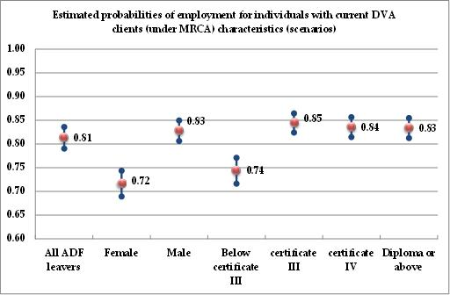

Our model suggests that when the average DVA client under the MRCA (aged 35.9 years and 84.8 per cent male) undertakes VET training, then we would expect them to find employment with a probability of 0.81 (81 per cent). If we make the comparison with the sample estimates for the whole sample in the previous subsection, we can say that the typical DVA client would experience a penalty in terms of employability compared to non-ADF individuals. Considering the average unemployment rate of the civilian population in the period covered by the data, this estimate implies that ADF leavers suffer a disadvantage in terms of employment opportunities when leaving the ADF. Since the basis of comparison with the civilian population is with respect to individuals who had a job before investing in further VET training, we may conjecture that part of the disadvantage observed for ADF personnel may be that their employment experience and expertise built within the ADF is not as transferable as the experience and expertise of their civilian counterparts.

Scenarios in Figure 44 show that there is a gender gap between the employment probabilities of males and females, in that females experience a larger penalty than males. As we will see in the subsequent figures, the gender gap persists in all outcomes considered in this study, always to the disadvantage of females.

Female ADF leavers have a 72 per cent probability of finding employment after VET, against 83 per cent for males[18]. The difference between males and females is more than 10 percentage points and cannot be attributed to differences in probabilities of leaving the ADF after training. Indeed, in Table 34 (and in the following scenarios) we show that females are as likely as males to transit to a civilian life. A potential explanation may reside in differences regarding choices of field of study, where we have already identified (see the previous subsection) fields with wider gender gaps. But this is probably only part of the story. A combination of other factors, well-documented in the field of Labour Economics, comes into play in explaining the existence of a gender gap with respect to labour market outcomes[19]. The same combination of factors can be invoked to explain gender differences in the estimated wages and probabilities of obtaining a skilled job.

Figure 44 also shows how employment probability differs by the level of education of the VET participant. We note that there is a fairly large return in terms of employability associated with Certificate III, which has a probability of 85 per cent, compared with below Certificate III which has a much lower probability of 74 per cent. By contrast, employment probabilities do not improve for those with higher training (Certificate IV and Diploma have probabilities of 84 per cent and 83 per cent respectively.

Figure 45 below compares the same education-level scenarios distinguishing between males and females to see if payoffs to VET training differ by gender. Figure 45 shows that a female with a Certificate III is as employable (at 76 per cent) as a male with less than a Certificate III (also 76 per cent). A male with a Certificate III, is 10 percentage points more likely to become employed (at 86 per cent). The gender differences in employment probability appear to be the same for those with Certificate IV and Diplomas.

Figure : Probability of employment by scenarios of DVA client characteristics, gender differences

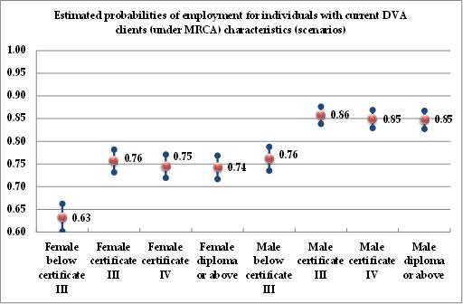

The next subsection carries the same scenarios through the next model which consists of estimating the probability, for ADF personnel, of leaving the ADF after VET training.

### Probability of Changing Job after Training: Scenarios Comparing ADF-CIV with ADF-ADF

The following figures show the scenarios about the probability of leaving the ADF after completion of the VET course. We first display scenarios for the average DVA client (under MRCA) and then rerun the same scenarios, distinguishing by gender.

Figure : Probability of changing job by scenarios of DVA client characteristics

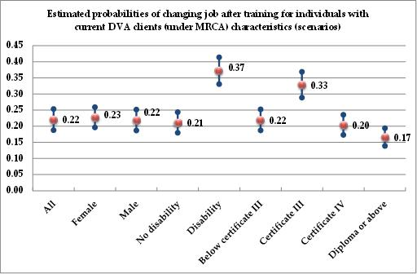

The probability of leaving the ADF after training is fairly low at about 22 per cent. This indicates that VET participants among the ADF personnel are partly a selected group. It is to be expected that a large proportion of these individuals were sent by the ADF to complete only a module needed for their current employment. This is corroborated by the negative coefficient for module completers (see Table 34). Moreover, some of the DVA claimants who experience higher level of disability may not have the opportunity to engage in VET training for health reasons; hence we are missing part of the story with the current data available to us. We note that scenarios with disability or long-term conditions involve a higher probability of leaving the ADF. We also observe that individuals undertaking Certificate III are most likely to leave the ADF. Beyond this level, the probability decreases.

Figure 47 represents the education scenarios by gender and shows a minimal gender gap in the probability of leaving the ADF. Females are as likely as males to leave the ADF, no matter what their level of VET training.

Figure : Probability of changing job by scenarios of DVA client characteristics, gender differences

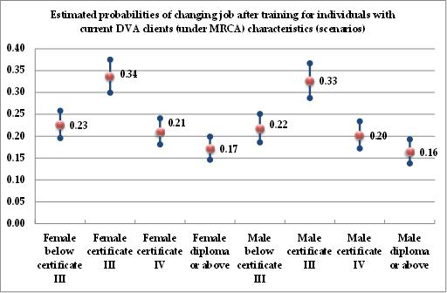

### Estimated Weekly Earnings after Training: Scenarios

Multivariate analysis suggests that there are significant earnings differences by transition type (see Table 35), especially between ADF leavers and ADF stayers. Here we introduce the distinction between leavers and stayers in our scenarios.

#### ADF stayer vs. ADF leavers

The outcomes for ADF stayers are presented in Figure 48 and those of ADF leavers in Figure 49. The wages of ADF leavers’ wages (everything else held constant) are significantly lower than those of the stayers. The average DVA client[20] who stays with the ADF after training, is expected to make $983 per week, compared to $722 for their ADF leaver counterpart. The gap between the two amounts to about a 30 per cent drop.[21] Part of this gap can be explained by the fact that leavers and stayers differ in terms of the amount of previous experience that can be transferred into their new job after training. Much of the previous experience of ADF stayers will be transferable to their new position after training. They may even be promoted after VET. By contrast, part of the ADF experience of ADF leavers may not be relevant to their new civilian role and may therefore not be reflected in the wage paid by their new civilian job.

As with the probability of employment, there are sharp gender differences in wages. The average female is paid a wage after training which is about 20 per cent lower than the equivalent male is paid. The likely reasons for this have already been pointed out in the discussion on the scenarios for employment probabilities.

An interesting result comes from looking at the returns to the level of the VET degrees. When we looked at employment, we noticed that the probability of employment was greatly increased for those who completed a VET Certificate III. However, further training—at Certificate IV or Diploma level—did not increase the probability of employment (indeed, it decreased it for the Diploma level). In contrast, Certificate IV and Diploma level VET bring further returns in terms of wages. Certificate III brings about an extra 13 per cent compared to training below Certificate III, for both ADF-ADF and ADF-CIV cases. Certificate IV represents a further 12 to 13 per cent extra wage over and above the return from Certificate III. Diplomas confer a further, but small, increase. Hence, while VET training at the level of Certificate IV and Diploma is not associated with a significant increase in the employment probability compared to Certificate III, it is associated with a further 12 to 13 per cent return in terms of higher wages.

It is interesting to note that while the return to each degree is the same for both ADF-ADF and ADF-CIV, the gap in absolute value is large between these two groups. The leavers with the higher degrees get wages still more than 20 per cent lower than the stayers: the highest degree for leavers still leads to an estimated wage that is lower than that of a stayer with the lowest VET degree.

While loss of transferable experience explains part of these differences, economic theory also points towards a number of factors that may play a role. Indeed, the wage is meant to pay workers for their personal attributes (experience, education, skills in general, talent, and so on) and also for the job attributes (degree of honesty required to perform a job, riskiness, health risks attached to the job, noise, dirtiness, probability of success, and so on). For instance, everything else held constant[22], a riskier job should attract an additional remuneration in the form of a premium compared to a less risky job. If risk could be rightly considered as an undesirable attribute of a job, and if it were not compensated for by a wage premium, then everyone would leave the risky jobs and try to get the less risky ones. At the level of the market, this would lead to a decrease in the wage paid for non-risky jobs (oversupply of labour would allow employers to attract the right number of workers for lower wages) and an increase in the wage paid for the riskier jobs (under supply, or labour would force employers to offer higher wages to attract the right number of workers). It is for this reason that labour markets reach equilibrium wages which reflect a risk premium in the form of higher wages for riskier jobs. This type of adjustment premium is called a compensating wage differential and is positive for undesirable attributes of jobs and negative for desirable attributes of jobs.[23] ADF jobs have a number of attributes that would attract such premiums, like the higher riskiness of the job, geographical mobility requirements, and so on. These compensating differentials explain part of the observed differences between stayers and leavers, over and above the impact of the degree of transferability of sector-specific work experience.

Figures 48 and 49 also suggest the presence of a relatively large wage penalty for disability and long-term health conditions. The estimated wage of ADF stayers is $889 and for ADF leavers is $653, which is about 10 per cent lower than their counterparts who do not have a disability or long-term health condition.

Figure : Weekly earnings by scenarios of DVA client characteristics, stayers (ADF-ADF)

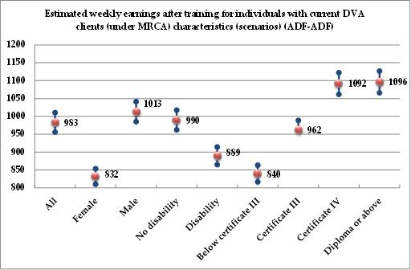

Figure : Weekly earnings by scenarios of DVA client characteristics, leavers (ADF-CIV)

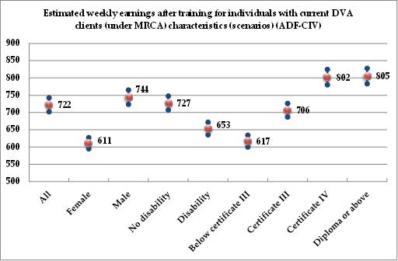

We note that the scenarios we present give us an indication of the DVA client at the mean age for the relevant group. They also provide us with an indication of the sensitivity of our results to the age group that we deal with, by presenting two further estimates, one for half a standard deviation above and half below the mean age. These are seen in all figures as the smaller dots above and below the mean age estimate. It is very reassuring that these further estimates lie very close to those for the mean age, as this implies that the scenario results do not depend much on the specific mean age that we assume in order to derive them. Bearing this point in mind, and in order to simplify the picture that each scenario offers, we use Figures 50 and 51 to summarise the information contained in the previous two figures, showing only the estimated wages for mean ages.[24] The blue histogram bars represent the estimated wages for ADF stayers and the orange bars for ADF leavers.

Figure : Weekly earnings by scenarios of DVA client characteristics, stayers versus leavers

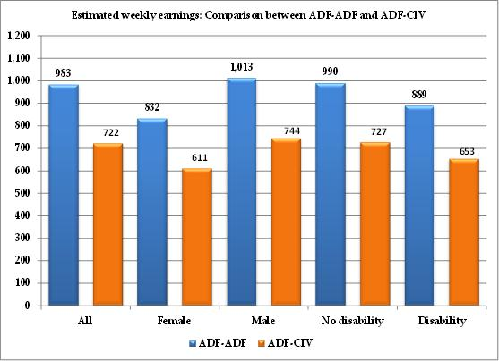

Figure : Weekly earnings by scenarios of DVA client characteristics, stayers versus leavers by VET training level

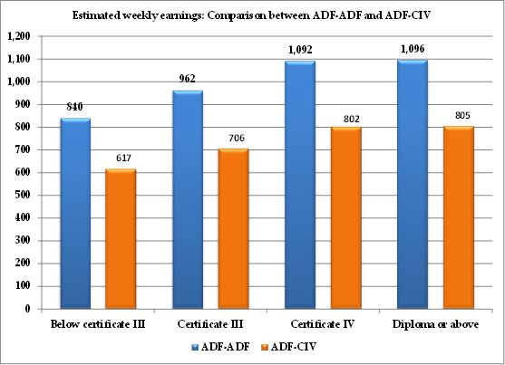

Figures 50 and 51 sum up clearly the overall result that, for both genders, for both levels of health and disability, and for all levels of education: ADF stayers command higher wages than ADF leavers.

#### ADF stayer versus ADF leavers: Gender differences in the returns to VET

Figures 52 and 53 take the analysis of wages further by distinguishing between males and females. Female ADF leavers experience a 30 per cent lower wage as compared to their counterpart ADF stayers. Their wage is also 19.5 per cent lower than that of the equivalent male. The calculation of the returns to VET by gender had to be constrained due to sample-size limitations, so we only look at the actual wage levels to see the extent of the gender gap.[25] The wage of female ADF stayers with Certificate IV is estimated to be lower than that of a male with Certificate III, and almost 20 per cent lower than that of the counterpart male with Certificate IV. The same applies for female ADF leavers but with wage levels 30 per cent lower.

Figure : Weekly earnings by scenarios of DVA client characteristics, gender differences, stayers (ADF-ADF)

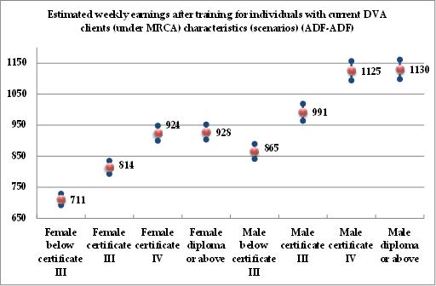

Figure : Weekly earnings by scenarios of DVA client characteristics, gender differences, stayers (ADF-CIV)

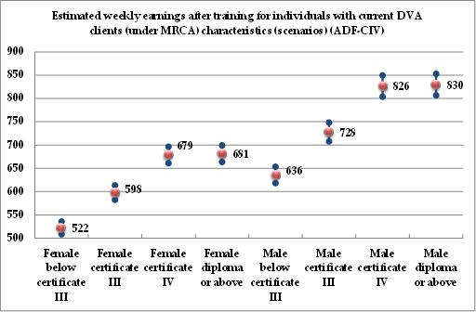

Noting how close the estimates for higher and lower age are in Figures 52 and 53, we use Figures 54 and 55 to summarise them, grouping VET levels together and comparing directly the ADF stayers with the ADF leavers.

Figure : Weekly earnings by scenarios of DVA client characteristics, female stayers versus leavers

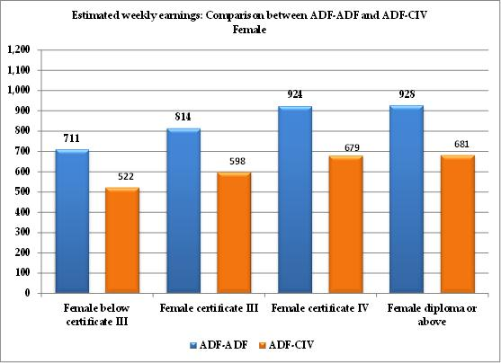

Figure : Weekly earnings by scenarios of DVA client characteristics, male stayers versus leavers

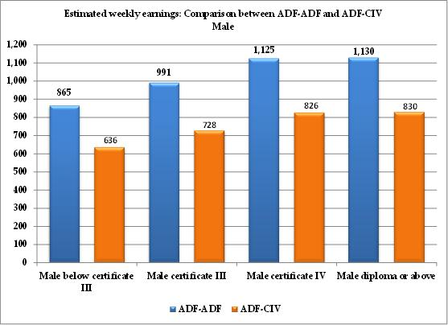

### Using the Model Results to Infer Veterans’ Combined Earnings and Employment Outcomes after VET

|  |
| --- |
| Box 14: Combining earnings and employment outcomes |
| How do VET choices influence the possible future outcomes of ADF leavers and stayers? What would be the appropriate career advice to ADF personnel who may be contemplating leaving the ADF? Results to this point showed that the level of VET study makes a difference in two major ways: the chances of getting a job and the level of the pay that job will offer. Whether a VET leaver has studied at the level of Certificates I or II, Certificate III, Certificate IV, or Diploma influences both employability and pay outcomes. This section combines these two outcomes and shows how they fare together after different levels of VET study. |

In the previous sections we used the results of the econometric model to create scenarios about the earnings, employability, and other outcomes that may interest ADF leavers and stayers when they weigh up their plans for their future careers. This section advances this thinking by presenting hypothetical outcomes that combine employability and pay outcomes. The exercise resembles the calculation of a ‘probability-weighted’ outcome and is explained in Box 15 below. For the non-technical reader, this exercise amounts to examining the predictions that our model has generated, and adapting them to different possible outcomes for different types of ADF personnel. This enables us to create a picture of how much better or worse off they can expect to be if they pick one career path as opposed to another. Simply put, we consider five levels of VET qualifications—Certificate I, Certificate II, Certificate III, Certificate IV, and Diploma—and we calculate their joint impact on the employment probability and the level of pay. This allows us to provide some concrete advice to ADF leavers about the relative desirability of each of these qualifications.

The main message that arises from these scenarios is that when ADF leavers join the civilian labour market, a minimum of a Certificate III is a must. Obtaining a Certificate IV is better, in that it pays better, but it will not improve the chances of getting a job. Finally, our data suggest that the extra effort that a Diploma would require cannot be justified by short-term employability and pay considerations; it would have to be based on longer-term career-enhancement plans. These messages apply to both males and females, the only difference being that females can expect to suffer a stronger loss than males when leaving the ADF—both in terms of pay and chances of employment.

|  |
| --- |
| Box 15: Computing the expected earnings after VET |
| The following figure depicts the possible situations that ADF personnel who undertake VET training may be in, along with the weights that apply to the earnings attached to these situations:  Since we are interested in how ADF leavers fare, we discard the first branch of this tree and compute the combined earnings and employment outcomes for the leavers.  WADF-CIV stands for the earnings of individuals who leave the ADF after VET training.  WDVA stands for earnings received from DVA following an accepted claim which results in a compensation for an inability to work full time.  W0 stands for the earnings received through any other means except paid employment or DVA incapacity payment.  P1 stands for the probability of leaving the ADF after training (estimated through the model depicted in Table 34)  P2 stands for the probability of finding employment after training (estimated through the model depicted in Table 33)  P3 stands for the proportion of ADF leavers who are not in paid employment and who receive some compensation from DVA.  Given the figure depicted above, the combined earnings and employment outcomes for an individual who leaves the ADF after VET training is given by:  We do not have any information about W0,therefore we normalise its value to 0. Alternatively, it could be set to the value of (relevant) unemployment benefits.  P2 is obtained through the corresponding models. P3 is obtained through DVA information and represents the proportion of MRCA clients who received compensation for incapacity to work full time as a result of an accepted claim. With regard to these compensations, we have been supplied with two types of information. One is the total amount paid to individuals since the introduction of the MRCA. The second is the amount paid in the last fortnight. We had to use this latter information to compute an estimate of the average compensation received by a client, because the information on the total amounts paid is not accompanied by the corresponding duration of the payments.  WADF-CIV is the earnings estimate from the model depicted in Table 35.  With regard to P3 and WDVA, we use DVA data to work out a proxy of these quantities. WDVA is obtained by looking at the average incapacity payments that are paid by DVA for the last fortnight of available information (week ending 12 September 2012). P3 is the proportion of DVA clients (under the MRCA) who received incapacity payments for that fortnight. These quantities are the best approximation that we can obtain, given the data that were made available to us. The following table summarises the values of the two quantities that we used to compute the combined earnings and employment outcomes according to gender. In scenarios involving females (males), we pick the values described below for females (males). In scenarios where gender is not distinguished we pick the average value.   |  |  |  | | --- | --- | --- | |  | **P3** | **WDVA** | | **Female** | **0.088** | **617.5** | | **Male** | **0.091** | **721.2** | | **all ADF** | **0.09** | **705.7** | |

The combined earnings and employment outcomes per week for veterans after VET training for the various scenarios investigated are summarised by the two following figures (Figure 56 and Figure 57). It is important to note that this is a calculation of how things look *before* the VET graduate has entered the labour market, so the desirability of a job consists of both the chance of getting a job and the level of pay that the job offers. Of course, after an individual job seeker has obtained a job, the probability of getting that job becomes irrelevant for that person; the level of pay becomes more relevant, but it is worth remembering that when we want to advise on career decisions that entail job search, the chance of getting a job has to be part of the advice. This is the main point of the scenarios in this section. We present our main scenarios in Figure 56, and we provide a gender perspective in Figure 57.

We explain how the figures are calculated using male ADF leavers who have completed a Certificate IV. Those who got a job are paid $826 per week (see Figure 55). We also know that the probability or getting a job after a Certificate IV is 85 per cent (see Figure 45). In addition, of the 15 per cent who do not work, we approximate that 9.1 per cent of them receive incapacity payments from DVA, proxied at $721, which leaves 91 per cent with no known payment. Combining these figures (usually called the ‘expected wage’, ($826 × 85) + 15× ( 9 × $721 + 91 × 0)= S712) portrays our best guess of the ‘value’ of a Certificate IV career as viewed through the eyes of someone who wants to decide whether they will follow this or another career path. It is worth noting that this ‘guess’ is based on the experiences of a very large number of individuals who followed this and similar career paths and can provide invaluable objective information to the future job seeker.

We now move to the interpretation of Figure 56. Combining employability and pay shows a massive gender gap, where male expected wages at $629 are almost 40 per cent higher than female expected wages at $455. This shows that females not only receive lower wages than males, but are also less likely to receive any wages (due to lower employment chances) after leaving the ADF. The relative value of each VET qualification level is clear. By far the lowest expected wage is $475 after completing a Certificate I or II course. These two qualifications are too short to confer any substantial new skills, so the result is not surprising. Moving to a Certificate III is associated with about 28 per cent higher expected wages, at $607. Then what we see is that a Certificate IV qualification is associated with about 12 per cent higher expected wages, at $681, which is mainly due to the fact that the pay is higher (as the employment probability remains about the same). Finally, we find that getting a Diploma does not confer any additional short-term benefits, as compared with a Certificate IV. We note, however, that Diplomas present superior possibilities for obtaining a university degree in the future, an aspect that must be kept in mind when choosing the right VET career partway. Figure 57 confirms the results about the gradient of VET qualifications and expected wages, indicating that the gender gap is at its highest among those with the lowest qualifications (with VET Certificates I or II).

Figure : Combined earnings and employment outcomes by scenarios of DVA client characteristics

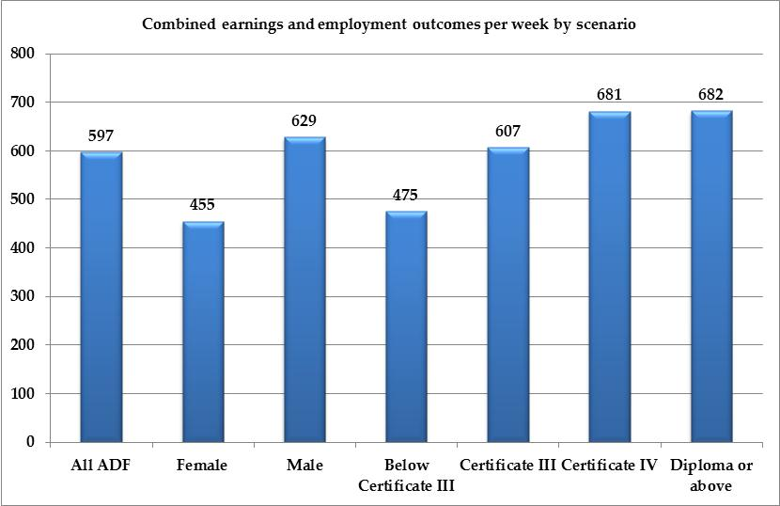

Figure : Combined earnings and employment outcomes by scenarios of DVA client characteristics, gender differences

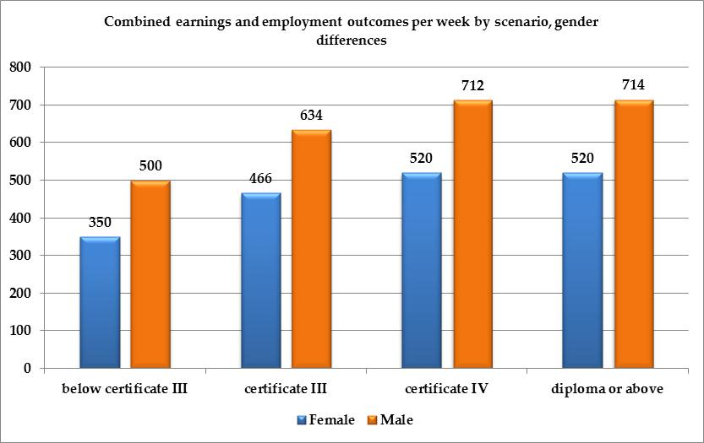

### Probability of Obtaining a Skilled Job after VET: Scenarios

Results on the propensity to get a skilled job after training are particularly interesting, because on this metric they show better outcomes for leavers than for ADF stayers. If we look at the average ADF personnel at the far left of Figure 58, the probability of coming back to a skilled job in the ADF is below 50 per cent (47 per cent). On the other hand, the ADF leavers have an estimated probability of 69 per cent. As we’ve seen through the estimation of the probability of leaving the ADF, ADF stayers are more likely to be only module, not course, completers. This partly explains the result obtained on the probability of getting a skilled job. Indeed, if many ADF stayers are only module completers, they are only partly up-skilled through VET. It is likely that module-only completion corresponds to a prerequisite of the current ADF job or is a step taken for later promotion. Six months later though[26], the training does not translate into a significant job up-skilling for more than half of the stayers. By definition, the leavers compete on the civilian labour market with other civilians. Hence they are more likely to complete the whole course, as the need for up-skilling is definitely there. They are more likely to obtain a skilled job after training as a consequence.

Disability or long-term health condition is not a significant hurdle for those VET graduates who attempt to obtain a skilled job. As we have already pointed out, the SOS data are not likely to contain the most severely disabled individuals, since SOS surveys only those who completed *at least* a VET module. While their disability may be job-limiting to some extent, these individuals have still been able to undertake VET training. Therefore, individuals who record a disability or long-term health condition in our data form a select group, namely those with the least job-limiting conditions.

The second figure confirms that the probability of obtaining a skilled job is positively related to the level of VET training. However, we notice that this positive relationship only kicks in for training above Certificate III. Any training below or equal to Certificate III does not lead to significant differences with respect to one’s ability to get a skilled job. This result is surprising, since Certificate III has been related, so far, to improved employment probabilities and an increased wage compared to lower VET course levels.

Figure : Probability of finding a skilled job by scenarios of DVA client characteristics, stayers versus leavers

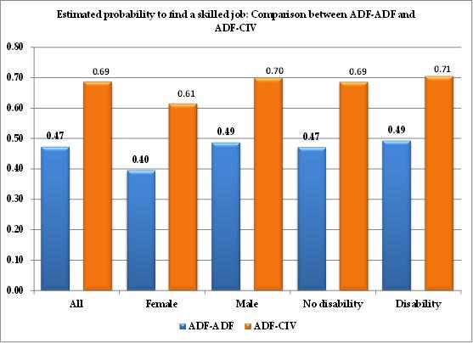

Figure : Probability of finding a skilled job by scenarios of DVA client characteristics by VET level, stayers versus leavers

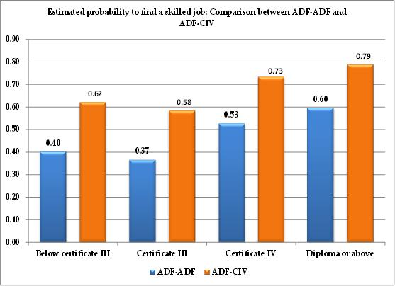

The next two figures expand the scenarios to provide the distinction between males and females. They highlight, yet again, the existence of a gender gap. Interestingly, ADF stayers with a Diploma experience a larger gender gap. Among males with a Diploma, it makes no difference as to whether they are stayers or leavers; the probabilities are only marginally affected. Hence, the stayers-versus-leavers difference observed for the Diploma is entirely absorbed at the female level: female leavers with a Diploma are more likely to find a skilled job.

Figure : Probability of finding a skilled job by scenarios of DVA client characteristics by VET level, female stayers versus leavers

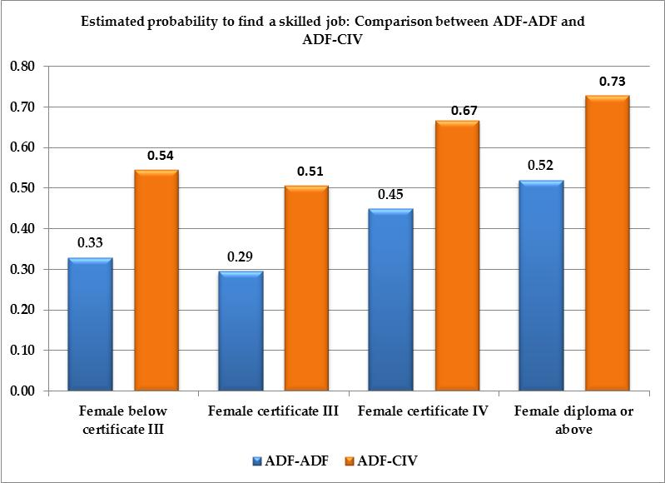

Figure : Probability of finding a skilled job by scenarios of DVA client characteristics by VET level, male stayers versus leavers

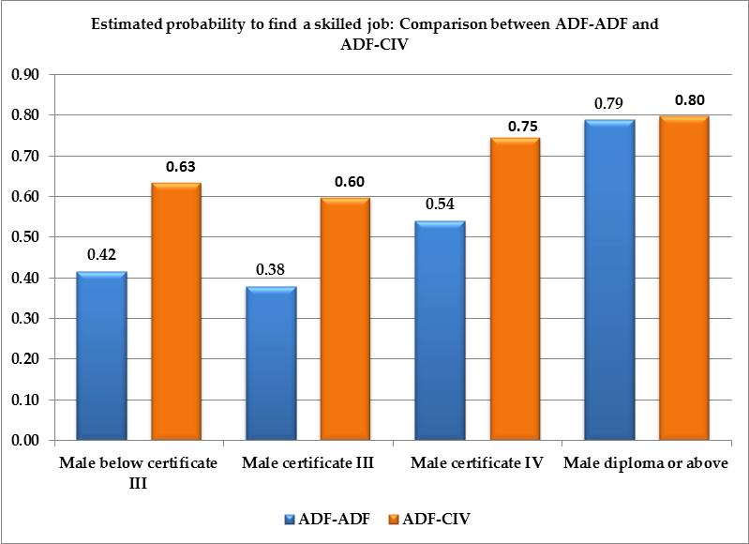

All of the scenarios presented in this section are based on people with the characteristics of DVA clients under the MRCA, to the extent that the data made available to us allowed. Most of these scenarios are computed on the assumption of individuals having the average age of all current DVA clients who had a claim accepted under the *Military Rehabilitation and Compensation Act 2004* (MRCA). In the appendices, we add some extra computations involving older people in order to provide further illustrations of the expected outcomes for ADF personnel undertaking VET studies. More scenarios can be designed, upon request, by DVA.

# Conclusion

The role of the DVA has changed substantially in the past 10 years following the transformation of its client-base demographics. As the number of overseas deployments of the ADF has increased in the past decade, the DVA has seen the age composition of its clients change from being mainly composed of war widows and veterans of older conflicts, to younger age groups. The adoption of the *Military Rehabilitation and Compensation Act* *2004* (MRCA), which determines the administration of all service-related injuries incurred by serving and ex-serving ADF personnel since June 2004 has further contributed to increase the proportion of DVA’s younger clients. This change in client demographics has brought to the policy forefront the issues of rehabilitation and the transition to a civilian life for younger veterans who have many more years of potential working life ahead of them. Investing in further education and up-skilling is an avenue through which younger veterans can assist their transition. The DVA can be instrumental in facilitating such investments for younger DVA veterans and in improving their chances of success through education-oriented rehabilitation programs, and by providing their young veterans with information on future labour market prospects.

The main objectives of the project were to analyse the educational choices made by ADF veterans who left the ADF, and to study the success of their subsequent labour market outcomes, compared to those who returned to the ADF after training, and compared to the broader group of civilians who undertook the same type of training, and with whom the ADF leavers will be competing in the civilian labour market.

The project analyses those veterans who undertook a VET course prior to transiting to the civilian labour market, using national data on VET enrolments and completions (SOS, from the NCVER). The project documents the type, location, and providers of courses chosen, the reason why they were chosen, and a variety of outcomes and measures of the single modules or whole courses they completed. The project compares the differences between veterans and the average (nationally representative) VET student, in terms of their characteristics, choices, and subsequent labour market outcomes. We make the comparison too with ADF personnel who undertake a VET course and remain with the ADF after their training.

The project uses multivariate analysis to identify the determinants of these outcomes and it estimates the returns to the various VET qualification levels from Certificate I and Certificate II to Diplomas. It evaluates the effect of disability and long-term health conditions on labour market outcomes after VET. This analysis follows the premise that many DVA clients may be suffering from health conditions that limit their future work, training, and health. The methodology of the project enables us to evaluate the penalties faced by veterans transiting to the civilian labour market and to measure the relationship between the age at which training is undertaken and the subsequent labour market outcomes. Multivariate regression methodology enables the project researchers to investigate the existence of a gender gap in these outcomes. We use limited DVA information on its clients who had claims accepted under the *Military Rehabilitation and Compensation Act* *2004* (MRCA) to define scenarios of particular interest. We do this in order to provide an indication of the types of labour market outcomes that can be expected after VET for the typical DVA claimant who may transit to a civilian life.

The results of the project’s analysis lead to the conclusion that ADF leavers experience a penalty in terms of employability (the probability of finding a job), and in terms of earnings (weekly earnings). The transition to a civilian life is accompanied by an almost 30 per cent drop in earnings per week when compared to those who remain with the ADF. The results of the project suggest that the leavers’ weekly earnings after VET are comparable to those of civilians who undertake the same type of training. However, results also suggest that ADF leavers experience a penalty compared to their civilian counterparts with regard to their ability to find a job after training. This penalty is overcompensated for by above-average human capital characteristics, such as a better focused choice of study and better performance, as well as higher indications of strong labour market engagement.

The analysis of individuals’ ability to find a job after training shows that employability increases strongly upon completion of Certificate III, but is not further significantly improved by completing a higher-level VET course. The project also finds that older ADF leavers experience lower probabilities of subsequently finding a job.

The presence of a disability or long-term health condition does not seem to affect significantly the probability of finding a job after training. This result may not be representative of all DVA clients, as those undertaking VET training may be a select group who experience the least serious work-limiting conditions.

With respect to weekly wages, the analysis shows that ADF leavers who get a job in the civilian sector after VET are paid considerably less when compared to their ADF stayer counterparts after VET. One explanation would be that ADF personnel receive a *wage premium* when compared with their civilian counterparts, and that this premium is independent of their VET training. Following this line of thought, higher wages could be compensating for negative job attributes that may be characteristic of ADF jobs. As a consequence, ADF leavers experience a strong negative wage shock upon leaving. This is evidenced by the fact that ADF leavers have similar weekly wages to comparable civilians. This effect is also observed in other countries—such as Canada—which monitor the transition to civilian life of their military personnel.

With regard to the returns to training, the project shows that Certificate III involves a very significant improvement compared to lower or no certificates, and that Certificate IV provides further returns. The additional returns to a Diploma are found to be fairly small. The project finds that the returns to VET degrees—the percentage by which weekly earnings increase after completion of a degree—do not vary significantly by the type of transition that we investigated. More specifically, whether one remains with the ADF or not after training, or whether one remains a civilian, the return to each VET qualification remains largely the same. It is evaluated at about 10 per cent for a Certificate III, an added 6 per cent for Certificate IV, and a further 2 per cent for a Diploma.

Through sample estimates, the project finds that the choice of field of study is important in determining the labour market outcomes upon leaving the ADF. Fields such as Health and Education and IT, SET, and Physical Science are associated with the highest (and with the least-dispersed) weekly earnings. Physical Science is also associated with the highest probability of finding a job upon leaving the ADF, and to some extent, a higher probability of finding a skilled job (the highest probability being associated with Health and Education).

The project suggests that the majority of those who return to the ADF after training do not use their training to get a more skilled job. This contrasts with the ADF leavers who are a lot more likely to get a skilled job after training. Certificate III does not seem to help in getting a skilled job, at least to a degree that is significantly different from any form of training below Certificate III. On the contrary, Certificate IV and a Diploma do lead to higher probabilities of getting skilled jobs. We also notice that ADF leavers are more likely to complete the entire course for which they enrolled, as opposed to those who stay with the ADF and who tend just to be module completers.

Summing up the relationship between labour market outcomes and VET training levels, one can say that a Certificate III guarantees an increased probability of finding a job upon leaving the ADF, with higher VET qualifications adding very little more. A Certificate III is also linked to higher probabilities of leaving the ADF. However, individuals who invest in a Diploma are less likely to leave the ADF. It is with respect to weekly earnings that we see a clear relationship between the level of the training and earnings, implying that the higher the training the higher the earnings.

Looking at the relationship between labour market outcomes and disability and long-term health conditions, the project finds no significant effect on employment probabilities but finds a large penalty in terms of weekly earnings—of about 19 per cent. Not surprisingly, disability and long-term health conditions are also associated with higher probabilities of leaving the ADF. It is notable that the penalties observed are significant, despite the fact that the individuals in the SOS sample are the least likely to suffer from the most severe disabilities and long-term health conditions among all ADF leavers.

Finally, the project finds a sizeable gender gap against females in most outcomes. Female ADF leavers are 12 per cent less likely to find a job after training, and the size of their disadvantage in terms of weekly earnings is comparable to the effect of having a disability or a long-term health condition.

# Appendix

This section will be gradually built up to contain the more technical and less central parts of the information used in the report, including tables that are informative but that do not necessarily belong to the main text of the report.

Table A : Number of observed employment transitions by year: Student Outcomes Survey

|  |  |  |  |  |  |  |  |  |  |  |
| --- | --- | --- | --- | --- | --- | --- | --- | --- | --- | --- |
|  | 2001 | 2002 | 2003 | 2004 | 2005 | 2006 | 2007 | 2008 | 2009 | 2010 |
| **adf-adf** | 178 | 140 | 165 | 58 | 210 | 66 | 205 | 114 | 205 | 112 |
| **adf-civ** | 82 | 33 | 58 | 25 | 54 | 19 | 59 | 25 | 51 | 27 |
| **civ-adf** | 66 | 44 | 42 | 17 | 54 | 26 | 49 | 22 | 69 | 31 |
| **civ-civ** | 46,982 | 31,231 | 38,176 | 13,121 | 47,005 | 17,700 | 47,275 | 19,623 | 51,723 | 21,790 |
| **Total** | **47,308** | **31,448** | **38,441** | **13,221** | **47,323** | **17,811** | **47,588** | **19,784** | **52,048** | **21,960** |

Table A : Disability or long-term condition (not employed-ADF & ADF-not employed)

|  |  |  |  |  |  |  |
| --- | --- | --- | --- | --- | --- | --- |
|  |  | adf-uem | adf-nlf | uem-adf | nlf-adf | Total |
| **With disability** | Cases | 7 | 12 | 5 | 2 | 26 |
|  | ***%*** | ***13*** | ***16*** | ***7*** | ***3*** | ***10*** |
| **No disability** | Cases | 47 | 65 | 64 | 60 | 236 |
|  | ***%*** | ***87*** | ***84*** | ***93*** | ***97*** | ***90*** |
| **All** | **Cases** | **54** | **77** | **69** | **62** | **262** |

Note: SOS years 2001-2010; *UEM: Unemployed, looking for a job; NLF: Not in the Labour Force*

Table A : Highest school year completion (not employed-ADF & ADF-not employed)

|  |  |  |  |  |  |  |  |  |  |  |
| --- | --- | --- | --- | --- | --- | --- | --- | --- | --- | --- |
|  | adf-uem | | adf-nlf | | uem-adf | | nlf-adf | | Total | |
|  | No. | ***%*** | No. | ***%*** | No. | ***%*** | No. | ***%*** | No. | ***%*** |
| **Year 12 or eqv** | 26 | ***49*** | 37 | ***49*** | 45 | ***65*** | 36 | ***59*** | 144 | ***56*** |
| **Year 11 or eqv** | 7 | ***13*** | 9 | ***12*** | 11 | ***16*** | 10 | ***16*** | 37 | ***14*** |
| **Year 10 or eqv** | 14 | ***26*** | 24 | ***32*** | 12 | ***17*** | 14 | ***23*** | 64 | ***25*** |
| **Below Year 10** | 6 | ***11*** | 6 | ***8*** | 1 | ***1*** | 1 | ***2*** | 14 | ***5*** |
| **Total** | **53** | ***100*** | **76** | ***100*** | **69** | ***100*** | **61** | ***100*** | **259** | ***100*** |

Table A : Highest pre-training qualification (not employed-ADF & ADF-not employed)

|  |  |  |  |  |  |  |
| --- | --- | --- | --- | --- | --- | --- |
|  |  | adf-uem | adf-nlf | uem-adf | nlf-adf | Total |
| **Bachelor degree or higher** | Cases | 0 | 4 | 6 | 4 | 14 |
| ***%*** | ***0*** | ***9*** | ***16*** | ***13*** | ***10*** |
| **Advanced diploma or associate degree** | Cases | 0 | 2 | 0 | 2 | 4 |
| ***%*** | ***0*** | ***5*** | ***0*** | ***6*** | ***3*** |
| **Diploma or associate diploma** | Cases | 2 | 4 | 3 | 1 | 10 |
| ***%*** | ***7*** | ***9*** | ***8*** | ***3*** | ***7*** |
| **Certificate IV** | Cases | 7 | 9 | 3 | 1 | 20 |
| ***%*** | ***26*** | ***21*** | ***8*** | ***3*** | ***14*** |
| **Certificate III** | Cases | 5 | 8 | 1 | 2 | 16 |
| ***%*** | ***19*** | ***18*** | ***3*** | ***6*** | ***11*** |
| **Below certificate III or with no post-school qualification** | Cases | 13 | 17 | 25 | 22 | 77 |
| ***%*** | ***48*** | ***39*** | ***66*** | ***69*** | ***55*** |
| **All** | **Cases** | **27** | **44** | **38** | **32** | **141** |
| ***%*** | ***100*** | ***100*** | ***100*** | ***100*** | ***100*** |

Note: Years 2001-2003 are excluded due to data incompatibilities.

Table A : VET course level by turnover category (not employed-ADF & ADF-not employed)

|  |  |  |  |  |  |  |  |  |  |  |
| --- | --- | --- | --- | --- | --- | --- | --- | --- | --- | --- |
|  | adf-uem | | adf-nlf | | uem-adf | | nlf-adf | | Total | |
|  | No. | *%* | No. | *%* | No. | *%* | No. | *%* | No. | *%* |
| **Diplomas or above** | 14 | *26* | 7 | *9* | 9 | *13* | 14 | *23* | 44 | *17* |
| **Certificate IV** | 8 | *15* | 18 | *23* | 6 | *9* | 5 | *8* | 37 | *14* |
| **Certificate III** | 11 | *20* | 17 | *22* | 12 | *17* | 10 | *16* | 50 | *19* |
| **Certificate II** | 10 | *19* | 17 | *22* | 20 | *29* | 18 | *29* | 65 | *24* |
| **Certificate I** | 2 | *4* | 4 | *5* | 6 | *9* | 8 | *13* | 20 | *8* |
| **Other** | 9 | *17* | 14 | *18* | 17 | *24* | 7 | *11* | 47 | *18* |
| **Total** | **54** | ***100*** | **77** | ***100*** | **70** | ***100*** | **62** | ***100*** | **263** | ***100*** |

Table A : Field of VET study by labour turnover category (employed before and after training)

|  |  |  |  |  |  |  |  |  |  |  |
| --- | --- | --- | --- | --- | --- | --- | --- | --- | --- | --- |
|  | adf-adf | | adf-civ | | civ-adf | | civ-civ | | Total | |
|  | No. | ***%*** | No. | ***%*** | No. | ***%*** | No. | ***%*** | No. | ***%*** |
| **Natural and Physical Sciences** | 8 | ***1*** | 1 | ***0*** | 1 | ***0*** | 1,543 | ***1*** | 1,553 | ***1*** |
| **Information Technology** | 64 | ***6*** | 14 | ***4*** | 16 | ***5*** | 7,273 | ***3*** | 7,367 | ***3*** |
| **Engineering and Related Technologies** | 335 | ***30*** | 97 | ***31*** | 94 | ***30*** | 44,423 | ***17*** | 44,949 | ***17*** |
| **Architecture and Building** | 30 | ***3*** | 20 | ***6*** | 3 | ***1*** | 13,203 | ***5*** | 13,256 | ***5*** |
| **Agriculture, Environmental and Related Studies** | 43 | ***4*** | 19 | ***6*** | 13 | ***4*** | 16,235 | ***6*** | 16,310 | ***6*** |
| **Health** | 40 | ***4*** | 18 | ***6*** | 12 | ***4*** | 15,920 | ***6*** | 15,990 | ***6*** |
| **Education** | 161 | ***14*** | 22 | ***7*** | 18 | ***6*** | 16,485 | ***6*** | 16,686 | ***7*** |
| **Management and Commerce** | 221 | ***20*** | 51 | ***16*** | 84 | ***27*** | 59,938 | ***23*** | 60,294 | ***23*** |
| **Society and Culture** | 81 | ***7*** | 30 | ***9*** | 26 | ***8*** | 31,838 | ***12*** | 31,975 | ***12*** |
| **Creative Arts** | 14 | ***1*** | 6 | ***2*** | 6 | ***2*** | 7,495 | ***3*** | 7,521 | ***3*** |
| **Food, Hospitality and Personal Services** | 47 | ***4*** | 17 | ***5*** | 19 | ***6*** | 22,951 | ***9*** | 23,034 | ***9*** |
| **Mixed field programs** | 54 | ***5*** | 12 | ***4*** | 11 | ***4*** | 15,423 | ***6*** | 15,500 | ***6*** |
| **Subject only enrolment** | 37 | ***3*** | 11 | ***4*** | 7 | ***2*** | 3,670 | ***1*** | 3,725 | ***1*** |
| **Total** | **1,135** | ***100*** | **318** | ***100*** | **310** | ***100*** | **256,397** | ***100*** | **258,160** | ***100*** |

Note: Years 2001 and 2002 are excluded due to data incompatibilities

Table A : Field of VET study by labour turnover category (not employed-ADF & ADF-not employed)

|  |  |  |  |  |  |  |  |  |  |  |
| --- | --- | --- | --- | --- | --- | --- | --- | --- | --- | --- |
|  | **adf-uem** | | **adf-nlf** | | **uem-adf** | | **nlf-adf** | | *Total* | |
|  | No. | *%* | No. | *%* | No. | *%* | No. | *%* | No. | *%* |
| **Natural and Physical Sciences** | 1 | *3* | 0 | *0* | 1 | *2* | 0 | *0* | 2 | *1* |
| **Information Technology** | 2 | *5* | 6 | *12* | 3 | *6* | 5 | *10* | 16 | *9* |
| **Engineering and Related Technologies** | 9 | *24* | 10 | *20* | 18 | *35* | 13 | *27* | 50 | *27* |
| **Architecture and Building** | 0 | *0* | 0 | *0* | 3 | *6* | 2 | *4* | 5 | *3* |
| **Agriculture, Environmental and Related Studies** | 5 | *14* | 4 | *8* | 1 | *2* | 4 | *8* | 14 | *8* |
| **Health** | 0 | *0* | 0 | *0* | 0 | *0* | 0 | *0* | 0 | *0* |
| **Education** | 1 | *3* | 4 | *8* | 1 | *2* | 1 | *2* | 7 | *4* |
| **Management and Commerce** | 10 | *27* | 13 | *26* | 9 | *18* | 11 | *23* | 43 | *23* |
| **Society and Culture** | 3 | *8* | 1 | *2* | 1 | *2* | 7 | *15* | 12 | *6* |
| **Creative Arts** | 1 | *3* | 0 | *0* | 1 | *2* | 3 | *6* | 5 | *3* |
| **Food, Hospitality and Personal Services** | 2 | *5* | 6 | *12* | 7 | *14* | 2 | *4* | 17 | *9* |
| **Mixed field programs** | 2 | *5* | 6 | *12* | 5 | *10* | 0 | *0* | 13 | *7* |
| **Subject only enrolment** | 1 | *3* | 1 | *2* | 1 | *2* | 0 | *0* | 3 | *2* |
| **Total** | **37** | ***100*** | **51** | ***100*** | **51** | ***100*** | **48** | ***100*** | **187** | ***100*** |

Note: Years 2001 and 2002 are excluded due to data incompatibilities

Table A : Sector of education providers (not employed-ADF & ADF-not employed)

|  |  |  |  |  |  |  |  |  |  |  |
| --- | --- | --- | --- | --- | --- | --- | --- | --- | --- | --- |
|  | adf-uem | | adf-nlf | | uem-adf | | nlf-adf | | *Total* | |
|  | No. | ***%*** | No. | ***%*** | No. | ***%*** | No. | ***%*** | No. | ***%*** |
| **TAFE** | 24 | ***89*** | 38 | ***97*** | 36 | ***90*** | 24 | ***83*** | 122 | ***90*** |
| **Private** | 2 | ***7*** | 1 | ***3*** | 4 | ***10*** | 5 | ***17*** | 12 | ***9*** |
| **Other** | 1 | ***4*** | 0 | ***0*** | 0 | ***0*** | 0 | ***0*** | 1 | ***1*** |
| **Total** | **27** | ***100*** | **39** | ***100*** | **40** | ***100*** | **29** | ***100*** | **135** | ***100*** |

Note: Data is available only for 2005-2010.

Table A : Number of “actual” graduates and module completers (not employed-ADF & ADF-not employed)

|  |  |  |  |  |  |  |
| --- | --- | --- | --- | --- | --- | --- |
|  |  | **adf-uem** | **adf-nlf** | **uem-adf** | **nlf-adf** | **Total** |
| **Graduates** | Cases | 39 | 48 | 49 | 43 | 179 |
| ***%*** | **72** | **65** | **74** | **71** | **70** |
| **Module completers** | Cases | 15 | 26 | 17 | 18 | 76 |
| ***%*** | **28** | **35** | **26** | **29** | **30** |
| **All** | Cases | 54 | 74 | 66 | 61 | 255 |

Note: SOS years 2001-2010

Table A : Additional study since undertaking the training (not employed-ADF & ADF-not employed)

|  |  |  |  |  |  |  |
| --- | --- | --- | --- | --- | --- | --- |
|  |  | **adf-uem** | **adf-nlf** | **uem-adf** | **nlf-adf** | **Total** |
| **No** | Cases | 27 | 35 | 27 | 29 | 118 |
| ***%*** | **66** | **56** | **50** | **59** | **57** |
| **Yes, but cancelled** | Cases | 2 | 1 | 3 | 2 | 8 |
| ***%*** | **5** | **2** | **6** | **4** | **4** |
| **Yes** | Cases | 12 | 27 | 24 | 18 | 81 |
| ***%*** | **29** | **43** | **44** | **37** | **39** |
| **All** | Cases | 41 | 63 | 54 | 49 | 207 |
| ***%*** | **100** | **100** | **100** | **100** | **100** |

Note: SOS years 2001-2010

Table A : Main reason for doing the training (not employed-ADF & ADF-not employed)

|  |  |  |  |  |  |  |
| --- | --- | --- | --- | --- | --- | --- |
|  |  | **adf-uem** | **adf-nlf** | **uem-adf** | **nlf-adf** | **Total** |
| **Employment related** | Cases | 40 | 47 | 56 | 44 | 187 |
|  | % | 77 | 64 | 82 | 72 | 74 |
| **Further study or interest** | Cases | 12 | 26 | 12 | 17 | 67 |
|  | % | 23 | 36 | 18 | 28 | 26 |
| **All** | Cases | 52 | 73 | 68 | 61 | 254 |

Note: SOS years 2001-2010

Table A : Was the main reason for training achieved? (not employed-ADF & ADF-not employed)

|  |  |  |  |  |  |  |  |  |  |  |
| --- | --- | --- | --- | --- | --- | --- | --- | --- | --- | --- |
|  | **adf-uem** | | **adf-nlf** | | **uem-adf** | | **nlf-adf** | | **Total** | |
|  | No. | % | No. | % | No. | % | No. | % | No. | % |
| **Yes** | 23 | 43 | 38 | 50 | 43 | 61 | 39 | 63 | 143 | 55 |
| **No** | 7 | 13 | 8 | 11 | 15 | 21 | 6 | 10 | 36 | 14 |
| **Partly** | 9 | 17 | 14 | 18 | 10 | 14 | 12 | 19 | 45 | 17 |
| **Don’t know yet** | 15 | 28 | 16 | 21 | 2 | 3 | 5 | 8 | 38 | 15 |
| **Total** | 54 | 100 | 76 | 100 | 70 | 100 | 62 | 100 | 262 | 100 |

Table A : Overall satisfaction with the chosen training (not employed-ADF & ADF-not employed)

|  |  |  |  |  |  |  |  |  |  |  |
| --- | --- | --- | --- | --- | --- | --- | --- | --- | --- | --- |
|  | **ADF-UEM** | | **ADF-NLF** | | **UEM-ADF** | | **NLF-ADF** | | **Total** | |
|  | No. | % | No. | % | No. | % | No. | % | No. | % |
| **Agree** | 38 | 70 | 58 | 75 | 53 | 78 | 47 | 77 | 196 | 75 |
| **Disagree** | 3 | 6 | 6 | 8 | 7 | 10 | 5 | 8 | 21 | 8 |
| **Neither** | 13 | 24 | 13 | 17 | 8 | 12 | 9 | 15 | 43 | 17 |
| **Total** | 54 | 100 | 77 | 100 | 68 | 100 | 61 | 100 | 260 | 100 |

Table A : Relevance of training to job after training (not employed-ADF)

|  |  |  |  |  |  |  |
| --- | --- | --- | --- | --- | --- | --- |
|  | **uem-adf** | | **nlf-adf** | | **Total** | |
|  | No. | **%** | No. | **%** | No. | **%** |
| **Highly relevant** | 23 | **33** | 15 | **24** | 38 | **29** |
| **Some relevance** | 18 | **26** | 16 | **26** | 34 | **26** |
| **Little relevance** | 13 | **19** | 6 | **10** | 19 | **14** |
| **Not relevant** | 16 | **23** | 25 | **40** | 41 | **31** |
| **Total** | 70 | **100** | 62 | **100** | 132 | **100** |

Table A : When main job commenced after training (not employed-ADF)

|  |  |  |  |  |
| --- | --- | --- | --- | --- |
|  |  | **uem-adf** | **nlf-adf** | **Total** |
| **Before the training began** | Cases | 10 | 3 | 13 |
| **%** | **25** | **10** | **19** |
| **While undertaking the training** | Cases | 5 | 5 | 10 |
| **%** | **13** | **17** | **15** |
| **After the training finished** | Cases | 25 | 21 | 46 |
| **%** | 62 | 72 | 67 |
| **All** | Cases | 40 | 29 | 69 |
| **%** | **100** | **100** | **100** |

Note: SOS years 2005 to 2010 only

Table A : Time taken to find a job after training (not employed-ADF)

|  |  |  |  |  |  |  |
| --- | --- | --- | --- | --- | --- | --- |
|  | **uem-adf** | | **nlf-adf** | | **Total** | |
|  | No. | **%** | No. | **%** | No. | **%** |
| **< 1 month** | 18 | **38** | 16 | **36** | 34 | **37** |
| **1 to 3 months** | 14 | **29** | 14 | **31** | 28 | **30** |
| **4 to 6 months** | 11 | **23** | 9 | **20** | 20 | **22** |
| **>6 months** | 5 | **10** | 6 | **13** | 11 | **12** |
| **Total** | 48 | **100** | 45 | **100** | 93 | **100** |

Table A : Occupation before training (ADF-not employed)

|  |  |  |  |  |  |  |
| --- | --- | --- | --- | --- | --- | --- |
|  | **adf-uem** | | **adf-nlf** | | **Total** | |
|  | No. | **%** | No. | **%** | No. | **%** |
| **Managers** | 3 | **6** | 2 | **3** | 5 | **4** |
| **Professionals** | 5 | **9** | 10 | **13** | 15 | **12** |
| **Technicians and trades workers** | 8 | **15** | 8 | **11** | 16 | **12** |
| **Other** | 38 | **70** | 55 | **73** | 93 | **72** |
| **Total** | 54 | **100** | 75 | **100** | 129 | **100** |

Table A : Occupation after training (not employed-ADF)

|  |  |  |  |  |  |  |
| --- | --- | --- | --- | --- | --- | --- |
|  | **uem-adf** | | **nlf-adf** | | **Total** | |
|  | No. | **%** | No. | **%** | No. | **%** |
| **Managers** | 0 | **0** | 2 | **3** | 2 | **2** |
| **Professionals** | 7 | **10** | 7 | **12** | 14 | **11** |
| **Technicians and trades workers** | 7 | **10** | 7 | **12** | 14 | **11** |
| **Other** | 54 | **79** | 45 | **74** | 99 | **77** |
| **Total** | 68 | **100** | 61 | **100** | 129 | **100** |

Table A : Entitled to paid sick leave or holiday leave before training (ADF-not employed)

|  |  |  |  |  |  |  |
| --- | --- | --- | --- | --- | --- | --- |
|  | **adf-uem** | | **adf-nlf** | | **Total** | |
|  | No. | **%** | No. | **%** | No. | **%** |
| **Sick+holiday leave** | 43 | **80** | 58 | **75** | 101 | **77** |
| **Sick leave only** | 1 | **2** | 2 | **3** | 3 | **2** |
| **Holiday leave only** | 3 | **6** | 2 | **3** | 5 | **4** |
| **Neither** | 7 | **13** | 15 | **20** | 22 | **17** |
| **Total** | 54 | **100** | 77 | **100** | 131 | **100** |

Table A : Entitled to paid sick leave or holiday leave after training (not employed-ADF)

|  |  |  |  |  |  |  |
| --- | --- | --- | --- | --- | --- | --- |
|  | **uem-adf** | | **nlf-adf** | | **Total** | |
|  | No. | **%** | No. | **%** | No. | **%** |
| **Sick+holiday leave** | 50 | **72** | 41 | **66** | 91 | **69** |
| **Sick leave only** | 2 | **3** | 0 | **0** | 2 | **2** |
| **Holiday leave only** | 2 | **3** | 3 | **5** | 5 | **4** |
| **Neither** | 15 | **22** | 18 | **29** | 33 | **25** |
| **Total** | 69 | **100** | 62 | **100** | 131 | **100** |

Table A : Hours worked per week before training (ADF-not employed)

|  |  |  |  |  |
| --- | --- | --- | --- | --- |
|  |  | **adf-uem** | **adf-nlf** | **Total** |
| **35 hours or more** | Cases | 48 | 67 | 115 |
| **%** | **91** | **87** | **89** |
| **1-34 hours** | Cases | 5 | 10 | 15 |
| **%** | **9** | **13** | **11** |
| **All** | Cases | 53 | 77 | 130 |

Table A : Hours worked per week after training (not employed-ADF)

|  |  |  |  |  |
| --- | --- | --- | --- | --- |
|  |  | **uem-adf** | **nlf-adf** | **Total** |
| **35 hours or more** | Cases | 60 | 47 | 107 |
|  | **%** | **87%** | **78%** | **83%** |
| **1-34 hours** | Cases | 9 | 13 | 22 |
| **%** | **13%** | **22%** | **17%** |
| **All** | Cases | 69 | 60 | 129 |
| **%** | **100** | **100** | **100** |

Table A : Further scenarios: labour market outcomes of 40 years old males

|  |  |  |  |  |  |  |
| --- | --- | --- | --- | --- | --- | --- |
| **Male, 40 years old at time of**  **VET completion** | **Good health** | | | **With a disability** | | |
| **Employment probability** | **Wage**  **ADF-ADF** | **Wage**  **ADF-CIV** | **Employment probability** | **Wage**  **ADF-ADF** | **Wage**  **ADF-CIV** |
| **Below Certificate III** | 0.743 | 889 | 653 | 0.734 | 799 | 587 |
| **Certificate III** | 0.844 | 1019 | 748 | 0.837 | 915 | 672 |
| **Certificate IV** | 0.835 | 1156 | 849 | 0.828 | 1039 | 763 |
| **Diploma** | 0.833 | 1161 | 853 | 0.826 | 1043 | 766 |

Table A : Further scenarios: labour market outcomes of 40 years old females

|  |  |  |  |  |  |  |
| --- | --- | --- | --- | --- | --- | --- |
| **Female, 40 years old at time of**  **VET completion** | **Good health** | | | **With a disability** | | |
| **Employment probability** | **Wage**  **ADF-ADF** | **Wage**  **ADF-CIV** | **Employment probability** | **Wage**  **ADF-ADF** | **Wage**  **ADF-CIV** |
| **Below Certificate III** | 0.593 | 740 | 544 | 0.582 | 665 | 489 |
| **Certificate III** | 0.724 | 848 | 623 | 0.714 | 762 | 560 |
| **Certificate IV** | 0.712 | 963 | 707 | 0.702 | 865 | 636 |
| **Diploma** | 0.709 | 967 | 710 | 0.699 | 869 | 638 |

Table A : Correlations between explanatory variables used in multivariate regression

|  |  |  |  |  |  |  |  |  |  |  |  |  |  |  |
| --- | --- | --- | --- | --- | --- | --- | --- | --- | --- | --- | --- | --- | --- | --- |
|  | Age | Male | Disability | Below Year 12 before training | Study certificate III/IV | Study diploma or above | Module completer | Study for employment reason | Reason for study achieved | Not satisfied with training | Further study | Skilled job before training | Casual job before training | Part-time job before training |
| Age | 1 |  |  |  |  |  |  |  |  |  |  |  |  |  |
| Male | 0.02 | 1 |  |  |  |  |  |  |  |  |  |  |  |  |
| Disability | 0.09 | 0.03 | 1 |  |  |  |  |  |  |  |  |  |  |  |
| Below Year 12 before training | 0.18 | 0.06 | 0.06 | 1 |  |  |  |  |  |  |  |  |  |  |
| Study certificate III/IV | 0.00 | -0.04 | -0.01 | 0.00 | 1 |  |  |  |  |  |  |  |  |  |
| Study diploma or above | -0.04 | -0.05 | -0.02 | -0.15 | -0.42 | 1 |  |  |  |  |  |  |  |  |
| Module completer | 0.16 | 0.07 | 0.03 | 0.01 | -0.31 | -0.11 | 1 |  |  |  |  |  |  |  |
| Study for employment reason | 0.08 | 0.06 | -0.01 | 0.02 | 0.11 | -0.01 | -0.05 | 1 |  |  |  |  |  |  |
| Reason for study achieved | 0.06 | 0.06 | -0.04 | 0.04 | 0.03 | -0.07 | -0.06 | -0.04 | 1 |  |  |  |  |  |
| Not satisfied with training | -0.05 | -0.01 | 0.00 | -0.03 | 0.02 | 0.05 | -0.03 | -0.00 | -0.22 | 1 |  |  |  |  |
| Further study | -0.17 | -0.07 | 0.00 | -0.07 | 0.01 | 0.04 | -0.18 | -0.10 | -0.03 | 0.01 | 1 |  |  |  |
| Skilled job before training | 0.25 | 0.14 | -0.01 | -0.08 | -0.02 | 0.02 | 0.11 | 0.04 | 0.07 | -0.01 | -0.06 | 1 |  |  |
| Casual job before training | -0.25 | -0.08 | 0.02 | -0.01 | -0.06 | 0.01 | -0.06 | -0.11 | -0.08 | 0.02 | 0.10 | -0.21 | 1 |  |
| Part-time job before training | -0.21 | -0.30 | 0.028 | -0.02 | -0.02 | 0.02 | -0.09 | -0.12 | -0.08 | 0.01 | 0.12 | -0.27 | 0.50 | 1 |

Figure A : Sample estimates of Males earnings with 95% confidence intervals around the mean (ADF before training: ADF-ADF + ADF-CIV)

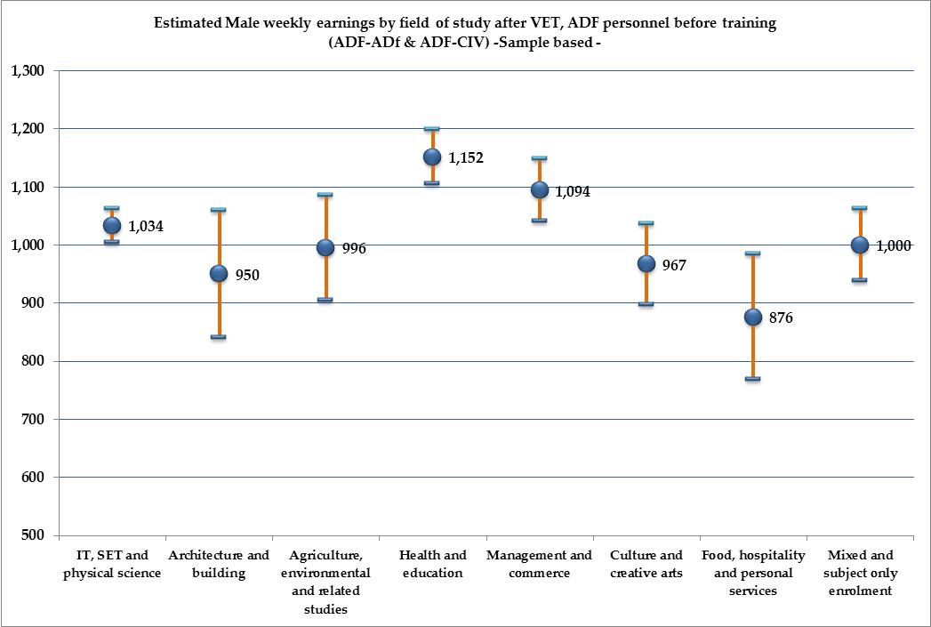

**Figure A 2: Sample estimates of Females earnings with 95% confidence intervals around the mean (ADF before training: ADF-ADF + ADF-CIV)**



1. In this section, we present a number of descriptive statistics tables and figures. Because of the rounding up of percentages to one (or none) decimal points, it may be that some categories do not add up exactly to 100%.
2. Data source: Australian Vocational Education and Training statistics: Students outcomes 2010 and 2009 technical manual.
3. We used the years 2009 and 2010 sample sizes and response rates to calculate these factors. For the large sample of 2009, the appropriate factor would be 15.9. For the small sample of 2010, the appropriate factor would be 40.
4. An annual split of all observations is presented in Table A1 in the Appendix
5. For more information, see Australian Vocational Education and Training statistics: Students outcomes 2010 data dictionary, NCVER.
6. The additional question of whether one moved to a higher skill level shows 31 per cent report a higher level and 35 per cent a lower level, but these changes allow for the possibility that someone who was already in a high-skilled job may have moved higher, and someone who was in a lower-skilled job may have moved lower, thus making the two statistics hard to compare.
7. There is no hard and fast rule about what, in practice, we should consider as a strong or a weak correlation. It is a matter of judgement and will depend on several considerations. Much depends on our judgement of the circumstances we study. It also depends on the quality of the data, as a weak correlation in a poor quality data set may be concealing a strong correlation in the population that is, however, not coming through due to data quality. In the context of large data sets with labour market variables a correlation above 0.10 (or as it will often be called, a 10 per cent correlation) is considered noteworthy, and in some instances even a 0.05 correlation should be looked at carefully.
8. Note that the z-scores in both are (for each variable) almost identical. This is correct, as the method for calculating either of them is through numerical iterations which cannot provide completely identical results. In practice, the differences are of no consequence whatsoever. For the same reason the Probit overall fit is approximated by the Pseudo R-square.
9. A z-score is like a t-ratio. The values of 1.645, 1.96, 2.326, and 2.576 correspond to 10%, 5%, 2%, and 1% levels of significance. The z-scores can be converted to P-values or used to construct confidence intervals. The higher the z-score the better and the more trustworthy the estimate is.
10. Atkinson, T, 2005, *Atkinson Review: Final Report – Measurement of Government Output and Productivity for the National Accounts*, TSO, London, January
11. MacLean MB, Van Til L, Thompson JM, Poirier A, Sweet J, Adams J, Sudom K, Campbell C, Murphy B, Dionne C & Pedlar D. Income Study: Regular Force Veteran Report. Veterans Affairs Canada, Research Directorate and Department of National Defence, Director General Military Personnel Research and Analysis. January 4, 2011: 70p.
12. A longitudinal study in Canada linked the defence records released between 1998 and 2007 for 36,638 veterans to their general family tax records after release. It was found that the income of veterans declined on average by 10 per cent per annum during the first three years, compared to the year prior to release. Females experienced a 30 per cent decline, the medically released had a decline by 29 per cent, and veterans who had served from 10 to 19 years suffered a 21 per cent decline. It was also found that the groups who experienced the highest income decline were also more likely to be current Veterans Affairs Canada clients.
13. For given individual characteristics.
14. With the exception of CIV-ADF who undertake Certificate IV. The significance threshold is quite low and the estimated coefficient is based on a very small number of observations.
15. Given the large number of broad categories of field of study and the relatively small number of observations of ADF personnel in the data, we would be reluctant to introduce the field of study directly into the estimations.
16. Model 2, Table 35, shows that earnings outcomes for ADF-CIV and CIV-CIV individuals differ significantly. Their coefficients are respectively -0.31 and -0.23 (the reference category is ADF-ADF). The meaning of these coefficients is that taking two identical persons in terms of all observed by the data characteristics used in the estimation, except from their transition, the ADF-CIV individuals would be paid, on average, 8 per cent less than the CIV-CIV individuals.
17. See Cain Polidano and Kostas Mavromaras, (2010), “The role of vocational education and training in the labour market outcomes of people with disabilities”, NCVER report 2010, Adelaide.
18. It is interesting to note that since age is negatively associated with employment probability (see Table 33), and since female DVA clients are on average two years younger than male DVA clients, the age-adjusted (that is the corrected) gender gap in employment probabilities will be slightly larger than what is reported in the figure. If we took a female whose average age corresponds to that of the average male DVA client, she would experience a slightly lower probability of employment than 72 per cent (about 70 per cent).
19. These include discrimination, life style decisions related to family matters, self-selection into precarious and lower-paid forms of employment, choices of field of study with lower returns, household decisions where the male labour force outcomes are prioritised compared to those of the female, and so on.
20. Average DVA client age, gender, and with a level of training corresponding to the mean individual in the sample.
21. Using the mid-point formula: (722-983)/0.5*(722+983)
22. That is for an individual’s given level of education, experience, age and so on.
23. Workers will accept lower pay from a job that offers other valuable non-pecuniary benefits and will require higher pay from a job that imposes non-pecuniary costs. Compensating differentials are shown to guide the selection of workers into jobs also. For example, those workers who are more capable of handling physical risk will require less compensation than those who are less capable; and hence they will be a better choice for employers with jobs involving physical risks. Similarly, workers who have a very strong need for flexible hours will pay a higher compensation (that is they will accept a lower wage) than those who do not need flexible hours and will therefore be a better choice for employers with jobs that offer flexible hours. This self-sorting will ameliorate the size of observed compensating differentials and mask their presence in employment data.
24. The mean age for a DVA client whose age corresponds to the average age found among the DVA clients under the *Military Rehabilitation and Compensation Act* *2004* (MRCA).
25. A way of looking at whether VET leads to different returns for females as opposed to males would be to introduce interaction terms in the wage estimation (female times each of the VET qualification levels). However, the sample is too small to allow us to use this technique. As a consequence, we use a simpler method which implicitly assumes that the return to each VET degree is gender-blind, and that only the absolute differences can be interpreted.
26. The SOS survey is conducted six months after completion of the VET module or course.